/* -----------------------------------------------

Name: J-Zach Loke

Course: CMPS-385

Semester: Spring 2020

Project: No. 9 Part 1

Purpose: Write a program to insert the name of the months from "JAN" to "DEC"

in a Hash table of size 5

a. Display the hash table

b. Ask the user to enter a month name, then display the month name

followed by the number of days in that month

----------------------------------------------- */

#include <iostream>

#include <string>

class HASH

{

private:

struct node

{

std::string month;

int days;

node *next;

};

node *H[5];

public:

void init()

{

for (int i = 0; i < 5; ++i)

{

H[i] = NULL;

}

}

int hashFun(std::string name)

{

// given definition

return (int(name[0]) + int(name[1]) + int(name[2])) % 5;

}

void insert(std::string x, int n)

{

int index = hashFun(x);

node *p = new(node);

p->month = x;

p->days = n;

p->next = H[index];

H[index] = p;

}

void display()

{

for (int i = 0; i < 5; ++i)

{

std::cout << "H[" << i << "]-->\t";

node *p = H[i];

while (p != NULL)

{

std::cout << "(" << p->month << ", " << p->days << ") -->\t";

p = p->next;

}

std::cout << "NULL" << std::endl;

}

}

int search(std::string x)

{

int index = hashFun(x);

node *p = H[index];

while (p != NULL && p->month != x)

{

p = p->next;

}

if (p == NULL)

{

return -1;

}

return p->days;

}

};

int main()

{

/* name: main

input: N/A

output: N/A

purpose: main function to drive the program */

// given

std::string months[12] = {"JAN", "FEB", "MAR", "APR", "MAY", "JUN", "JUL", "AUG", "SEP", "OCT", "NOV", "DEC"};

int days[12] = {31, 28, 31, 30, 31, 30, 31, 31, 30, 31, 30, 31};

HASH calendar = HASH();

for (int i = 0; i < 12; ++i)

{

calendar.insert(months[i], days[i]);

}

// part a

calendar.display();

// part b

std::string input;

std::cout << "Enter a month: ";

std::cin >> input;

int d = calendar.search(input);

if (d == -1)

{

std::cout << "That is not a valid month." << std::endl;

}

else

{

std::cout << "That month has " << d << " days in it." << std::endl;

}

system("pause");

return 0;

}

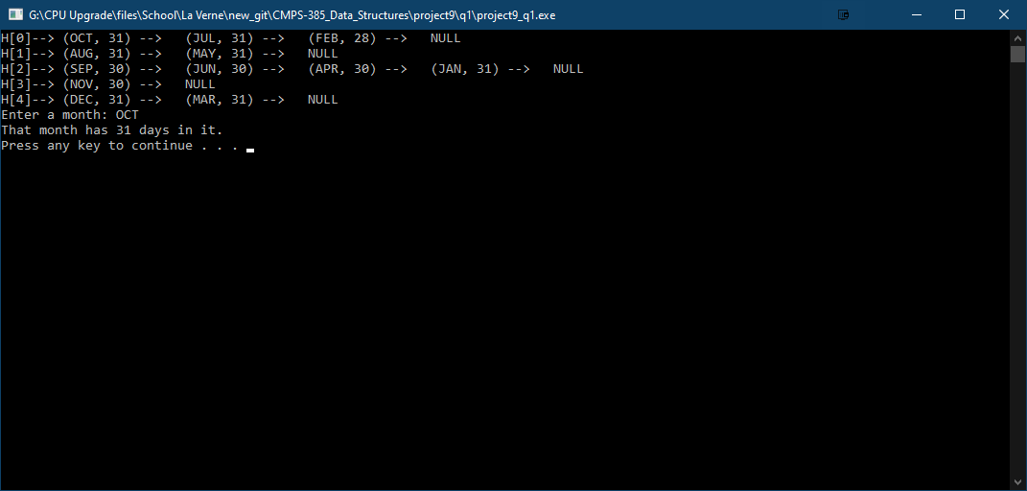

1. Sort the array using Radix sort. Show all steps for full credit

int a[9]= { 199, 200, 077, 045, 015, 278, 066, 009, 100 };

|  |  |  |
| --- | --- | --- |
| 1’s Place Hash | 10’s Place Hash | 100’s Place Hash |
| 200  100  045  015  066  077  278  199  009 | 200  100  009  015  045  066  077  278  199 | 009  015  045  066  077  100  199  200  278 |