BigMart Sales Prediction
Market Sales Analysis using AI / Machine Learning
Internship Project Report
Data Analysis & AI Internship
Dataset: Big Mart Sales Data (Kaggle)
Tech Stack: Python · pandas · scikit-learn · Flask · Streamlit · Plotly
September 2026

1. Introduction & Objective
BigMart operates a chain of supermarkets and grocery stores across multiple cities. This project analyzes 2013 sales data for 1,559 products sold across 10 stores to understand what drives product sales, and to build an AI model capable of predicting sales for a given product-store combination.
The project has three objectives:
- Clean and explore the raw sales data to uncover the key factors behind product sales.
- Train and compare machine learning models that predict Item Outlet Sales.
- Deploy the trained model behind a live web application (REST API + interactive dashboard) so predictions can be generated on demand, and summarize the findings as actionable business recommendations.

2. Dataset Description
Source: Big Mart Sales Data (Kaggle) — 8,523 rows and 12 columns. Target variable: Item_Outlet_Sales.
Column | Description
Item_Identifier | Unique product ID
Item_Weight | Weight of the product
Item_Fat_Content | Low Fat / Regular
Item_Visibility | % of display area allocated to the item
Item_Type | Product category (Dairy, Snacks, Household, etc.)
Item_MRP | Maximum Retail Price
Outlet_Identifier | Unique store ID
Outlet_Establishment_Year | Year the store was opened
Outlet_Size | Small / Medium / High
Outlet_Location_Type | Tier 1 / Tier 2 / Tier 3 city
Outlet_Type | Grocery Store / Supermarket Type1-3
Item_Outlet_Sales | Target — sales of the product in that store

3. Methodology

3.1 Data Cleaning
- Standardized inconsistent Item_Fat_Content labels (LF, low fat → Low Fat; reg → Regular).
- Imputed missing Item_Weight (~17% missing) using the mean weight of that specific product.
- Imputed missing Outlet_Size (~28% missing) using the most common size for that store's Outlet_Type.
- Result: a fully clean, model-ready dataset with zero missing values.

3.2 Feature Engineering
- Outlet_Age — years since the store opened (reference year 2013).
- Item_Category — consolidated the 16 Item_Type values into Food / Drinks / Non-Consumable.
- Outlet_Identifier and a derived MRP price-bucket were deliberately excluded from the deployed model so predictions generalize to new, hypothetical stores rather than only the 10 stores seen in training.

3.3 Exploratory Data Analysis
Item_Outlet_Sales is right-skewed: most products sell modestly, with a long tail of high performers.
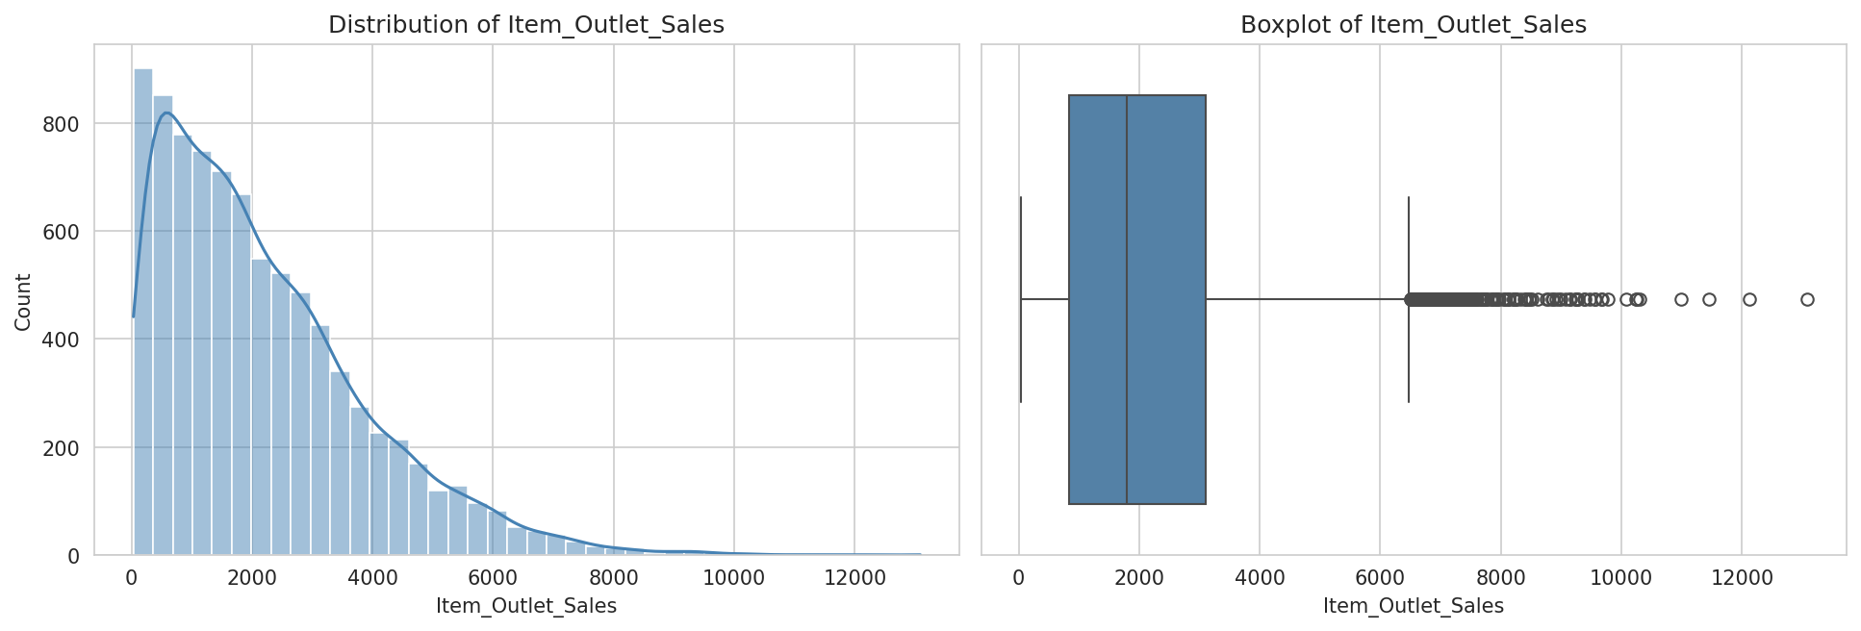
Figure 1. Distribution of Item Outlet Sales
Store format is one of the strongest sales drivers — Supermarket Type3 massively outsells Grocery Store outlets, more than store size or city tier.
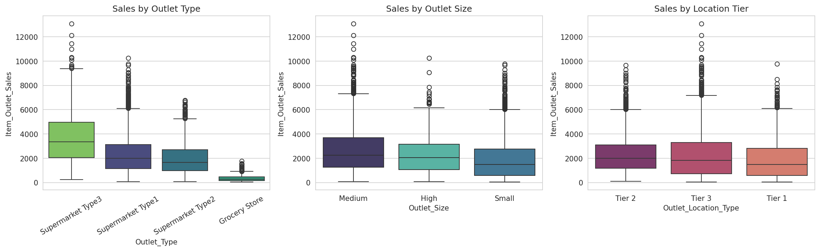
Figure 2. Sales by Outlet Type, Size, and Location Tier
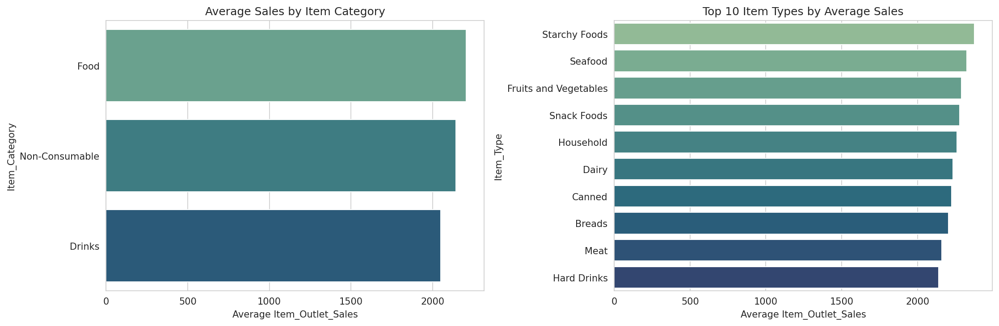
Figure 3. Average Sales by Item Category and Top Item Types
Item_MRP (price) shows a clear positive relationship with sales, visible as upward bands in the scatter plot; among numeric features, only price correlates meaningfully with the target.
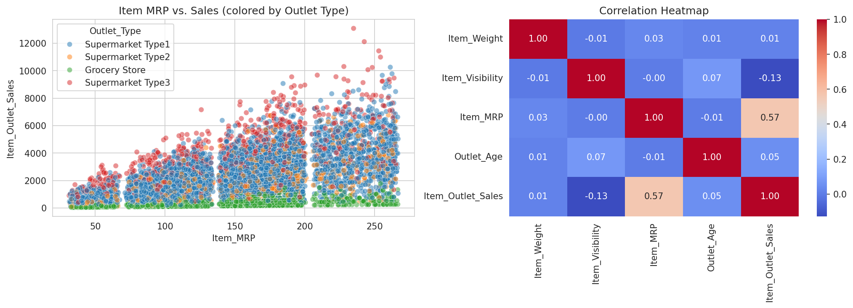
Figure 4. Item MRP vs. Sales, and Correlation Heatmap

3.4 Model Training
Categorical features were label-encoded and the data was split 80/20 into train and test sets. Three regression models were trained and compared to predict Item_Outlet_Sales:
- Linear Regression — simple baseline
- Random Forest Regressor — captures non-linear relationships and feature interactions
- XGBoost Regressor — gradient boosting, typically strong on tabular data

4. Results
Model | RMSE | MAE | R² Score
Random Forest (deployed) | 1022.68 | 716.03 | 0.6152
XGBoost | 1033.55 | 723.03 | 0.6070
Linear Regression | 1142.93 | 856.35 | 0.5194

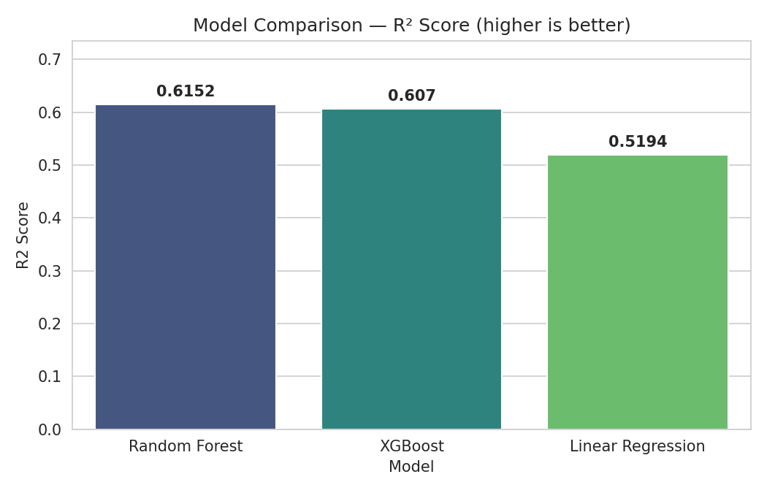
Figure 5. Model Comparison — R² Score
Random Forest was selected as the deployed model. Item_MRP and Outlet_Type dominate its predictions, together accounting for the large majority of the model's predictive power — store format and product pricing matter far more than product weight, fat content, or shelf visibility.
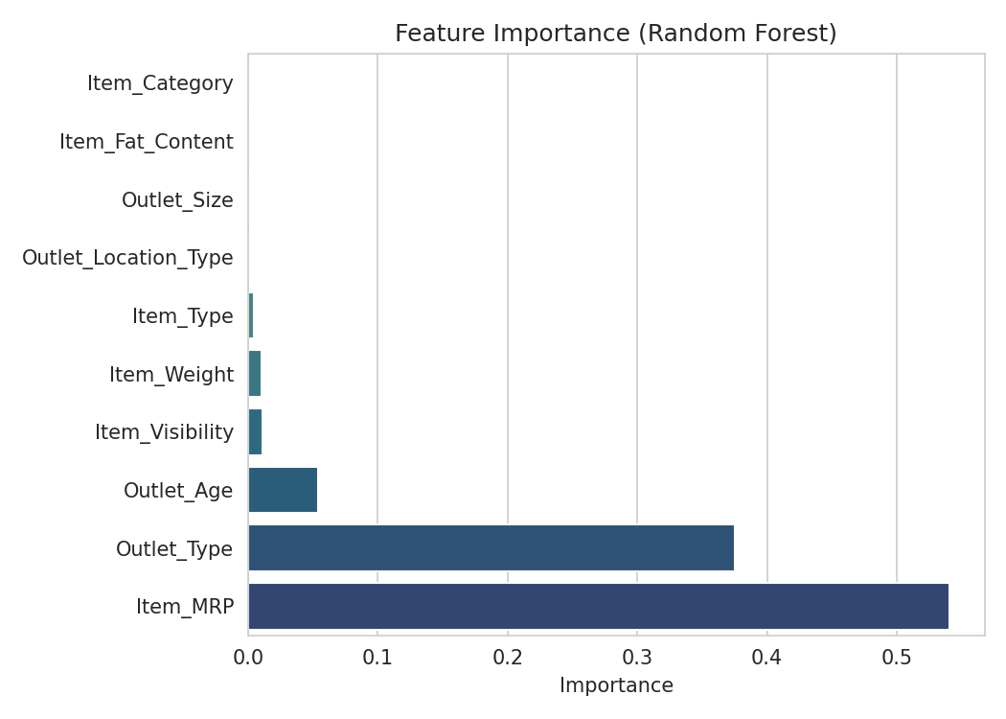
Figure 6. Feature Importance (Random Forest)
The diagnostics below show predictions tracking actual sales reasonably well, with residuals centered close to zero and no strong systematic bias, though variance increases for very high-sales outliers.
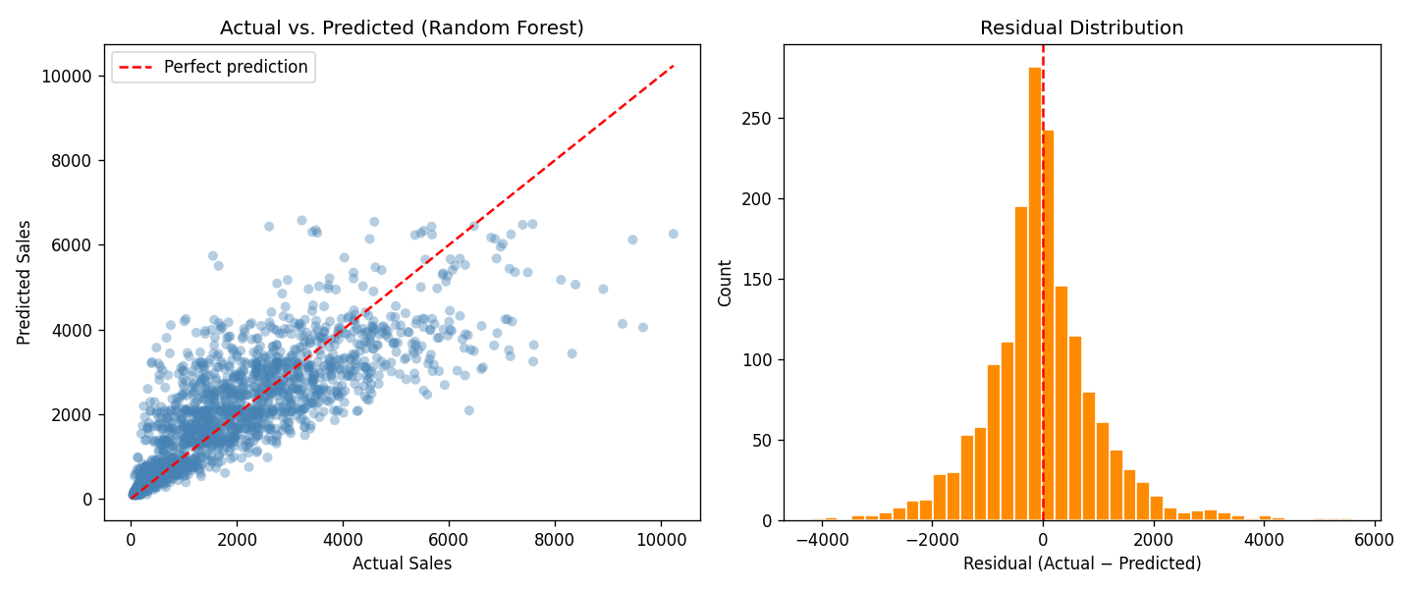
Figure 7. Actual vs. Predicted Sales and Residual Distribution

5. Business Insights & Recommendations
- Store format (Outlet_Type) and price (Item_MRP) are the two biggest sales drivers — decisions about which store format to open matter more than fine-tuning individual product attributes.
- Grocery Stores dramatically underperform Supermarkets; converting or upgrading Grocery Store locations to a Supermarket format is likely to lift revenue substantially.
- Store age has little effect on sales — the oldest outlet in the data is actually the weakest performer, pointing to a format problem rather than a maturity problem.
- Item weight, fat content, and shelf visibility have minimal impact on sales; resources are better spent on pricing and store-format strategy than shelf placement.
- The trained model can flag under-performing product-store combinations (large gap between predicted and actual sales) for manual review — e.g. stock-outs or local demand issues.

6. System Architecture
The trained model is deployed behind a small full-stack application so predictions can be generated live rather than only inside a notebook.
Layer | Technology | Role
ML Model | scikit-learn (Random Forest) | Predicts Item_Outlet_Sales
Backend | Flask REST API | Serves predictions and model/data endpoints
Frontend | Streamlit + Plotly | Interactive dashboard for predictions and EDA
Data | pandas, numpy | Cleaning, feature engineering

API Endpoints (Flask backend, http://localhost:5000):
Method | Endpoint | Description
GET | /health | Health check
POST | /predict | Predict sales for a product/store combination
GET | /dataset | Return the cleaned dataset as JSON
GET | /model_info | Model type, metrics, feature importance

Frontend Pages (Streamlit UI, http://localhost:8501): Predict Sales (live prediction form with a gauge chart), Dataset Explorer (distribution, boxplots, correlation heatmap), and Model Insights (metrics, model comparison, feature importance, diagnostics).

7. Conclusion & Future Work
This project walked through a complete data analysis and AI pipeline: cleaning messy real-world retail data, engineering useful features, visualizing the key sales drivers, training and comparing machine learning models, and deploying the best model behind a live web application — ending with concrete business recommendations.
Possible extensions:
- Hyperparameter tuning (GridSearchCV / Optuna) to push R² higher
- SHAP values for more granular, per-prediction explainability
- Authentication and deployment of the Flask + Streamlit app to a cloud host
- Incorporating external data (seasonality, promotions) since this dataset is a single-year snapshot

