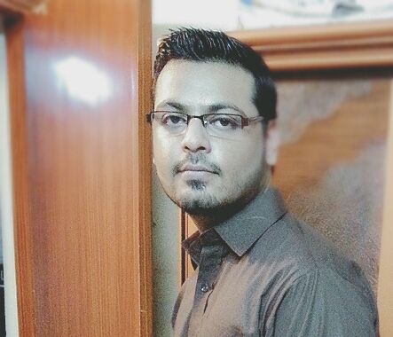
Adil Siddiq
Flat #: 102 Sadiquain Basaira, Block 13A, Gulshan-e-Iqbal, Karachi, Pakistan.

Cell #: 0331-2256765
Email: adilsiddiq98@gmail
___________________________________________________________________________________

OBJECTIVE:
Dedicated administrative professional with excellent customer service skills and extensive knowledge of bookkeeping procedures. Interested in opportunities in the travel industry focusing on sales, customer care, and office management.

PROFESSIONAL PROFILE:

- Result-driven achiever and effective team leader with exceptional interpersonal skills.

- Creative problem solver who works hard and loves challenges.

- Articulate communicator who can fluently speaks the language of both people and technology, blending technical expertise with exceptional interpersonal skills while interacting effectively with customers, clients and technical teams.

- Highly knowledgeable, creative and result-oriented management person with huge background in establishing and maintaining positive impact, planning and delivering effective management strategies and monitoring the progress of farm.

ACADEMIC BACKGROUND:

- Passed Software Engineering from the Aptech computer Education in 2013.

- Passed H.S.C - Commerce from Board of Intermediate Education Karachi in 2009.
- Passed S.S.C - Science from Board of Secondary Education Karachi in 2007.

PROFESSIONAL EXPERIENCE:

- Aptech Computer Education
Tenure: August 2014 till to date
As a Asst.Manager Academics
(Four Promotions in 3 years)

Responsibilities:
• Manage faculty
• Manage all classes
• Maintain relationship between faculty and students
• Preparing all lectures
- Developing new plans for improvements in academics.
- Performing market research for new Courses
- Generate requirement for faculty upgradation.

COMPUTER SKILLS:

- Basic, Windows 7, Windows Vista, Windows XP, Windows 8, Windows 10.
- MS Office (MS Word, MS Excel & MS Power Point, MS Outlook, Internet).
- HTML, CSS, JavaScript, Java, C#, Wordpress .
- Efficient Skills in Internet browsing and surfing.

SPECIAL SKILLS:

- Excellent communicator and presenter with the ability to engage influence and persuade at all levels.

- Have leadership qualities, excellent interpersonal, marketing / management and administration skills.
- A fast learner, able to understand new ideas and concepts quickly.

OTHER ACTIVITIES:

- Participated in “Aptech Vision 2015”, on 25th August 2015.
- Participated in “Karachi Sity Scout Camporee” ON 4th TO 6th March 205.
- Participated in “Microsoft Open Door 2011”, 20th to 22nd September 2011.
- Participated in a workshop "Telephone Courtesy", on 18th February 2009.
- Participated in “Aptech 11th Anniversary”, on 20th November 2011.

PERSONAL INFORMATION:

Father’s Name Siddiq Ismail
Domicile Karachi(Sindh)
Nationality Pakistani

References:

References will be furnished upon request.

