致编辑的逐点回复
中文审核框架（七点）
期刊：Computers and Electrical Engineering
稿件编号：COMPELECENG-D-26-05719
论文题目：Privacy-Preserving Interpretable Single-Domain Generalization for Multi-Label Ocular Disease Recognition
尊敬的 Suganthan 教授：
感谢您给予我们修改稿件的机会，并提出具体而宝贵的意见。我们十分感谢您和审稿人为评阅本稿付出的时间与精力，也认真对待您对实验比较、结果分析及稿件呈现提出的建议。
针对上述意见，我们按以下七点逐项回复。每一点将说明我们的处理方式、并摘录相应的修订内容；修订稿中的对应修改将予以高亮。

1. 与最新优秀方法的公平比较
编辑意见：请作者完善相关工作，并尽可能在相同或可比的基准上，与最新且最相关的优秀方法进行公平比较；同时说明结果来源及调参过程。仅在确有相关文献时引用本刊工作。
作者回复：
感谢您关于完善相关工作与方法比较的宝贵建议。我们理解，清楚说明比较依据及各方法的研究侧重，有助于更客观地评价本文的贡献。为尽可能提高比较的可比性，我们以ODIR数据集及其官方评价指标为依据，选取了四种代表性多标签眼病识别方法，并在表2中比较其公开报告的Kappa、F1、AUC及Final结果。
其中，Li等人[46]建立了ODIR多病识别基准；Gour和Khanna[49]采用迁移学习进行多标签眼病识别；He等人[20]通过密集相关网络建模双眼信息及疾病关联；Ou等人[50]利用双流交互与特征增强改善分类性能。针对您的建议，我们将进一步完善相关工作与比较分析，明确这些方法的贡献及其与本文的联系。
在表2所列方法中，我们的方法在Off-site和On-site上的Final分别达到78.85和77.49，均高于上述四种方法。此外，本文还围绕单源训练条件下的跨数据集泛化和隐私保护开展了相应实验，以评价分类性能之外的应用需求。分类模块与隐私保护模块的分别比较将在第2点中进一步说明。再次感谢您的指导，帮助我们更清楚地呈现比较依据、实验结果与研究贡献。
修订内容：
以下摘录修订稿第4.3节全文及表2、图7。黄色标注的首段和末段为本次修改；其余为原稿已有的相关内容。
4.3 Comparison with Existing Methods
To compare classification performance on a common benchmark, we select four representative methods that report multi-label ocular disease recognition results on ODIR using its official Kappa, F1, AUC, and Final metrics. These include the benchmark baseline of Li et al. [46] and the methods of Gour and Khanna [49], He et al. [20], and Ou et al. [50]. Their results are taken from the corresponding publications, whereas the results of our method are obtained in our experiments.
Gour and Khanna [49] proposed a transfer-learning-based CNN framework with VGG16 as the backbone. The ODIR dataset is expanded through data augmentation, and the model is fine-tuned using the SGD optimizer. The method uses pretrained weights to capture structural abnormalities involving vessels, optic discs, and maculae, thereby improving recognition performance in multi-class co-occurrence scenarios.
He et al. [20] developed a dense correlation network (DCNet), which includes a backbone CNN for extracting binocular features, a spatial correlation module for capturing pixel-level relevance, and a classifier for generating patient-level classification results. Its core idea is to fuse binocular features through dense convolutional blocks and model disease co-occurrence such as DR and AMD, but it relies on binocular input.
Ou et al. [50] designed a two-stream interactive CNN. A feature enhancement module captures local-global binocular dependencies through an attention mechanism, and a multi-scale module aggregates features at different resolutions to enrich representations. The method enhances lesion regions, such as microaneurysms and hemorrhages, through two-stream interaction to improve multi-label recognition performance, but it does not consider privacy or cross-domain scenarios.
Table 2 and Fig. 7 compare binocular metrics on the Off-site test and On-site test sets. The proposed method achieves a Final score of 78.85 on Off-site, outperforming Ou et al. [50] by 0.85, and achieves 77.49 on On-site, outperforming Ou et al. [50] by 0.79. These results demonstrate the effectiveness of dual-branch guided feature learning and adaptive label-feature relevance construction on the ODIR multi-label recognition task.
Table 2. Comparison of binocular metrics with existing methods on ODIR Off-site and On-site. Red denotes the best result for each metric, and blue denotes the second-best result.
Method | Off-site |  |  |  | On-site
Method | Kappa | F1 | AUC | Final | Kappa | F1 | AUC | Final
Li et al. [46] | 35.45 | 84.83 | 83.72 | 68.00 | 36.97 | 85.35 | 84.08 | 68.80
Gour and Khanna [49] | 43.30 | 85.30 | 84.90 | 71.20 | 42.00 | 84.90 | 83.40 | 70.10
He et al. [20] | 52.00 | 88.60 | 90.30 | 77.00 | 50.00 | 87.70 | 89.70 | 75.80
Ou et al. [50] | 53.50 | 89.20 | 91.20 | 78.00 | 51.30 | 88.60 | 90.30 | 76.70
Ours | 57.05 | 89.03 | 90.48 | 78.85 | 54.03 | 88.38 | 90.07 | 77.49
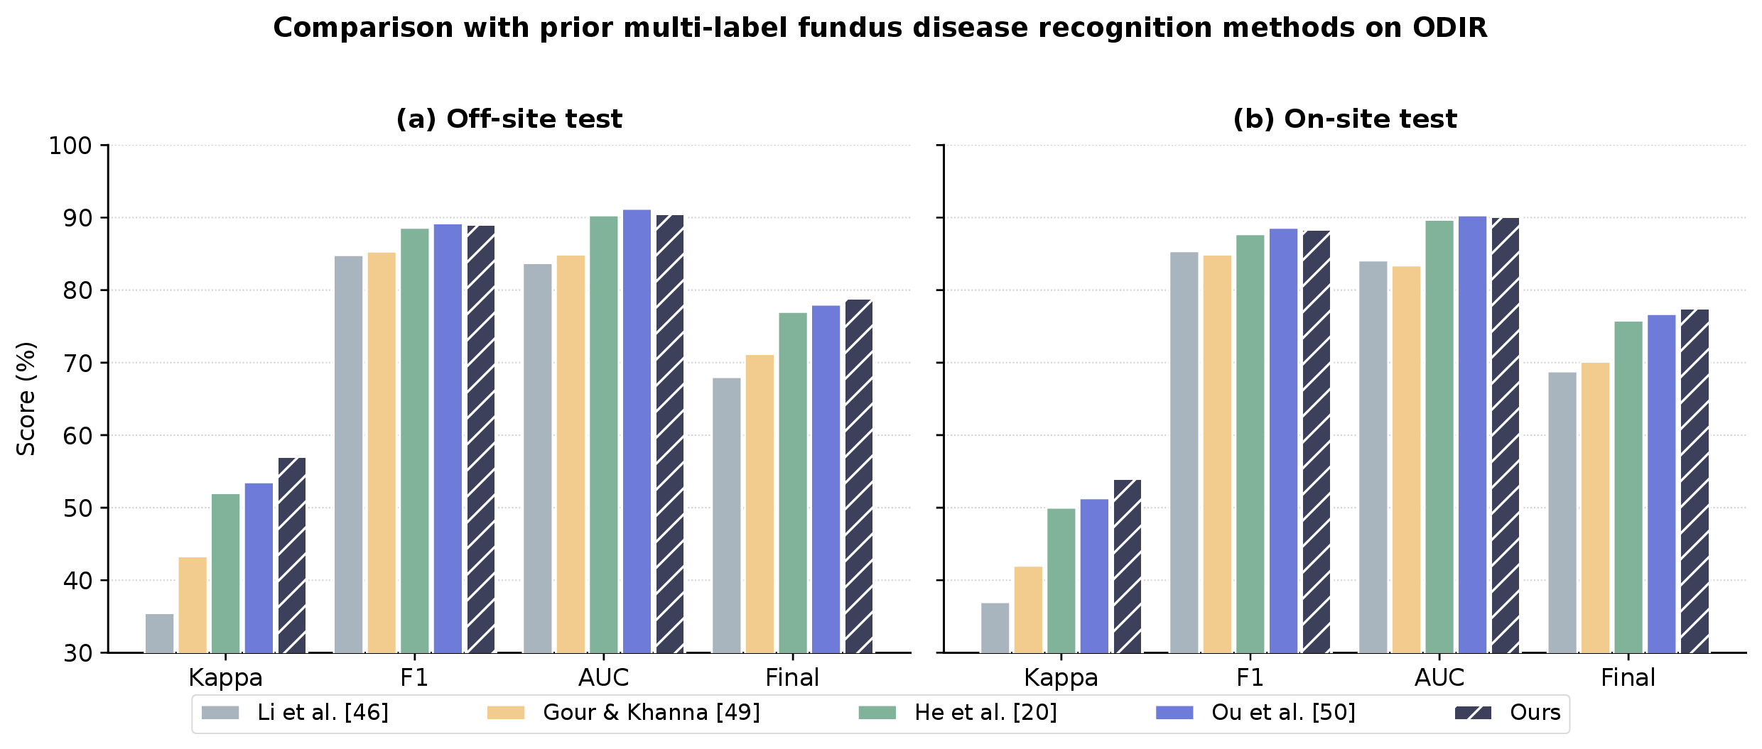
Figure 7. Visual comparison of metrics with existing methods on ODIR, where (a) Off-site test and (b) On-site test correspond to the two groups of binocular metrics in Table 2. The bars are grouped by the four metrics Kappa, F1, AUC, and Final score; within each metric, red values mark the best result and blue values mark the second-best. The proposed method (Ours) achieves the best Kappa and Final score on both test sets.
The methods listed in Table 2 mainly focus on improving in-domain multi-label classification on ODIR. To address cross-institutional application needs and restrictions on medical data sharing, our framework extends multi-label recognition by incorporating single-source domain generalization and privacy protection. The proposed method achieves higher Final scores than the four compared methods on both ODIR Off-site and On-site. We also evaluate cross-dataset generalization on RFMiD and EDID under single-source training and examine classification performance under privacy-preserving training. These results suggest the framework’s potential for clinical ocular disease recognition where generalization and privacy protection are required.

2. 分类模块与隐私保护模块的分别比较
编辑意见：请作者将分类模块和隐私保护模块分别与相应的现有优秀方法进行比较。
作者回复：
感谢您关于分别比较分类模块与隐私保护模块的宝贵建议。我们将据此完善第2节的相关工作讨论，进一步说明各模块与现有方法的联系及区别。
在分类模块方面，ML-GCN和Query2Label侧重标签关联建模，ASL和DKCNet关注类别不平衡，DCNet建模双眼特征关联。LDRNet通过标签解耦与分布重构改善长尾识别，其报告的ODIR Final分数为83.8，高于本文的78.85，但两者采用了不同的数据划分。上述研究为多标签识别提供了重要参考。本文则将自适应标签—特征关联建模与单源域不变特征学习相结合，在改善分类性能的同时，进一步关注跨数据集泛化，并在整体框架中引入隐私保护，面向医疗数据共享受限的跨机构应用。
在隐私保护模块方面，联邦学习通过本地训练减少原始数据共享，FedProx进一步处理客户端异质性；同态加密和安全多方计算分别支持密文计算与协作中的输入保护；高斯差分隐私研究则为训练过程中的梯度扰动提供了重要基础。结合单源训练的多标签眼病识别需求，本文采用高斯梯度扰动，并随训练阶段调整噪声强度，考察隐私约束下识别性能的保持情况。我们将进一步说明这一设计与现有方法的联系，以及针对本文医学任务的适配考虑。
再次感谢您的指导，帮助我们更清楚地阐述两个模块的设计依据与应用定位。
修订内容：
以下摘录修订稿第2.1节第2—4段及第2.3节全文。黄色标注为本次新增或改写的句子；其余为原稿已有的相关内容。
2.1 Multi-Label Image Recognition（第2—4段）
To alleviate these problems, recent multi-label image recognition methods have increasingly focused on label relevance modeling and sample imbalance. ML-GCN [10] constructs a label graph from label co-occurrence statistics and propagates label relevance information through graph convolutional networks. Asymmetric Loss (ASL) [16] introduces different focusing parameters for positive and negative samples and suppresses the loss contribution of easy negative samples through negative probability shifting, thereby alleviating positive-negative sample imbalance in multi-label recognition. Query2Label [17] further uses a Transformer query mechanism to model label interactions and achieves strong performance on natural image datasets such as VOC [18]. These studies show that explicitly or implicitly incorporating label relevance into the model can improve the completeness and accuracy of multi-label prediction.
In medical fundus images, multi-label recognition is clinically important because multiple diseases may occur simultaneously in the same eye, and ignoring disease co-occurrence relationships may cause false positives and false negatives [9]. Existing studies have explored multi-label ocular disease recognition from different perspectives. For example, Cheng et al. [19] transferred ML-GCN to multi-label recognition of fundus lesions and modeled lesion label relevance by constructing a fundus lesion corpus and GloVe label representations. DCNet, proposed by He et al. [20], captures pixel-level relevance between left-eye and right-eye fundus image features through a spatial correlation module and fuses binocular features for patient-level multi-label ocular disease recognition. DKCNet [21] uses an attention module to generate discriminative regional features and combines channel recalibration with resampling strategies to alleviate class imbalance in ocular datasets.
Overall, existing methods have partially addressed label relevance modeling and class imbalance. However, in fundus images with multi-disease co-occurrence, disease relationships are complex and lesion manifestations are often localized. Relying only on disease co-occurrence statistics or generic attention mechanisms may still be insufficient to characterize label-feature relevance reliably. Therefore, adaptive label-feature relevance construction for fundus images remains an important research problem. Building on label relevance modeling, this study couples adaptive label-feature relevance construction with single-source domain-invariant feature learning to address disease co-occurrence and cross-dataset application needs.
2.3 Privacy Preservation
Medical images and electronic health records contain highly sensitive personal information, and model training, parameter sharing, or cloud inference may all introduce privacy leakage risk [35]. In medical artificial intelligence applications, privacy preservation is tied not only to patient rights but also to data compliance requirements. Common privacy-preserving approaches include federated learning, encrypted computation, secure multi-party computation, and differential privacy. Among them, Federated Learning (FL) allows multiple clients to train models locally and upload parameters or gradients, thereby reducing the need for centralized sharing of raw data [36]. For example, FedProx [37] handles heterogeneous client data by adding a proximal term, alleviating instability in collaborative optimization.
Beyond federated learning, encryption mechanisms can provide stronger privacy preservation against privacy leakage. Homomorphic Encryption (HE) allows computation over ciphertexts [38] and has been explored for medical image analysis [39], but it usually incurs high computational overhead. Secure Multi-Party Computation (SMPC) [40] can protect the input privacy of each party during multi-party collaboration. Differential Privacy (DP) injects noise into query results or training gradients to provide quantifiable constraints on the privacy leakage risk of individual samples [41]. Among DP mechanisms, Gaussian differential privacy [42] injects Gaussian noise into clipped gradients and provides quantifiable privacy preservation for continuous gradient updates, making it well suited to gradient protection in deep learning.
Existing privacy-preserving mechanisms can reduce privacy leakage risk, but they still face additional challenges in domain generalization tasks. Federated learning, homomorphic encryption, and secure multi-party computation often introduce communication, computation, or system-level collaboration costs. Differential privacy is relatively straightforward to deploy, but noise injection may affect model accuracy, and this effect may vary across classes or data distributions [43]. These issues make privacy preservation more challenging under multi-domain generalization. In summary, the privacy sensitivity of medical data further restricts cross-institutional data sharing and makes the aforementioned multi-source collaboration assumption even harder to hold. Therefore, controlling the privacy-performance trade-off during local single-source training is important for cross-institutional multi-label ocular disease recognition. Building on Gaussian gradient perturbation, this study adjusts noise intensity over training to examine this trade-off within the proposed framework.

3. 各模块及整体的消融实验
编辑意见：若论文包含多个组成模块，请作者通过消融实验说明各模块单独使用以及组合使用对性能的影响。
作者回复：
感谢您关于验证各模块独立贡献及组合效果的宝贵建议。我们认同，分别分析各模块及其组合的表现，有助于更清楚地说明方法设计的有效性。
原稿第4.4节及表3设置了四组消融实验：ResNet50基线、ResNet50＋DFE、ResNet50＋ARC，以及ResNet50＋DFE＋ARC。在ODIR Off-site双眼评价下，四组模型的Final分数分别为76.19、78.37、76.98和78.85。单独加入DFE和ARC分别较基线提高2.18和0.79个百分点，两者结合提高2.66个百分点，表明两个模块分别带来性能增益，组合后取得了四组配置中最好的结果。表3同时报告了单眼评价结果，图8进一步展示各项指标的变化。
对于隐私保护机制，第4.5节另行报告了不同噪声配置及引入隐私保护后的性能变化，用于分析隐私保护与识别性能之间的权衡。我们将进一步梳理上述实验的说明，使各模块的作用及组合效果更加清晰。再次感谢您的建议，帮助我们更充分地呈现各项设计的实验依据。
修订内容：
以下摘录修订稿第4.4节全文及表3、图8、图9，以及第4.5节第4点和表7。黄色标注为本次修改；其余为原稿已有的相关内容。
4.4 Ablation Study Results
To assess the independent contributions and combined effects of the two core modules in the proposed method, namely Dual-Branch Guided Domain-Invariant Feature Extraction (DFE) and Adaptive Label-Feature Relevance Construction (ARC), and to examine the improvement in model interpretability brought by CAM guidance, we conduct module-wise ablation experiments using ODIR Off-site metrics. The results are shown in Table 3, and Fig. 8 provides an intuitive radar-chart comparison of the metric distributions across models. Table 3 reports both monocular and binocular metrics, which show a consistent improvement trend; to align with the official patient-level evaluation standard and keep the main text concise, the following analysis focuses on the binocular metrics.
Table 3. Ablation study results. The table reports monocular and binocular metrics on the ODIR Off-site test set. Compared with ResNet50 (baseline), introducing DFE or ARC alone and combining the two both yield performance improvements.
Model | Monocular |  |  |  | Binocular
Model | Kappa | F1 | AUC | Final | Kappa | F1 | AUC | Final
ResNet50 | 58.52 | 90.18 | 89.40 | 79.37 | 52.75 | 87.83 | 88.00 | 76.19
ResNet50+DFE | 62.09 | 91.04 | 91.64 | 81.59 | 56.20 | 88.80 | 90.10 | 78.37
ResNet50+ARC | 59.41 | 90.14 | 91.74 | 80.43 | 53.19 | 87.45 | 90.29 | 76.98
ResNet50+DFE+ARC (Ours) | 62.61 | 91.08 | 92.33 | 82.00 | 57.05 | 89.03 | 90.48 | 78.85
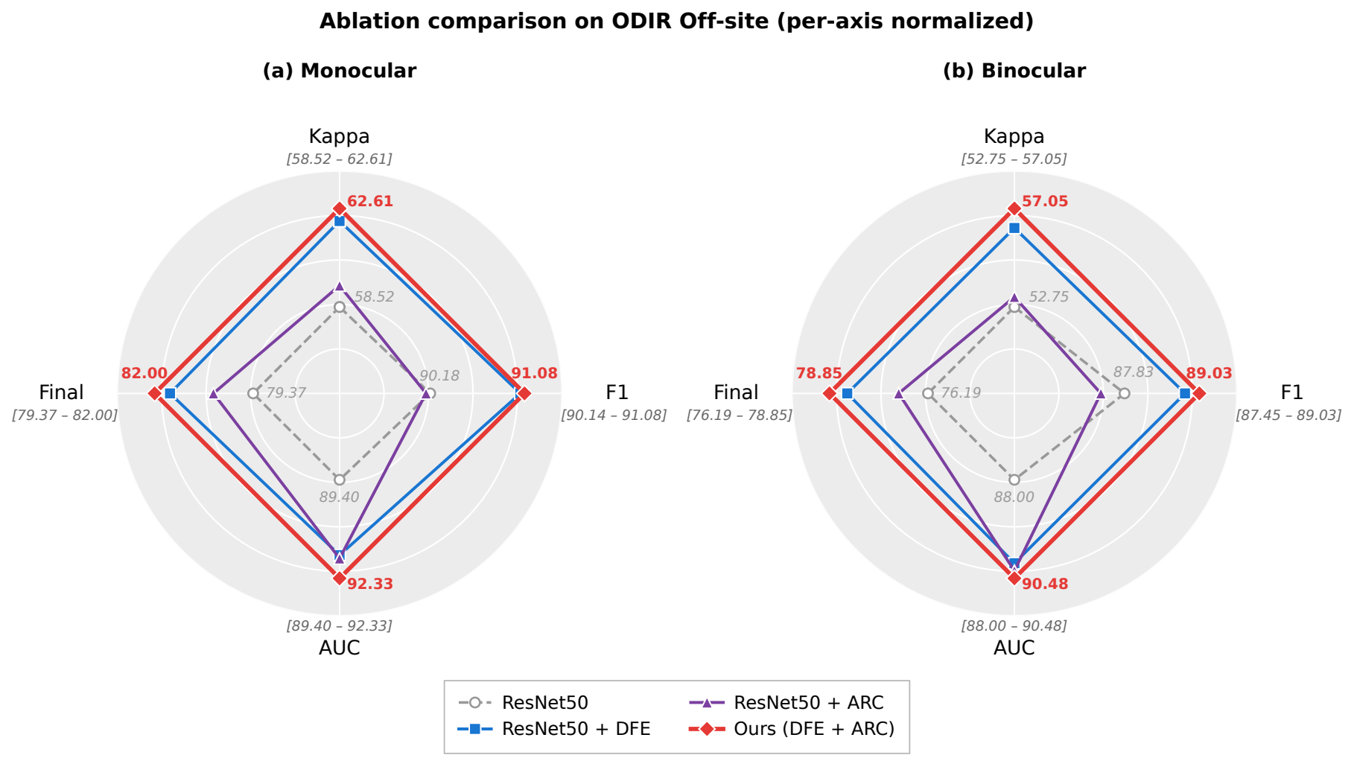
Figure 8. Radar charts of the metrics of each model on ODIR Off-site in the ablation study, showing the results under (a) monocular and (b) binocular evaluation protocols, both consistent with Table 3. Each axis corresponds to one metric (Kappa, F1, AUC, Final) and is independently normalized according to the value range of that axis to amplify differences among models; the further the polygon extends outward, the higher the metric.
ResNet50: only a single-branch ResNet50 and a standard multi-label classification head are used. The Final score is 76.19, Kappa is 52.75, and AUC is 88.00.
ResNet50+DFE: only the complete Dual-Branch Guided Domain-Invariant Feature Extraction module is introduced. The Final score increases to 78.37 (+2.18), Kappa increases by 3.45, and AUC increases by 2.10. The improvement mainly comes from CAM-guided residual weighting and the mask mechanism, which effectively suppress domain-specific noise and encourage the model to focus on domain-invariant features.
ResNet50+ARC: only the Adaptive Label-Feature Relevance Construction module is introduced. The Final score increases to 76.98 (+0.79), Kappa increases by 0.44, and AUC increases by 2.29. By explicitly modeling disease co-occurrence dependencies, such as DR and AMD or Myopia and optic-disc abnormalities, this module reduces the false-negative rate and improves multi-label recognition performance.
ResNet50+DFE+ARC (the proposed method, ours): when both modules are enabled, the Final score further increases to 78.85 (+2.66 over the baseline), Kappa reaches 57.05 (+4.30), and F1 and AUC reach 89.03 (+1.20) and 90.48 (+2.48), respectively. The combined model improves the Final score by 0.48 and 1.87 percentage points over the DFE-only and ARC-only configurations, respectively. These results show that each module contributes to performance improvement and that their combination achieves the best performance among the four configurations. DFE provides more stable domain-invariant features for ARC, enabling Transformer to learn label-label relevance and label-feature relevance more accurately. Conversely, the attention consistency loss of ARC further constrains the output distributions of the two branches and improves feature stability. In addition, the visualization results in Fig. 9 show that, compared with the baseline, the CAMs obtained by the proposed method respond less to image edges and illumination artifacts, and the model-attended regions concentrate more on the eyeball, vessels, and other disease-related regions, indicating enhanced model interpretability.
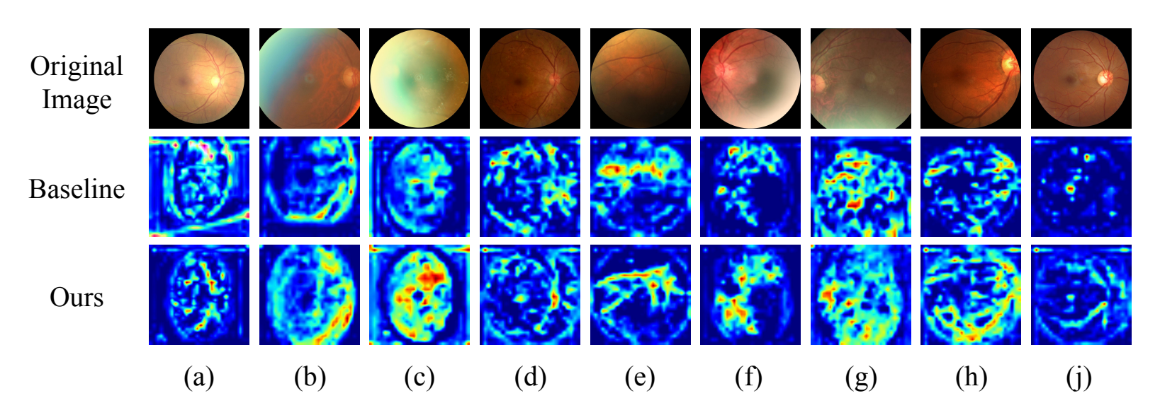
Figure 9. Comparison of CAM-based model-attended region visualizations between the baseline and the proposed method on selected ODIR Off-site samples, where (a)–(j) denote different test samples. Compared with the baseline, the model-attended regions of the proposed method are more concentrated on the eyeball, vessels, and disease-related regions, with weaker responses to irrelevant background factors such as image edges and illumination artifacts.
The ablation results show that Adaptive Label-Feature Relevance Construction (ARC) improves label relevance modeling in multi-disease co-occurrence scenarios, while Dual-Branch Guided Domain-Invariant Feature Extraction (DFE) supports learning domain-invariant features from a single source domain when multi-institutional joint training is restricted. The integration of the two modules further improves multi-label recognition performance under single-source-domain training and provides a basis for the subsequent cross-domain generalization results.
4.5 Generalization Performance Results — Point 4
4. Final generalization performance under privacy preservation. The results are shown in Table 7. Since existing generalization studies on multi-label ocular disease recognition rarely report metrics under privacy-preserving training, this study uses the official ODIR ResNet50 baseline provided by Li et al. [46] as a public reference point to assess whether privacy-preserving training can maintain performance comparable to a public benchmark. Under their respective training configurations, our non-private and private models achieve Off-site Final scores of 78.85 and 68.96, and On-site Final scores of 77.49 and 68.42, respectively. The differences of 9.89 and 9.07 percentage points quantify the recognition performance cost associated with privacy-preserving training. Compared with the official baseline, the proposed method is slightly better on Off-site (68.96 vs. 68.00) and slightly lower on On-site (68.42 vs. 68.80), remaining around the public benchmark overall. This indicates that, under a moderate privacy budget, the Adaptive Gaussian Differential Privacy mechanism can provide effective privacy preservation while keeping performance within an acceptable range.
Table 7. Comparison of generalization performance under privacy preservation. The table reports ODIR in-domain binocular Final score. Ours (privacy) uses the optimal privacy checkpoint selected in Table 6, with the official baseline reported by Li et al. [46] as a public reference.
Model | Off-site | On-site
Li et al. [46] | 68.00 | 68.80
Ours (privacy) | 68.96 | 68.42

4. 实验设置与可复现信息
编辑意见：请作者说明数据集及其训练、验证和测试划分、参数调优过程与参数值、结果来源、计算复杂度，以及代码和数据的可用性。统计检验可酌情补充。
作者回复：
感谢您关于完善实验设置与可复现信息的细致建议。我们理解，清楚说明数据使用方式、参数配置及结果来源，有助于读者理解实验设计并复现本文工作。
原稿第4.1节介绍了ODIR、RFMiD和EDID数据集，包括数据划分、实际使用的子集及跨数据集评价中的标签对应关系；第4.2节说明了评价指标、基线设置、优化器、学习率策略、训练轮数、批量大小、输入分辨率及硬件配置。第4.5节及表5进一步报告了隐私机制的参数扫描与最终选择，并说明了隐私训练所采用的学习率调整。
针对您的建议，我们将在这些说明的基础上，进一步明确各数据子集的用途、主要参数的选择依据及模型选择方式。文献方法的结果取自相应论文，本文基线及所提方法的结果来自作者实验，两类结果的来源将在文中清楚区分。此外，我们将补充方法主要计算开销的分析，以及数据获取途径和代码公开安排的说明。再次感谢您的指导，帮助我们提高实验描述的透明度和可复现性。
修订内容：〔待该点讨论并审核通过后填写〕

5. 结果表格的标注规范
编辑意见：请作者在文献方法名称旁标注文献编号，为性能指标标明方向箭头，并将最佳结果加粗呈现。
作者回复：〔待该点讨论并审核通过后填写〕
修订内容：〔待该点讨论并审核通过后填写〕

6. 篇幅、摘要与语言格式
编辑意见：请作者将单栏审稿稿控制在约35页，必要时将次要结果放入补充材料；定义摘要中的缩写，标题中不使用缩写，并避免生硬或不自然的表达。
作者回复：〔待该点讨论并审核通过后填写〕
修订内容：〔待该点讨论并审核通过后填写〕

7. 图文摘要与研究亮点
编辑意见：请作者在修订提交时提供图文摘要（graphical abstract）和研究亮点（research highlights）。
作者回复：〔待该点讨论并审核通过后填写〕
再次感谢您和审稿人的认真评阅与指导。
此致
敬礼！
作者团队

