Project Part 2 : ESE 558 Digital Image Processing
ECE, SUNY, Stony Brook University, Murali Subbarao

Write programs in Matlab/Octave for gray level (black/white) images to implement the following operations. Your program should perform explicit computations using the value of individual pixels and assigning value to individual pixels of the output image. You should not use built in functions of Matlab/Octave that operate on entire images (e.g. a Matlab function that takes an entire image and a filter as arguments and produces an entire output filtered image). You can use Matlab functions for reading and writing image files (e.g. imread()), and for converting color images to gray level images.

Submission: For Part 1, you can submit programs for both color images ( RGB channels) and gray-level image. For Part 2, you should just use the gray-level image (not RGB). You can just upload your source files and input/output images on Blackboard. A separate report is not needed. Label all source files and image files appropriately.

2. (10 points): Spatial domain non-linear filtering: Edge-preserving noise smoothing with a 5x5 Median filter and K-Nearest Neighbor (KNN) filter. Outline of the algorithm here could be useful in other parts of this project.
Write a program for edge-preserving noise smoothing of an image using
(a) a 5x5 Median Filter, and
(b) a 3x3 k-nearest neighbor (KNN) mean filter (set k=4).
Input image is f[m][n] and output image is g[m][n]; both are of size MxN. For median filter, at each pixel f[m][n], consider an image region of size 5x5 with f[m][n] at the center, find the median of the values of the image pixels in this 5x5 block, and use that as the output pixel value for g[m][n]. Use image reflection at the borders.

//The pseudo-code below uses C language syntax. Adapt it to Matlab
// The algorithm for computing the median need not sort the whole array

total=(2P+1)*(2Q+1) , P=Q=2 // total number of pixels used in the filter
double Med[total] // 1d array to store the data for sorting

for m = 0 to M-1 { //for each row of input image

for n = 0 to N-1 { // for each column of input image
r=0 // index for Med[]

for p = -P to P { // copy 2d data into a 1D array for sorting.

If m-p<0, then set k=|m-p|; //image reflection at the borders
else if m-p>M-1, then set k=M-1-[(m-p)-(M-1)];
else k=m-p;

for q = -Q to Q {

If n-q<0, then set l=|n-q| //image reflection at the borders
else if n-q>N-1, then set l=N-1-[ (n-q)-(N-1) ];
else l=n-q;

Med[r++] = f[k][l]

} // end q loop
} // end p loop

sort(Med[]) // sort Med[] data array and find the median
g[m][n] = Med[total/2 ] // assign the median as the output pixel value
} // end n loop
} // end m loop

Write output image g[m][n].

3. (5*4=20 points) Linear transforms: Image size: MxN, image: f[m][n]. filter h[m][n][u][v]
m,u=0,1,2,…,M-1, n,v= 0,1.2….,N-1
Take M=8 , N= 10, generate random numbers in the range 0.0 to 100.0 to fill up h and f , and compute and print g for the cases below. In the case of convolution, use circular convolution.

- General (shift-variant) linear transform (GLT):
Inputs: h and f, ouput g. m,u=0,1,2,…,M-1, n,v= 0,1.2….,N-1
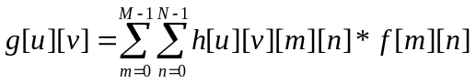

g=H f % another form of the above equation in vector matrix form

- Separable linear transform (SLT):
Inputs: h1,h2, f. Output: g.
Compute g1[m][v] first. Then compute g[u][v].

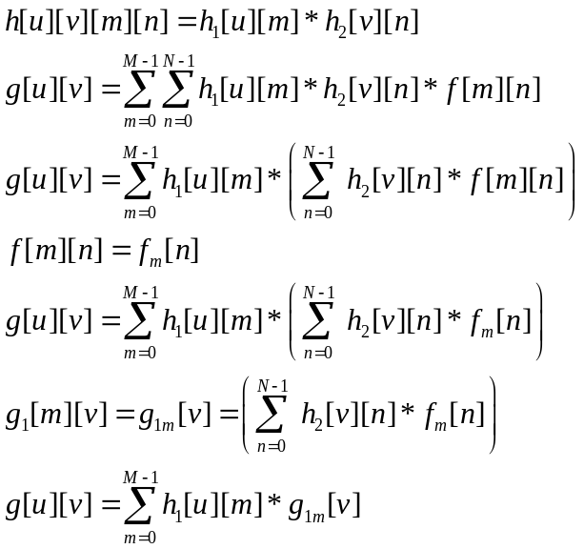

G= H1 * F * H2 % another form of the above equation in matrix form

- Circular Convolution:
Convolution l (linear shift-invariant) transform: CLT:
Inputs: hc[m][n] and f[m][n]. output: g[u][v]
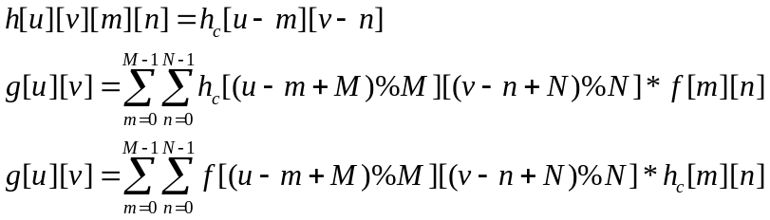

u,m= 0, 1, 2, …, M-1, and v,n= 0,1,2,3,…,N-1

- Separable Convolution linear transform (SCT):
Inputs h1c[m], h2c[n], f[m][n]. Output g[u][v].
First compute g1[m][v], then compute g[u][v].
For circular convolution,
substitute (u-m) with ((u-m+M)%M), and
substitute (v-n) with ((v-n+N)%N),

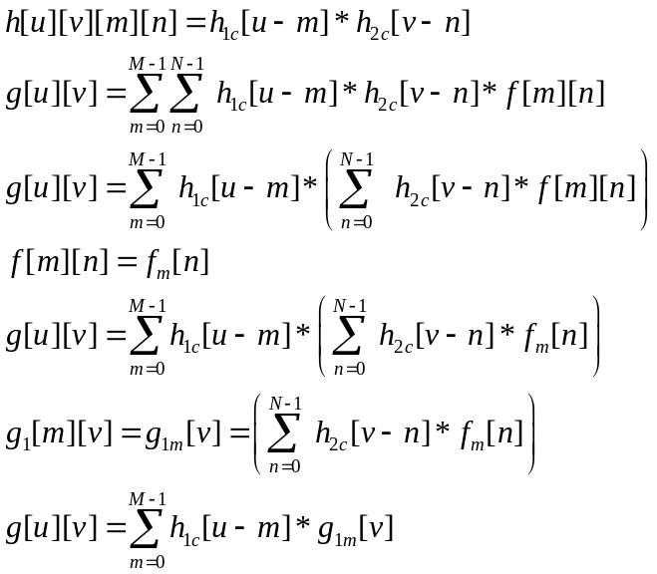

All the equations above can be expressed in matrix notation and matrix multiplication.

4. Spatial domain linear filtering (5x4=20 points)
Modify the programs in item 3 to complete this part.
4.1 Write a program for computing the blurred image of a planar object and adding different levels of Gaussian independent noise. This corresponds to the image captured by a camera of a planar object when the camera’s optical axis is perpendicular to the planar object. The blurring kernel or point spread function (PSF) is
(i) (5 pts) a 2D cylindrical function with radius r in the range 1.0 to 5.0 pixels, or
(ii) (5 pts) a Gaussian with parameter sigma in the range 1.0 to 5.0 pixels.
Implement the cylindrical PSF as a direct convolution in the spatial domain. The Gaussian psf must be implemented as a separable filter.

Direct convolution algorithm(with image reflection at the borders):

for m = 0 to M-1 { //for each row of input image

for n = 0 to N-1 { // for each column of input image

sum=0.0;
for p = -P to P {

If m-p<0, then set k=|m-p|; //image reflection at the borders
else if m-p>M-1, then set k=M-1-[(m-p)-(M-1)];
else k=m-p;

for q = -Q to Q {

If n-q<0, then set l=|n-q| //image reflection at the borders
else if n-q>N-1, then set l=N-1-[ (n-q)-(N-1) ];
else l=n-q;

sum = sum + h[p][q] * f[k][l]

} // end q loop
} // end p loop

g[m][n] = sum; // assign the output pixel value
} // end n loop
} // end m loop

Write output image g[m][n].

For comparison:

5. Frequency domain filtering (10 points)
Modify the programs in item 3b to complete this part. Write a program to attenuate lower (spatial freq. < 5) frequency components by a factor of 0.5 and leaving the higher frequency components unchanged (H[u][v] filter is defined below). The input image f[m][n] has a size of 128x128. Explicitly compute (do not use the built in library function or the FFT algorithm) the Discrete Fourier Transform F[u][v] of the image (using separable property) , and multiply it by
H[u][v] = 0.5 for ( (u<5) and (v<5) ) or ( (u>(M-5)) and (v<5) ) or
( (u<5) and ( v>(N-5) ) ) or ( (u>(M-5)) and (v>(N-5)) ),
And
H[u][v] = 1.0 for other cases.
Here u and v are spatial frequencies. Note that, lower frequencies are near the corner of the F[u][v] matrix and the center of the matrix corresponds to the high spatial frequencies (unless f[m][n] is multiplied by -1 when m+n is an odd integer). Then compute the inverse Discrete Fourier Transform g[m][n] of the product G[u][v]=H[u][v] F[u][v].

Definition of DFT (Discrete Fourier Transform). This equation is equivalent to matrix multiplication [F]=[P]*[f]*[Q].
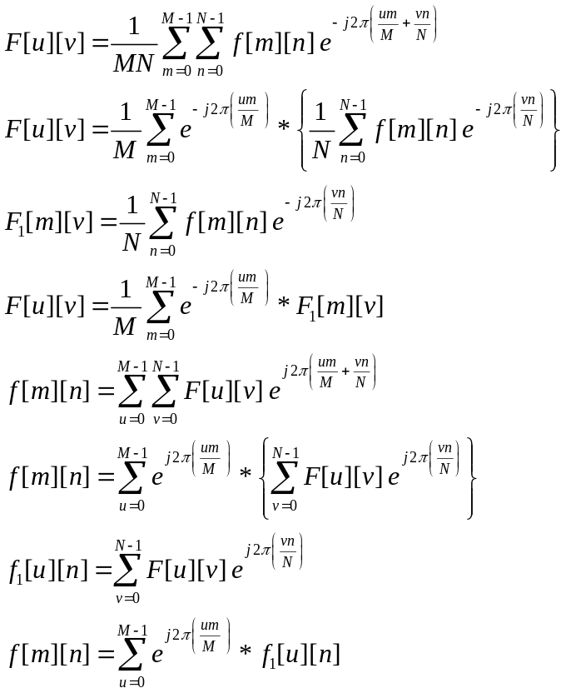

Computing DFT:
Construct a complex valued MxM matrix [P]=P[u][m] = 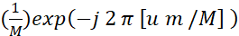 , and
Construct a complex valued NxN matrix [Q]=Q[v][n] = 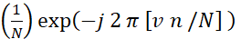
DFT [F] of [f] is computed by [F]=[P]*[f]*[Q] ( matrix multiplication—it is associative).

Computing inverse DFT (IDFT):
Construct a complex valued MxM matrix [P’]=P’[u][m] = , and
Construct a complex valued NxN matrix [Q’]=Q’[v][n] =

Let the image be an MxN complex valued matrix—[f] = f[m][n], and let [F]=F[u][v] be its DFT which is a matrix of size MxN.

Then, in matrix notation, DFT is given by the matrix multiplications:
[F] = [P] * [f]* [Q].
And the inverse DFT is
[f’]=[P’] * [F]*[Q’].

One thing you need to know is that,
exp(jx) = Cos(x)+j Sin(x). (j = sqrt(-1) = i).

That is, Cos(x) is the real part and Sin(x) is the imaginary part.

%
% Prof. Murali Subbarao, ESE 558, 2/15/2019, ECE, SBU
%
% Creating a random image/filter f
% Size is decided at runtime
%
M=input('Enter M : ');
N=input('Enter N : ');
f=zeros(M,N);
for m= 1 : M
for n=1:N
f(m,n)=rand();
end
end
f % print f

