Applications Development Laboratory (ADL)

Individual Work
Lab. No: 2 , Assignment No.: 2, Date: 18.12.2024, Day: Wednesday
Topic: Bacics of Pythons
Roll Number: | 22052486 | Branch/Section: | CSE
Name in Capital: | PRASENJEET SINGH

(Instruction: Rename this file as r-AD Lab-x where r is your roll number & x is your lab. number & Suppose your roll number is 1905123 & you want to submit lab-2 programs, then file name should be 1905123-AD Lab-2. Finally delete all texts inside parentheses, also parenthesis)

Program No: 02.1
Program Title: Write a python program to analyze the given number is positive using simple if
statement.

Input/Output Screenshots:
RUN-1:
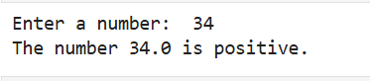

RUN-2

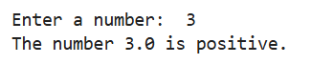

Source code

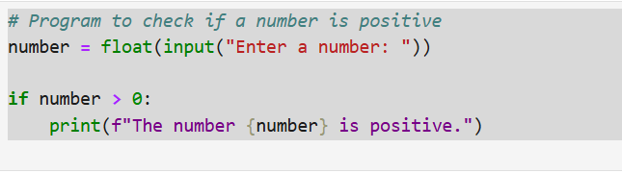

Conclusion/Observation:
The program is running.

Program No: 02.2
Program Title: Write a python program to check whether the given number is positive or not
using if…else statement.

Input/Output Screenshots:
RUN-1:
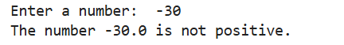

RUN-2
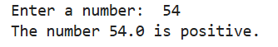

Source code
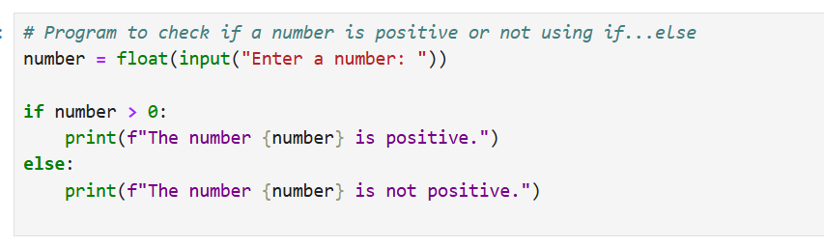

Conclusion/Observation
The program is running.

Program No: 02.3
Program Title: Write a python program to analyze whether the given year is a leap year or not?

Input/Output Screenshots:
RUN-1:

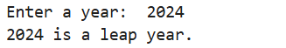

RUN-2

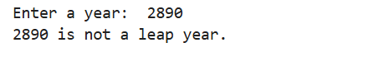

Source code

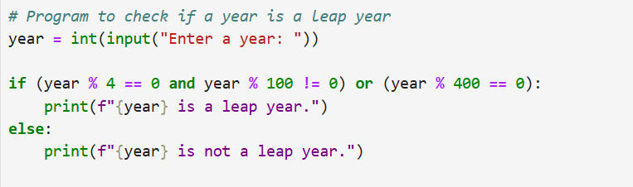

Conclusion/Observation
The program is running.

Program No: 02.4
Program Title: Write a python program to check whether the given number is positive or not
using if…else statement.

Input/Output Screenshots:
RUN-1:

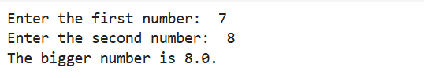

RUN-2

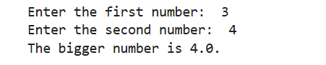

Source code

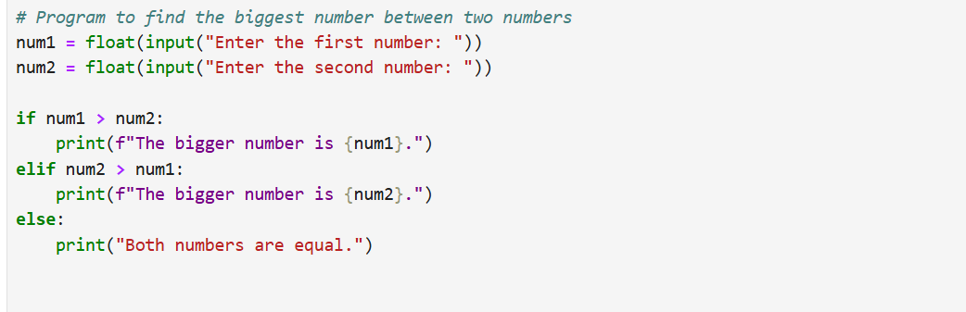

Conclusion/Observation
The program is running.

Program No: 02.5
Program Title: Write a python program to enter a 3-digits number and check whether it is
palindrome no. or not?

Input/Output Screenshots:
RUN-1:

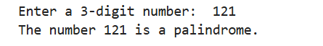

RUN-2

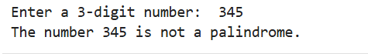

Source code

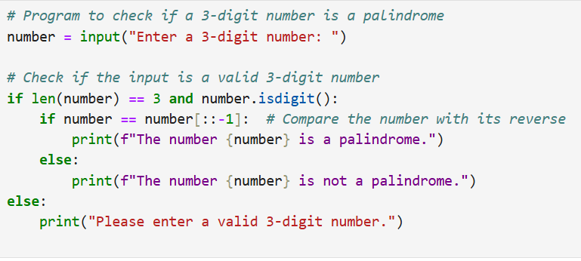

Conclusion/Observation
The program is running.

Program No: 02.6
Program Title: Write a python program to enter marks in 3 subjects and then calculate the total
mark and average. Assign the grade according to the B.Tech evaluation system.

Input/Output Screenshots:
RUN-1:
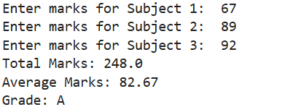

RUN-2
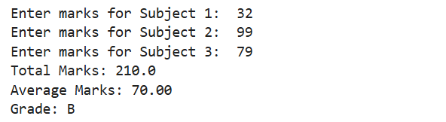

Source code
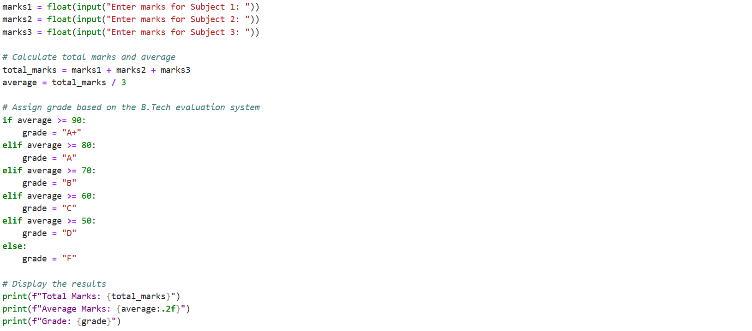

Conclusion/Observation
The program is running.

Program No: 02.7
Program Title: Write a python program to design a menu driven program as follows and then
evaluate any one of the operation according to your choice using switch case
statement. Area of circle, 2. Area of rectangle, 3. Area of Triangle

Input/Output Screenshots:
RUN-1:
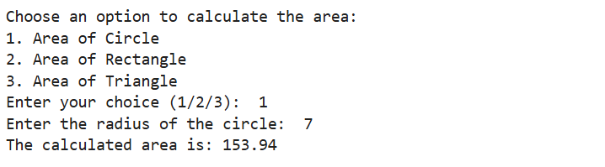

RUN-2
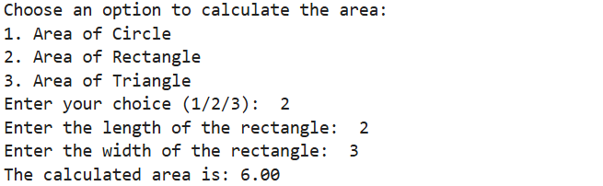

Source code
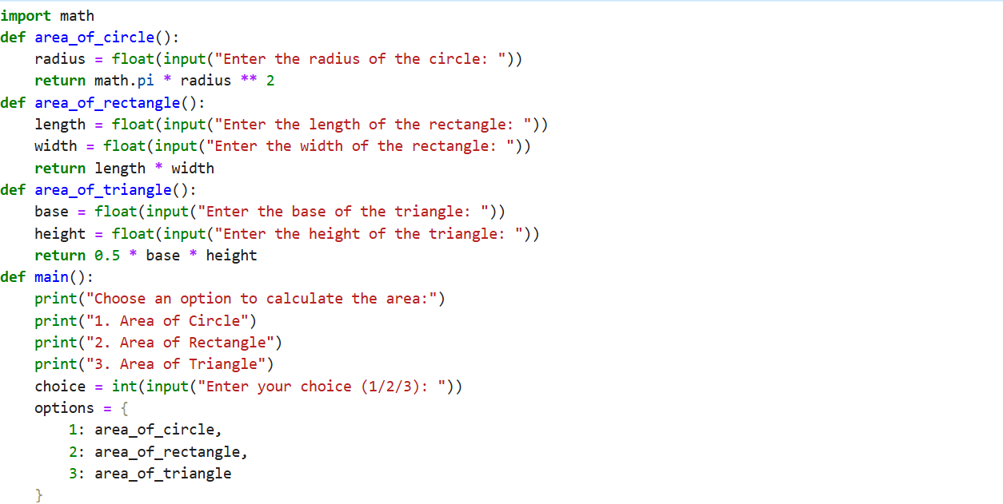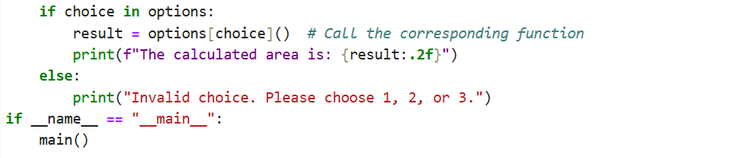

Conclusion/Observation
The program is running.

Program No: 02.8
Program Title: Write a python program to design a menu driven program as follows and then
display any one of the color according to your choice using switch case statement.
R- Red
G- Green
B- Blue

Input/Output Screenshots:
RUN-1:

RUN-2

Source code

Conclusion/Observation
The program is running.

Program No: 02.9
Program Title: Write a python program to generate the number series as follows using while
loop- 1 4 9…………n

Input/Output Screenshots:
RUN-1:

RUN-2

Source code

Conclusion/Observation
The program is running.

Program No: 02.10
Program Title: Write a python program to find out the factorial of the given no. using for loop.

Input/Output Screenshots:
RUN-1:

RUN-2

Source code
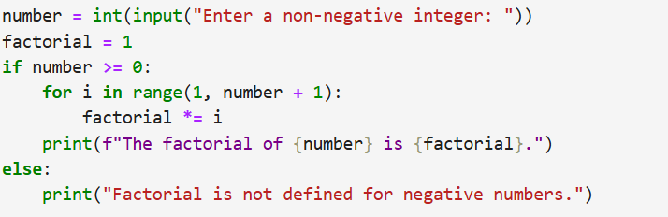

Conclusion/Observation
The program is running.

Program No: 02.11
Program Title: Write a python program to generate fibonacci series upto n terms

Input/Output Screenshots:
RUN-1:

RUN-2

Source code
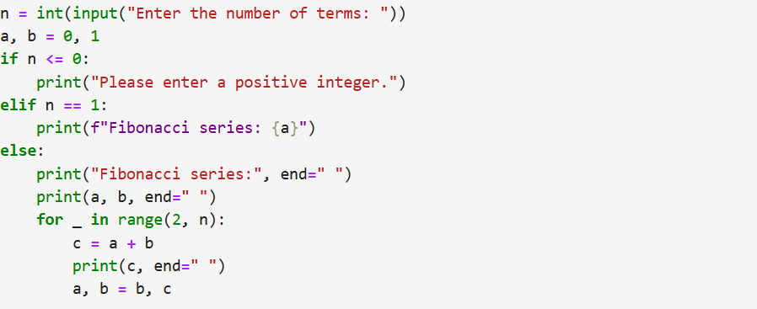

Conclusion/Observation
The program is running.

Program No: 02.12
Program Title: Write a python program to find whether a number is prime or not

Input/Output Screenshots:
RUN-1:

RUN-2

Source code
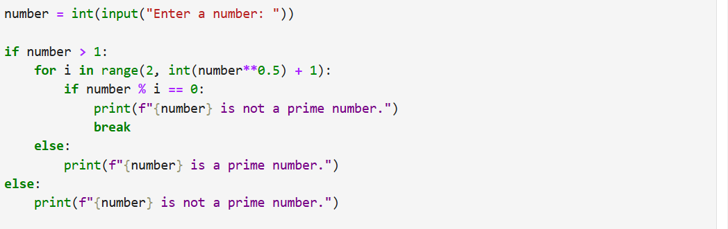

Conclusion/Observation
The program is running.

Program No: 02.13
Program Title: Write a python program to check whether an input integer is perfect number or
Not.

Input/Output Screenshots:
RUN-1:

RUN-2

Source code
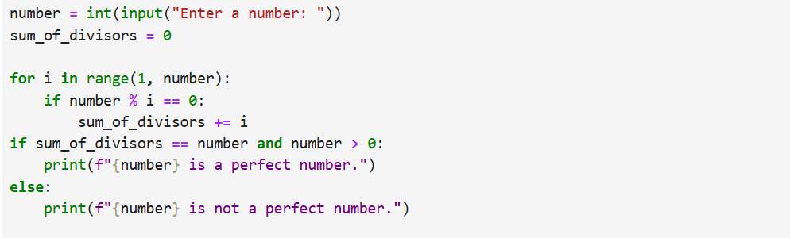

Conclusion/Observation
The program is running.

Program No: 02.14
Program Title: Write a python program to reverse the number

Input/Output Screenshots:
RUN-1:

RUN-2

Source code
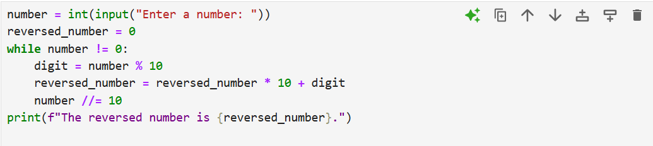

Conclusion/Observation
The program is running.

Program No: 02.15
Program Title: Write a python program to check whether an integer number is an Armstrong
number or not. If sum of cubes of each digit of the number is equal to the number
itself, then the number is called an Armstrong number. For example, 153 = ( 1 * 1
* 1 ) + ( 5 * 5 * 5 ) + ( 3 * 3 * 3 )

Input/Output Screenshots:
RUN-1:

RUN-2

Source code
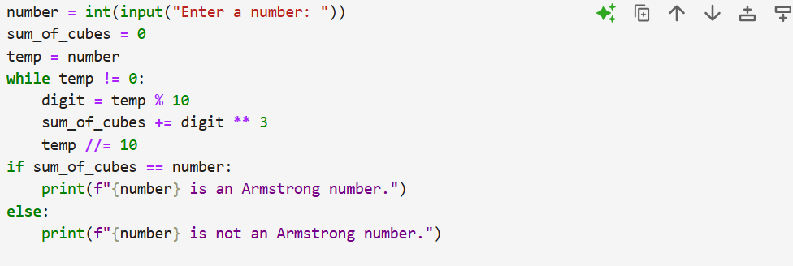

Conclusion/Observation
The program is running.

Program No: 02.16
Program Title: Write a python program to print the following pattern for n rows. Ex. for n=5
rows
1
2 1
1 2 3
4 3 2 1
1 2 3 4 5

Input/Output Screenshots:
RUN-1:
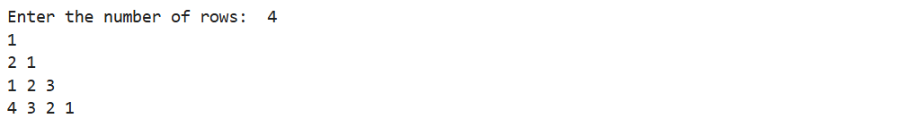

RUN-2
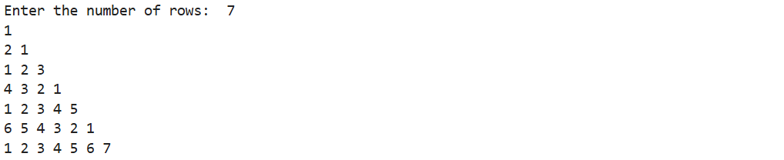

Source code
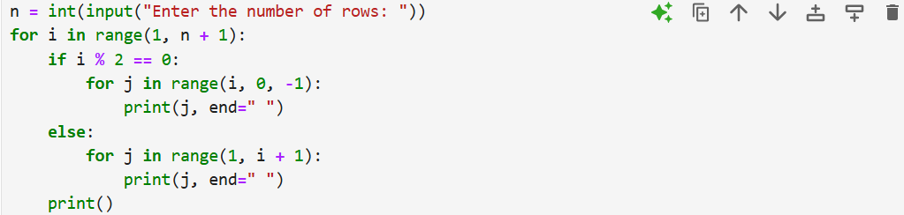

Conclusion/Observation
The program is running.

Program No: 02.17
Program Title: Write a python program to evaluate average of 3 numbers using function.

Input/Output Screenshots:
RUN-1:
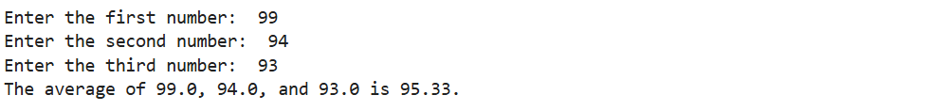

RUN-2
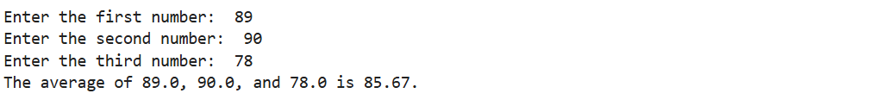

Source code
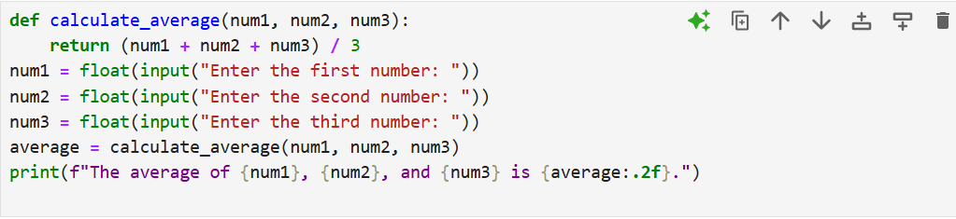

Conclusion/Observation
The program is running.

Program No: 02.18
Program Title: Write a python program to find out the factorial of a number using function

Input/Output Screenshots:
RUN-1:

RUN-2

Source code
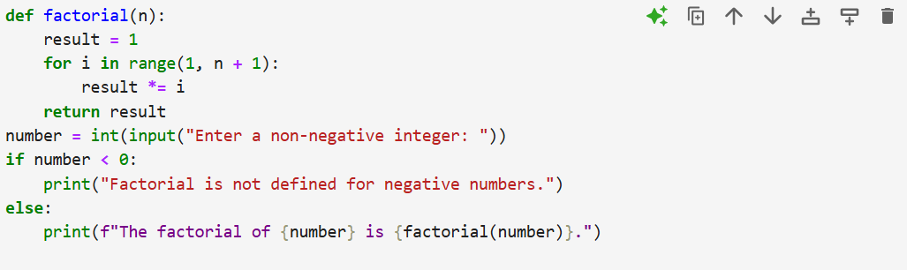

Conclusion/Observation
The program is running.

Program No: 02.19
Program Title: Write a python program to find out HCF and LCM of the given two numbers
using function

Input/Output Screenshots:
RUN-1:
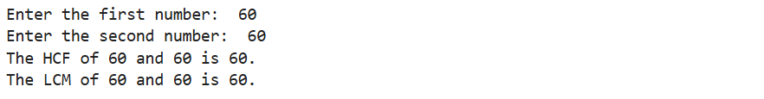

RUN-2
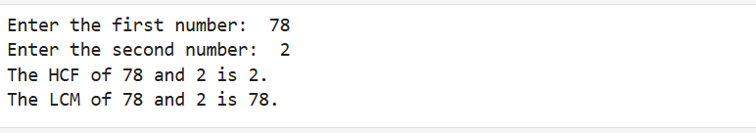

Source code
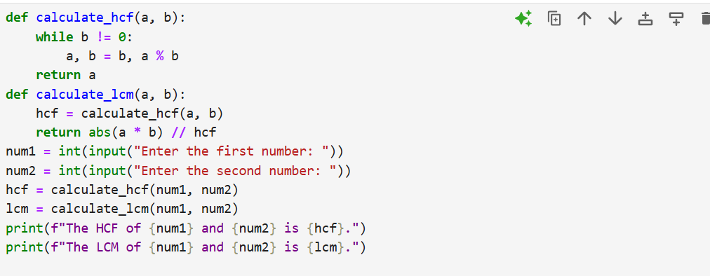

Conclusion/Observation
The program is running.

Program No: 02.20
Program Title: Write a python program to evaluate sum of the following series using recursive
function 1+2+3+................... +N

Input/Output Screenshots:
RUN-1:

RUN-2

Source code
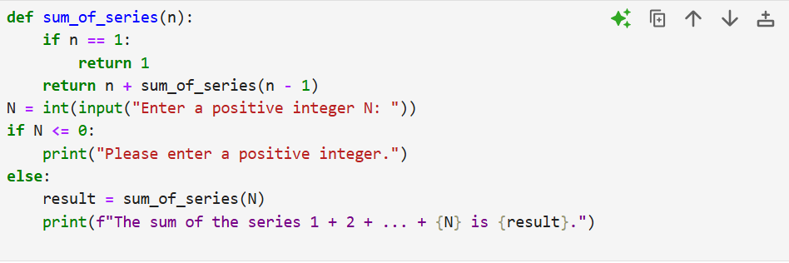

Conclusion/Observation
The program is running.

Program No: 02.21
Program Title: Write a python program to display the reverse of the given no. using recursive
function

Input/Output Screenshots:
RUN-1:

RUN-2

Source code
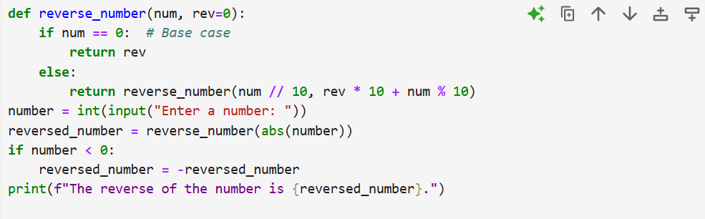

Conclusion/Observation
The program is running.

Program No: 02.22
Program Title: Write a python program to evaluate the simple interest of the given P, T, R using
function, where function takes the default value for R

Input/Output Screenshots:
RUN-1:
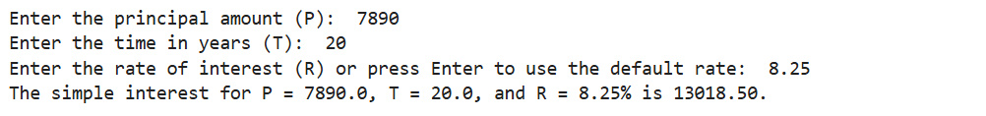

RUN-2
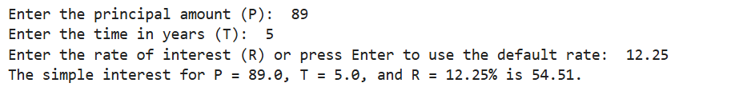

Source code
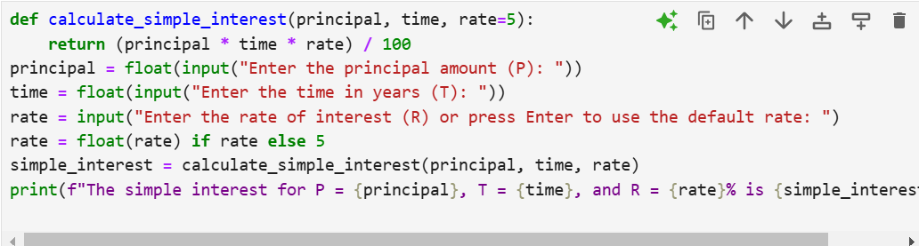

Conclusion/Observation
The program is running.

Program No: 02.23
Program Title: Write a python program to convert decimal into binary using recursive function

Input/Output Screenshots:
RUN-1:

RUN-2

Source code
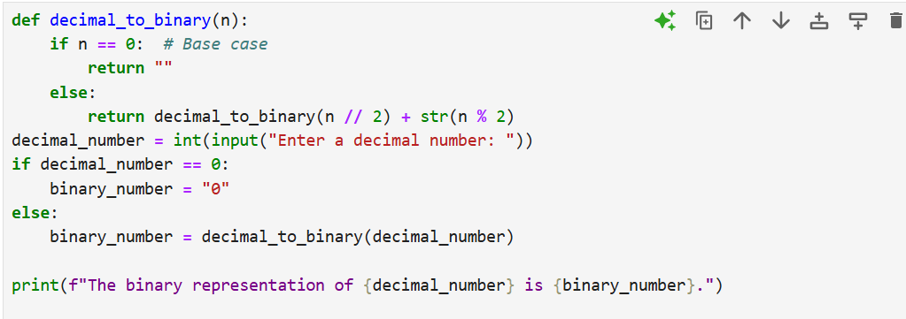

Conclusion/Observation
The program is running.

Program No: 02.24
Program Title: Write a python program to find the factorial of a number using recursive function

Input/Output Screenshots:
RUN-1:

RUN-2

Source code
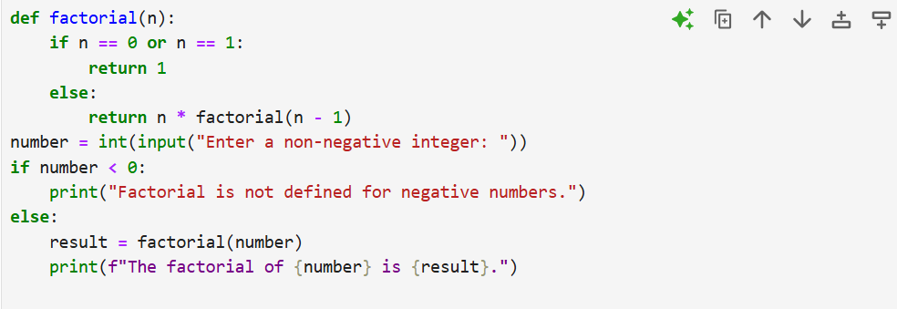

Conclusion/Observation
The program is running.

Program No: 02.25
Program Title: Write a python program to find the Find Sum of Series 12+22+32+.....+n2 using
recursive function

Input/Output Screenshots:
RUN-1:

RUN-2

Source code
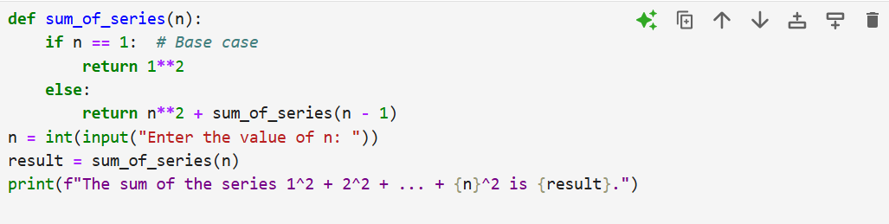

Conclusion/Observation
The program is running.

Program No: 02.26
Program Title: Write a python program to develop a function that receives 5 numbers and
display the sum, average and standard deviation of these numbers.

Input/Output Screenshots:
RUN-1:
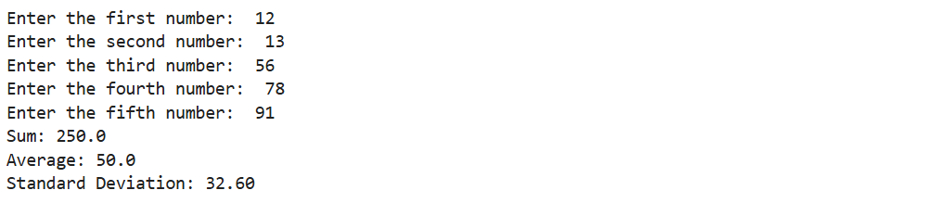

RUN-2
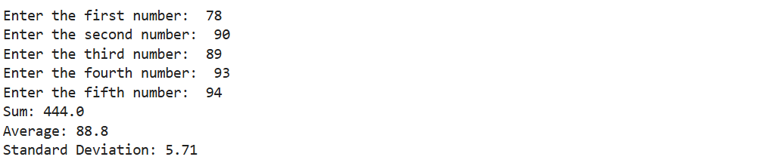

Source code
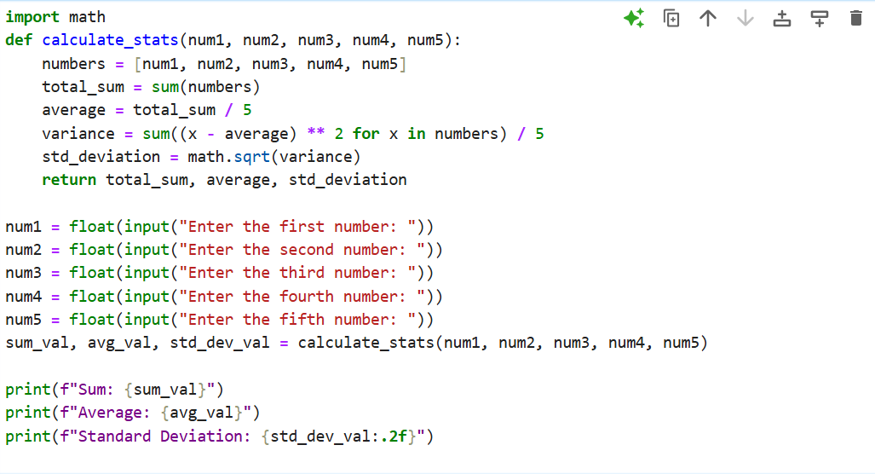

Conclusion/Observation
The program is running.

