README

Following steps need to be configured in order to bring Employee portal up

* Check out project
* Run Config.bat

Project: service-discovery:

This project Use Neltflix Service registry to register and publish micro-services of project employee-service.

* Run mvnw.bat in project “service-discovery”

NetFlix Eureka registry Service:  
<http://localhost:8761/>

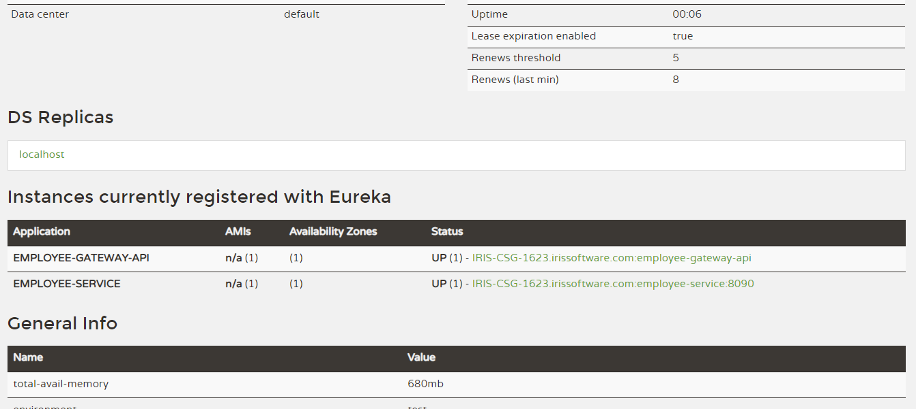

Project: employee-service.

This project provides RESTFull micro services and registered with Netflix to publish these services

* Run mvnw.bat in project “employee-service”

REST- Micro Services:  
<http://localhost:8090/employee-service/Employee/>

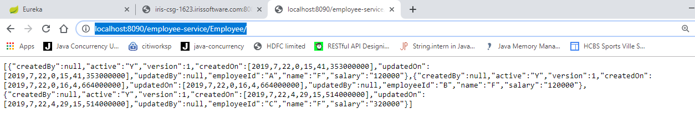

Project: employee-gateway-api

This application act as a API-Gateway for services exposed by employee-service.

* Run mvnw.bat in project “service-discovery”

Employee Portal (Employee Portal + API-Gateway:  
<http://iris-csg-1623.irissoftware.com:8080/employee-gateway/Portal/>