**LAB – 3**

**Problem Statement:**

**Write a program that lets the user type some text, consisting of words separated by blanks, ending with a carriage return, and displays the text in the same word order as entered, but with the letters in each word reversed and change the each letter small to capital except vowel.**

**Description:**

In this problem each word was stored in a stack and popped that word and again stored in a string in reversed with capitalized when necessary. The space was also stored after each word. Finally the resultant string was printed with each word reversed and capitalized each letter except vowel.

**Code:**

1. .MODEL SMALL
2. .STACK 100H
3. .DATA
5. OUTPUT DB 255 DUP("$")
7. .CODE
9. MAIN PROC
11. MOV AX,@DATA
12. MOV DS,AX

15. XOR CX,CX
16. XOR BX,BX
17. MOV SI,OFFSET OUTPUT
19. MOV AH,1
20. LOOP1:
21. ;taking input
22. INT 21H
23. CMP AL,0DH ;if new line
24. JE END_LOOP1
25. CMP AL,20H ;if space input
26. JE LOOP2
27. INC CX
28. PUSH AX
29. JMP LOOP1
31. END_LOOP1:
32. MOV BX,1 ;flag for end input
33. JMP LOOP2
35. ;if any space found then loop2 reverse this word
36. LOOP2:
38. POP DX
39. CMP DL,97
40. JG CAPITAL
41. MOV [SI],DL
42. INC SI
43. JMP END_LOOP2
44. ;if input is small letter then cpital convert it capital
45. CAPITAL:
46. CMP DL,101 ;if input is "e"
47. JE VOWEL
48. CMP DL,105 ;if input is "i"
49. JE VOWEL
50. CMP DL,111 ;if input is "o"
51. JE VOWEL
52. CMP DL,117 ;if input is "u"
53. JE VOWEL
54. SUB DL, 32 ;converting to capital
55. MOV [SI],DL
56. INC SI
57. JMP END_LOOP2
58. ;if vowel found then it unchange
59. VOWEL:
60. MOV [SI],DL
61. INC SI

64. END_LOOP2:
66. LOOP LOOP2
67. MOV [SI],32 ;after end of reversing word a space is taken
68. INC SI
69. CMP BX,0 ;check if input end line
70. JE LOOP1
72. ;print the full string
73. ;SHOW NEW LINE
74. MOV AH,02
75. MOV DL,13
76. INT 21H
77. MOV DL,0AH
78. INT 21H

81. MOV AH,09H
82. LEA DX,OUTPUT
83. INT 21H
84. MOV AH,4CH
85. INT 21H
87. MAIN ENDP
88. END MAIN

**Input & Output:**

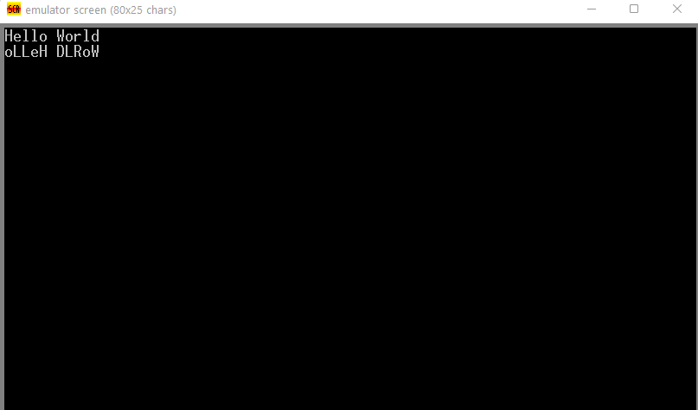

**Conclusion:**  The program run correctly and the gave valid output.