**LAB – 4**

**Problem Statement:**

**Write a program that starts with an initially undefined byte array of maximum size 100, and lets the user Insert single characters into the array in such a way that the array is always sorted in descending order. The program should print a question mark, let the user enter a character, and display the array With the new character Inserted. Input ends when the user hits the ESC key.**

**Description:**

In this problem at first a 100 size array was taken and initialize the array with “$” character.Then each character taken by input.After taken input the character the correct place of this character was searched as like as insertion sort. When the correct place was find then insert the character in this location.When enter button is clicked the program show output the array with sort.

**Code:**

1. INCLUDE 'EMU8086.INC'
2. .MODEL SMALL
3. .STACK 100H
4. .DATA
6. STR DB 100 DUP("$")
8. .CODE
10. MAIN PROC
12. MOV AX,@DATA
13. MOV DS,AX
15. PRINT "?"
16. LOOP1:
17. MOV AH,1
18. INT 21H
20. ;IF ESC INPUT
21. CMP AL,27
22. JE END_LOOP1
24. ;IF NEW LINE INPUT
25. CMP AL,0DH
26. JE PRINT

29. ;-----------------START OF INSERTION SORTING----------------------
31. ;si take the 0 index of the array
32. MOV SI,OFFSET STR
34. ;sort: check and compare every value with input value and find correct insertion index
35. SORT:
36. CMP [SI],AL
37. JL SWAP1
38. CMP [SI],36
39. JE FUNC1
40. INC SI
41. JMP SORT
43. ; func1 execute when input character shoutl be insert at the end of string
44. FUNC1:
45. MOV [SI],AL
46. JMP LOOP1
48. ; swap1 execute when a value insert into middle point of array
49. SWAP1:
50. MOV BL,[SI]
51. MOV [SI],AL
52. MOV AL,BL
53. INC SI
54. CMP [SI],36
55. JE FUNC1
56. JMP SWAP1

59. ;------------------END OF INSERTION SORTING-------------------------
61. PRINT:
63. ;print new line for show output
64. MOV AH,02
65. MOV DL,13
66. INT 21H
67. MOV DL,0AH
68. INT 21H

71. ;print output
72. MOV AH,09H
73. LEA DX,STR
74. INT 21H
75. ;print new line for taking new input
76. MOV AH,02
77. MOV DL,13
78. INT 21H
79. MOV DL,0AH
80. INT 21H
81. PRINT "?"
82. JMP LOOP1
84. END_LOOP1:
85. MOV AH,4CH
86. INT 21H
88. MAIN ENDP
89. END MAIN

**Input & Output:**

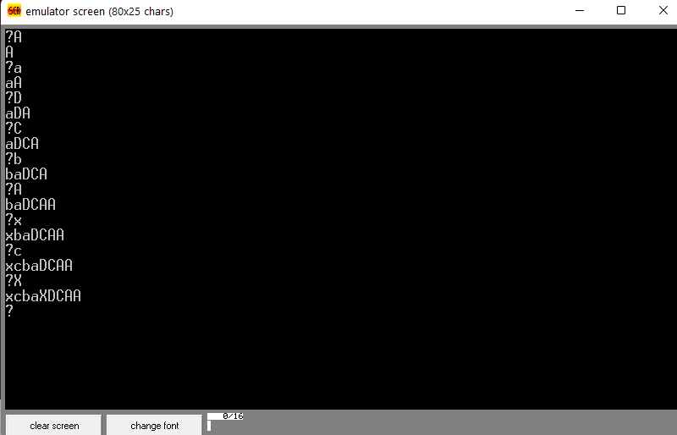

**Conclusion:**  The program run correctly and the gave valid output.