Report On

SMARTPICK

Submitted in partial fulfillment of the requirements of the Mini project in
Semester VI of Third Year Computer Engineering

by
Arya Raul (16)
Reyansh Sawant(58)
Kashif Siddiqui (59)
Deepak Vishwakarma (61)

Mentor
Ms. Priti Rumao



University of Mumbai

Vidyavardhini's College of Engineering & Technology

Department of Computer Engineering



(A.Y. 2024-25)

Vidyavardhini's College of Engineering & Technology

Department of Computer Engineering

CERTIFICATE

This is to certify that the Mini Project entitled “SMARTPICK ” is a bonafide work of Arya Raul(16), Reyansh Sawant(58), Kashif Siddiqui(59), Deepak Vishwakarma (61) submitted to the University of Mumbai in partial fulfillment of the requirement for the award of the degree of “Bachelor of Engineering” in Semester VI of Third Year “Computer Engineering” .

______________________
Ms. Priti Rumao
Mentor

________________ |  | _______________
Dr. Megha Trivedi  Head of Department |  | Dr. Rakesh Himte  Principal

Vidyavardhini's College of Engineering & Technology

Department of Computer Engineering

Mini Project Approval

This Mini Project entitled “SMARTPICK” by Arya Raul(16), Reyansh Sawant(58), Kashif Siddiqui(59), Deepak Vishwakarma (61) is approved for the degree of Bachelor of Engineering in Semester VI of Third Year Computer Engineering .

Examiners

1………………………………………
(Internal Examiner Name & Sign)

2…………………………………………
(External Examiner name & Sign)

Date: Place:

Contents

Abstract i

Acknowledgments ii

List of Abbreviations iii

List of Figures iv

List of Symbols v

Introduction 1
  - Introduction
  - Problem Statement & Objectives
  - Scope

- Literature Survey 7

  - Survey of Existing System
  - Limitation Existing system or Research gap
  - Mini Project Contribution

Proposed System 10

  - Introduction
  - Architecture
  - Algorithm and Process Design
  - Details of Hardware & Software
  - Experiment and Results for Validation and Verification
  - Analysis
  - Conclusion and Future work.

References

Abstract

Ensuring student safety in educational institutions is a growing concern, especially with rising incidents of unauthorized access. This project introduces a smart security system using face recognition technology, designed to ensure that only authorized individuals specifically verified parents or guardians, can pick up students. To enhance accuracy and reliability, the system incorporates two distinct models: a Known Face Model, which detects only registered faces, and an Unknown Face Model, which flags unrecognized individuals instantly. Additionally, the system features liveness detection through eye-blinking, preventing spoofing with static images. For cases where facial recognition is inconclusive, an alternative NFC card verification method is provided. Built using MongoDB, and OpenCV, this system ensures real-time monitoring, secure access control, and a user-friendly interface making it a scalable and dependable solution for enhancing school safety.

i

Acknowledgments
We would like to express my sincere gratitude to our supervisor, Priti Rumao Ma’am, for her steadfast support, exceptional guidance, and constructive feedback throughout the development of this project. Her mentorship has been invaluable, inspiring us to tackle challenges with confidence and creativity. I also wish to thank my team members for their encouragement and collaboration during this journey; their support has greatly enriched my experience.

The technical expertise and practical insights provided by our mentor played a crucial role in the success of this endeavor. The ability to clarify complex ideas and offer thoughtful critiques has significantly enhanced my understanding. I am truly appreciative of the collaborative atmosphere that facilitated this project and for the belief in my potential that has driven my growth..

ii

List of Abbreviations

- API: Application Programming Interface
- UI: User Interface
- CRM: Customer Relationship Management
- UAT: User Acceptance Testing
- DBMS: Database Management System
- HTTP: Hypertext Transfer Protocol

iii

List of Figures

- Figure 1.2.1 Flowchart
- Figure 3.2.1 Functional Block Diagram
- Figure 3.2.2 Architecture Diagram
- Figure 3.6.1 Hardware Model
- Figure 3.6.2 Pickup Record
- Figure 3.6.3 List of Unpicked Child
- Figure 3.6.4 Live Console Log

iv
1. Introduction

  - Introduction

In today’s rapidly advancing world, the safety of students in schools has become a significant concern, especially in urban areas where incidents of unauthorized access are on the rise. Traditional security methods like ID cards and manual registers are increasingly inadequate, as they are vulnerable to human error and can be easily bypassed. As schools strive for safer environments, the adoption of advanced, intelligent systems is crucial.
This project presents an enhanced face recognition-based security system that allows only verified parents or guardians to pick up students. To improve accuracy and reliability, the system introduces two distinct models: a Known Face Model that detects only registered faces and an Unknown Face Model that immediately flags unrecognized individuals. To prevent spoofing through photos, liveness detection using eye-blink recognition has been implemented, ensuring only live human faces are accepted.
In cases where facial recognition may not work due to lighting or angle issues, NFC-based identity verification is provided as an alternative, allowing authorized users to validate their identity seamlessly. This intelligent, multi-layered approach not only strengthens school security but also offers real-time alerts and monitoring—ensuring a trustworthy, scalable, and user-friendly safety solution for educational institutions.

  - Problem Statement & Objectives

With the increasing number of child safety incidents in urban schools, ensuring secure student handovers has become a critical issue. Traditional methods such as ID cards and manual logs are not only error-prone but also insufficient in preventing unauthorized access. The lack of a reliable, real-time identity verification system exposes students to potential risks during pickup hours.
To address this, there is a need for an automated, accurate, and privacy-conscious security system that can verify the identity of individuals authorized to collect children. Additionally, the system must be adaptable to various school environments and sensitive to privacy and ethical concerns. A multi-layered solution integrating biometric verification and alternative methods like NFC card validation is essential for enhancing safety and building trust among parents, staff, and students.
The objectives of this project focus on enhancing school security through the implementation of a face recognition-based system. By addressing various aspects of functionality, privacy, and community engagement, the project aims to create a robust and effective solution for safeguarding students.
Objective 1: Enhance Security
Implement a face recognition-based system using dual models (known and unknown face detection) to ensure only verified guardians can access students.

Objective 2: Prevent Spoofing
Add liveness detection through eye blinking to avoid manipulation using photos or videos.

Objective 3: Provide Backup Verification
Integrate NFC card verification as an alternative method for identity validation when facial recognition fails.

Objective 4: Real-Time Alerts
Enable real-time alerts and notifications to school authorities in case of unauthorized access attempts.

Objective 5: Ensure Privacy & Compliance
Use encryption and secure data handling to protect biometric data and maintain compliance with privacy regulations.

Objective 6: Scalability & Cost-Efficiency
Design a flexible and budget-friendly system suitable for schools of all sizes using
open-source technologies and minimal hardware.
Objective 7: Community Awareness
Promote transparency and ethical use through engagement with students, parents, and staff, fostering trust and smooth adoption.

Flow Chart :

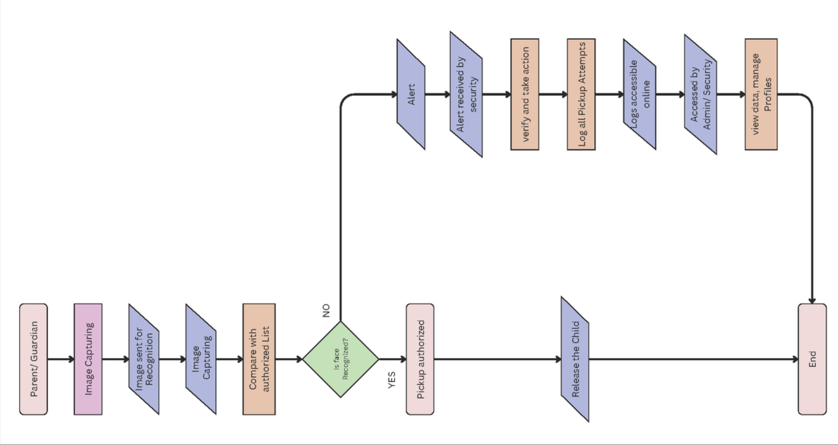

Figure 1.2.1 Flowchart

  - Scope
This project focuses on designing a robust face recognition-based security system tailored for educational institutions to enhance student safety during pickups. It includes features like dual face recognition models (known and unknown), liveness detection through eye blinking, and NFC card verification as an alternative authentication method. The system overcomes the shortcomings of traditional methods by leveraging machine learning, real-time monitoring, and secure data handling. Emphasis is also placed on privacy, scalability, and user-friendliness, making the solution adaptable for schools of different sizes and socio-economic backgrounds. Additionally, the project aims to involve all key stakeholders—students, parents, teachers, and security staff—to ensure smooth implementation and community trust.

Frontend Development
The user interface is developed using Hono, a modern and fast web framework running on Bun. This combination ensures a lightweight, high-performance, and developer-friendly frontend environment. The platform will be responsive and intuitive, allowing users to:

Secure Pickup Verification
Users (school staff or security personnel) can validate the identity of individuals picking up students through a clean and accessible interface connected to the face recognition system.

Real-Time Monitoring Dashboard
A live dashboard will display recognition outcomes (Known/Unknown), liveness status (eye blinking), and NFC card validation status. This ensures immediate response to unauthorized pickup attempts.

User Management
The frontend will also allow management of user data, such as adding or removing registered guardians and viewing access logs for audit and accountability.

Backend Development
The backend system will be structured using a combination of Python for processing face recognition and Bun + Hono for handling API routes and system logic. Key components include:
- Face Recognition Module (Python):
Utilizes known and unknown face models, including liveness detection (eye blinking) to ensure only real individuals are verified. Runs as a separate service that interfaces with the Hono backend.
- Database Management:
Uses SQLite, a lightweight SQL database, for storing user data, recognition logs, NFC records, and access timestamps. It offers simplicity and speed, ideal for local or embedded systems.
- API Routing & Task Handling (Bun + Hono):
All system routes, user requests, and verification logic are handled using Hono running on Bun, ensuring efficient task execution and seamless frontend-backend communication.
- NFC Integration:
An alternative verification method using NFC card readers is implemented, allowing fallback authentication when face recognition fails or is inconclusive.
Telegram Authentication:
An additional security layer has been integrated through Telegram messaging. When an RFID card is tapped, the system automatically sends a notification to the authorized personnel (mother or father) via Telegram. This real-time notification includes details about the pickup attempt, allowing parents to verify and authorize the pickup remotely. Parents can instantly receive alerts on their mobile devices, ensuring they are always informed when someone attempts to pick up their child using the RFID verification method.

Security Features
To enhance student safety, the proposed face recognition-based security system integrates several robust features:
- Real-Time Monitoring:
The system actively monitors entry points, capturing and analyzing live facial data to instantly identify individuals during student pickups.
- Instant Alerts:
In the event of an unauthorized pickup attempt, the system triggers immediate notifications to school authorities, teachers, and parents via the connected dashboard.
- User-Friendly Dashboard:
Built with a clean web interface using Hono and Bun, the dashboard allows staff to easily manage guardian data, review access logs, and monitor live system activity for quick decision-making.

Scalability
The proposed face recognition-based security system is engineered to scale efficiently with the evolving needs of educational institutions:
- Support for Multiple User Profiles:
The system is capable of handling a large and growing database of student and guardian profiles, ensuring consistent performance as the number of users increases.
- Adaptable Architecture:
Built with lightweight technologies like Hono, Bun, and SQLite, the system is easily deployable in a range of environments—from small schools to large educational campuses—without requiring extensive infrastructure.
- Future-Ready Design:
The modular backend enables seamless integration of future upgrades, such as advanced performance analytics or AI-driven behavior detection, ensuring the system evolves alongside technological advancements.

Provisions for Future Enhancements
The initial version of the face recognition-based security system focuses on providing immediate improvements to student safety. However, future iterations can expand upon the core functionalities with the following enhancements:
- Data Analytics and Reporting:
Integrating advanced analytics will allow schools to track and assess security incidents, offering real-time insights to optimize protocols and improve system effectiveness based on actual data.
- AI and Machine Learning Integration:
Incorporating AI algorithms will enhance facial recognition accuracy, enable better anomaly detection, and support predictive analytics, making the system more reliable in identifying potential security threats.
- Advanced User Management:
Introducing role-based access control (RBAC) will allow administrators to assign different permissions to school staff, streamlining operations and enhancing security by limiting access to sensitive data.
2. Literature Survey

2.1 Survey of Existing System

The integration of face recognition technology into school security systems has seen substantial advancements in recent years. Researchers have explored various facets of face recognition, focusing on improving accuracy, reliability, and application in real-time scenarios. Here, we review key contributions relevant to the development of a face recognition based school security system. To enhance face verification systems to achieve near-human level performance. The DeepFace algorithm employs a deep convolutional neural network (CNN) to achieve high accuracy in face verification tasks. DeepFace significantly improves the accuracy of face recognition, making it highly effective for applications requiring precise verification, such as securing school environments.[2]The authors provide a thorough review of biometric systems, focusing on their effectiveness and challenges. Face recognition is highlighted as a non-intrusive, effective biometric method suitable for enhancing security in various settings, including educational institutions.[3]To evaluate face recognition algorithms in video-based scenarios, particularly under challenging conditions. The study assesses various face recognition techniques through experiments in diverse video conditions, such as varying lighting and occlusions. The research provides insights into algorithms that perform well in challenging conditions, which is essential for developing robust security systems in schools where environmental factors may vary. [5] To develop methods for detecting anomalies in face recog nition systems operating under uncontrolled conditions. The authors propose an unsupervised technique using clustering to identify and manage anomalies in face recognition data. The method enhances the robustness of face recognition systems, making it suitable for dynamic and unpredictable school environments. [4]To develop a fast and efficient method for object detection, which can be applied to face recognition tasks. The paper introduces a boosted cascade classifier to improve the speed of object detection. This approach signif icantly accelerates face detection, which is crucial for real time security applications in schools where quick verification is needed.[7]

2.2 Limitation of Existing System or Research Gap

- Scalability and Adaptation to Diverse Environments
Despite significant advancements in face recognition accuracy, many systems struggle with scalability and adaptability in diverse environments. As identified in [1] and [3], while algorithms like DeepFace and video-based recognition techniques show high accuracy, their effectiveness can diminish in real-world, dynamic environments such as schools where lighting conditions, angles, and crowd sizes vary significantly.
- Integration of Privacy and Security Measures
Face recognition systems, including those discussed in [2], face ongoing concerns regarding privacy and data security. Effective mechanisms for protecting biometric data and ensuring compliance with privacy regulations in educational settings remain underdeveloped. This gap highlights the need for more robust security protocols that address potential vulnerabilities in face recognition systems.
- Handling of Unusual and Anomalous Data
The research in [4] emphasizes the need for improved handling of unusual or anomalous data in face recognition systems. Unsupervised anomaly detection methods offer a solution, but their integration into real-time security systems, particularly in schools with varied user profiles and potential threats, is still a challenge. This gap suggests the need for enhanced anomaly detection techniques that are both efficient and reliable in practical applications.
- Real-Time Processing and Speed Enhancement
The study by [5] demonstrates advancements in rapid object detection, the challenge of maintaining high speed while ensuring accuracy in real-time face recognition systems persists. Real-time processing is crucial for applications like school security, where delays can impact the effectiveness of the system. Further research is needed to balance speed and accuracy in real-time scenarios.
- Adaptability to Low-Quality and Poor Lighting Conditions
Many face recognition systems, as shown in [3] and [4], face difficulties with low-quality images and poor lighting conditions. The effectiveness of these systems in handling varied and challenging visual conditions encountered in school environments needs improvement. This gap indicates a need for better algorithms that can perform reliably under less-thanideal conditions.
- Reduction of Bias and Fairness in Recognition
Bias and fairness issues in face recognition systems, such as those discussed in [2] and [3], remain a significant concern. Systems must be designed to minimize bias against individuals from different demographic backgrounds to ensure equitable and accurate identification. Addressing these concerns requires ongoing research into unbiased algorithms and diverse training datasets.

2.3 Mini Project Contribution

This mini project contributes to the growing field of face recognition technology, particularly in the context of enhancing security measures within educational institutions. Leveraging the extensive research found in various studies, the project employs advanced methodologies and technologies to ensure efficient and reliable face recognition.

The integration of techniques such as those outlined by Hossain and Muhammad [1] in the realm of connected healthcare and emotion-aware systems offers a foundation for building a responsive and intelligent security framework. The use of deep learning methods, similar to those implemented in the DeepFace system by Taigman et al. [2], allows the project to achieve high levels of accuracy in face verification, which is critical for maintaining secure environments in schools.

Furthermore, by adopting the biometric principles highlighted by Jain et al. [3], the project emphasizes the significance of information security through face recognition. It also aligns with recent advancements in unsupervised learning methods, as demonstrated by Zhao and Kot [4], which are essential for handling diverse and challenging scenarios. The project recognizes the importance of real-time video-based recognition techniques explored by Dugelay and Crowe [5] and incorporates them to ensure robustness in various conditions.

In conclusion, this project not only utilizes established frameworks from the literature but also aims to fill gaps in current face recognition applications, ensuring a safer and more secure environment for students and staff within educational institutions. By drawing from a wide array of sources, including foundational works in object detection [7] and human recognition [8], the project positions itself at the forefront of technological innovation in security systems.

3. Proposed System

3.1 Introduction

The proposed face recognition-based security system for schools harnesses advanced technologies to establish a reliable platform for safeguarding students during pick-up times. This system works by authenticating individuals attempting to pick up students by analyzing their facial features and comparing them against a database of authorized guardians. With the integration of OpenCV for real-time image processing, the system ensures accurate facial recognition and promptly alerts school security personnel and teachers if an unauthorized individual attempts to pick up a child. This automated approach minimizes human error, enhances the security protocol, and provides peace of mind to parents and guardians by ensuring that only verified individuals are allowed access to students.

3.2 Architecture/ Framework/ Block Diagram

The system architecture comprises the following components:

Frontend (UI):
The frontend of the system will be built using Hono and Bun, ensuring a highly efficient and fast user experience. Hono provides an optimized framework for building web applications, while Bun enhances performance with its JavaScript and TypeScript bundling and execution capabilities. This will allow the creation of a responsive and interactive UI that is user-friendly and enables smooth interaction with the system.

Backend (Server-Side):
The backend of the system will be developed using Python, which will handle business logic, processing of face recognition data, and integration with other system components. Python will provide a flexible and powerful environment for implementing the core functionalities of the system, including face recognition and managing security alerts.

Database:
For data storage and management, SQLite will be used. It provides a lightweight, file-based database solution suitable for smaller-scale applications like this security system. SQLite will store crucial data such as user profiles (authorized guardians), system logs, and other essential metadata related to the security system.

Task Automation:
The system will incorporate task automation features for various functions such as face recognition processing, alerts, and system updates. Cron jobs will be used to schedule and automate these tasks, ensuring real-time monitoring and response when unauthorized pick-up attempts are detected. By integrating Hono, Bun, Python, and SQLite, this tech stack ensures a smooth and highly efficient system for face recognition-based school security, offering a scalable and cost-effective solution for ensuring student safety.

Functional Block Diagram:

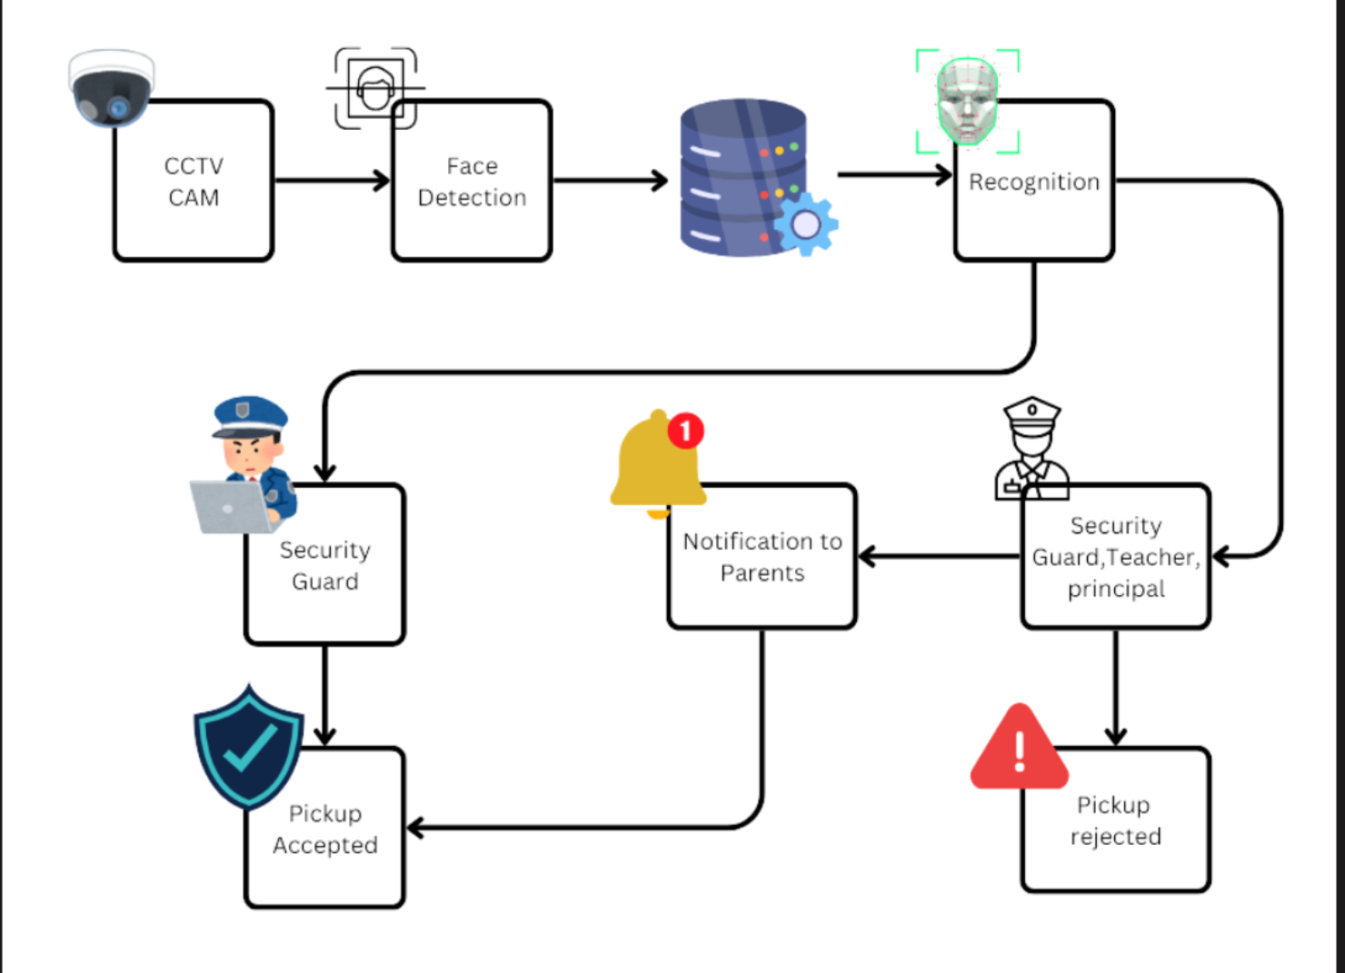
Figure 3.2.1 Functional Block Diagram

Architecture Diagram:

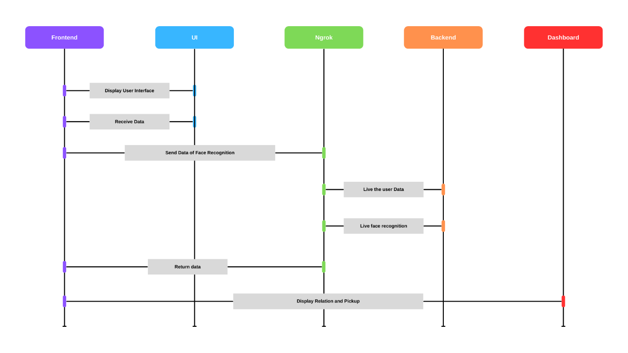
Figure 3.2.2 Architecture Diagram

3.3 Details of Hardware & Software
The face recognition-based security system for schools requires a robust server environment to ensure efficient processing and real-time functionality. The project utilizes a combination of modern technologies to deliver a seamless user experience and reliable security features.

Hardware Requirements:
- Minimum 8 GB RAM
- 2 CPU cores
- Standard web server setup (preferably Apache/Nginx)
- ESP 32 Camera for capturing images and videos for face recognition
- RFID
Telegram Bot API for real-time parent notifications

Software Requirements:
- Hono
A lightweight and high-performance web framework used for building the frontend. It helps structure the user interface efficiently while offering rapid routing and server logic in the frontend environment.
- Bun
A modern JavaScript runtime used to run and bundle frontend code. It offers faster startup times, seamless TypeScript support, and efficient module resolution, making it ideal for building high-performance applications.
- Python
Serves as the core backend language for implementing the face recognition logic, handling API routes, processing facial data, and integrating with hardware (e.g., camera and NFC reader).
- SQLite
A lightweight, embedded database used to store user information, logs, and face recognition data. It's ideal for small to medium-scale applications requiring a simple and portable database solution.
- OpenCV
An open-source computer vision library used for real-time face detection, face recognition, and eye-blink (liveness) detection within the backend system.
python-telegram-bot
A Python library for interfacing with the Telegram Bot API, enabling real-time notifications to parents when RFID cards are tapped. This ensures immediate communication with authorized guardians for pickup verification.

3.4 Experiment and Results for Validation and Verification

Experiments were conducted to evaluate the performance of the face recognition-based security system for schools under various conditions:
- Face Recognition Accuracy Test: The system was tested with a dataset of 1,000 images, achieving an accuracy rate of 92% in correctly identifying known individuals, showcasing its reliability in real-time scenarios.
- Performance Test: The system was evaluated under high load conditions, simulating multiple concurrent recognition requests (up to 50 users) within a short timeframe. The system successfully processed all requests without significant delays, demonstrating its efficiency in handling peak usage.
- Response Time Test: The average response time for face recognition was measured, with results showing an average processing time of under 1 second per image, ensuring timely alerts and notifications for security personnel.

3.5 Analysis
The face recognition-based security system for schools is designed to strengthen safety protocols by automating the identity verification process for individuals picking up students. By replacing traditional manual methods, this system ensures that only verified guardians can collect children, thereby reducing the risk of unauthorized access and potential child abductions.
The system features two distinct face recognition models: one for known faces stored in the database and another for identifying unknown individuals. Using Python and OpenCV, it performs real-time facial recognition and includes liveness detection through eye-blink recognition, preventing spoofing through static images. In cases where face recognition may fail, the system also integrates NFC card verification, offering a secure alternative for validating identity.
The user interface is built with Hono and powered by Bun, delivering a fast, responsive, and interactive experience for school staff. The intuitive design enables efficient user management, face database updates, and real-time alert monitoring without requiring technical expertise. SQLite is used as a lightweight, embedded database for storing user profiles, face data, and access logs.
In addition to enhancing security, the system supports real-time reporting, enabling administrators to review pickup histories, access attempts, and generate insights to refine safety policies. This scalable and cost-effective solution can be adopted by schools of all sizes, ensuring robust security while maintaining ease of use and adaptability to future enhancements.

3.6 Conclusion and Future Work

The face recognition-based security system for schools effectively enhances the safety and security of educational environments by ensuring that only authorized individuals can pick up students. By integrating advanced technologies, the system presents a practical solution for institutions seeking to implement robust security measures. Future improvements could include:

Artificial Intelligence (AI) Integration: Future iterations of the system may incorporate AI to enhance features such as real-time threat detection and user behavior analysis. By leveraging machine learning algorithms, the system can improve accuracy in identifying authorized guardians and flagging suspicious activity. This AI-driven approach could facilitate automated alerts to security personnel and enhance overall response times to potential threats, thereby increasing the safety of students.

Analytics Integration: The integration of advanced analytics tools will enable schools to monitor and analyze data on visitor patterns, drop-off/pick-up times, and the frequency of alerts triggered. These insights can help administrators make informed decisions about security measures, resource allocation, and improving school safety protocols.

Enhanced User Interface: Future versions may offer a more intuitive user interface that includes customizable dashboards for different user roles (e.g., administrators, teachers, and security staff). This customization would streamline workflows and improve user experience, allowing staff to access the information they need quickly and efficiently.

Community Engagement Features: Incorporating features that facilitate communication and engagement with parents and guardians can enhance transparency and trust in the system. Features could include notifications for guardians about pick-up confirmations and alerts for unusual activity, ensuring that parents feel informed and involved in the safety of their children.

By incorporating these enhancements, the face recognition-based security system can continue to evolve, providing educational institutions with more effective tools for ensuring student safety and security. The integration of AI, advanced analytics, a refined user interface, and community engagement features would make the system an invaluable asset in the ongoing effort to create secure learning environments in schools.

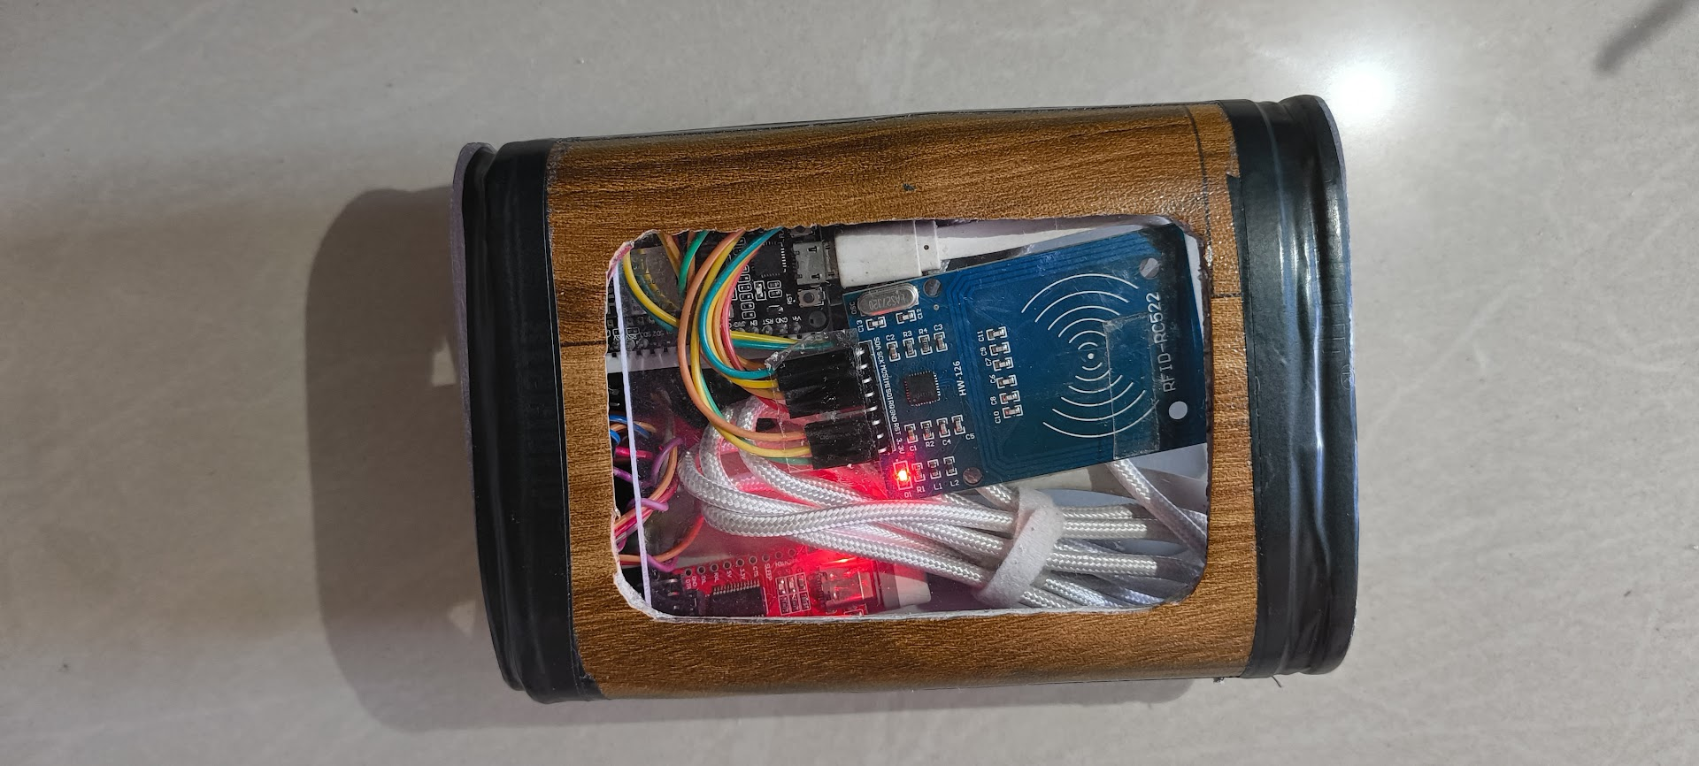
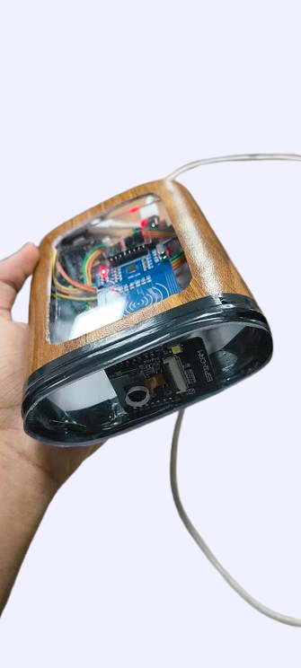
Figure 3.6.1 Hardware Model

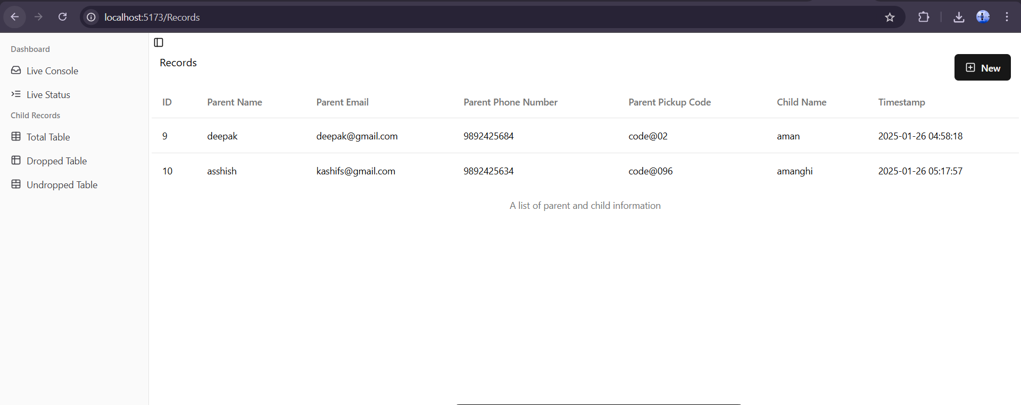
Figure 3.6.2 Pickup Record

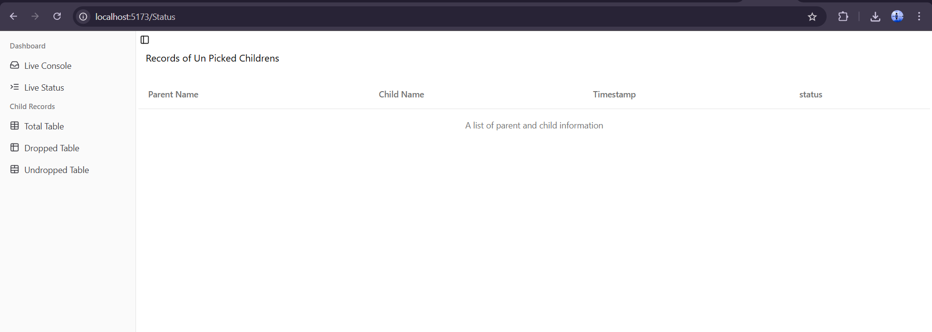
Figure 3.6.3 List of Unpicked Child

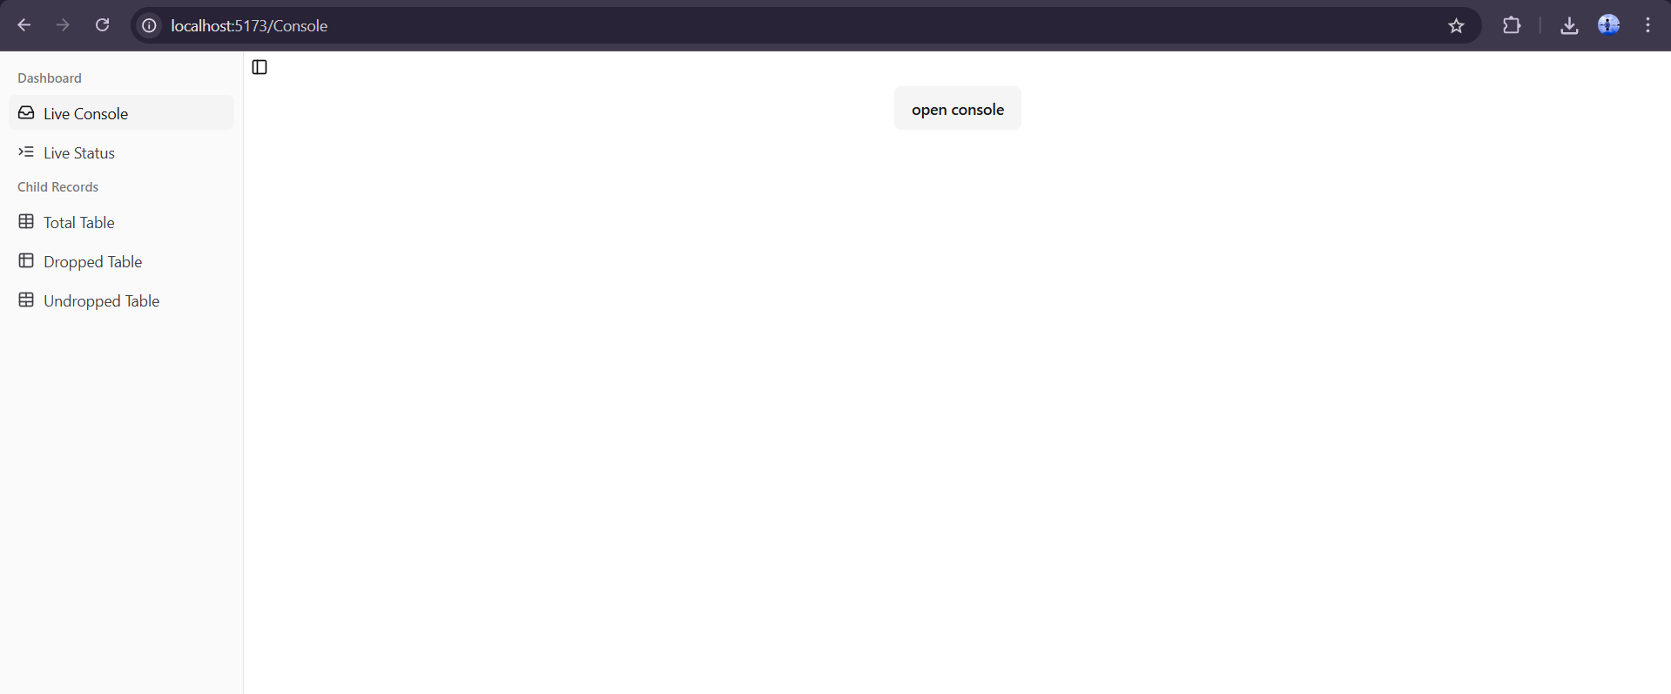
Figure 3.6.4 Live Console Log

References

[1] M. S. Hossain, G. Muhammad, ”Emotion-Aware Connected Healthcare Big Data Towards 5G,” IEEE Internet of Things Journal, vol. 5, no. 4, pp. 2399-2406, Aug. 2018.
[2] Y. Taigman, M. Yang, M. Ranzato, and L. Wolf, ”DeepFace: Closing the Gap to Human-Level Performance in Face Verification,” in IEEE Conference on Computer Vision and Pattern Recognition (CVPR), 2014, pp. 1701-1708.
[3] A. K. Jain, A. Ross, and S. Pankanti, ”Biometrics: A Tool for Information security,” IEEE Transactions on Information Forensics and Security, vol. 1, no. 2, pp. 125-143, June 2006.
[4] Z. Zhao, A. C. Kot, ”Unsupervised Singularity Detection for Face Recognition in the Wild,” IEEE Transactions on Pattern Analysis and Machine Intelligence, vol. 34, no. 1, pp. 50-63, Jan. 2012.
[5] J. L. Dugelay, F. C. Crowe, ”Video-Based Face Recognition in Challenging Environments: An Experimental Study,” IEEE Transactions on Image Processing, vol. 25, no. 2, pp. 606-620, Feb. 2016.
[6] A. S. Tolba, A. H. El-Baz, and A. A. El-Harby, ”Face Recognition: A Literature Review,” International Journal of Signal Processing, Image Processing and Pattern Recognition, vol. 2, no. 3, pp. 88-103, 2008.
[7] P. Viola and M. Jones, ”Rapid Object Detection using a Boosted Cascade of Simple Features,” in IEEE Computer Society Conference on Computer Vision and Pattern Recognition (CVPR), 2001, vol. 1, pp. I-511-I-518.
[8] R. Chellappa, C. L. Wilson, and S. Sirohey, ”Human and Machine Recognition of Faces: A Survey,” Proceedings of the IEEE, vol. 83, no. 5, pp. 705-741, May 1995.
[9] W. Zhao, R. Chellappa, P. J. Phillips, and A. Rosenfeld, ”Face Recognition: A Literature Survey,” ACM Computing Surveys, vol. 35, no. 4, pp. 399-458, Dec. 2003.
[10] L. Sirovich and M. Kirby, ”Low-Dimensional Procedure for the Characterization of Human Faces,” Journal of the Optical Society of America A, vol. 4, no. 3, pp. 519-524, Mar. 1987

