Experiment 1

Student Name: Reyansh Arora UID: 24BAI70273
Branch: CSE - AIML Section/Group: 24AIT_KRG G1
Semester: 4 Date of Performance: 9/1/26
Subject Name: DBMS Subject Code: 24CSH-298

Aim
To design and implement a Library Management System database using appropriate tables, primary keys, foreign keys, and constraints, and to perform DML operations along with DCL commands such as role creation, privilege granting, and revoking to ensure database security.

Software Requirements
- Database Management System:
  - PostgreSQL
- Database Administration Tool:
  - pgAdmin

Objectives
To gain practical experience in implementing Data Definition Language (DDL), Data Manipulation Language (DML), and Data Control Language (DCL) operations in a real database environment. This will also include implementing role-based privileges to secure data.

Problem Statement
- A Library wants to develop a Library Management System database to manage information about books, members, and book issue records efficiently. The database should be designed using appropriate tables, primary keys, foreign keys, and constraints to ensure data integrity.
- The system must support basic database operations such as inserting records, updating existing data, and deleting obsolete entries. To ensure database security.
- To ensure database security, a database role named Librarian must be created. This role should be password protected and granted SELECT, INSERT, and DELETE permissions on the required tables. The system administrator (pgAdmin) should also have the ability to revoke these permissions when required using role-based access control.

Code
TRUNCATE TABLE BOOK_S RESTART IDENTITY

CREATE TABLE BOOK_S(
BOOK_ID INT PRIMARY KEY,
BOOK_NAME VARCHAR(20) NOT NULL UNIQUE,
AUTHOR_NAME VARCHAR(40) NOT NULL
)

ALTER TABLE BOOK_S
ADD BOOK_COUNT INT CHECK (BOOK_COUNT>0) NOT NULL

INSERT INTO BOOK_S VALUES(101,'HARRY POTTER','DAVID',1)

SELECT * FROM BOOK_S

CREATE TABLE LIBRARY_VISITORS(
USER_ID INT PRIMARY KEY,
USER_NAME VARCHAR(40) NOT NULL,
AGE INT CHECK(AGE>=17) NOT NULL,
EMAIL VARCHAR(40) NOT NULL UNIQUE
)

INSERT INTO LIBRARY_VISITORS(USER_ID,USER_NAME,AGE,EMAIL)
VALUES(501,'REYANSH ',19,'REYANSH@GMAIL.COM')

CREATE TABLE BOOK_ISSUE(
BOOK_ISSUE_ID INT PRIMARY KEY,
USER_ID INT NOT NULL,
BOOK_ID INT NOT NULL,
FOREIGN KEY(BOOK_ID) REFERENCES BOOK_S(BOOK_ID),
FOREIGN KEY(USER_ID) REFERENCES LIBRARY_VISITORS(USER_ID)
)

ALTER TABLE BOOK_ISSUE
ADD ISSUE_DATE DATE

INSERT INTO BOOK_ISSUE VALUES(1001,501,101,'2026-01-09')

SELECT * FROM BOOK_ISSUE

UPDATE BOOK_ISSUE
SET ISSUE_DATE ='2026-01-08'
WHERE BOOK_ISSUE_ID=1001

SELECT * FROM BOOK_ISSUE

CREATE ROLE LIBRARIAN_2
WITH LOGIN PASSWORD 'REYANSH'

SELECT CURRENT_USER

GRANT SELECT, INSERT, DELETE , UPDATE ON BOOK_S TO LIBRARIAN_2

GRANT SELECT, INSERT, DELETE , UPDATE ON BOOK_ISSUE TO LIBRARIAN_2

GRANT SELECT, INSERT, DELETE , UPDATE ON LIBRARY_VISITORS TO LIBRARIAN_2

REVOKE SELECT, INSERT, DELETE , UPDATE ON LIBRARY_VISITORS FROM LIBRARIAN_2

Output
Table books:
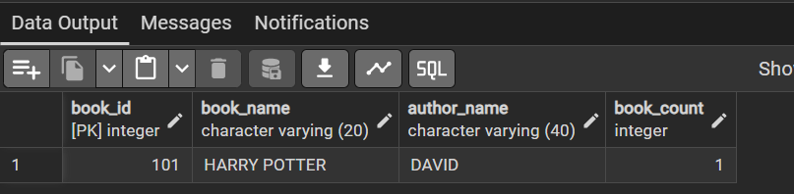

Table library_visitors:

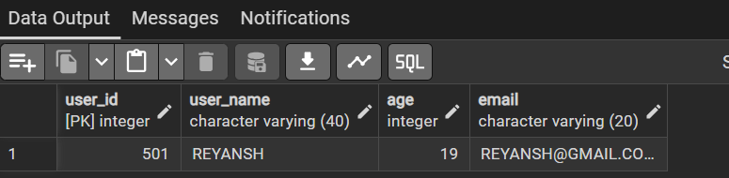

Table book_issue:
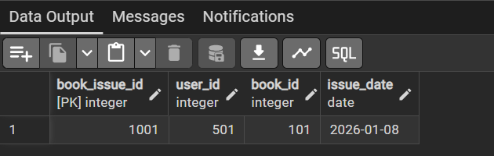

Access granted to role – librarian:
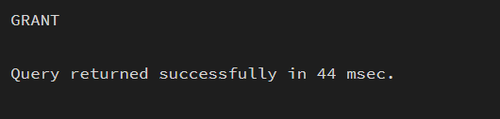

Learning Outcomes
- Gained hands-on experience to work with PostgreSQL and pgAdmin
- Writing queries to create and delete tables
- Learnt to alter tables, view tables, create roles, granting and revoking access to the roles
- Primary and foreign keys implementations and roles

