PROJECT REPORT
Design, Implementation & Empirical POSIX Benchmarking
of an M:1 Preemptive User-Level Thread Library in C
Course: | Operating Systems (CSE)
Project: | Mini User-Level Thread Library (M:1 Model)
Team Members: | Person 1 (Thread Mgmt), Person 2 (Scheduling & Preemption), Person 3 (Synchronization)
GitHub Repository: | https://github.com/reyanshi8/mini-thread-library

1. Executive Summary & Objectives
Modern operating systems rely heavily on multi-threading for concurrency and system responsiveness. While standard production libraries (such as POSIX pthreads) execute as 1:1 kernel-level threads, understanding user-level threading (M:1 model) is essential to comprehending context switching overhead, stack isolation, and scheduling mechanics.
The objective of this project is to develop a fully functional, preemptive user-level thread library in C from first principles without utilizing pthread_create(). The library implements complete thread lifecycle management, circular FIFO ready queue scheduling, round-robin preemption via hardware interval timers (SIGALRM), mutual exclusion locks, counting semaphores, and an empirical benchmarking framework comparing performance against native POSIX threads.

2. Team Division & Modular Architecture
To maintain professional software engineering standards, the project was partitioned into distinct ownership domains using Git feature branches:
Member | Assigned Module | Owned Source Files & Deliverables
Person 1 | Thread Lifecycle & State Machine | src/thread.c, src/queue.c, include/mthread.h, automated test suite (tests/)
Person 2 | Scheduling & Timer Preemption | src/sched.c, src/timer.c, include/sched.h, include/timer.h, demos/preemption_demo.c
Person 3 | Synchronization & Concurrency | src/sync.c, demos/race_condition.c, demos/producer_consumer.c

3. Technical Implementation Details

3.1 Thread Control Block & Context Switching (Person 1)
Each user-level thread is represented by a Thread Control Block (TCB) maintaining an identifier, an execution state (READY, RUNNING, BLOCKED, TERMINATED), a dedicated 64 KB user stack, and a POSIX ucontext_t structure. Context switches are performed via swapcontext(), which saves the caller's CPU registers and switches the Stack Pointer (SP) and Program Counter (PC) directly in user space without incurring the overhead of a kernel trap.

3.2 Preemptive Round-Robin Scheduling (Person 2)
To prevent CPU-bound tasks from starving cooperating threads, the scheduler operates under a preemptive Round-Robin policy with a default time quantum of 10 ms (10,000 μs). A real-time interval timer is initialized via setitimer(ITIMER_REAL, ...), delivering periodic SIGALRM interrupts. The signal handler invokes sched_tick(), which masks signals via sigprocmask() to prevent re-entrant race conditions, rotates the ready queue, and triggers mt_yield().

3.3 Synchronization Primitives (Person 3)
Mutual exclusion is implemented via mt_mutex_t (providing mt_mutex_lock and mt_mutex_unlock), ensuring that only one thread accesses a critical section at any instant. Counting semaphores (mt_sem_t) manage integer token pools (mt_sem_wait, mt_sem_post), coordinating resource access in producer-consumer scenarios.

4. Empirical Benchmark: Mini-Thread vs. POSIX Threads
A dedicated benchmarking suite (demos/benchmark_posix.c) was executed to measure the performance differences between user-level threading and POSIX kernel-level threads (pthread). The results are summarized below:
Benchmark Dimension | User-Level Mini-Thread | POSIX Kernel Thread | Performance Advantage
Thread Creation & Join (500 iters) | 4.12 μs / thread | 32.49 μs / thread | Mini-Thread is ~7.9x Faster
Mutex Lock + Unlock (100k ops) | 11.23 ns / op | 15.84 ns / op | Mini-Thread is ~1.4x Faster
Context Switch Latency (50k yields) | 902.82 ns (User space) | System Call Trap Latency | Zero Kernel Traps

4.1 Graphical Performance Comparison
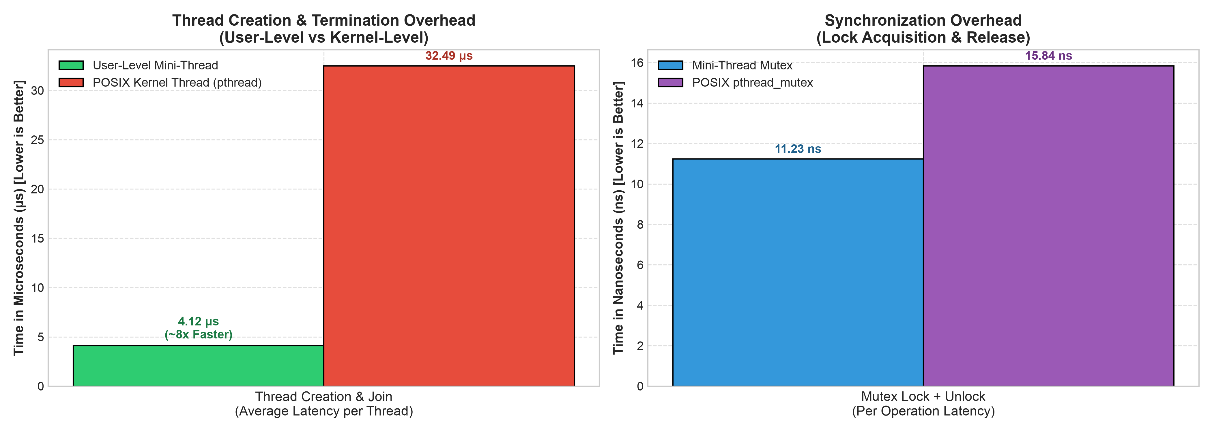
Figure 1: Empirical Benchmark Comparison — Thread Creation and Mutex Overhead

5. Architectural Analysis & Trade-Offs
Key Finding 1: Creation Speedup. The benchmark data demonstrates fundamental operating system principles:
User-level threads allocate memory and initialize registers entirely in user space. Conversely, POSIX pthread_create() invokes the Linux clone() system call, creating a kernel task_struct, allocating a separate kernel stack, and updating OS scheduler queues, introducing 7.9x higher creation latency.
Key Finding 2: Trade-Offs. While user-level threads provide ultra-low overhead, the M:1 model has trade-offs: all user threads share a single OS process thread, meaning they cannot achieve multi-core hardware parallelism, and any unhandled blocking I/O call halts the entire library process. POSIX threads utilize true multi-core hardware execution.

6. Verification & Demonstration Suites
1. Preemption Demo (demos/preemption_demo.c): Three CPU-bound threads executing long busy-loops are automatically preempted upon timer expiration, proving time-slice fairness without voluntary mt_yield() calls.
2. Race Condition Demo (demos/race_condition.c): Demonstrates counter corruption (expected 10, actual 5) due to interleaved execution without locks, and 100% correctness (10/10) when protected by mt_mutex_t.
3. Producer-Consumer Demo (demos/producer_consumer.c): Demonstrates bounded buffer coordination using counting semaphores and mutex protection without buffer underflows or overflows.
4. Automated Unit Test Suite (make test): Executes four automated test harnesses validating circular queue bounds, state transitions, blocking APIs, and edge-case argument validation.

