NIP Project — Submission Template
Pega Platform project · This document is your complete submission
Read this before you start:
1. Fill in Section 1 completely. The Pega application name must follow the format NIP-[Project]-[YourName].
2. Create a new Operator in Pega with your full name and log in as that operator before taking any screenshot.
3. When you create your test case, enter YOUR FULL NAME in the Issue Description (Vehicle) or Movie Name (Movie) field.
4. Complete only the section for your chosen project. Delete the other project section.
5. Paste one screenshot per user story (10 total). Follow the screenshot rules in your selected project section.
6. Answer every question in Sections 3 and 4 in your own words.
7. Save the file using this format: ProjectName_FirstName_LastName.docx. Use VehicleService or MovieTicket as the ProjectName. Examples: VehicleService_Ravi_Kumar.docx or MovieTicket_Ravi_Kumar.docx.

Section 1 — Your Details
Full Name | Reyas B
Email ID (registered on NIP) | reyasajju@gmai.com
Phone Number | 8778637310
College Name | VSB ENGINEERING COLLEGE
Course (e.g. IT, CS) | B.E Computer Science and Engineering
State | Tamil Nadu
Project Chosen (Vehicle Service OR Movie Ticket Booking) | Movie Ticket Booking
Pega Application Name (e.g. NIP-VehicleService-YourName) | NIP-Movie Ticket-ReyasB
Case Type Name (exact) | Movie Ticket Request
Pega Instance URL | https://f6hwtggq.pegacea.net/prweb/app/book-ur-shows/
Operator Name (created in Pega with your full name) | Reyas B

Section 2B — Movie Ticket Booking Management Application
Complete this section only if you selected this project. Delete the other project section before submitting.

Screenshot rules — IMPORTANT before you start:
1. Name your Pega application as: NIP-VehicleService-YourName OR NIP-MovieTicket-YourName
2. Create a new Operator in Pega with your full name (Security → Operators) and log in as that operator.
3. When you create your test case, enter YOUR FULL NAME in the Issue Description (Vehicle) or Movie Name (Movie) field.
4. The logged-in operator name must be visible in every screenshot wherever the Pega interface displays it.
5. The student's full name must be visible in all running-case screenshots.
6. Configuration screenshots must clearly show the relevant application or rule name.
Screenshots that do not show these will not be accepted.

US-001 — Submit Movie Ticket Request
What is expected:
Case created, customer submits Movie Name, Show Date, Show Time, Number of Tickets. Validation applied.
Screenshot — paste your screenshot below this line:
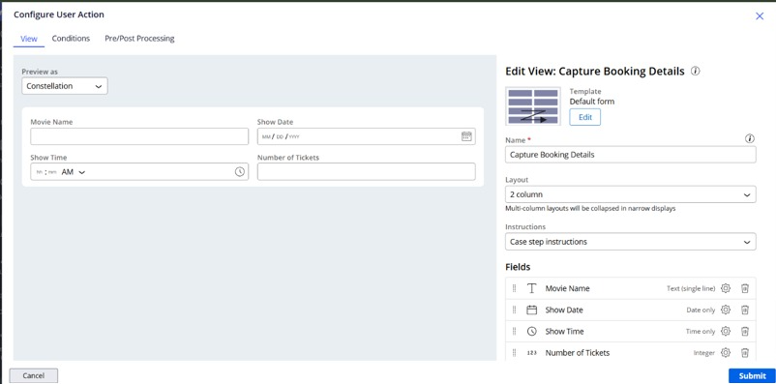

What I built for this (1–2 lines in your own words):
[ Type here ]
Configured the initial Collect Information step to capture movie details along with validation ensuring required fields are populated properly.

US-002 — Check Show Availability
What is expected:
Availability stage. Seat Availability Status and Available Seats Count captured. Booking proceeds only if available.
Screenshot — paste your screenshot below this line:
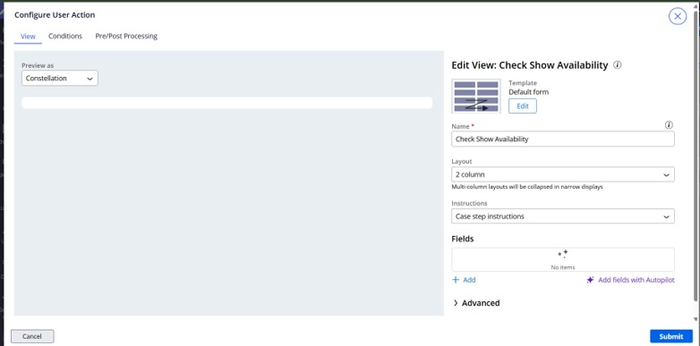

What I built for this (1–2 lines in your own words):
[ Type here ]
Created the availability verification step to evaluate capacity and dynamically determine if seats are available before progressing.

US-003 — Calculate Booking Cost
What is expected:
Total Cost calculated automatically from Ticket Price and Number of Tickets using a business rule.
Screenshot — paste your screenshot below this line:
[ Paste screenshot here - follow the screenshot rules above ]
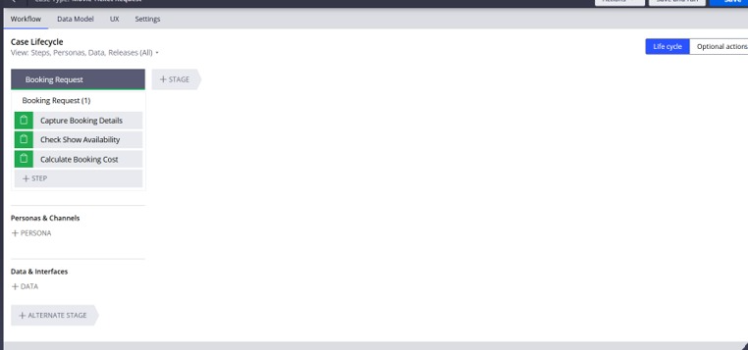

What I built for this (1–2 lines in your own words):
[ Type here ]
Implemented a calculation rule that automatically multiplies Ticket Price and Number of Tickets to compute the Total Cost dynamically.

US-004 — Confirm Booking Request
What is expected:
Approval stage assigned to Customer. Booking Status captured. Flow branches on confirm/cancel.
Screenshot — paste your screenshot below this line:
[ Paste screenshot here - follow the screenshot rules above ]

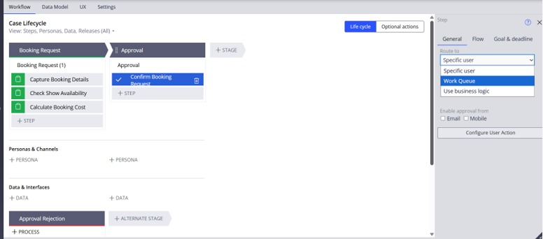

What I built for this (1–2 lines in your own words):
[ Type here ]
Configured an approval step allowing the user to review details and either confirm or reject the booking request.

US-005 — Maintain Movie and Show Data
What is expected:
Reusable Movie and Show data objects created with Movie Name, Genre, Show Date, Show Time, Seat Capacity — linked to case.
Screenshot — paste your screenshot below this line:
[ Paste screenshot here - follow the screenshot rules above ]

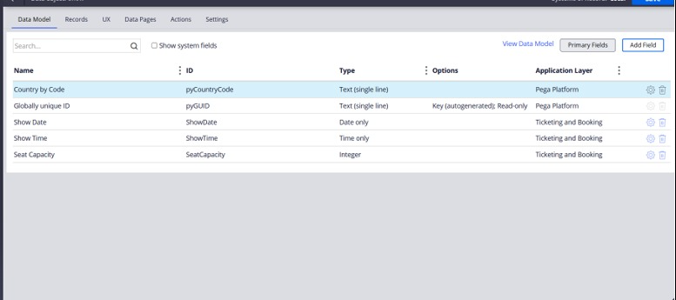

What I built for this (1–2 lines in your own words):
[ Type here ]
Configured reusable Data Records and Data Objects to link movie and show schedules directly into the case type.

US-006 — Review Booking Details
What is expected:
Confirmation screen shows Movie Name, Show Timing, Number of Tickets and Total Cost clearly.
Screenshot — paste your screenshot below this line:
[ Paste screenshot here - follow the screenshot rules above ]
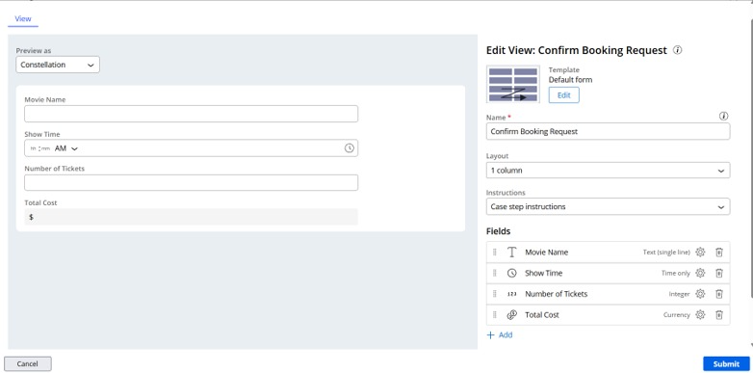

What I built for this (1–2 lines in your own words):
[ Type here ]
Created a read-only review view to summarize booking details, timing, and total cost clearly prior to final confirmation.

US-007 — Process Ticket Booking
What is expected:
Booking Execution stage. Seat Numbers, Ticket ID and Booking Confirmation Status maintained.
Screenshot — paste your screenshot below this line:
[ Paste screenshot here - follow the screenshot rules above ]
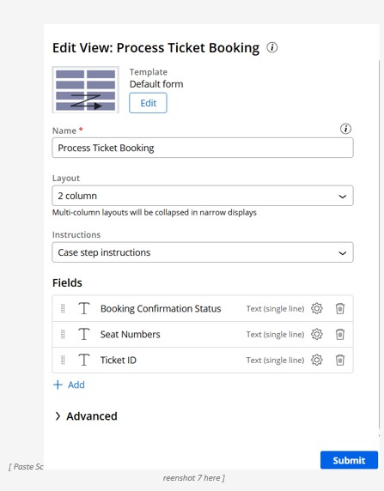

What I built for this (1–2 lines in your own words):
[ Type here ]
Set up the execution step to track seat allocation, generate ticket identifiers, and set the final booking confirmation status.

US-008 — Notify Booking Confirmation
What is expected:
Correspondence rule triggered on case resolution. Email includes movie, show, seat and cost details.
Screenshot — paste your screenshot below this line:
[ Paste screenshot here - follow the screenshot rules above ]
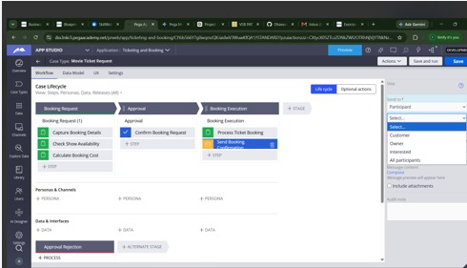

What I built for this (1–2 lines in your own words):
[ Type here ]
Configured an automated Send Email correspondence step containing case ID, seat numbers, and pricing details sent upon booking completion.

US-009 — Define Booking SLA
What is expected:
SLA configured on the case type. Goal: 1 day. Deadline: 2 days. Priority increases on breach.
Screenshot — paste your screenshot below this line:
[ Paste screenshot here - follow the screenshot rules above ]

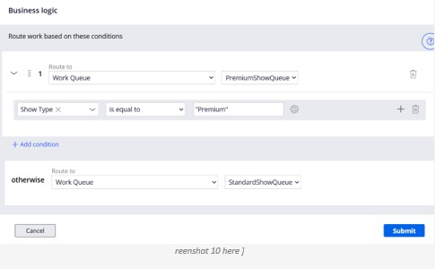

What I built for this (1–2 lines in your own words):
[ Type here ]
Configured a Custom Case SLA in Settings with a Goal of 1 day (+10 urgency) and Deadline of 2 days (+20 urgency).

US-010 — Route by Show Type
What is expected:
Routing rule or Decision Table routes to PremiumShowQueue or StandardShowQueue based on Show Type property.
Screenshot — paste your screenshot below this line:
[ Paste screenshot here - follow the screenshot rules above ]



What I built for this (1–2 lines in your own words):
[ Type here ]
Implemented business logic routing on the Process Ticket Booking step to route to PremiumShowQueue when Show Type is Premium, otherwise to StandardShowQueue.

Section 3 — About Your Application
These answers are checked against your screenshots. Write exactly what is in your application.

Q1. List your stages in the order they appear in your case lifecycle.
Stage names in order, separated by commas.
[ Type here ]
Booking Request, Approval, Booking Execution (Alternate Stage: Approval Rejection)

Q2. Name the data object(s) you created and the properties inside them.
Data object name and its properties.
[ Type here ]
● Data Object: Movie Data / Show Details
● Properties: Movie Name, Show Date, Show Time, Seat Capacity, Ticket Price, Show Type, Available Seats, Availability Status.

Q3. What is the exact name and type of the rule you used to calculate Total Cost?
Provide:
• Rule Name
• Rule Type
• Properties used in the calculation
• Formula used
[ Type here ]
● Rule Name: CalculateTotalCost
● Rule Type: Declare Expression
● Properties used: .TicketPrice, .NumberOfTickets
● Formula used: .TotalCost = .TicketPrice * .NumberOfTickets

Section 4 — Your Understanding
Short, honest and specific answers score well.

Q4. What did Blueprint generate for you, and what did you add or change yourself afterwards?
Be specific about what was already there and what you built or modified on top.
[ Type here ]

Blueprint generated the fundamental stages (Booking Request, Approval, Booking Execution) and base data properties. Afterwards, I configured the custom field types (such as Show Type picklist), implemented automated cost calculations, set up case-level SLAs, and defined business logic routing to separate work queues.

Q5. Was there anything Blueprint created that you had to correct or configure further? Describe one example.
A real example from your own work.
[ Type here ]
The Blueprint setup did not include the Show Type property required for routing logic. I had to manually add Show Type as a Picklist (Premium, Standard) under the Data Model tab to enable business logic routing in the execution stage.

Q6. Explain your case flow from creation to resolution, in order.
What happens first, who does what, when the case closes.
[ Type here ]
First, the customer submits the movie booking details and required tickets. The system verifies availability and calculates the total cost. The request enters the Approval stage where the customer reviews and confirms the booking. Upon approval, the case moves to Booking Execution where it routes automatically to either PremiumShowQueue or StandardShowQueue based on Show Type. Finally, a confirmation email is triggered, and the case resolves.

Q7. Pick two design choices you made in your application and explain why you made them.
For each design choice, provide:
• What you implemented
• Why you chose that approach
• What benefit it provides to the application
[ Type here ]

● Design Choice 1 (Business Logic Routing): Implemented automated work queue routing based on Show Type (PremiumShowQueue vs StandardShowQueue) to segregate VIP/special screenings from regular screenings, enabling efficient team task handling without manual intervention.
● Design Choice 2 (Case-level Custom SLA): Defined a 1-day Goal and 2-day Deadline to ensure ticket booking requests do not sit unaddressed and raise urgency automatically.

Q8. What was the hardest part, and how exactly did you fix it?
Specific and honest. A real challenge scores much better than a generic answer.
[ Type here ]
Configuring the conditional work queue routing was challenging because the Show Type property was initially unavailable in the business logic rule builder. I resolved this by returning to the Data Model tab, defining Show Type with appropriate picklist choices, and reconnecting it inside the step's business logic settings

Q9. If the approval step was only needed when Total Cost is above a certain amount, what would you change in your application?
Explain what you would change and where. You do not need to build this.
[ Type here ]
I would configure a skip condition on the Approval step or process (e.g., using a When rule TotalCost > ThresholdAmount) so that cases below the threshold proceed directly to Booking Execution.

Q10. List three exact rule names from your application that you personally created or modified.
Include the rule name and rule type for each one (for example: CalculateTotalCost - Declare Expression).
[ Type here ]

● CalculateBookingCost — Declare Expression
● SendBookingConfirmation — Correspondence Rule / Send Email Step
● ProcessTicketBooking_Routing — Business Logic / Decision Rule

Q11. List all personas used in your application.
List the persona names exactly as they appear in your application.
[ Type here ]

● Customer
● Author / Administrator

Q12. List all work queues used in your application and explain when each one is used.
For each work queue, provide its exact name and the condition or type of work routed to it.
[ Type here ]
● PremiumShowQueue: Used when Show Type equals Premium.
● StandardShowQueue: Used for all other standard screenings.

Before You Submit — Check These
Read through once before uploading.
1. Section 1 filled in. Application named as NIP-[Project]-[YourName]. Names match the actual application.
2. New Operator created in Pega with my full name. I logged in as that operator for all screenshots.
3. Only my chosen project section remains — the other project section is deleted.
4. All 10 user story screenshots are pasted and follow the operator, running-case, application, and rule-name evidence requirements.
5. Every question in Sections 3 and 4, including Q10, Q11, and Q12, is answered in my own words.
6. This file is named using the required format: ProjectName_FirstName_LastName.docx (for example, VehicleService_Ravi_Kumar.docx or MovieTicket_Ravi_Kumar.docx) and uploaded as required.

