NORSU Bais ConsultLink: Instructor – Student Consultation Scheduling and Notification System

A Capstone Project Presented to the Faculty of the Computer
Science and Information Technology Department College of Arts and Sciences Negros Oriental State University Bais City

In Partial Fulfillment of the Requirements for the degree of Bachelor of Science and Information Technology

By:
Condaraan, Allanez G.
Calibo, Rechiel T.
Fernandez, Ruby Marie A.
Garsula, Argelyn G.
Robles, Paolo Miguel U.

CHAPTER I
INTRODUCTION

Project Context
At NORSU, consultation between students and instructors plays an important role in the learning process. It allows students to ask questions, clarify lessons, and seek guidance about their academic concerns. Through consultation, instructors can also better understand the difficulties that students experience in their studies. This interaction helps strengthen communication between students and instructors. Because of this, consultation is considered an important support system for students’ academic success.
However, the current method of consultation in the university is mostly informal and unorganized. Many students simply approach their instructors without scheduling an appointment first. This often results in unexpected interruptions while instructors are doing other tasks. In some cases, multiple students try to consult at the same time, which creates confusion and overlapping consultations. Another issue is that consultation schedules are rarely recorded or tracked properly. Many instructors rely on verbal arrangements, handwritten notes, or simply their memory. Because of this, some consultation schedules are forgotten, misplaced, or not updated. This can lead to missed appointments and unclear documentation of student concerns.
Students also experience difficulty in knowing whether their instructors are available. Most of the time, students go directly to the faculty office hoping to meet their instructor. Unfortunately, there are times when the instructor is in class, attending meetings, or not present at the office. This situation causes students to waste time and delays them from receiving the academic help they need.
To address these problems, the researchers propose ConsultLink, a web-based Instructor–Student Consultation Scheduling and Notification System. This system will allow students to book consultation appointments online in a more convenient way. Instructors will also receive email notifications whenever a student schedules a consultation. With automated scheduling, digital records, and real-time notifications, the system aims to make the consultation process more organized and efficient. It will also help improve communication, reduce interruptions, and support better time management for both instructors and students.

Purpose and Description
The primary purpose of this project is to develop ConsultLink: Instructor Student Consultation Scheduling and Notification System. This web-based platform is meticulously designed to revolutionize the consultation process at Negros Oriental State University (NORSU) Bais City. By transitioning from the current unstructured, walk-in consultation model to a streamlined and automated system, ConsultLink aims to provide tangible benefits for instructors, students, and the institution as a whole.
Online Appointment Booking: Students gain the ability to book consultation appointments online through an intuitive and user-friendly interface. This feature eliminates the need for impromptu visits to instructors' offices, reducing interruptions and increasing convenience. Students can view available time slots, select their preferred time, and provide a brief description of the consultation topic. Instructor Schedule Management: Instructors are empowered with a comprehensive schedule management system. They can digitally view incoming consultation requests, approve or decline appointments based on their availability, and block out specific times for other commitments. This functionality ensures that instructors maintain control over their schedules and can effectively manage their consultation workload.
The system incorporates an automated email notification system. When a student schedules a consultation, the instructor receives an immediate email notification with details of the appointment. Reminders are also sent closer to the consultation time, minimizing the risk of missed appointments. Students can log in to the system and view the status of their consultation requests. They can see whether their request is pending, approved, or declined, ensuring transparency and reducing uncertainty. Admin Dashboard (Future Implementation): While not explicitly mentioned in the original document, a potential future enhancement would be the inclusion of an administrative dashboard. This would allow administrative staff to oversee the entire consultation process, generate reports on consultation activity, manage user accounts, and configure system settings.
The purpose of this project is to develop ConsultLink: Instructor-Student Consultation Scheduling and Notification System, a web-based platform designed to streamline the consultation process at NORSU. The system aims to replace the unstructured walk-in approach with a more organized and automated scheduling system. The instructors will be providing a reliable schedule, automated notifications, and digital records of consultations. The students offering a convenient way to book appointments anytime and ensuring the instructor is available. The Institution promoting a more organized and efficient academic support system. ConsultLink, consultation sessions will become more systematic, time-efficient, and well-documented, improving communication and academic productivity.

Objectives of the Study
To develop a web-based consultation scheduling and notification system that enhances the communication and appointment process between instructors and students at NORSU. The main objective of this study is to develop NORSU Bais Consultlink an efficient and user-friendly Instructor–Student Consultation Scheduling and Notification System designed to streamline and enhance the consultation process within NORSU Bais Campus. The system aims to improve communication, reduce scheduling conflicts, and provide a more organized and accessible method for managing academic consultations.

Specific Objectives
- To create a centralized online scheduling platform where instructors can set consultation hours and students can conveniently book appointments.
- To implement an automated notification feature that alerts users about approved, pending, cancelled, or upcoming consultations.
- To provide real-time updates and status tracking to help both instructors and students stay informed about consultation requests.
- To build a secure database that stores consultation history, user information, and scheduling logs for academic reference.
- To design a user-friendly and mobile-responsive interface that ensures accessibility across different devices.
- To allow instructors to manage and modify their schedules easily, including adding, updating, or disabling consultation slots.
- To enable students to view instructor availability and choose consultation times that best fit their schedules.
- To include a notification system for reminders to reduce missed appointments and improve punctuality.
- To generate reports and summaries regarding consultation frequency, attendance, and scheduling trends for administrative evaluation.
- To minimize manual processes, such as walk-ins and paper-based scheduling, by transitioning to an automated digital system.

- To improve communication flow between instructors and students by providing a reliable and structured consultation channel.
- To support academic performance and student success by making consultations more organized, accessible, and consistent.

Scope and Limitations

Scope
The system will include features such as online consultation booking, instructor schedule management, email notifications, and digital record-keeping. It will support two types of users the student who can request, view, and track consultation schedules and also the instructors can view, manage, and receive notifications of consultation requests. The development of NORSU Bais ConsultLink focuses on creating a digital platform that streamlines and enhances the consultation scheduling process between instructors and students within the Negros Oriental State University–Bais Campus.

Limitations
The development of the NORSU Bais ConsultLink system is limited only to NORSU Bais Campus and does not extend to other campuses. The system also relies heavily on stable internet connectivity. The students and instructors with weak or unstable connections may experience delays in accessing features or receiving updates. The accuracy of consultation schedules depends on instructors manually updating their availability, and the system cannot automatically detect changes unless entered by the user. In the notification feature may be affected by third party email or SMS services, which can result in delayed or failed message delivery. The system does not provide automated academic advising or generate consultation recommendations, as it only facilitates scheduling and reminders. It also offers limited conflict detection, preventing only double-booking within the platform but not conflicts with external schedules such as classes or meetings. Lastly, the system focuses solely on scheduling and notifications and does not include built-in video conferencing or real-time chat features, requiring users to use external platforms for online consultations.

CHAPTER II
REVIEW OF RELATED LITERATURE

Related Literature
The integration of information technology in educational institutions has significantly improved academic communication and management processes. Many universities now use web-based systems to manage consultations, schedules, and communication between instructors and students. These digital platforms help institutions organize academic services, reduce manual processes, and provide more efficient support systems for students. The development of the proposed NORSU ConsultLink: Instructor–Student Management and Notification System align with this technological advancement by providing a digital platform that facilitates instructor-student consultation and automated notifications.
According to Hui (2023), online appointment scheduling systems improve efficiency by allowing users to schedule appointments through digital platforms. These systems reduce manual scheduling errors and allow users to select available time slots conveniently. The study emphasized that implementing appointment systems improves time management and service delivery. These features are relevant to the proposed NORSU ConsultLink system, which aims to streamline instructor-student consultation scheduling.
Another important component of modern information systems is automated notification technology. According to Mahfouz et al. (2023), automated notification systems such as email alerts and reminders help users stay informed about important events and scheduled activities. These technologies help reduce missed appointments and improve communication efficiency. This concept supports the implementation of the NORSU ConsultLink: Instructor–Student Management and Notification System, which integrates notification features to inform users about consultation schedules.
According to García-Peñalvo and Corell (2021), digital communication platforms play a significant role in improving collaboration between students and instructors in higher education institutions. These platforms provide communication channels that allow students to easily reach instructors for academic consultations. The study highlighted that digital platforms enhance accessibility to academic support services. This concept is related to the objectives of NORSU ConsultLink, which aims to improve communication between instructors and students through a web-based system.
Similarly, Alomari, Al-Shqeerat, and Al-Shdaifat (2021) emphasized the importance of centralized information systems in educational institutions. Their study explained that centralized databases allow institutions to manage student records, schedules, and communication more efficiently. These systems help administrators, instructors, and students access important information through a single platform. This concept supports the design of NORSU ConsultLink, which integrates consultation scheduling and notification features within one system.
Another study conducted by Al-Omari and Al-Zoubi (2023) highlighted the effectiveness of notification systems in digital platforms. Their research found that automated alerts significantly improve communication efficiency and ensure that users receive timely updates regarding important activities. These findings are relevant to the proposed NORSU ConsultLink system, which incorporates notification features to inform students and instructors about consultation appointments and updates.
Related Studies
Several studies have explored the development of appointment scheduling and consultation management systems in educational institutions. These studies provide insights that support the development of the NORSU ConsultLink: Instructor–Student Management and Notification System.
According to the study of Noori (2021), an online appointment scheduling system for universities enables students to book consultation schedules with instructors through a digital platform. The system allows students to view available schedules and confirm appointments online. The researchers concluded that the system improved communication and organization of consultation schedules in universities.
According to Islam, Shill, and Hossain (2022), a web-based appointment management system significantly improves service efficiency by automating the scheduling process. Their study found that the system reduces waiting time and improves user satisfaction by allowing appointments to be booked online. These findings support the functionality of the NORSU ConsultLink system, which aims to improve consultation scheduling between students and instructors.
Another related study was conducted by Bondoc, Rabosa, and Peji (2024), who developed an online counseling appointment system for a university guidance office. The system allows students to request counseling sessions through an online platform while counselors manage schedules and consultation records digitally. The researchers found that the system improved consultation accessibility and service efficiency.
According to Bastola and Maharjan (2022), a smart appointment scheduling system developed for universities allows students to book consultations with lecturers through a digital platform. The system helps instructors manage their availability while allowing students to view available schedules. The study concluded that digital consultation systems help reduce scheduling conflicts and improve time management.
Another study conducted by Oyetunji and Akinwale (2023) developed a web-based appointment management system designed to streamline scheduling processes in institutions. The system allows users to manage appointments digitally and receive automated notifications regarding schedule updates. The study found that the system improved efficiency and reduced scheduling errors.

THEORITICAL FRAMEWORK
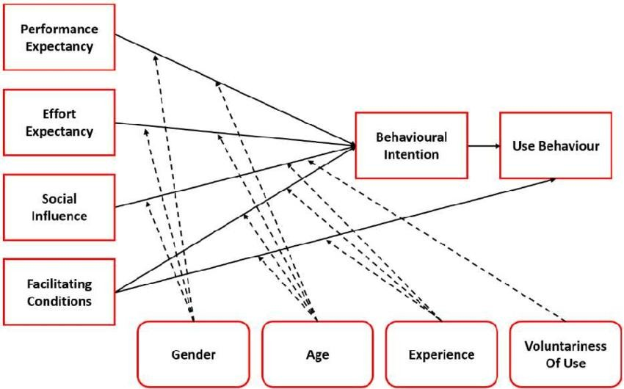

Figure 1: UTAUT MODEL

The development of ConsultLink: Instructor–Student Consultation Scheduling and Notification System is anchored in the Unified Theory of Acceptance and Use of Technology (UTAUT). This framework is appropriate for the study because it provides a comprehensive explanation of how users, both instructors and students decide to adopt and utilize new digital systems. The success of ConsultLink depends largely on whether its target users perceive it as beneficial, easy to use, and supported within the academic environment.
UTAUT identifies four key determinants that directly relate to the system. Performance Expectancy is addressed through the system’s ability to streamline scheduling and improve communication efficiency. Effort Expectancy is reflected in the user-friendly design of ConsultLink, which ensures that even users with limited technical skills can easily navigate the platform. Social Influence plays a role as instructors, peers, and institutionalpolicies encourage the adoption of the system. Lastly, Facilitating Conditions are met through the availability of technical support and infrastructure necessary for system operation.
By aligning the study with the UTAUT model, it establishes a strong theoretical basis for analyzing user acceptance, adoption behavior, and overall system effectiveness. Thus, UTAUT does not merely provide a definition but serves as the guiding theory that supports the study’s objectives of measuring usability, acceptance, and the potential adoption of ConsultLink within the academic setting.

Conceptual Framework
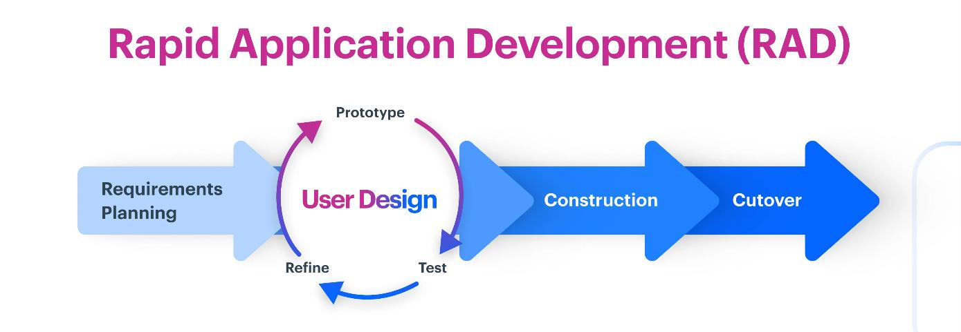

Figure 2: Rapid Application Development

The development of ConsultLink follows the Rapid Application Development (RAD) model, which is selected for its emphasis on iterative development, fast delivery, and intensive user involvement. RAD is particularly suitable for this project because the system requires continuous refinement based on real user feedback to ensure that its features, including scheduling, notifications, and consultation tracking, meet the practical needs of instructors and students.
The RAD model consists of four phases: Requirements Planning, User Design, Construction, and Cutover. In this study, the Requirements Planning phase allows the researchers to identify the essential features of the system. The User Design phase is critical, as both students and instructors collaborate with the developers to shape and refine the design through multiple prototypes. This ensures that the interface remains intuitive and aligned with user expectations. The Construction phase focuses on rapid development of system modules, while the Cutover phase prepares the system for deployment and user training.

RAD is chosen not only for its speed but also for its structured approach that minimizes project delays and prevents scope creep—an important consideration for Capstone development. By using RAD, the system can be tested, evaluated, and improved in shorter cycles, ensuring a more efficient development process and a final product that is highly responsive to user needs. Therefore, RAD supports the study by providing a practical and usercentered framework for building a functional and effective consultation scheduling system.

CHAPTER III
TECHNICAL BACKGROUND AND METHODOLOGY OF THE SYSTEM

This section provides an overview of the processes and techniques used in the development of the NORSU Bais ConsultLink: Instructor – Student Consultation Scheduling and Notification System. It discusses the data gathering procedure, system design, schedule feasibility, and cost-benefit analysis. It also presents the system’s Data Flow Diagram (DFD), Context Flow Diagram, Top-Level Diagram, and Use Case Diagram to illustrate system functions and processes. Additionally, this section outlines the hardware and software requirements, as well as the interface design, ensuring a comprehensive approach to system development and implementation.

Data Gathering Procedure
In order to develop an effective and reliable system, the researchers conducted several data gathering procedures to understand the current consultation process between instructors and students. These procedures were necessary to identify the problems encountered in managing consultation schedules and to determine the requirements of the proposed system.
The researchers first conducted interviews with selected instructors and students from Negros Oriental State University. The purpose of the interviews was to gather information about how consultations are currently scheduled and how communication between instructors and students is managed. Through these interviews, the researchers learned that most consultations are arranged informally through personal meetings, messaging applications, or email communication. This often leads to scheduling conflicts, delayed responses, and difficulty in monitoring consultation records.
Observation was also used as a method of data collection. The researchers observed how students request consultations and how instructors respond to these requests. During the observation process, it was discovered that the absence of a centralized consultation system makes it difficult for both instructors and students to manage schedules efficiently. Students often rely on approaching instructors during their available time, which may interrupt instructors during teaching or administrative tasks.
The researchers also reviewed related documents and existing records to better understand how consultation processes are currently handled. This review allowed the researchers to identify the limitations of the current manual or informal scheduling methods. The information gathered from these data collection activities served as the basis for designing the proposed NORSU ConsultLink system.
System Design
The system design of the NORSU ConsultLink system focuses on creating an efficient platform that allows instructors and students to manage consultation schedules through a web-based application. The system is designed to provide a centralized platform where students can request consultations, instructors can manage their availability, and administrators can monitor system records. The system design includes several major components that illustrate how the system operates and how users interact with the system. These components include the Data Flow Diagram, Entity Relationship Diagram, and Use Case Diagram. These diagrams help represent the structure of the system, the relationships between data, and the interactions between users and the system.
The system is designed to accommodate three types of users: the administrator, instructors, and students. Each user type has specific roles and responsibilities within the system. Students are able to view instructor availability and submit consultation requests. Instructors are able to review consultation requests and approve or reject them. Administrators are responsible for managing user accounts and monitoring system data.

Schedule Feasibility
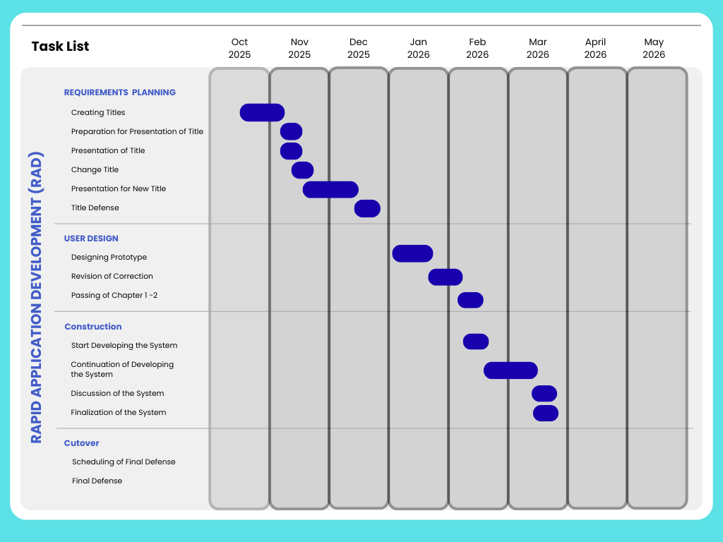
The researchers used a Gantt Chart to plan and track the project efficiently. It outlined key tasks like title creation, defense, revisions, and system development, ensuring each phase stayed on schedule. This structured approach helped monitor progress, manage deadlines, and maintain an organized workflow, leading to the project's successful completion.

Table 1. Gantt Chart
The Gantt chart presented above illustrates the anticipated timeline for a project extending from October 2025 to May 2026. The schedule begins in October 2025 with the "Creating Titles" phase, followed by a more extensive "Preparation for Presentation of Title" throughout November 2025, which culminates in the "Presentation of Title" in December 2025. The "Title Defense" is then scheduled for December 2025, leading to a "Revision of Correction" in January - February 2026, occurring at the same time as the "Passing of Chapter 1-2." The "Continuation of Doing System," representing the development phase, spans from February into March 2026, succeeded by the "Discussion of the System" and the "Finalization of the System," both taking place in March 2026. The "Scheduling of Final Defense" also occurs in March 2026, with the project concluding with the "Final Defense" in May 2026. This visual depiction outlines the ordered progression of project tasks and their estimated durations, offering a structure for project management and the monitoring of significant milestones throughout its implementation.

Economic Feasibility
HARDWARE | PRICE
Laptop | 30,000
Piso Wi-fi & Load | 550
Android Phones | 6,000
Total | 36,550

BENEFITS
- Improves communication between students and instructors.
- Enhances efficiency in managing consultation requests and schedules.
- Students can request, track, and receive consultation updates anytime, anywhere.

Table 2. Cost and Benefits Analysis
A cost-benefit analysis assesses the financial viability of a proposed system by comparing its potential benefits with development costs. It includes anticipated expenses like software, hardware, and maintenance, alongside expected gains such as efficiency, cost savings, and revenue. This evaluation helps determine if the system is a worthwhile investment.

DATA FLOW DIAGRAM
A. Context Flow Diagram
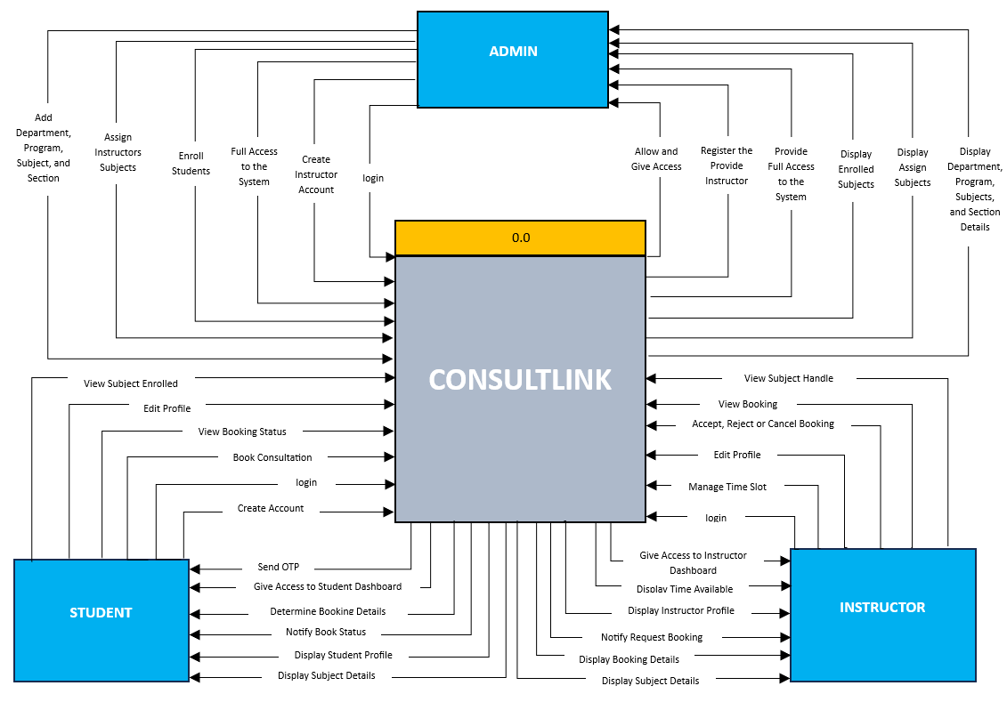

Figure 3. Context Flow Diagram
The context flow diagram illustrates the interactions between the ConsultLink: Instructor-Student Management and Notification System and its external stakeholders, namely the administrator, students, and instructors. The diagram presents a high-level view of how data and system requests are exchanged, showing the overall scope and functionality of the system in managing consultations, subjects, and user access.
At the center of the diagram is the ConsultLink system, which serves as the main processing unit responsible for handling all core operations such as user authentication, subject management, booking consultations, and notification processes. The administrator interacts with the system by managing departments, programs, subjects, and sections, as well as creating instructor accounts, assigning subjects, enrolling students, and granting access permissions within the system.
Students interact with the system by creating accounts, logging in, verifying their identity through OTP, booking consultations, viewing enrolled subjects, editing profiles, and receiving notifications regarding booking status and consultation updates. On the other hand, instructors use the system to manage their profiles, handle assigned subjects, set available time slots, and review or respond to consultation requests by accepting, rejecting, or canceling bookings.
Overall, the diagram demonstrates how the ConsultLink system facilitates efficient communication and coordination among users by centralizing data processing and ensuring timely notifications, thereby improving the management of instructor-student consultations.

B. Top- Level Diagram

Figure 4. Top- Level Diagram

Hardware And Software Requirements
ITEM OF SOFTWARE | Description Specification
 | CSS is used to design and enhance the visual presentation of the ConsultLink system. It controls the layout, colors, fonts, and overall interface of the platform. In this system, CSS plays an important role in creating a clean, responsive, and user-friendly environment that improves the experience of students, instructors, and administrators when managing consultations and navigating the system.
 | JavaScript adds interactivity to the ConsultLink system by enabling features like form validation, booking actions, and real-time updates, improving the overall user experience.
 | PHP is a server-side scripting language that powers the dynamic functions of the ConsultLink system. It handles user requests, processes inputs, manages bookings, and interacts with the database.
 | SQL is used to manage and query the ConsultLink database. It stores essential data such as user information, booking details, subjects, and notifications.

Table 3. Software Requirement

ITEM OF HARDWARE | Description specification
 | A smartphone is a mobile device that combines the functionality of a traditional mobile phone with advanced computing capabilities. It typically has a touchscreen interface, allowing users to access a wide range of applications and services, such as web browsing, email, and social-media, as well as multimedia playback and streaming.
 | A laptop is a portable electronic device that collects, stores, and processes information based on user instructions, delivering results efficiently and conveniently. Functionally, it is a programmable computer designed to perform arithmetic and logical operations automatically using a set of instructions, but with the added advantage of mobility. A specific example is the Acer Aspire Go 14 (AG14-31P-31M3), a 14-inch laptop powered by an Intel Core i3-N305 octa-core processor, equipped with 8GB of LPDDR5 RAM for smooth multitasking, and a 512GB NVMe SSD for fast storage and data access, making it suitable for everyday computing tasks such as studying, browsing, and productivity work.
 | An internet connection is a system that allows devices to access the internet, enabling communication, browsing, streaming, and more. It can be wired (fiber, DSL) or wireless (Piso Wi-Fi, mobile data). Connection speed and reliability depend on the provider and technology used.

Table 4. Hardware Requirements

User interface
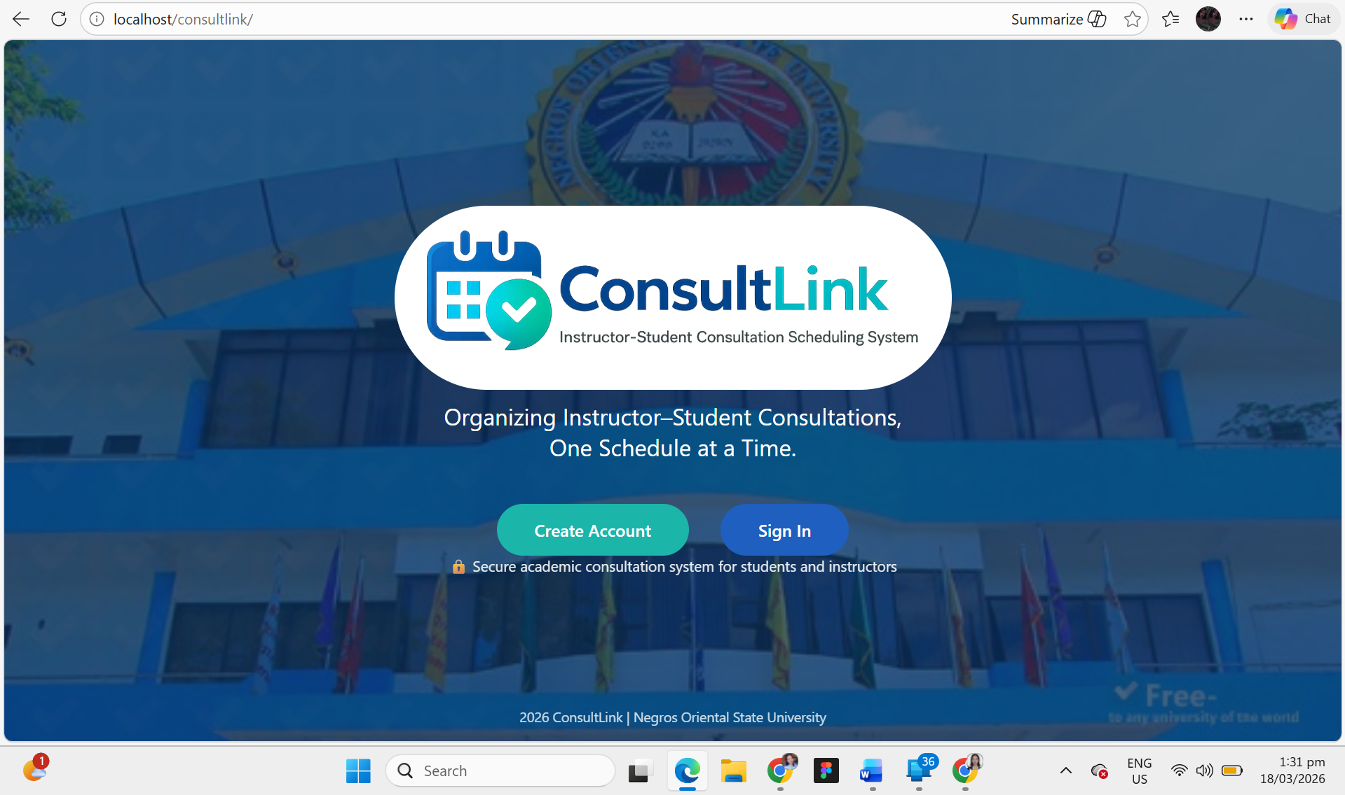

Figure 7. Home
This is the homepage of the ConsultLink system, designed to give users a clear and welcoming introduction to the platform. At the center of the page, the system logo and title “ConsultLink: Instructor-Student Consultation Scheduling System” are prominently displayed, along with a short tagline that emphasizes its purpose of organizing consultations efficiently. The background features an image of Negros Oriental State University, creating a strong institutional identity. Below the title, two important buttons are presented: “Create Account,” which allows new users to register in the system, and “Sign In,” which enables existing users to access their accounts. This layout serves as a simple and user-friendly entry point, guiding both new and returning users toward using the system.

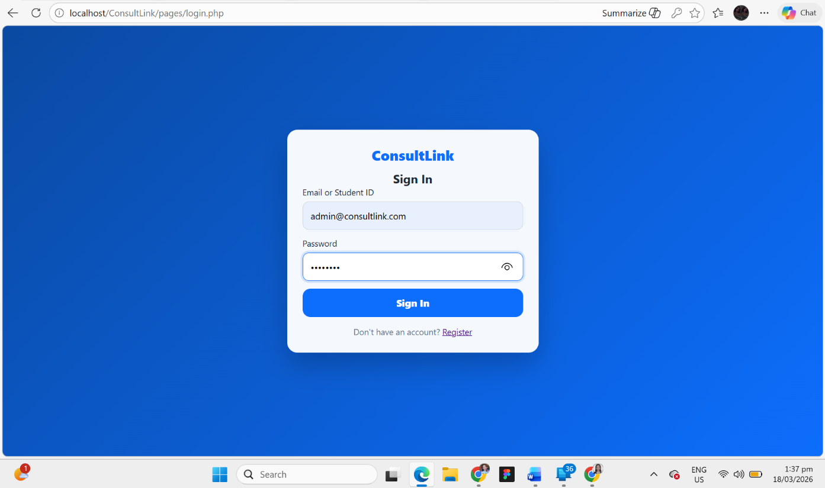

Figure 8. Sign In page
This is the Sign In page of the ConsultLink system, designed to allow registered users to securely access their accounts. At the center of the interface, a simple and clean login form is displayed with the system name “ConsultLink” at the top, followed by input fields for Email and Password. The password field includes a visibility toggle feature, enabling users to view or hide their password for convenience. Below the input fields, a prominent “Sign In” button allows users to log into the system. Additionally, a “Register” link is provided for users who do not yet have an account, guiding them to the registration page. The interface uses a modern blue gradient background and a centered layout, ensuring a focused, user-friendly, and visually appealing login experience.

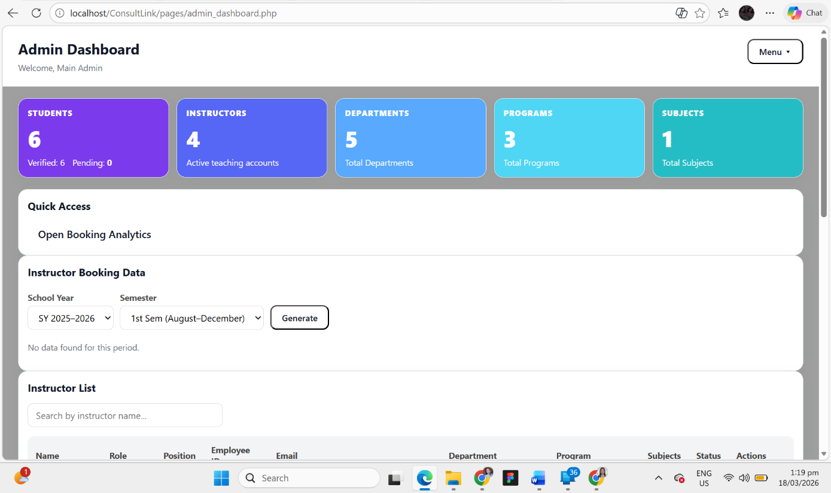

Figure 9. Admin Dashboard
This is the homepage of the Admin Dashboard for the ConsultLink system, designed to provide the administrator with a clear and organized overview of the platform. At the top of the page, the dashboard displays the title Admin Dashboard along with a welcome message for the main admin, creating a professional and personalized first impression. On the upper-right corner, there is a Menu button that allows the administrator to access more system options easily. Below this section, several colored summary cards are presented, showing important system data such as the total number of Students, Instructors, Departments, Programs, and Subjects, which helps the admin quickly monitor the system’s records. The dashboard also includes a Quick Access section for faster navigation to important features, such as booking analytics. Beneath it, the Instructor Booking Data section allows the administrator to filter records by School Year and Semester and generate booking reports. At the lower part of the page, there is an Instructor List section with a search bar and a table layout, making it easier for the admin to view and manage instructor information efficiently.
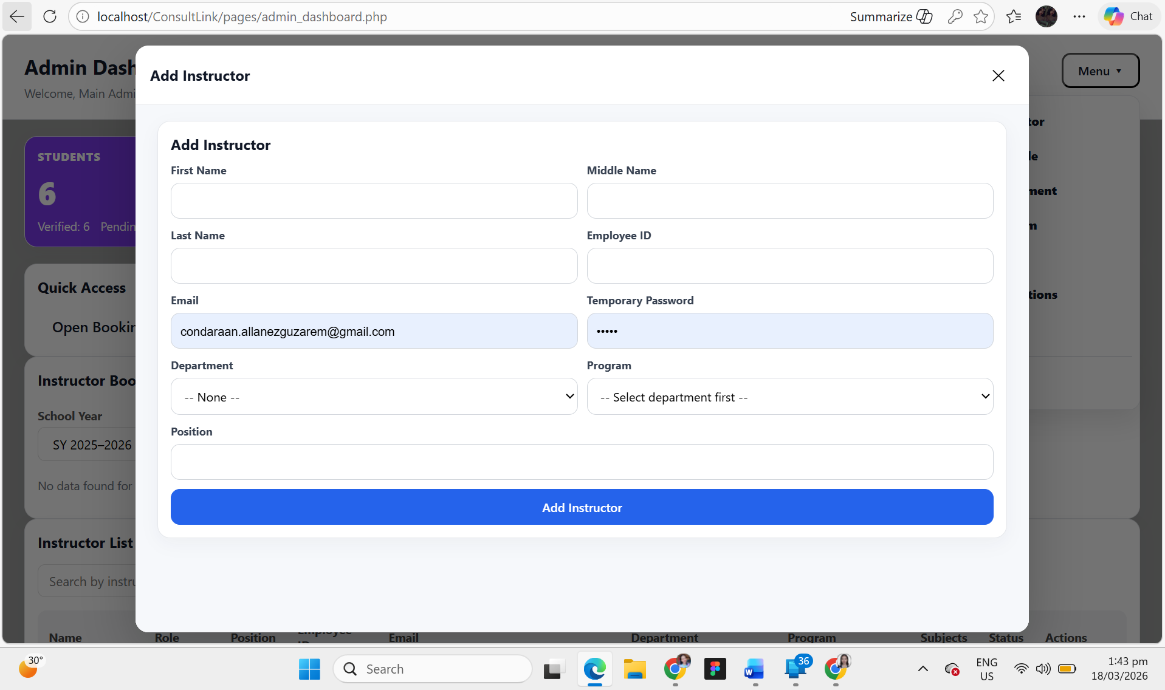

Figure 10. Add Instructor form
This interface shows the Add Instructor form in the ConsultLink system, presented as a modal window within the Admin Dashboard. It allows the administrator to input and manage instructor information efficiently. The form includes fields for First Name, Middle Name, Last Name, Employee ID, Email, and Temporary Password, ensuring that all essential details are captured during account creation. It also provides dropdown selections for Department and Program, where the program options depend on the selected department, helping maintain accurate data organization. Additionally, there is a field for Position, allowing the admin to specify the instructor’s role. At the bottom of the form, a prominent “Add Instructor” button is provided to submit the information. The modal design keeps the admin within the dashboard while performing tasks, making the process smooth, user-friendly, and efficient.

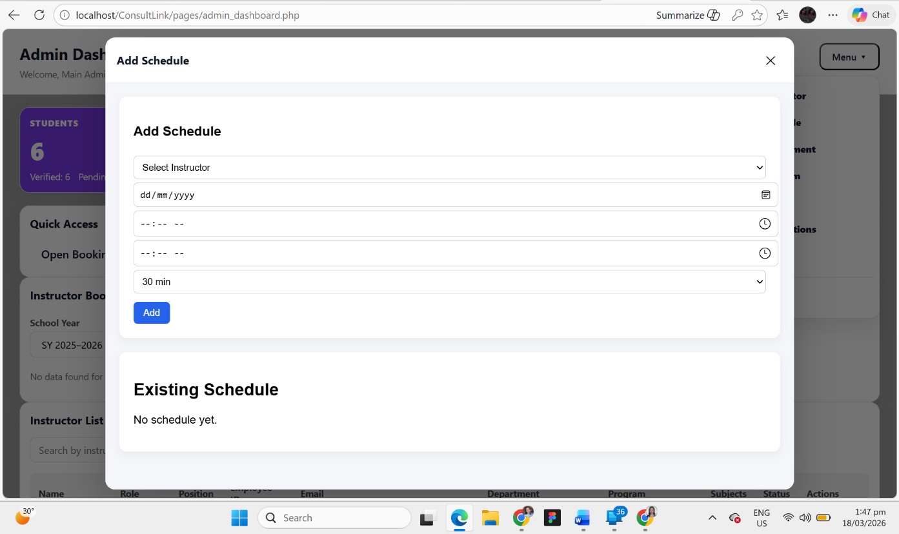

Figure 10. Add Schedule
This interface shows the Add Schedule module of the ConsultLink system, presented as a modal window within the Admin Dashboard. It allows the administrator to create and manage consultation schedules for instructors efficiently. At the top of the form, the admin can select an Instructor, followed by input fields for Date, Start Time, and End Time, enabling precise scheduling of consultation sessions. A dropdown option for duration (e.g., 30 minutes) is also provided to define the length of each session. Below the form, an “Add” button allows the administrator to save the schedule. Additionally, the interface includes an Existing Schedule section that displays current schedules, helping the admin monitor and avoid conflicts. The modal design ensures a smooth workflow by allowing schedule management without leaving the dashboard, making the system efficient and user-friendly.

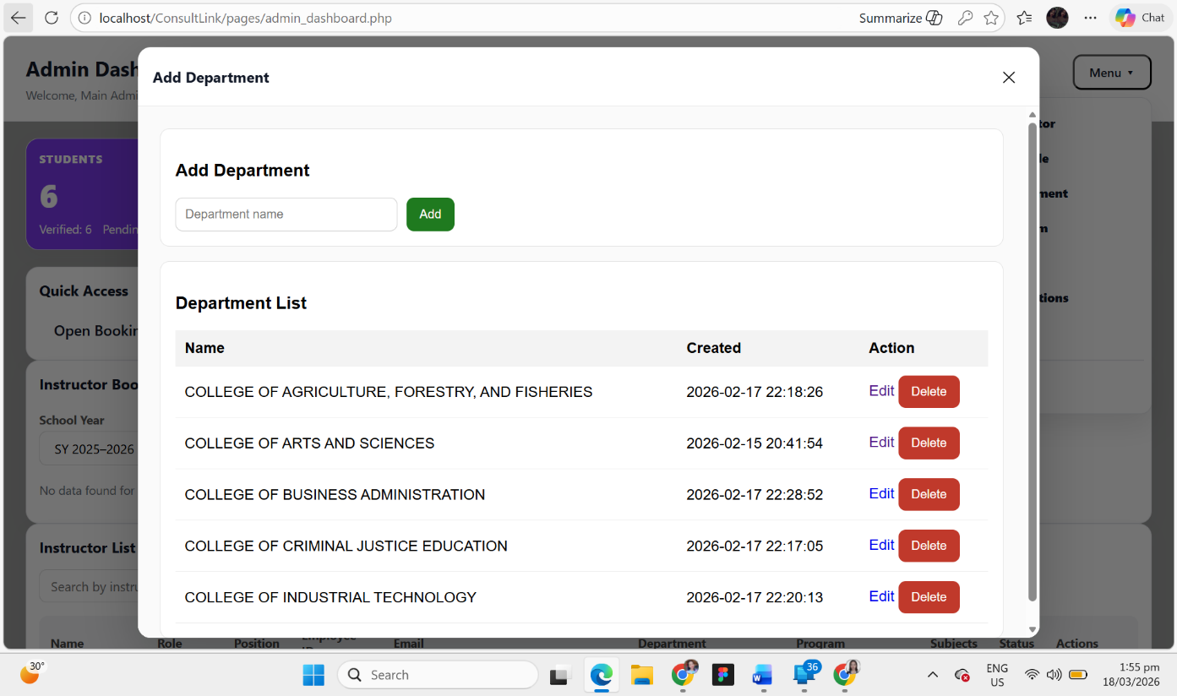

Figure 11. Add Department
This interface shows the Add Department module of the ConsultLink system, displayed as a modal window within the Admin Dashboard. It allows the administrator to manage academic departments efficiently. At the top section, there is a simple input field where the admin can enter the Department Name, along with an “Add” button to save the new department into the system. Below this, a Department List table is presented, displaying all existing departments along with their corresponding creation date and time. Each entry includes action buttons such as “Edit” and “Delete”, enabling the administrator to update or remove department records as needed. The modal layout ensures that the admin can perform these tasks without leaving the dashboard, promoting a smooth and organized workflow.

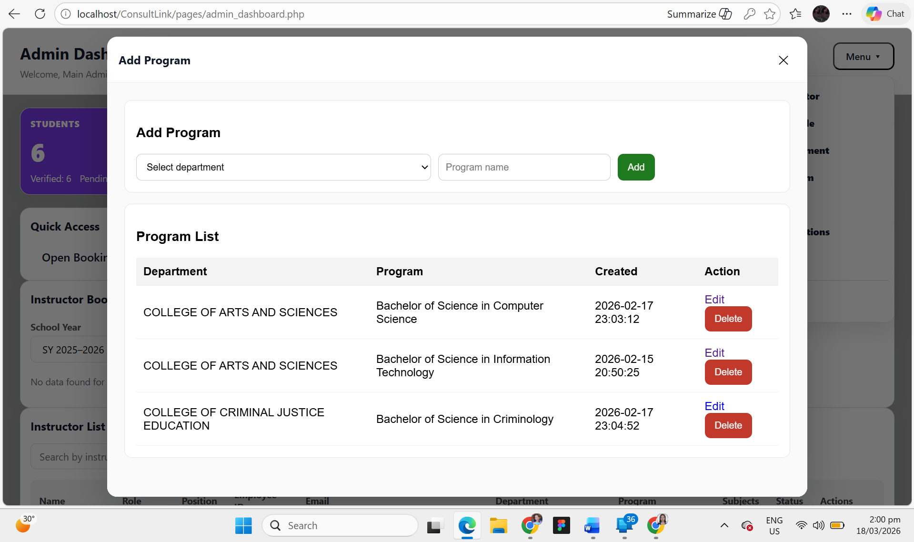

Figure 12. Add Program
This interface shows the Add Program module of the ConsultLink system, presented as a modal window within the Admin Dashboard. It allows the administrator to manage academic programs efficiently under specific departments. At the top section, the admin can select a Department from a dropdown menu and enter the Program Name, followed by an “Add” button to save the new program. Below this, a Program List table is displayed, showing existing programs along with their corresponding Department, creation date and time, and available actions. Each program entry includes “Edit” and “Delete” buttons, enabling the administrator to modify or remove records as needed. This design ensures proper organization of programs under their respective departments while maintaining a smooth and user-friendly workflow through the modal interface.

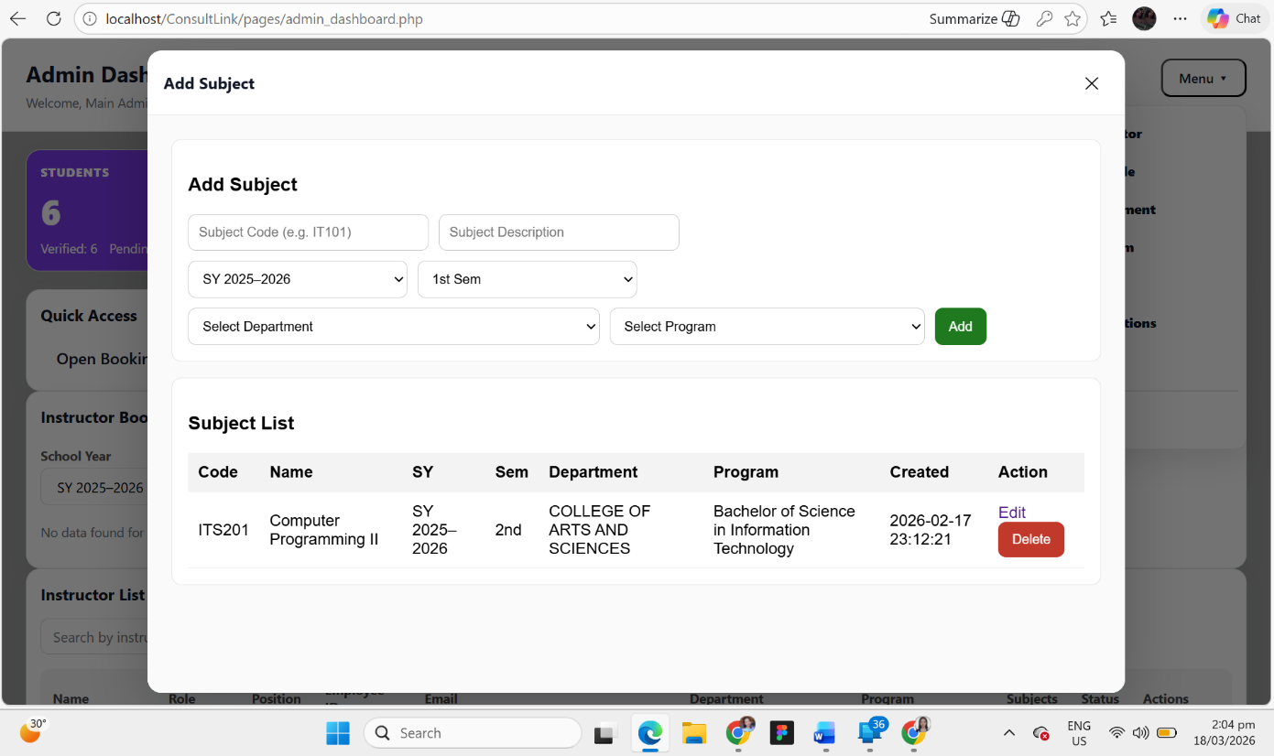

Figure 13. Add Subject
This interface shows the Add Subject module of the ConsultLink system, displayed as a modal window within the Admin Dashboard. It allows the administrator to manage subject information and assign it to specific academic structures. At the top section, the admin can input the Subject Code and Subject Description, along with selecting the appropriate School Year and Semester. The form also includes dropdown menus for Department and Program, ensuring that each subject is properly categorized. An “Add” button is provided to save the subject into the system. Below the form, a Subject List table displays existing subjects along with their code, name, school year, semester, department, program, and creation date, as well as action buttons such as “Edit” and “Delete” for easy management. The modal design allows the administrator to efficiently add and organize subjects without leaving the dashboard, promoting a smooth and user-friendly experience.

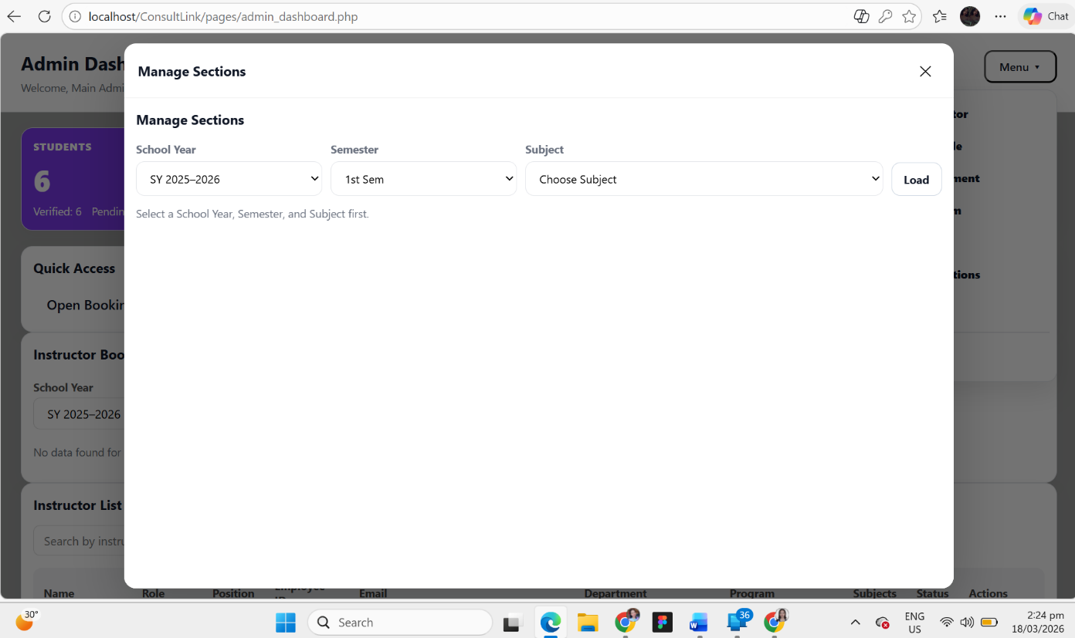

Figure 14. Manage Sections
This interface shows the Manage Sections module of the ConsultLink system, displayed as a modal window within the Admin Dashboard. It allows the administrator to organize and manage class sections based on specific academic parameters. At the top of the form, the admin can select the School Year, Semester, and Subject using dropdown menus, ensuring that sections are created and viewed within the correct academic context. A “Load” button is provided to retrieve and display the corresponding section data. The interface guides the administrator with a prompt to select all required fields before proceeding, helping prevent errors and ensuring accurate data handling. The modal design enables efficient section management without leaving the dashboard, contributing to a smooth and user-friendly workflow.

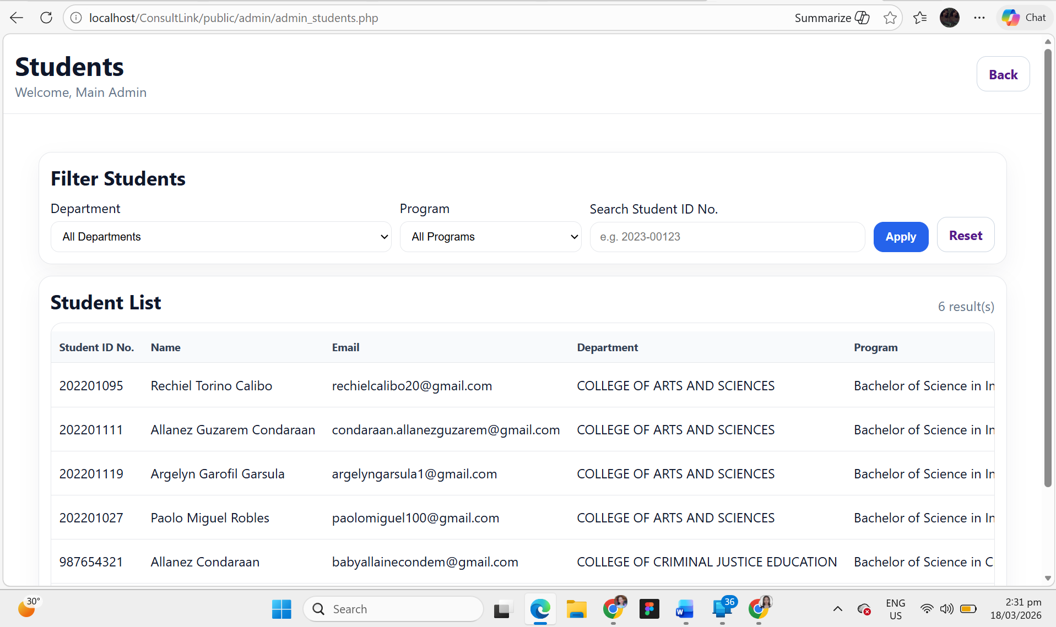

Figure 15. Students Management page
This interface shows the Students Management page of the ConsultLink system, designed to allow the administrator to view and manage student records efficiently. At the top of the page, a header displays the title “Students” along with a welcome message for the admin, and a “Back” button for easy navigation. Below this, a Filter Students section is provided, where the administrator can filter records by Department and Program, as well as search for a specific student using their Student ID Number. The “Apply” and “Reset” buttons allow the admin to manage and refine the displayed results. Beneath the filter section, a Student List table presents detailed information including Student ID Number, Name, Email, Department, and Program, enabling quick access and monitoring of student data. The layout is clean and structured, ensuring an organized, user-friendly, and efficient data management experience.

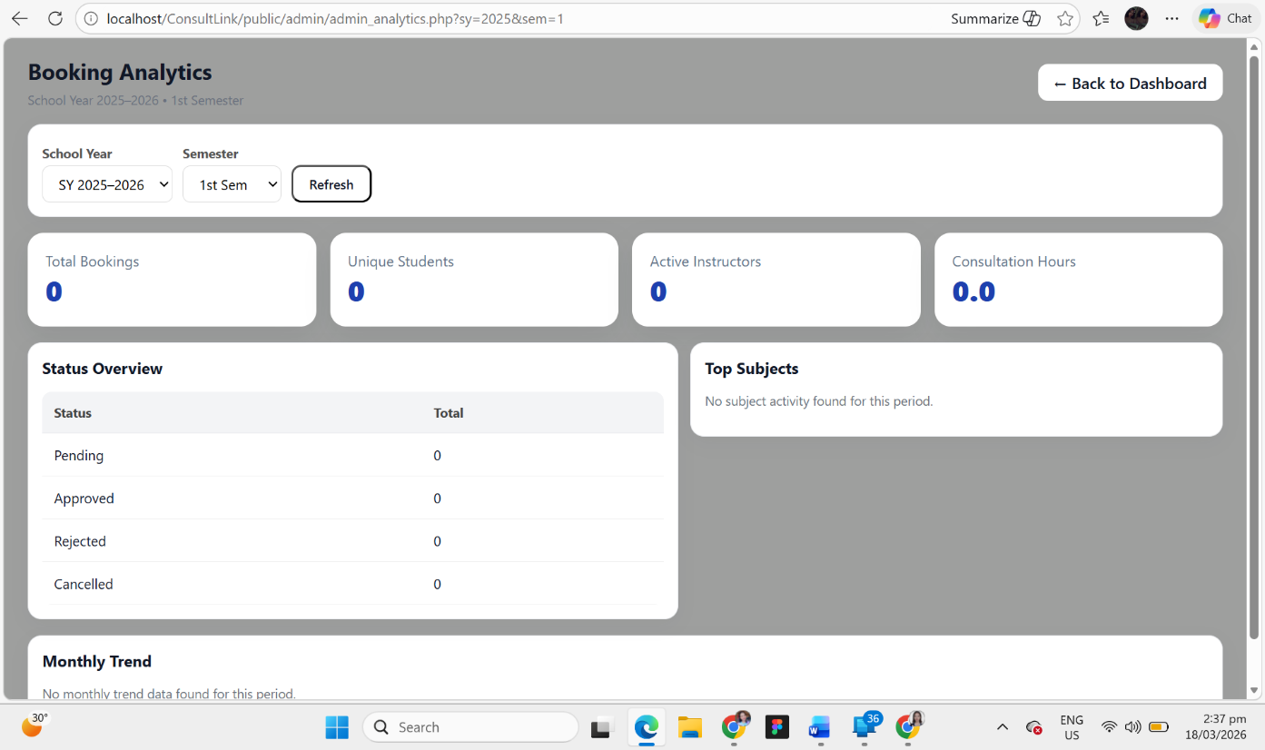

Figure 16. Booking Analytics page
This interface shows the Booking Analytics page of the ConsultLink system, designed to provide the administrator with insights and reports on consultation activities. At the top of the page, the admin can select the School Year and Semester, along with a “Refresh” button to update the displayed data. Below this, summary cards present key metrics such as Total Bookings, Unique Students, Active Instructors, and Consultation Hours, giving a quick overview of system activity. The page also includes a Status Overview section, which breaks down bookings into categories such as Pending, Approved, Rejected, and Cancelled, allowing the admin to monitor the status of consultations. Additionally, a Top Subjects section highlights the most active subjects, while a Monthly Trend section provides insights into booking patterns over time. The layout is organized and data-driven, enabling efficient monitoring and decision-making within the system.

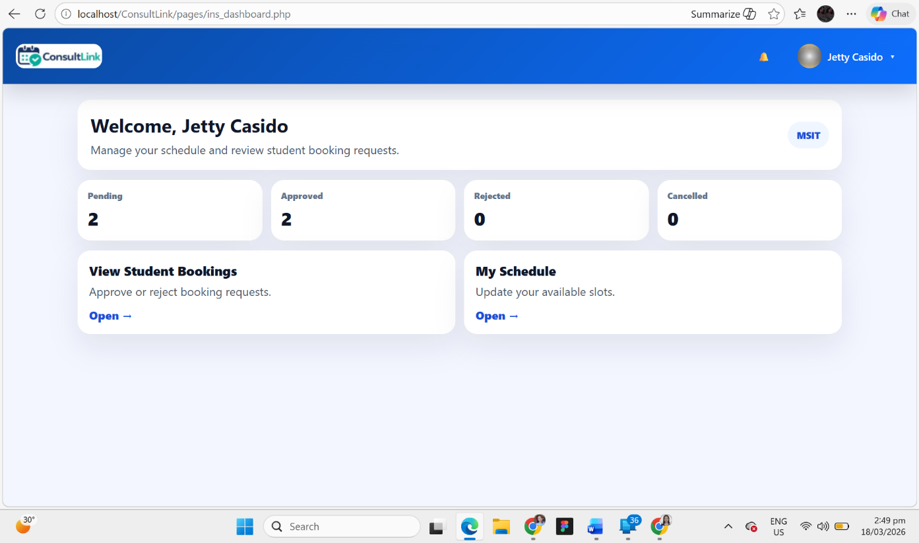

Figure 17. Instructor Dashboard
This interface shows the Instructor Dashboard of the ConsultLink system, designed to help instructors manage their consultation activities efficiently. At the top of the page, a navigation bar displays the system logo, a notification icon, and the instructor’s profile for easy access to account options. The main section begins with a personalized welcome message, providing a brief overview of the instructor’s role in managing schedules and reviewing student booking requests. Below this, summary cards display key booking statuses such as Pending, Approved, Rejected, and Cancelled, allowing instructors to quickly monitor their consultation requests. The dashboard also includes quick access sections like “View Student Bookings”, where instructors can approve or reject requests, and “My Schedule”, where they can update their available consultation slots. The layout is clean and intuitive, enabling instructors to efficiently handle their tasks within a user-friendly environment.

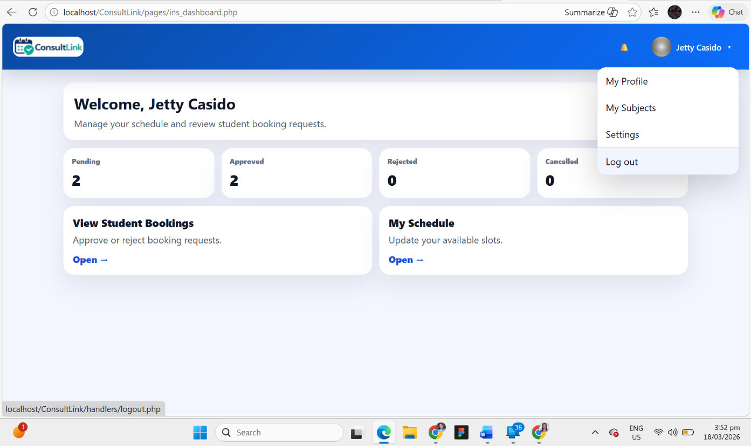

Figure 18. Instructor Navigation Menu
This interface shows the Instructor Navigation Menu within the ConsultLink system, accessible from the top-right corner of the Instructor Dashboard. When the instructor clicks on their profile section, a dropdown menu appears, providing quick access to important account-related features. The menu includes options such as “My Profile,” “My Subjects,” and “Settings,” allowing the instructor to easily navigate to personal information, assigned subjects, and account security settings. Additionally, a “Log out” option is provided to securely exit the system. This dropdown design enhances usability by grouping essential functions in one accessible location, enabling efficient navigation and a smoother user experience.

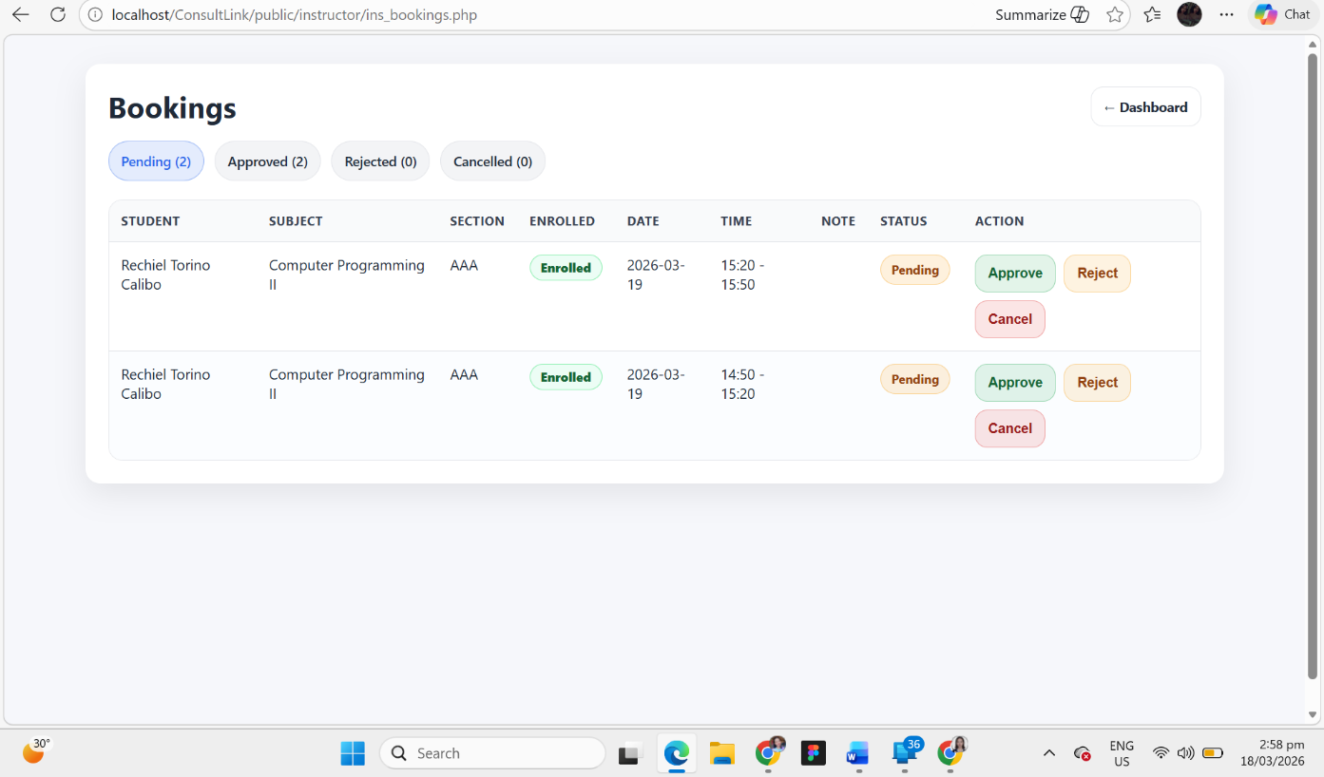

Figure 19. Instructor Bookings page
This interface shows the Instructor Bookings page of the ConsultLink system, designed to allow instructors to manage student consultation requests efficiently. At the top of the page, a header labeled “Bookings” is displayed along with status filter tabs such as Pending, Approved, Rejected, and Cancelled, enabling instructors to quickly sort and view requests based on their status. A “Dashboard” button is also provided for easy navigation back to the main instructor dashboard. Below this, a structured table presents detailed booking information including Student Name, Subject, Section, Enrollment Status, Date, Time, and Notes. Each booking entry includes action buttons such as “Approve,” “Reject,” and “Cancel,” allowing the instructor to respond to requests directly. The interface is organized and interactive, helping instructors efficiently review, manage, and update consultation bookings in a user-friendly environment.

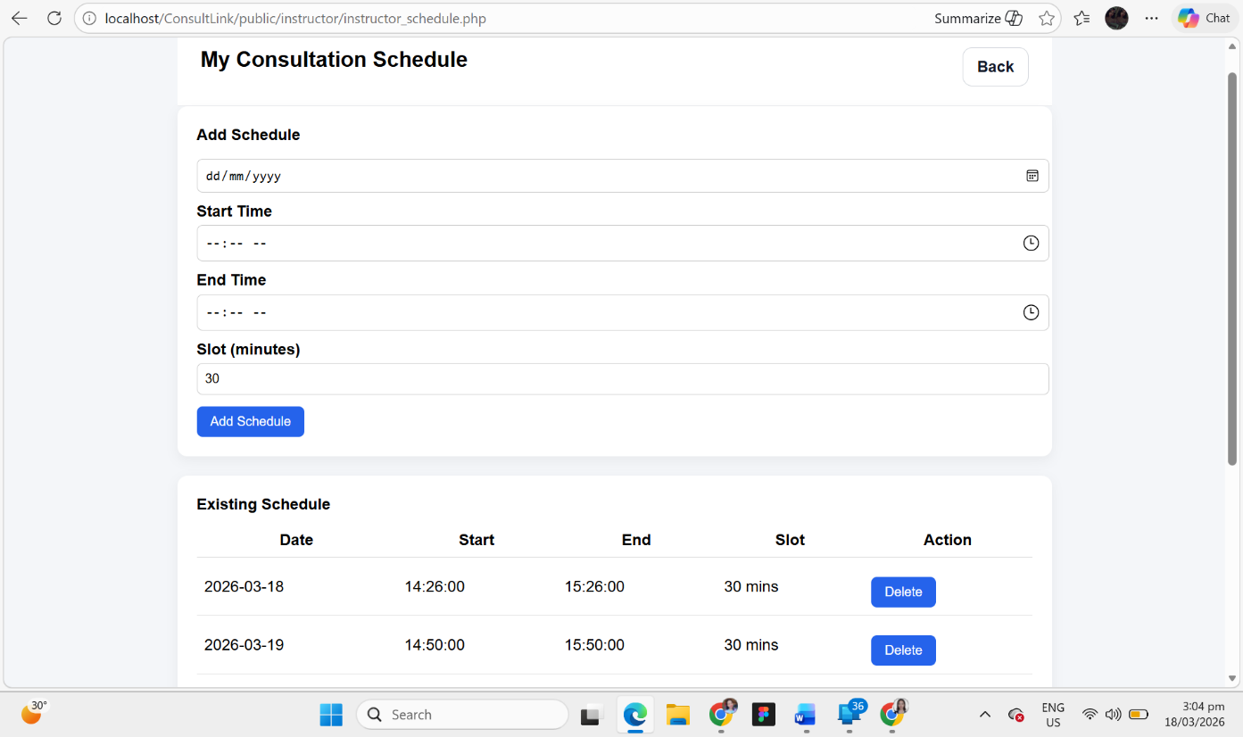

Figure 20. Instructor Consultation Schedule page
This interface shows the Instructor Consultation Schedule page of the ConsultLink system, designed to allow instructors to create and manage their available consultation time slots. At the top of the page, a header labeled “My Consultation Schedule” is displayed along with a “Back” button for easy navigation. The Add Schedule section provides input fields for Date, Start Time, and End Time, along with a slot duration field (in minutes), enabling instructors to define their consultation availability accurately. An “Add Schedule” button is provided to save the schedule. Below this, the Existing Schedule section presents a table displaying scheduled consultation slots, including Date, Start Time, End Time, and Slot Duration, along with an “Delete” button for removing entries when necessary. The interface is simple, organized, and user-friendly, allowing instructors to efficiently manage their consultation schedules.

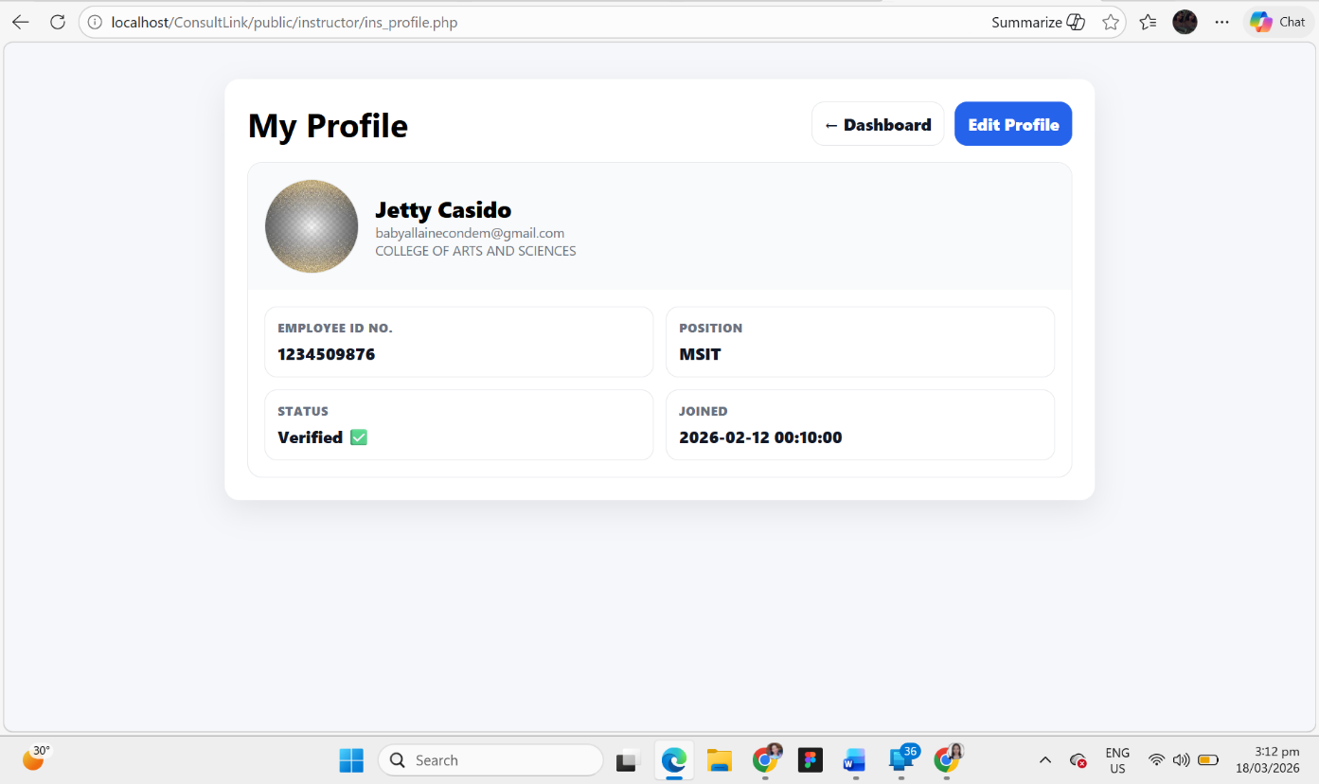

Figure 21. Instructor Profile page
This interface shows the Instructor Profile page of the ConsultLink system, designed to display and manage the personal and professional information of the instructor. At the top of the page, the title “My Profile” is presented along with navigation buttons such as “Dashboard” and “Edit Profile” for easy access and updates. The profile section includes a visual avatar along with key details such as the instructor’s name, email, and department, providing a clear identity overview. Below this, structured information fields display important data including Employee ID Number, Position, Account Status, and Date Joined. The status indicator (e.g., Verified) helps confirm account authenticity. The layout is clean, organized, and easy to read, allowing instructors to quickly review their information and update it when necessary, ensuring a user-friendly and efficient profile management experience.

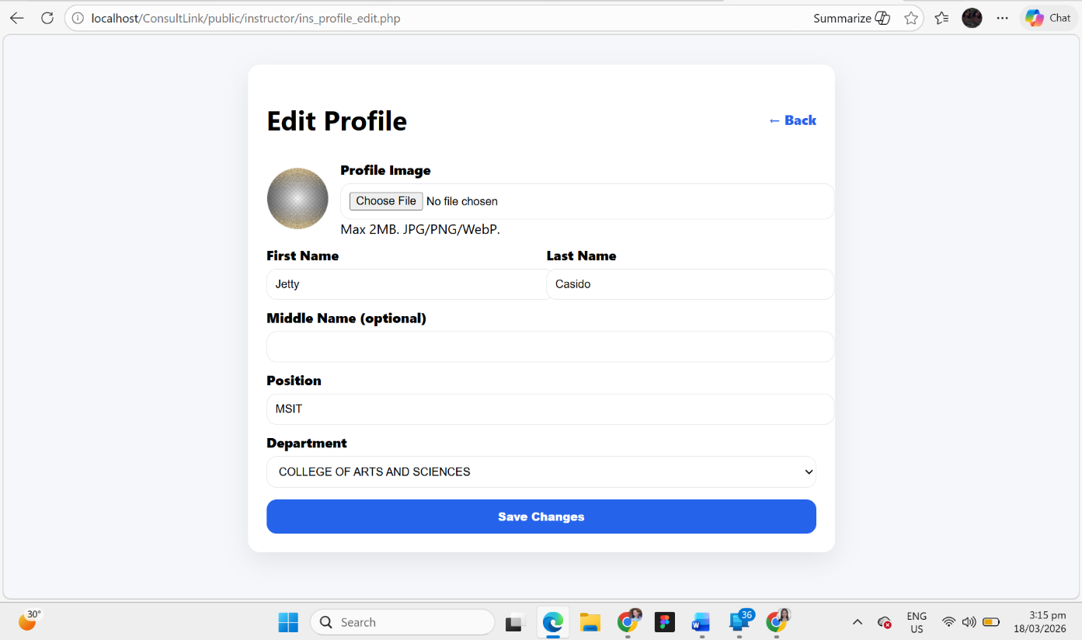

Figure 22. Edit Profile page
This interface shows the Edit Profile page of the ConsultLink system, designed to allow instructors to update their personal and professional information. At the top of the page, the title “Edit Profile” is displayed along with a “Back” button for easy navigation. The form includes an option to upload a Profile Image, with file format and size restrictions to ensure proper image handling. Below this, input fields are provided for First Name, Last Name, and Middle Name (optional), allowing users to update their identity details. Additional fields such as Position and Department enable instructors to maintain accurate professional information. At the bottom of the form, a prominent “Save Changes” button is available to apply updates. The interface is simple, structured, and user-friendly, ensuring a smooth and efficient profile editing experience.

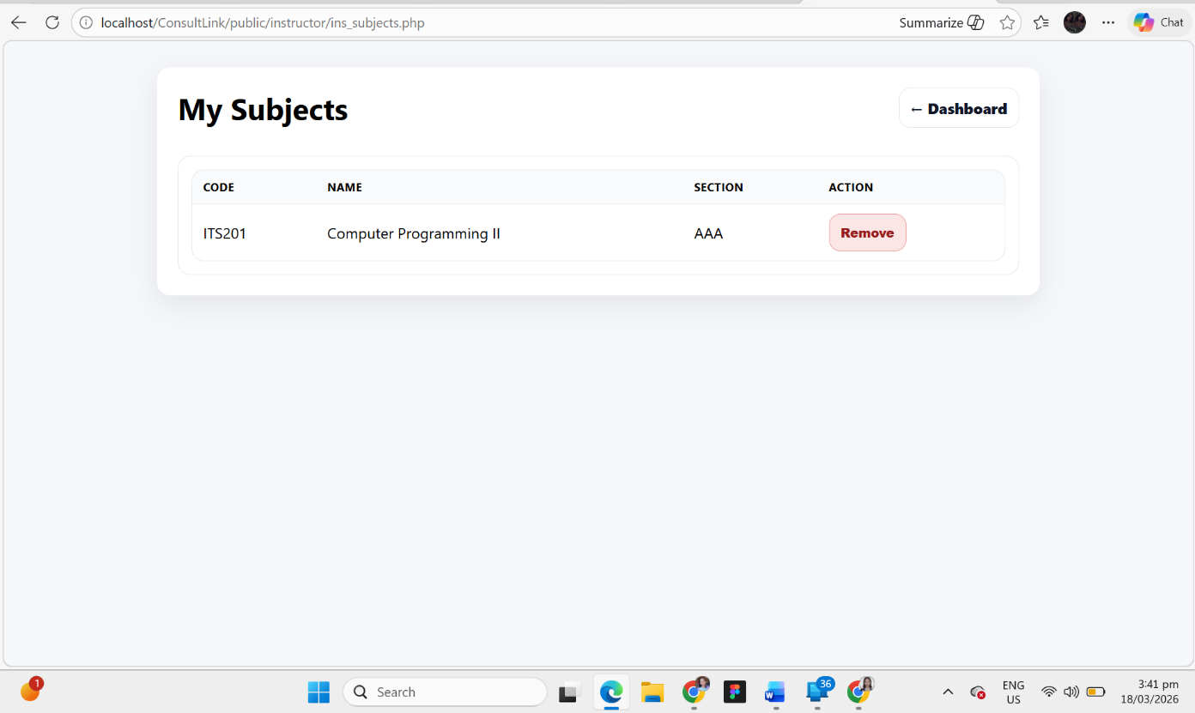

Figure 23. My Subjects page
This interface shows the My Subjects page of the ConsultLink system, designed to allow instructors to view and manage the subjects assigned to them. At the top of the page, the title “My Subjects” is displayed along with a “Dashboard” button for easy navigation back to the main instructor dashboard. Below this, a structured table presents the list of assigned subjects, including details such as Subject Code, Subject Name, and Section, providing a clear overview of the instructor’s teaching load. Each subject entry includes a “Remove” button, allowing the instructor to manage or unassign subjects when necessary. The layout is simple, organized, and user-friendly, enabling instructors to quickly review and manage their assigned subjects efficiently.

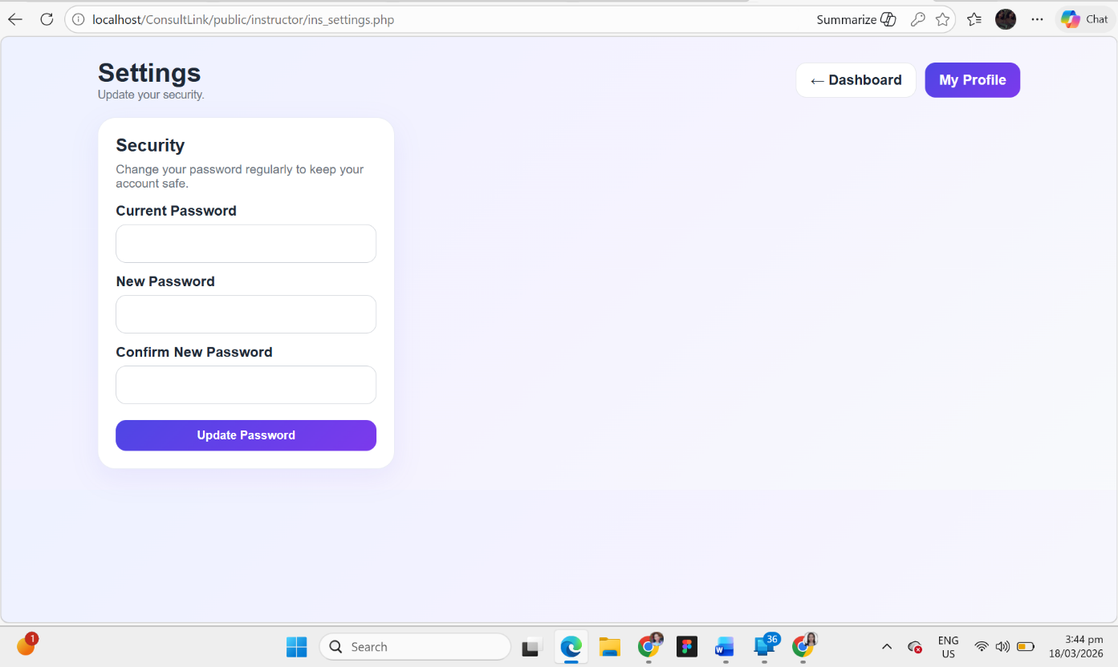

Figure 24. Settings page
This interface shows the Settings page of the ConsultLink system, designed to allow instructors to manage their account security. At the top of the page, the title “Settings” is displayed along with navigation buttons such as “Dashboard” and “My Profile” for easy access to other sections. The main section focuses on Security, where instructors can update their account password to maintain system safety. The form includes input fields for Current Password, New Password, and Confirm New Password, ensuring that users can securely change their credentials. An “Update Password” button is provided to apply the changes. The layout is simple, clean, and focused, promoting a secure and user-friendly experience for managing account settings.

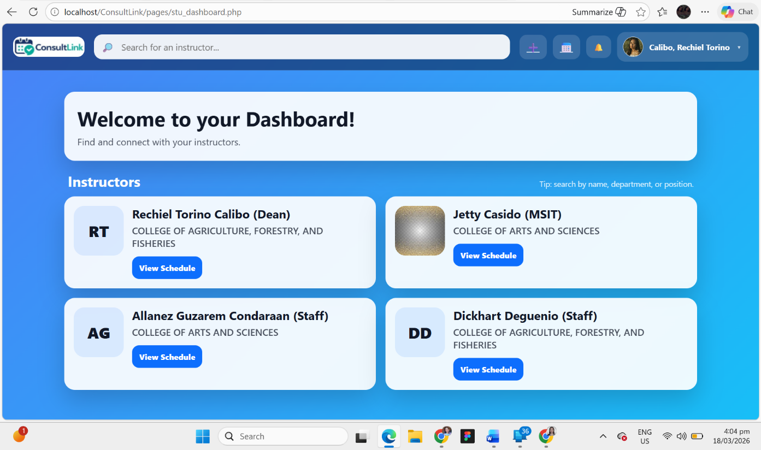

Figure 25. Student Dashboard
This interface shows the Student Dashboard of the ConsultLink system, designed to help students easily find and connect with instructors for consultation. At the top of the page, a navigation bar includes the system logo, a search bar for finding instructors by name, department, or position, and icons for quick actions and notifications, along with the student’s profile section. The main section displays a welcome message, guiding students to explore available instructors. Below this, the Instructors section presents a list of instructor cards, each showing the instructor’s name, position, and department. Each card includes a “View Schedule” button, allowing students to check the instructor’s available consultation times and proceed with booking. The layout is modern, interactive, and user-friendly, enabling students to efficiently browse and select instructors for consultation.

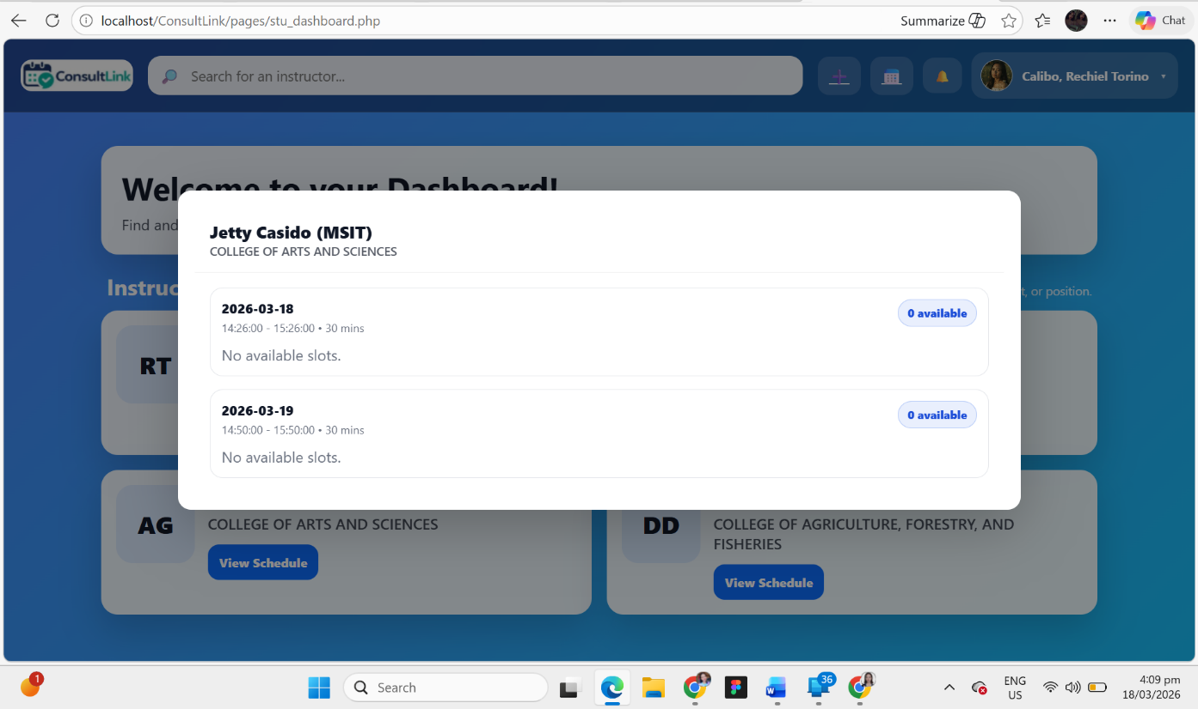

Figure 26. Instructor Schedule View
This interface shows the Instructor Schedule View modal in the ConsultLink system, accessed by students when selecting an instructor from the dashboard. The modal displays the instructor’s name, position, and department at the top, providing clear identification. Below this, the schedule is organized by date, showing the available consultation time range and slot duration. Each schedule entry includes an indicator of available slots (e.g., “0 available”) and a message such as “No available slots” when no bookings can be made. This design allows students to quickly check an instructor’s availability before attempting to book a consultation. The modal layout keeps the student within the dashboard while viewing schedules, ensuring a smooth, focused, and user-friendly experience.

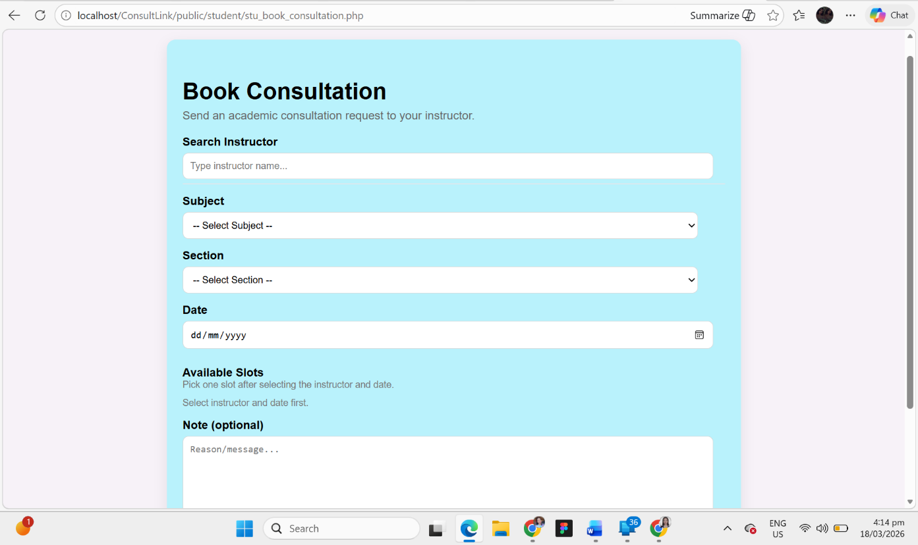

Figure 27. Book Consultation page
This interface shows the Book Consultation page of the ConsultLink system, designed to allow students to request a consultation with their instructor. At the top of the page, the title “Book Consultation” is displayed along with a short description guiding students on how to proceed. The form includes a Search Instructor field, enabling students to quickly find their desired instructor. Dropdown menus for Subject and Section are provided to ensure the consultation is properly categorized. Students can then select a Date for the consultation, after which the Available Slots section will display the instructor’s available time slots for booking. An optional Note field is also included, allowing students to add a message or reason for the consultation. The layout is clean, guided, and user-friendly, ensuring a smooth and efficient booking process.

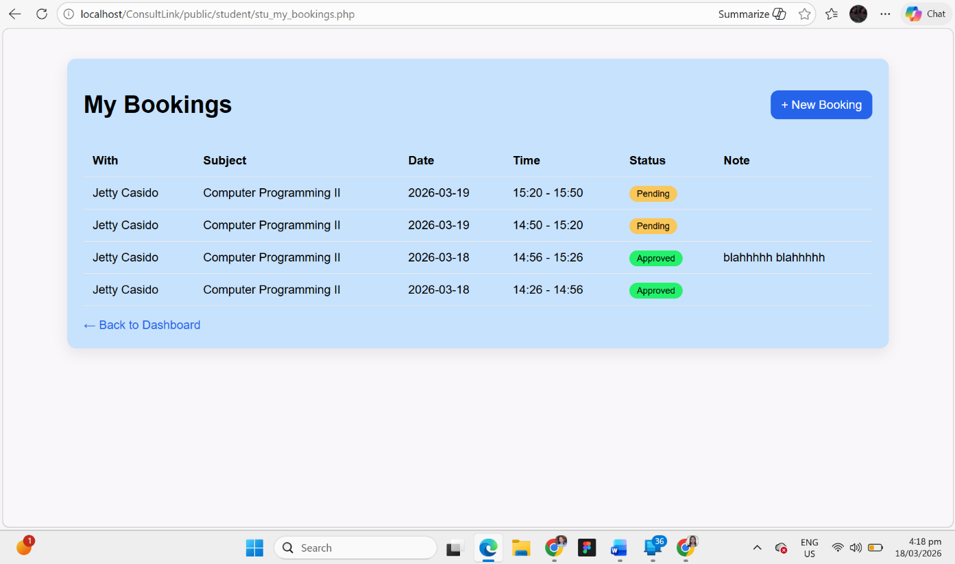

Figure 28. My Bookings page
This interface shows the My Bookings page of the ConsultLink system, designed to allow students to view and track their consultation requests. At the top of the page, the title “My Bookings” is displayed along with a “+ New Booking” button, enabling students to quickly create a new consultation request. Below this, a structured table presents detailed booking information including Instructor Name, Subject, Date, Time, Status, and Notes, providing a clear overview of all consultation activities. The status indicators (e.g., Pending, Approved) are visually highlighted to help students easily identify the progress of their requests. A “Back to Dashboard” link is also provided for easy navigation. The layout is simple, organized, and informative, allowing students to efficiently monitor and manage their consultation bookings.

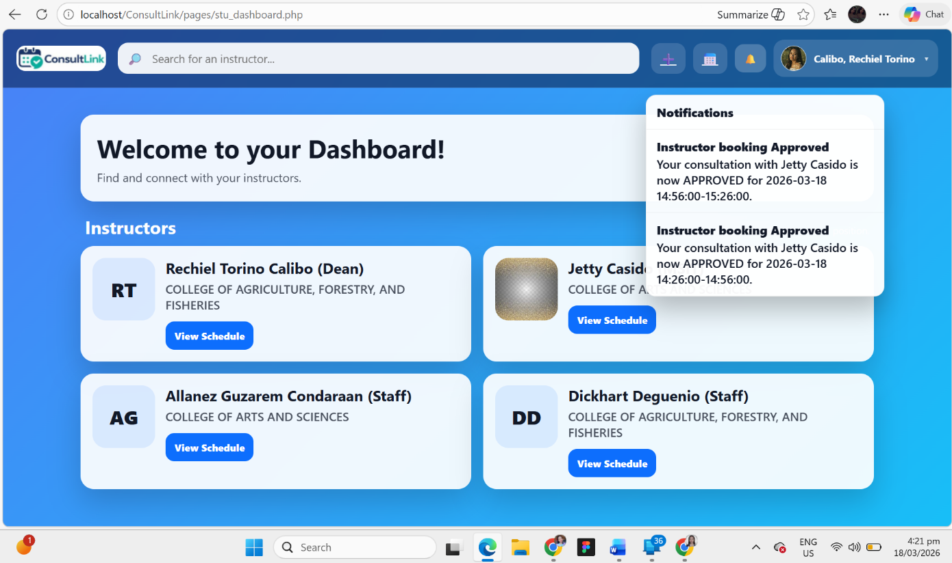

Figure 29. Notification Panel
The interface presents the Notification Panel of the ConsultLink system, which provides real-time updates to students regarding their consultation requests. This panel appears when the notification icon (bell) is selected and displays a list of recent alerts in a structured format. Each notification includes a title, such as “Instructor Booking Approved,” along with a detailed message indicating the instructor’s name, consultation date, and time schedule. This feature ensures that students are immediately informed about important updates, particularly the approval of their booking requests. The notifications are designed to be clear and concise, allowing users to quickly understand the status of their consultations without navigating to another page. Overall, the notification system enhances user experience by improving communication and keeping students informed in real time.

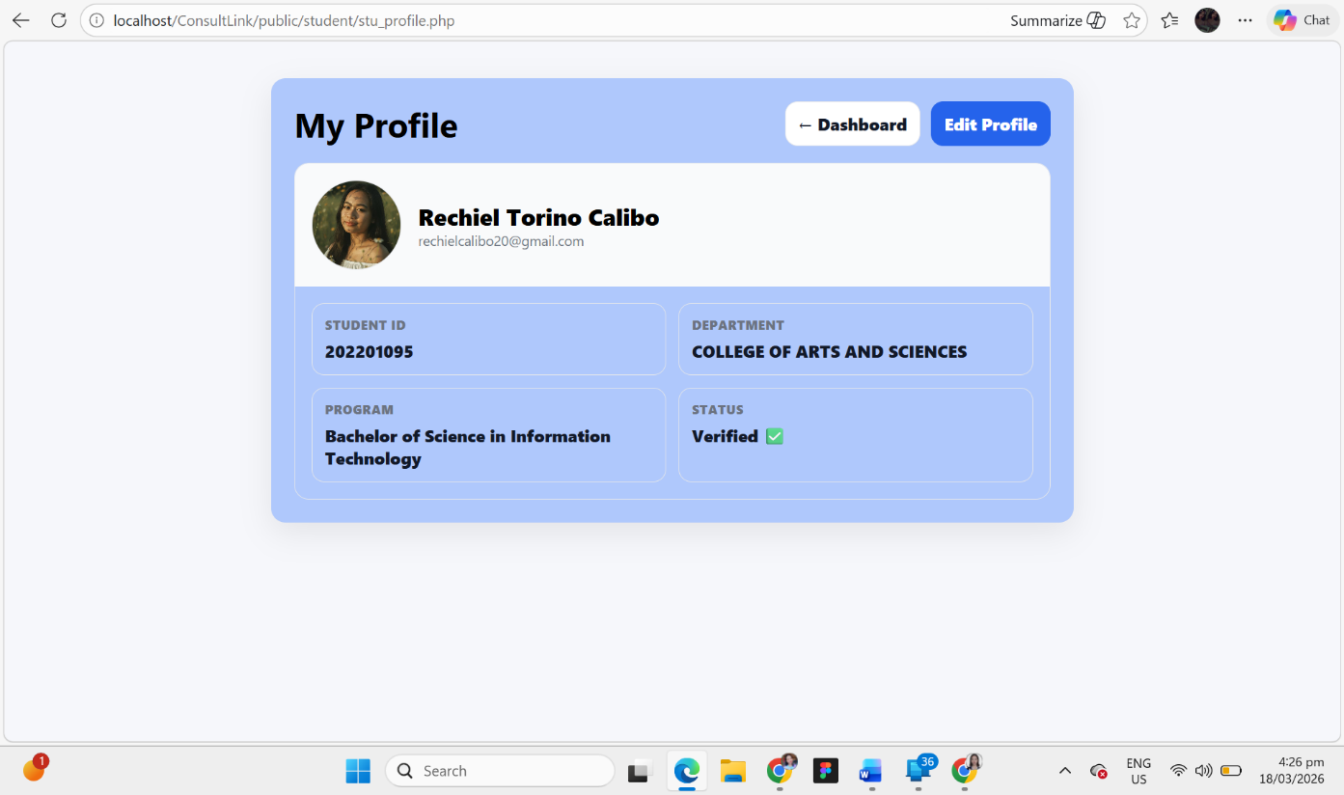

Figure 30. Student Profile page
The interface displays the Student Profile page of the ConsultLink system, which provides a comprehensive view of the student’s personal and academic information. At the top, the page includes navigation buttons such as “Dashboard” and “Edit Profile,” allowing users to easily return to the main page or update their details. The profile section presents the student’s profile picture, full name, and email address, followed by structured information panels that include the Student ID, Department, Program, and Account Status. The status indicator, such as “Verified,” confirms that the student’s account has been successfully authenticated within the system. The layout is clean and organized, ensuring that users can quickly access and review their information. This feature enhances user experience by providing transparency and easy profile management within the system.

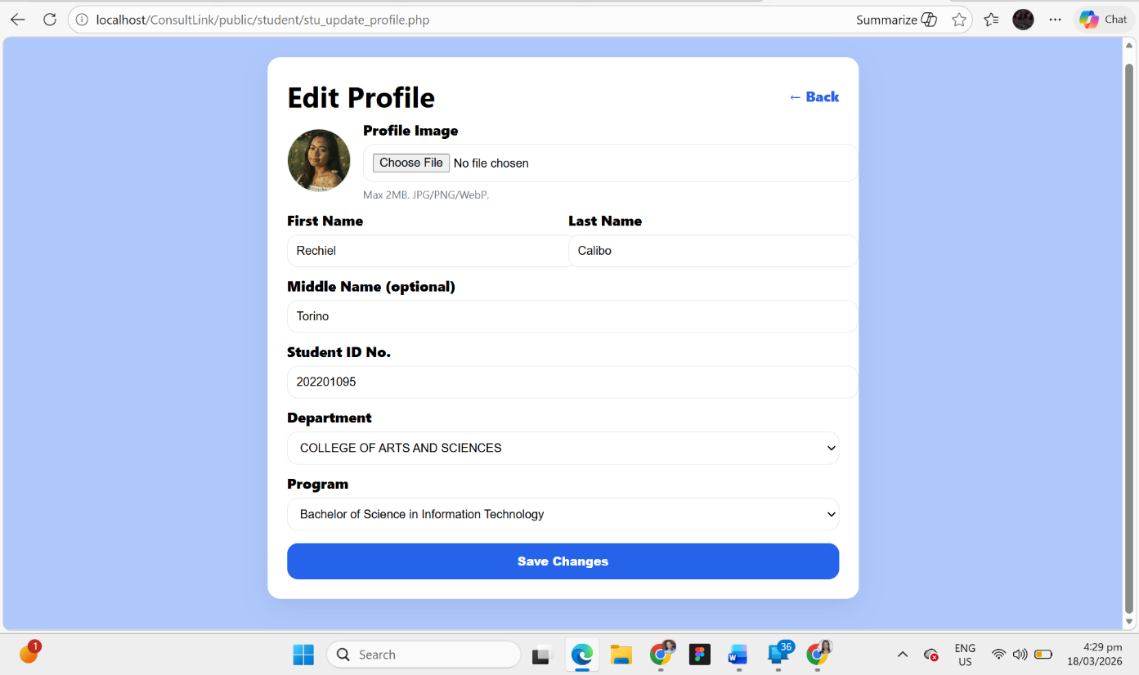

Figure 31. Edit Profile page
The interface shows the Edit Profile page of the ConsultLink system for students, which allows users to update their personal and academic information. At the top, the page includes a “Back” button for easy navigation to the previous page. The form is structured and user-friendly, beginning with an option to upload or change the profile image, followed by input fields for First Name, Last Name, and Middle Name (optional). It also includes editable academic details such as Student ID Number, Department, and Program, which are presented using text fields and dropdown selections for accuracy and consistency. At the bottom of the form, a “Save Changes” button is provided to submit and apply the updates. This page ensures that students can maintain accurate and up-to-date personal records, enhancing both usability and data reliability within the system.

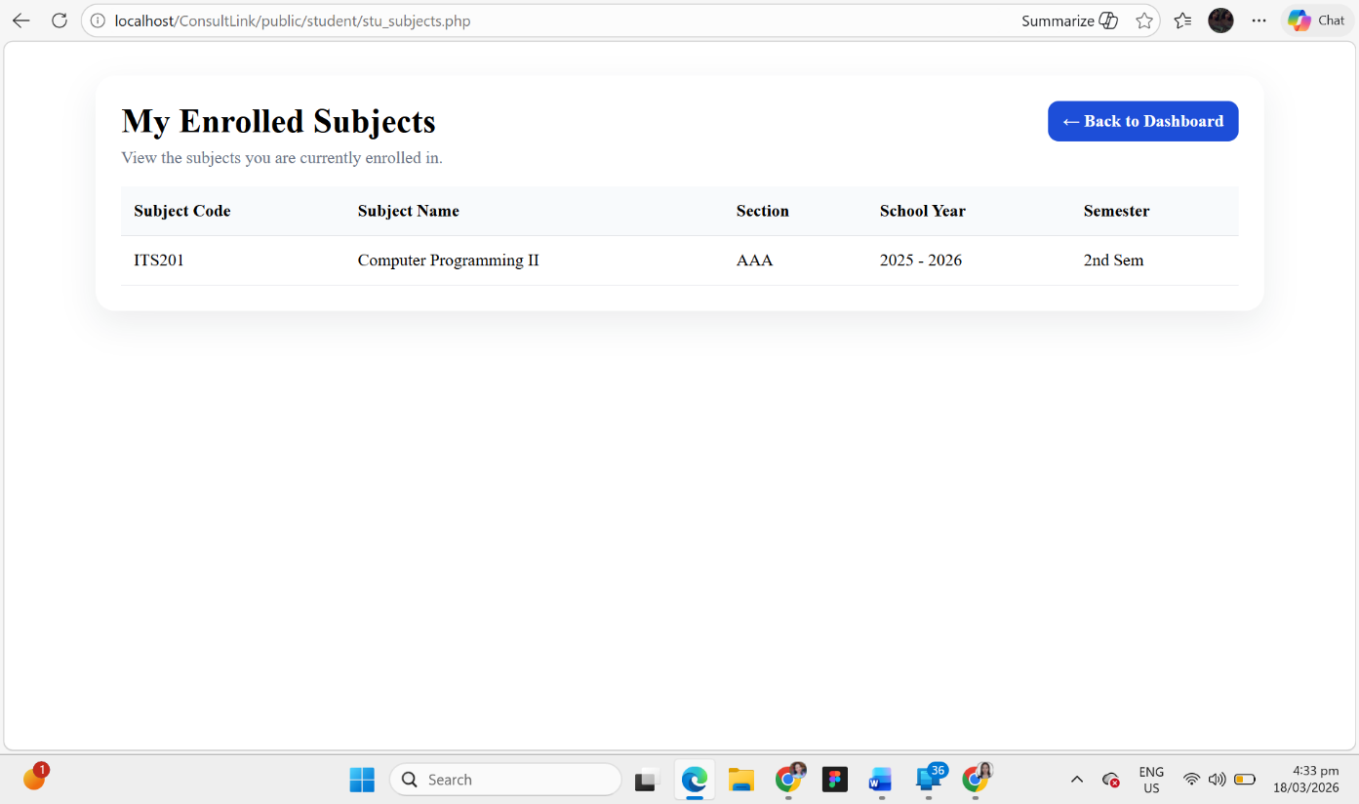

Figure 32. My Enrolled Subjects page
The interface displays the My Enrolled Subjects page of the ConsultLink system, which allows students to view the subjects they are currently enrolled in. At the top, the page includes a “Back to Dashboard” button for easy navigation. Below the title, a structured table presents detailed academic information, including Subject Code, Subject Name, Section, School Year, and Semester. This organized layout enables students to clearly identify their enrolled courses and associated details at a glance. The page is designed to be simple and informative, ensuring that students can easily access and review their academic enrollment without confusion. Overall, this feature enhances transparency and helps students stay informed about their current academic load within the system.

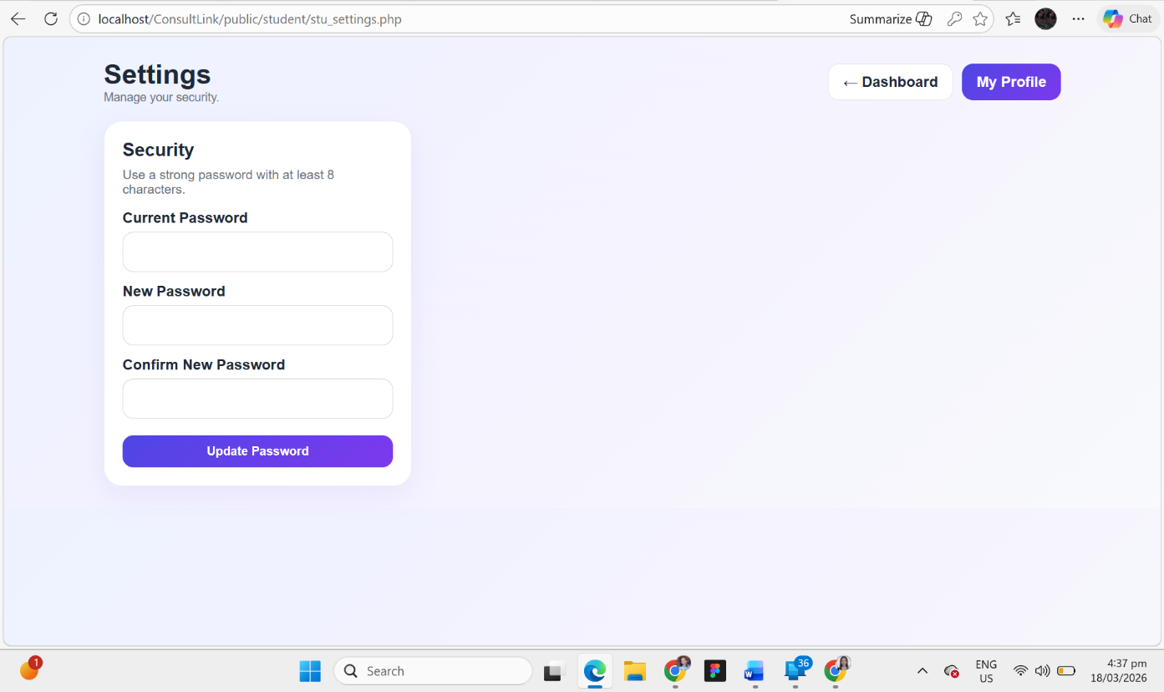

Figure 33. Settings page
The interface presents the Settings page of the ConsultLink system for students, which focuses on account security management. At the top, navigation buttons such as “Dashboard” and “My Profile” are provided for easy access to other sections of the system. The main section highlights the Security module, where students can update their account password to ensure account protection. The form includes fields for Current Password, New Password, and Confirm New Password, allowing users to securely change their credentials. A note is also provided to guide users in creating a strong password, enhancing overall system security. At the bottom, an “Update Password” button is available to apply the changes. This page ensures that students can maintain the security of their accounts and protect their personal information within the system.

