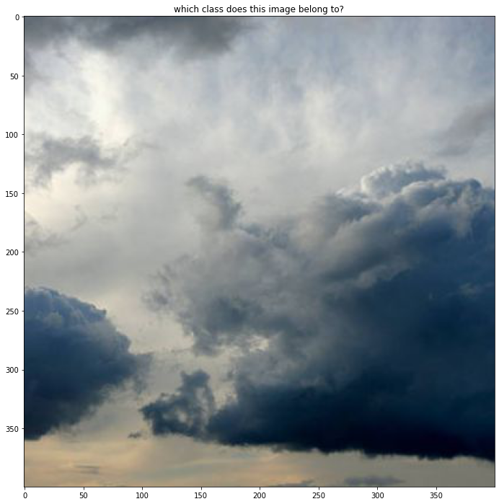

What the database classified this image as: As
What I think this image should be classified as: Cn

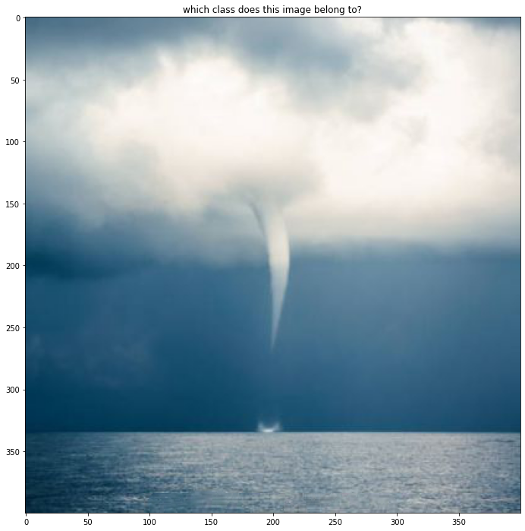

What the database classified this image as: Cc
What I think this image should be classified as: Cb?

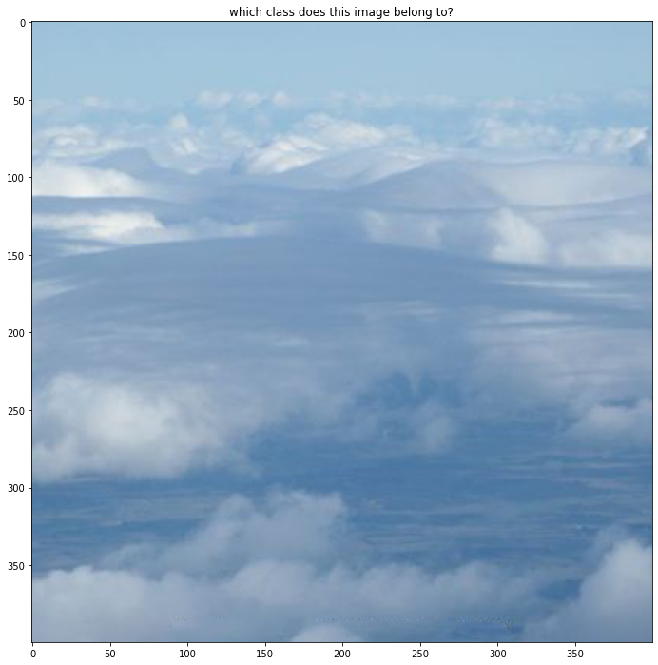

define the class: As
not quite
correct answer: Cu

