AIOps Sentinel
AI-Powered Infrastructure Monitoring & Incident Intelligence
Cloud Product and Platform Engineering
A Report
Submitted by:
R Nandhana [RA2311003010689]
Renu Gopu [RA2311003010713]

1. Project Overview
AIOps Sentinel is an AI-driven, fully serverless infrastructure monitoring and incident intelligence platform deployed on AWS. It detects infrastructure incidents in real time via Amazon CloudWatch alarms and EC2 state-change events, automatically fetches and sanitises relevant logs, performs AI-powered root cause analysis using Amazon Bedrock (Claude Haiku 4.5 / Nova Lite), and delivers structured Slack alerts with actionable remediation steps — all within under 7 seconds of the alarm firing.
Pipeline at a Glance
- Event Detection: CloudWatch alarms (CPU, status check, network anomaly) or EC2 state changes fire into SNS.
- SNS Fan-out: SNS publishes to Lambda and optional email subscribers.
- Lambda Orchestration: Master handler coordinates the full 6-stage pipeline.
- Log Fetching: CloudWatch Logs API retrieves the last 15 minutes of relevant events.
- Log Processing: Sensitive data is redacted; logs are trimmed to 4,000 chars preserving error lines.
- AI Analysis: Amazon Bedrock performs structured root cause analysis; OpenRouter is the fallback.
- Persistence: Enriched incident saved to DynamoDB with 30-day TTL.
- Notification: Rich Slack Block Kit alert with severity colour, root cause, and remediation actions.

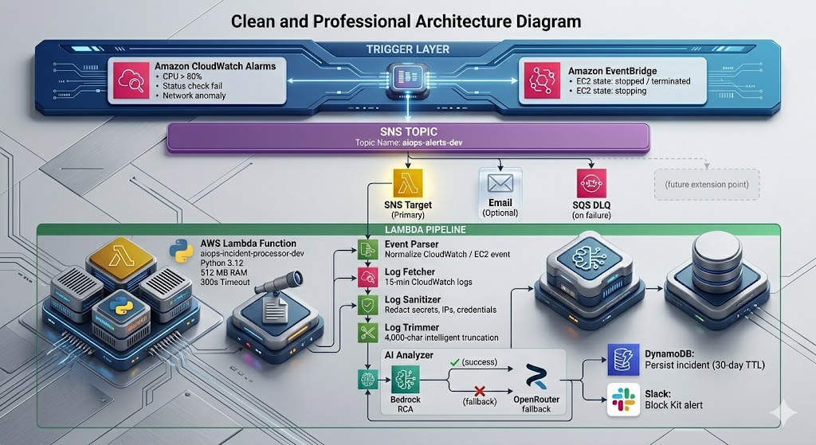
2. Functional Implementation
All core features are fully implemented and operational end-to-end in the AWS environment.
2.1 Event Parser — lambda/incident_processor/event_parser.py
- Normalises two distinct event shapes (CloudWatch Alarm and EC2 State Change) into a unified incident dict.
- CloudWatch Alarm path: extracts AlarmName, NewStateValue, alarm reason, InstanceId and AutoScalingGroupName from SNS dimensions.
- EC2 State Change path (EventBridge): captures instance ID and state transition, synthesises an alarm_name.
- Generates a UUID incident_id per event for full end-to-end traceability.
- Returns None for unrecognised events — the handler skips silently without error.
2.2 Log Fetcher — lambda/incident_processor/log_fetcher.py
- Queries the relevant CloudWatch log group with a configurable 15-minute lookback window.
- Optionally filters by instance ID to avoid noise from unrelated workloads.
- Caps output at 100 log lines to stay within Bedrock token limits.
- Returns a graceful placeholder string when the log group is missing or empty.
2.3 Log Processor — lambda/log_processor/
Three-stage module: Sanitise → Trim → Classify.
- Sanitise: Sanitiser (log_sanitizer.py) applies 7 regex patterns before any AI call:
- IPv4 addresses -> [IP_REDACTED]
- AWS Access Key IDs (AKIA...) -> [AWS_KEY_REDACTED]
- AWS Secret Key patterns -> [AWS_SECRET_REDACTED]
- Generic credentials (password=, token=, secret=, ...) -> [CREDENTIAL_REDACTED]
- Email addresses -> [EMAIL_REDACTED]
- AWS VPC internal DNS hostnames -> [INTERNAL_HOST_REDACTED]
- Home-directory usernames -> /home/[USER]/
- Trim: Trimmer (log_trimmer.py) caps at 4,000 chars / 50 lines, preserving error/critical/fatal/exception/OOM lines first.
- Classify: Rule-based pre-classification before AI: HIGH_CPU, MEMORY_EXHAUSTION, DISK_FULL, NETWORK_ISSUE, INSTANCE_FAILURE, APPLICATION_ERROR, UNKNOWN.
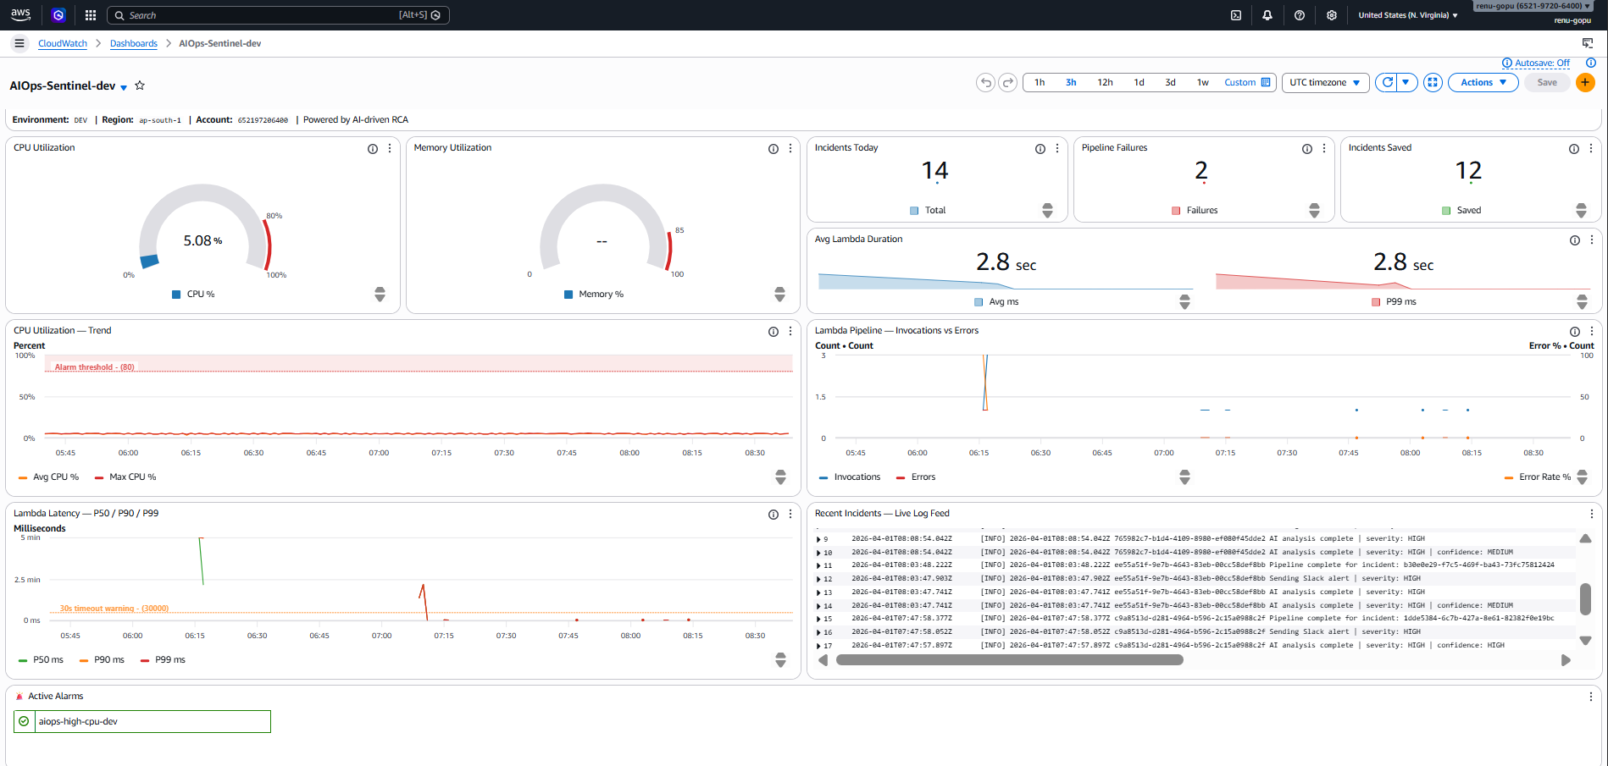
2.4 AI Analyser — lambda/ai_analyzer/
- Primary — bedrock_client.py: supports Anthropic Claude, Amazon Nova, and Titan request formats auto-detected from model ID. Retries 3x with exponential back-off. Strips markdown fences before JSON parsing.
- Fallback — groq_client.py: iterates through 4 free-tier OpenRouter models (Gemma 3N, GPT-OSS 20B, Qwen3-4B, GLM-4.5-Air) using Python built-in urllib, 30-second timeout each.
- Prompt — ai/prompts/rca_prompt.py: structured template injecting all incident fields and sanitised logs, demanding strict JSON output with 11 fields: summary, root_cause, severity, severity_reason, affected_components, immediate_actions, long_term_fix, pattern_detected, pattern_description, confidence, estimated_impact.
- Final safety net: if both providers fail, the handler inserts a HIGH-severity fallback so the pipeline never silently drops an incident.

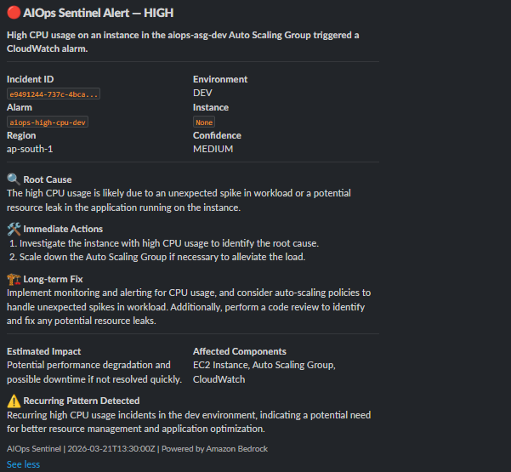
2.5 Notification Handler — lambda/notification_handler/
- slack_formatter.py builds a Slack Block Kit message with severity-mapped colours (CRITICAL=red, HIGH=orange, MEDIUM=gold, LOW=blue), metadata table, root cause, immediate actions, long-term fix, estimated impact, and a recurring-pattern warning block.
- secrets.py retrieves the webhook URL from AWS Secrets Manager with in-memory caching to avoid repeated API calls within the same Lambda container lifetime.
- notifier.py sends via HTTPS POST with a 10-second timeout, validates HTTP 200 + 'ok', and returns False on failure without crashing the pipeline.

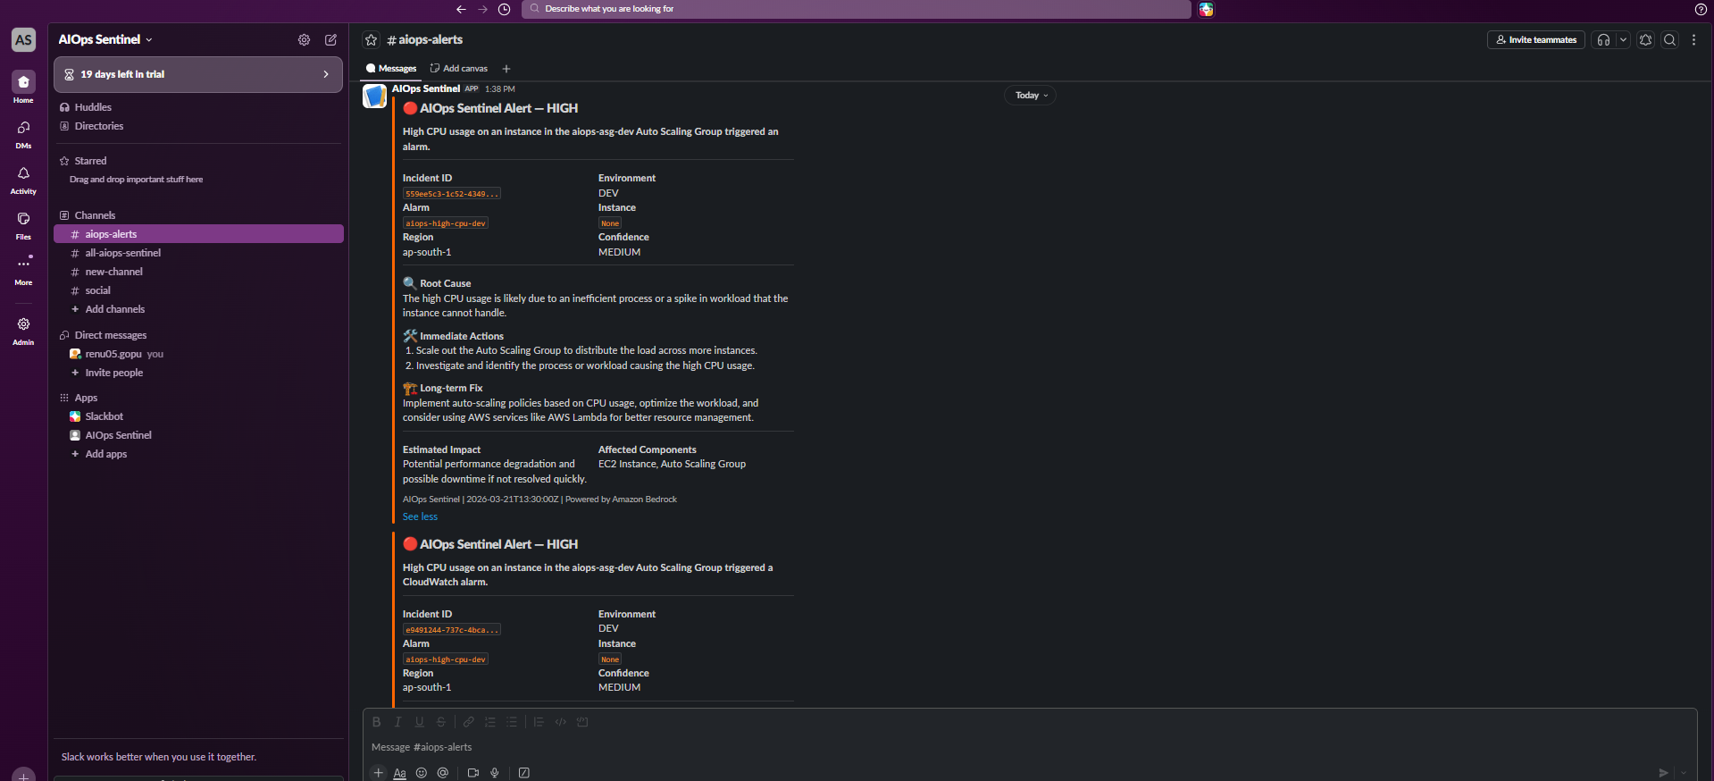
2.6 DynamoDB Persistence
- Writes 12 fields per incident: incident_id, timestamp, alarm_name, instance_id, severity, error_type, summary, root_cause, environment, status=OPEN, ttl.
- TTL attribute auto-deletes records after 30 days — no manual housekeeping required.
- DynamoDB write failures are logged and non-blocking — Slack notification is never delayed.
3. Cloud & Hyperscaler Usage
AIOps Sentinel uses ten AWS managed services purposefully, all provisioned via Terraform with environment-specific naming and default tags.
AWS Service | Configuration | Role in System
AWS Lambda | Python 3.12 / 512 MB / 300 s / X-Ray Active | Serverless compute — runs the entire incident pipeline
Amazon SNS | Topic: aiops-alerts-dev / Lambda + email subscriptions | Fan-out: distributes alarm events to Lambda and email
Amazon DynamoDB | PAY_PER_REQUEST / TTL enabled / incident_id hash key | Persistent incident store with auto-expiry
Amazon S3 | AES-256 / public access blocked / IA->Glacier->Delete | Log archiving with tiered cold storage
Amazon CloudWatch | 4 alarms / dashboard / 30-day log retention | Infrastructure monitoring and incident trigger
Amazon EventBridge | Rule: EC2 state-change (stopped/terminated/stopping) | Captures EC2 lifecycle events without polling
AWS Secrets Manager | Secret: aiops/slack/webhook / 7-day recovery window | Encrypted webhook URL storage
Amazon Bedrock | global.anthropic.claude-haiku-4-5-20251001-v1:0 | Primary AI engine for root cause analysis
AWS X-Ray | Active tracing on Lambda | Distributed tracing for latency and error forensics
EC2 + ALB + ASG | t3.micro x2 / ALB multi-AZ / 1-3 instance scaling | Monitored workload generating real alarm events

Terraform Module Breakdown
- modules/networking: VPC (10.0.0.0/16), 2 public + 2 private subnets across 2 AZs, Internet Gateway, ALB and EC2 security groups.
- modules/ec2: Launch template with CloudWatch agent user-data, ALB with health checks, ASG (1-3), step scaling policies, 50% min-healthy instance refresh.
- modules/iam: Separate IAM roles for EC2 (SSM + CW agent) and Lambda (10-statement least-privilege inline policy).
- modules/lambda: Lambda function, SQS DLQ (14-day retention), CW log group (30-day retention), SNS subscription and invoke permission.
- modules/alarms: 4 CloudWatch alarms (High CPU, Low CPU, Status Check Failed, Network Anomaly) all publishing to SNS.
- Remote state: versioned S3 backend — aiops-terraform-state-652197206400/dev/terraform.tfstate.

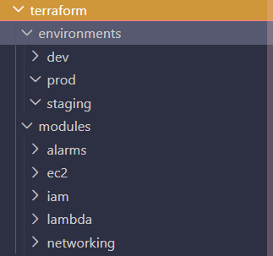

4. Data / ML / AI Workflow
Complete data-processing and AI inference workflow: raw log ingestion -> structured preprocessing -> prompt engineering -> model invocation -> response validation -> structured output delivery.
4.1 Data Processing
- Raw logs arrive as unstructured text from CloudWatch Logs FilterLogEvents API.
- Sanitiser strips 7 categories of sensitive data before any AI call.
- Trimmer prioritises error-bearing lines and caps at 4,000 chars to fit Bedrock context windows without losing critical information.
- Pre-classifier tags error type before the AI call, giving the model a structured hint and enabling faster human triage.
- Final payload contains 18 structured fields covering incident metadata, processed logs, and environment context.
4.2 Prompt Engineering (ai/prompts/rca_prompt.py)
- Role context: 'You are an expert AWS SRE and AIOps analyst.'
- Input section: incident ID, timestamp, event type, alarm details, instance/ASG metadata, pre-classified error type, environment, sanitised logs.
- Strict output instruction: return only valid JSON — no markdown, no prose.
- Output schema enforces 11 fields including severity (CRITICAL|HIGH|MEDIUM|LOW) and confidence (HIGH|MEDIUM|LOW) enums.
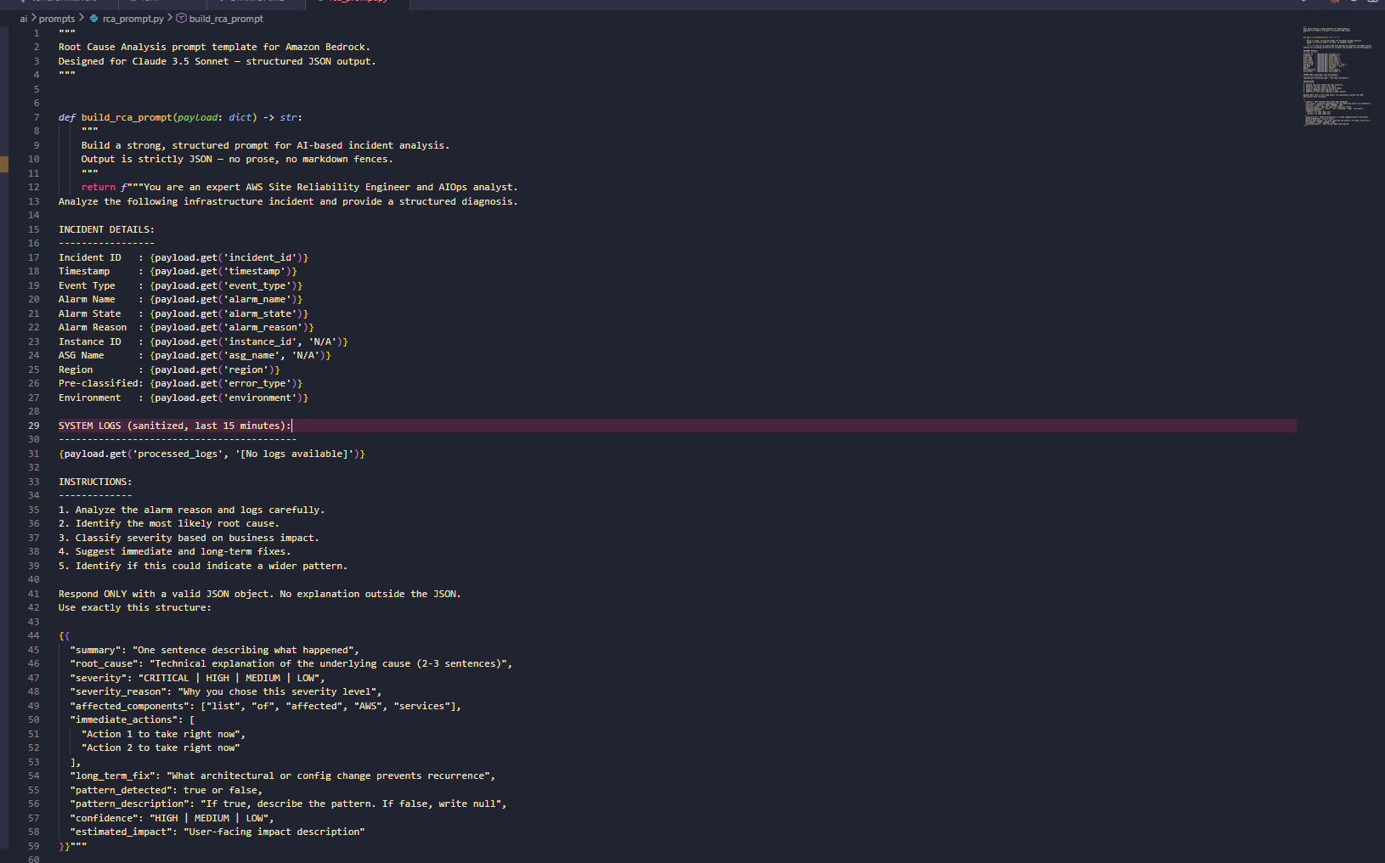
4.3 Model Integration & Fallback Chain
- Primary: Amazon Bedrock with global cross-region inference profile (global.anthropic.claude-haiku-4-5-20251001-v1:0). Temperature 0.1 for deterministic output. Max 2,048 output tokens.
- Multi-format support: bedrock_client.py auto-detects model family (Anthropic / Nova / Titan) and builds the correct request body.
- Retry logic: 3 attempts with exponential back-off on ThrottlingException. Permanent errors fast-fail without retry.
- Fallback: OpenRouter free-tier models tried in sequence — Gemma 3N, GPT-OSS 20B, Qwen3-4B, GLM-4.5-Air.
4.4 Response Validation
- Strips markdown JSON fences before parsing.
- Validates required fields: summary, root_cause, severity, immediate_actions.
- Normalises severity to uppercase and enforces the valid enum set.
- Returns a safe HIGH-severity fallback dict on parse failure — no exceptions propagate.

5. DevOps Practices
5.1 CI/CD Pipeline — .github/workflows/deploy.yml
Fully automated GitHub Actions pipeline. No manual deployment steps after initial repository setup.
Job | Trigger | Steps
Unit Tests | Every push and PR | Checkout -> Python 3.12 -> install boto3 moto pytest -> run all 3 test suites
Terraform Plan | Pull requests only | AWS credentials -> terraform init -> terraform plan (infra change review before merge)
Deploy | Push to main only | AWS credentials -> terraform apply -auto-approve -> python scripts/deploy_lambda.py

- Secrets passed to Terraform as TF_VAR_* environment variables — nothing sensitive written to disk.
- Plan job on PRs enables peer review of infrastructure changes before they are applied to AWS.
- Unit tests must pass before the deploy job runs (needs: test dependency chain).
- GitHub repository: github.com/reydar-05/AIOps-Sentinel

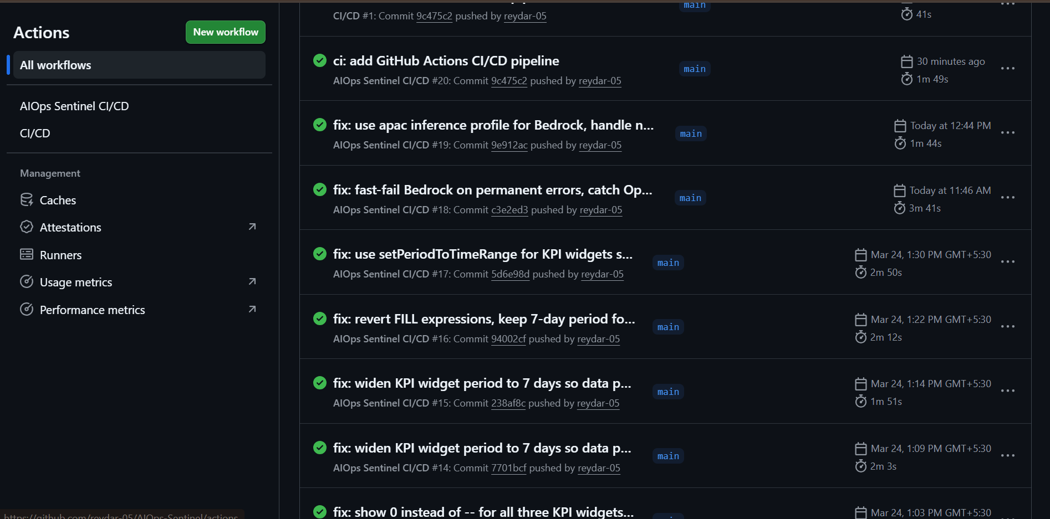
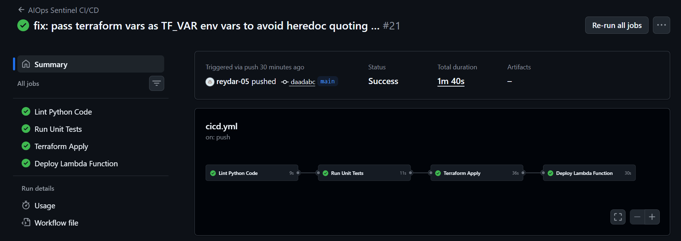
5.2 Automated Lambda Packaging — scripts/deploy_lambda.py
- Cleans previous build artefacts.
- Installs runtime dependencies to a temp directory.
- Copies all Lambda source modules (incident_processor, log_processor, ai_analyzer, notification_handler, ai/prompts) into a flat package.
- Creates a ZIP archive, excludes __pycache__.
- Deploys via aws lambda update-function-code and prints package size and HTTP status.
5.3 Infrastructure as Code — Terraform
- All AWS resources defined in HCL across 5 reusable modules.
- Remote state in versioned S3 bucket with environment-level key isolation.
- Default tags on all resources: Project, Environment, ManagedBy=Terraform, Owner.
- Sensitive variables (groq_api_key) marked sensitive=true to suppress plan/apply output.
- Module outputs (vpc_id, subnet_ids, lambda_role_arn, etc.) wired between modules in environments/dev/main.tf.
5.4 Automated Testing — tests/
10 unit tests across 3 files — all runnable locally without AWS credentials.
Test File | Tests | Coverage
test_local_lambda.py | 3 | CloudWatch alarm parsing / EC2 state-change parsing / invalid event handling
test_log_processor.py | 3 | Credential and IP redaction / log trimming with priority preservation / end-to-end processor
test_notifications.py | 4 | Block Kit structure / message content / severity colour mapping / full payload output

6. Security Implementation
6.1 IAM Least Privilege — terraform/modules/iam/main.tf
Lambda execution role uses a single inline policy with 10 tightly scoped statements. No statement uses Action: '*' or Resource: '*' for sensitive services.
Policy Statement | Actions Allowed | Resource Scope
CloudWatch Logs | CreateLogGroup, PutLogEvents, FilterLogEvents, GetLogEvents | All log groups (needed for log fetching)
EC2 Control | DescribeInstances, StartInstances, StopInstances, RebootInstances | All EC2 (auto-remediation)
Bedrock | InvokeModel, InvokeModelWithResponseStream | All foundation models + inference profiles
DynamoDB | PutItem, GetItem, UpdateItem, Query, Scan | aiops-incidents* tables only
S3 | PutObject, GetObject, ListBucket | aiops-log-archive* buckets only
Secrets Manager | GetSecretValue | aiops/* secrets only
SNS | Publish | aiops-* topics only
CloudWatch Metrics | GetMetricStatistics, DescribeAlarms, ListMetrics | All (read-only)
SQS (DLQ) | SendMessage, GetQueueAttributes | aiops-* queues only
X-Ray | PutTraceSegments, PutTelemetryRecords | All

6.2 Data Protection & Log Sanitisation
- All CloudWatch logs are sanitised (7 regex patterns) before being sent to Amazon Bedrock or any external provider — preventing credential leakage via AI prompts.
- S3 log archive has AES-256 server-side encryption and all public-access block settings set to true.
- Slack webhook URL stored in AWS Secrets Manager — never in environment variables, source code, or Terraform state in plaintext.
- GROQ_API_KEY marked sensitive in Terraform and never logged by Lambda.
6.3 Network Security
- EC2 instances deployed in private subnets — no direct internet access.
- ALB is the only public ingress point (HTTP/HTTPS from 0.0.0.0/0).
- EC2 security group allows inbound HTTP only from the ALB security group.
- Lambda uses IAM-authenticated AWS API calls for all service access — no VPC or NAT Gateway needed.
6.4 Threat Handling & Resilience
- SQS Dead Letter Queue (14-day retention) captures all Lambda invocation failures for replay and audit.
- X-Ray active tracing enables forensic analysis of latency spikes and unexpected errors.
- Bedrock permanent errors (ValidationException, AccessDeniedException) fast-fail without retry.
- All AI analysis failures fall back gracefully — the pipeline always completes with a HIGH-severity incident.
- DynamoDB write failures are logged and non-blocking — the Slack alert is never delayed.
- Secrets Manager 7-day recovery window prevents accidental permanent deletion.
7. Live End-to-End Test Evidence
CloudWatch log trace from a live Lambda invocation confirms the complete pipeline executes successfully in the AWS environment.
START RequestId: ee55a51f-9e7b-4643-83eb-00cc58def8bb
[INFO] AIOps Sentinel triggered | requestId: ee55a51f-...
[INFO] Incident parsed: b30e0e29-f7c5-469f-ba43-73fc75812424 | type: CLOUDWATCH_ALARM
[INFO] Log processing complete | error_type: HIGH_CPU
[INFO] Starting AI analysis for incident: b30e0e29-...
[INFO] Bedrock invoke attempt 1/3 | model: apac.amazon.nova-lite-v1:0
[INFO] Bedrock response received -- 1189 chars
[INFO] AI analysis via Bedrock complete
[INFO] AI analysis complete | severity: HIGH | confidence: MEDIUM
[INFO] Incident saved to DynamoDB: b30e0e29-f7c5-469f-ba43-73fc75812424
[INFO] Slack alert sent successfully
[INFO] Pipeline complete for incident: b30e0e29-f7c5-469f-ba43-73fc75812424
REPORT Duration: 2059 ms | Memory used: 92 MB / 512 MB
END RequestId: ee55a51f-9e7b-4643-83eb-00cc58def8bb

Invoke command: aws lambda invoke --function-name aiops-incident-processor-dev --region ap-south-1 --payload file://tests/fixtures/lambda_test_event.json --cli-binary-format raw-in-base64-out response.json
Response: {"statusCode": 200, "incident_id": "b30e0e29-...", "severity": "HIGH"}
8. Key Resource Inventory
Resource Type | Name / ID | Region
Lambda Function | aiops-incident-processor-dev | ap-south-1
SNS Topic | aiops-alerts-dev | ap-south-1
DynamoDB Table | aiops-incidents-dev | ap-south-1
S3 Log Archive | aiops-log-archive-dev | ap-south-1
SQS Dead Letter Queue | aiops-lambda-dlq-dev | ap-south-1
Secrets Manager | aiops/slack/webhook | ap-south-1
CloudWatch Dashboard | AIOps-Sentinel-dev | ap-south-1
Auto Scaling Group | aiops-asg-dev | ap-south-1
Terraform State Bucket | aiops-terraform-state-652197206400 | ap-south-1
CW Log Group | /aws/lambda/aiops-incident-processor-dev | ap-south-1
Bedrock Model | global.anthropic.claude-haiku-4-5-20251001-v1:0 | Global
GitHub Repository | github.com/reydar-05/AIOps-Sentinel | --

