MA223 Styles

Engineering Statistics I (MA223)

Insert Author 1, Insert CM Box #

Insert Author 2 or delete line

Insert Author 3 or delete line

# Level 1 Heading

This is normal text.

This is text in a block quote.

## Level 2 Heading

Here is an R code chunk.

summary(cars)

speed dist   
 Min. : 4.0 Min. : 2.00   
 1st Qu.:12.0 1st Qu.: 26.00   
 Median :15.0 Median : 36.00   
 Mean :15.4 Mean : 42.98   
 3rd Qu.:19.0 3rd Qu.: 56.00   
 Max. :25.0 Max. :120.00

## Problem Delimiter

This is text that should serve as a problem statement. It might include lists, such as

* item 1
* item 2

It might also include some equations

$$y_{i}=β_{0}+β_{1}x_{i}+ϵ_{i}$$

And, it will probably end with ordinary text.

### Level 3 Header; Part Delimiter

This would be more text to introduce the problem statement.

This is where the solution would be placed, which will probably include R code

qplot(data = cars,  
 x = speed,  
 y = dist,  
 xlab = "Speed of Car (mph)",  
 ylab = "Stopping Distance (ft)")

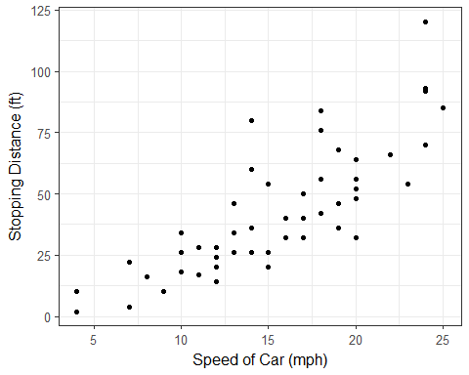

**SOLUTION**: This would be my solution to the problem. This might include some general explanation.

> # Solution Code which is included here, with prompts and comments, to denote it.  
> fit <- lm(dist ~ speed, data = cars)  
> tidy(fit)

## term estimate std.error statistic p.value  
## 1 (Intercept) -17.579095 6.7584402 -2.601058 1.231882e-02  
## 2 speed 3.932409 0.4155128 9.463990 1.489836e-12