Mario Reyes

Professor Burroughs

BIO 307 A

07 June 2024

Plant Phylogeny Lab

### Chara sequence:

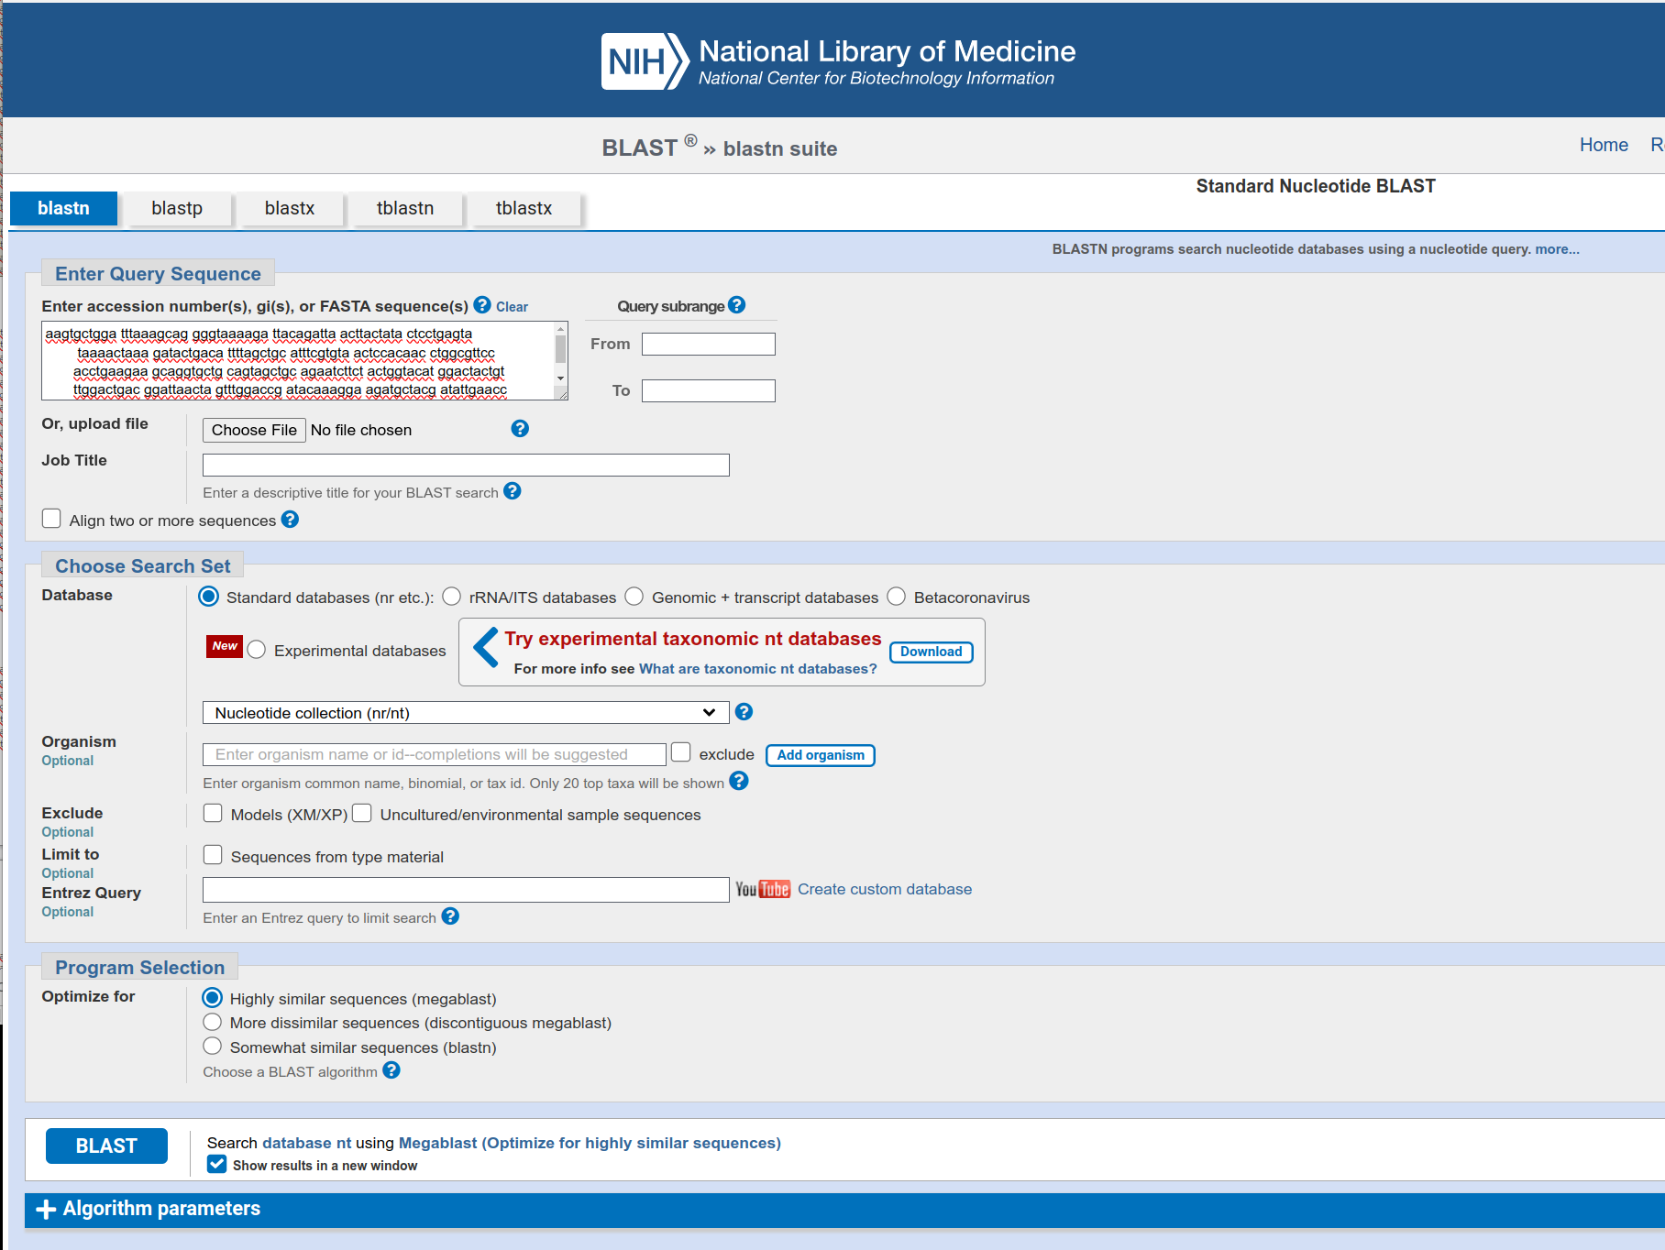

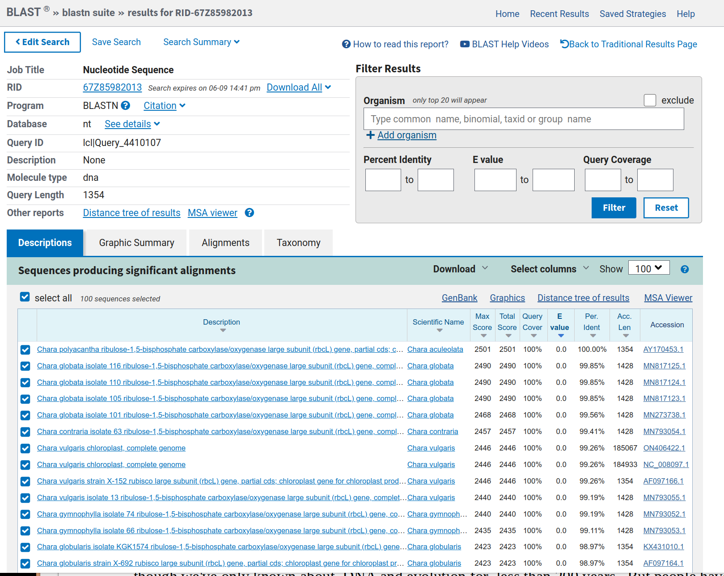Results for Chara

|  |  |  |
| --- | --- | --- |
| **Binomial Scientific Name** | **Percent Identical** | **E Value** |
| Chara acuelolata | 100 | 0.0 |
| Marchantia polymorpha | 100 | 0.0 |

