EV Mid-Range Market Analysis
Positioning, Pricing & Launch Strategy for a New Mid-Range EV ($35K–$55K)
November 2026 | Confidential — Internal Use Only

DATA SOURCES
- ev_market_2026.csv — Synthetic Kaggle dataset (2,000 EV models/variants, 20 brands, 2020–2026)
- Global EV Market 2025–2026: Mid-Range Segment Analysis and Launch Strategy (external research report)
- Computed aggregations from dataset: avg price/rating by segment, rating by range band, top brands by sales, avg charging speed

CONFIDENCE LABELING RULE
Label | Criteria
HIGH | Corroborated by two or more independent sources (e.g., Quick Research report + dataset pattern, or multiple external citations)
MEDIUM | Supported by a single credible source, or by the synthetic dataset alone
LOW | Early signal, speculative, or based on data with known quality issues (e.g., inflated synthetic totals)

Executive Summary
Strategic question: How should a new mid-range EV ($35K–$55K) be positioned, priced, and where should it launch to maximize success?

This analysis synthesizes external market research and synthetic dataset patterns to guide positioning, pricing, and launch market decisions for a new mid-range EV. Evidence is labeled throughout as Dataset (directional patterns only, not real figures) or Quick Research (external market research). Confidence levels are applied per the rule above.
KEY FINDINGS
Finding | Rationale | Confidence
Europe-first launch | EU EV sales grew +30% in 2025, projected +20% in 2026; CO₂ mandates provide structural tailwind unavailable in North America. | HIGH
Price at $35K–$42K | The Equinox EV and repriced Ioniq 5 have reset the mid-range value floor. Tax credit repeal in the US makes lower pricing essential. | MEDIUM
≥300 miles of range | Dataset shows a 0.24-point rating uplift per range band step. Corroborated by competitive set where 300+ mi is now table stakes. | HIGH
Fast charging >150 kW | Dataset shows mid-range averages 140.4 kW vs. luxury at 195.7 kW. Exceeding 150 kW would close gap to premium at lower price point. | MEDIUM

Section 1: Competitive Landscape

1.1 Tesla vs. BYD — The Defining Rivalry
Source: Quick Research — multiple external citations
CONFIDENCE: HIGH
- 2025: BYD overtook Tesla as the world's largest EV seller with ~3.97 million plug-in sales (~19% global share). Tesla delivered 1.64 million vehicles (−8.5% YoY).
- 2026: Market leadership seesaws quarterly. Tesla led Q1 (358,023 BEVs), BYD reclaimed Q2 (~557,090 BEVs), Tesla's Q3 reached 486,532 units.
- Full-year 2026 consensus: BYD ~2.4M BEVs vs. Tesla ~1.65M deliveries.

1.2 Other Key Players
Source: Quick Research — multiple external citations
CONFIDENCE: HIGH
- Hyundai Motor Group: ~575,000 EVs in H1 2026 (+19% YoY), 3.6% global share.
- Volkswagen Group: Top EV seller in Europe, but European share fell from 26.5% → ~15%, under pressure from Chinese brands.
- Stellantis: Took a €22B reset charge; significant EV portfolio restructuring underway.
- General Motors: EV sales fell 43% in 2026; pulling back from earlier aggressive EV targets.

1.3 Mid-Range Competitive Set ($35K–$55K)
Source: Quick Research
CONFIDENCE: HIGH
Model | Base MSRP | EPA Range | Key Differentiator
Chevrolet Equinox EV | ~$34,995 | 319 mi | Lowest price with 300+ mi range
Tesla Model 3 | $38,630 | 298 / 363 mi | Best efficiency; Supercharger network
Tesla Model Y | $39,990 | 321 mi | Best-selling EV globally; crossover versatility
Hyundai Ioniq 5 | ~$35,000 | 318 mi | 800V charging; V2L; US-built; repriced 2026
Kia EV6 | ~$42,900 | 319 mi | 800V ultra-fast charging (10–80% in ~18 min)
Volkswagen ID.4 | $45,095 | 291 mi | Spacious interior; heritage brand
BYD Atto 3 / Seal | Not sold in US | N/A | Blocked by 100% tariffs; highly competitive globally

Key takeaway: 300+ miles of range is now table stakes in this segment. The Equinox EV and repriced Ioniq 5 have reset the value floor at ~$35K.

1.4 Dataset Pattern — Brand Sales Volume Ranking
Source: Dataset — ev_market_2026.csv
CONFIDENCE: LOW Sales totals are inflated synthetic sums, not real-world figures
Tesla, BYD, and Volkswagen rank as the top three brands by total annual_sales_units in the synthetic dataset. However, these cumulative sums are synthetic artifacts (e.g., Tesla shows ~101M units). The directional ranking aligns with real-world patterns but absolute magnitudes are not meaningful and should not be cited as market data.

Section 2: Key Trends & Signals

2.1 Sales Growth
Source: Quick Research — multiple external citations
CONFIDENCE: HIGH
- 2025: Global EV sales grew ~20–21% YoY to an estimated 20–21.6M units (note: estimates vary — see Section 6: Data Quality Notes).
- 2026 YTD: Growth moderating to 3–6% YoY through mid-year, though Q2 saw a 24% BEV surge.
- IEA projects EVs will reach 29% of global car sales by end of 2026.

2.2 Regional Dynamics
Source: Quick Research — multiple external citations
CONFIDENCE: HIGH
Region | 2025 Performance | 2026 Outlook | Launch Attractiveness
Europe | Sales +30% YoY; 28% of total sales | Projected +20% YoY; 1 in 3 cars electric | ⭐ STRONGEST — EU CO₂ standards provide structural tailwind
China | 12.8M NEV units; ~55% penetration | Approaching 60% penetration | LARGE VOLUME — brutal price competition (BYD cuts up to 34%)
North America | ~10% of car sales; fell 4% in 2025 | Down ~25% YTD through April 2026 | ⚠️ WEAKEST — $7,500 tax credit repealed; 100% tariffs on Chinese EVs

2.3 Pricing Signals
Source: Quick Research
CONFIDENCE: MEDIUM Individual OEM pricing moves from single-source reporting
- Hyundai cut Ioniq 5 prices by $7,600–$9,800 to compete at the ~$35K floor.
- Tesla raised Model Y prices by $1,000 in mid-2026, signaling pricing confidence at the $40K+ level.
- In China, BYD's Seagull dropped to ~$7,700 — extreme discounting compresses margins industry-wide.

Section 3: Dataset Deep-Dive
All analyses in this section are computed from ev_market_2026.csv (synthetic dataset). Confidence is capped at Medium for dataset-only claims. Directional patterns only — not real-world figures.

3a. Average Price & Customer Rating by Market Segment
Source: Dataset — ev_market_2026.csv
CONFIDENCE: MEDIUM
Segment | Avg Price (USD) | Avg Customer Rating | Model Count
Budget | $29,321 | 3.45 | 151
Mid-range | $50,689 | 3.53 | 642
Premium | $81,102 | 3.55 | 712
Luxury | $127,340 | 3.70 | 495

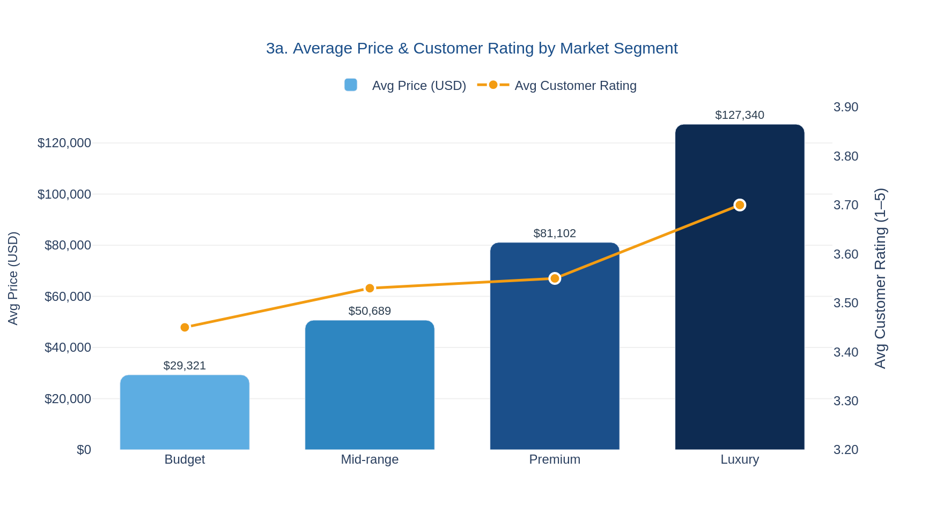
Figure 3a: Average Price (USD) and Customer Rating by Market Segment | Source: ev_market_2026.csv (synthetic)
▶ Insight: The rating gap between Mid-range (3.53) and Premium (3.55) is negligible — mid-range buyers can be satisfied without premium pricing if the right specs are delivered.

3b. Average Customer Rating by Range Band
Source: Dataset — ev_market_2026.csv + Quick Research (range as table stakes)
CONFIDENCE: HIGH Dataset pattern corroborated by competitive set research
Range Band | Avg Customer Rating | Model Count
Under 250 mi | 3.40 | 863
250–350 mi | 3.64 | 870
Over 350 mi | 3.88 | 267

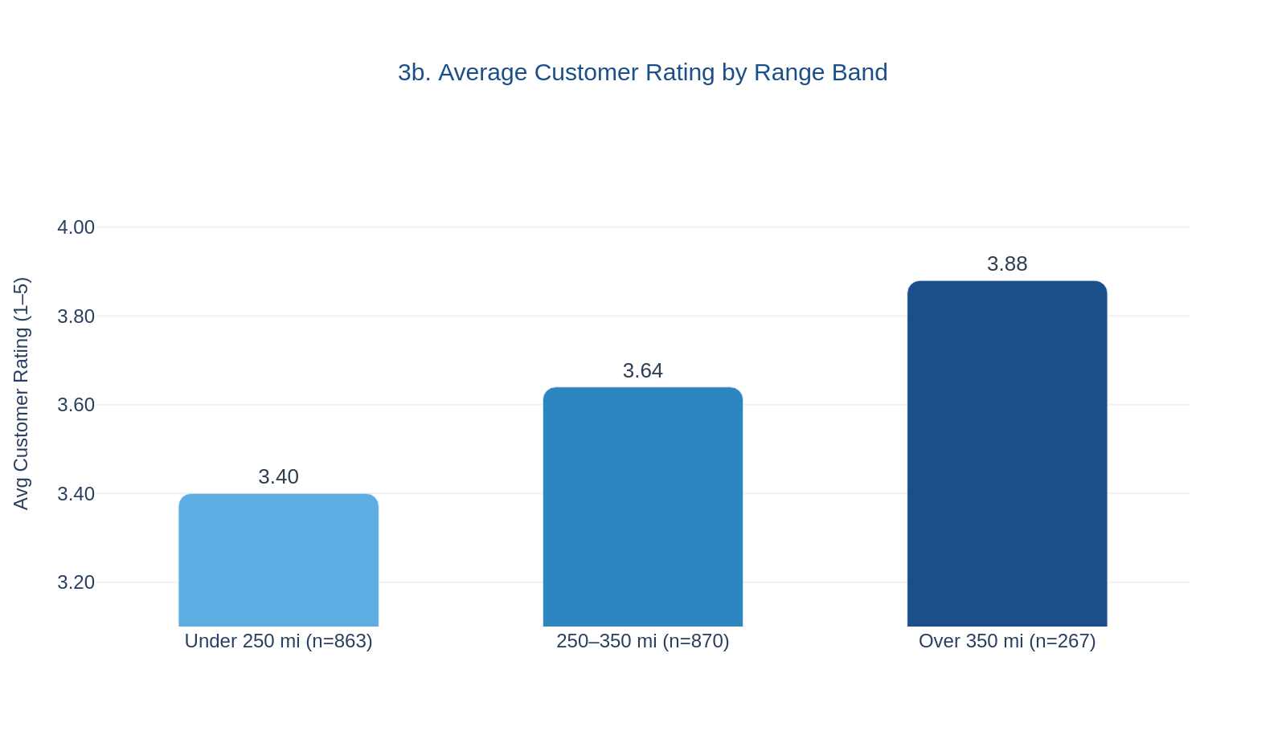
Figure 3b: Average Customer Rating by Range Band | Source: ev_market_2026.csv (synthetic)
▶ Insight: Clear monotonic relationship — each step up in range band adds ~0.24 rating points. A new entrant should target ≥300 miles to compete on customer satisfaction.

3c. Top 5 Brands by Total Annual Sales Units
Source: Dataset — ev_market_2026.csv
CONFIDENCE: LOW Totals are inflated synthetic sums — directional ranking only
Rank | Brand | Total Annual Sales Units*
1 | Tesla | 101,459,482
2 | BYD | 50,472,617
3 | Volkswagen | 48,186,657
4 | Kia | 16,612,129
5 | Hyundai | 15,223,045
* These are synthetic cumulative sums across all model-year-variant rows and do NOT represent real-world sales volumes.
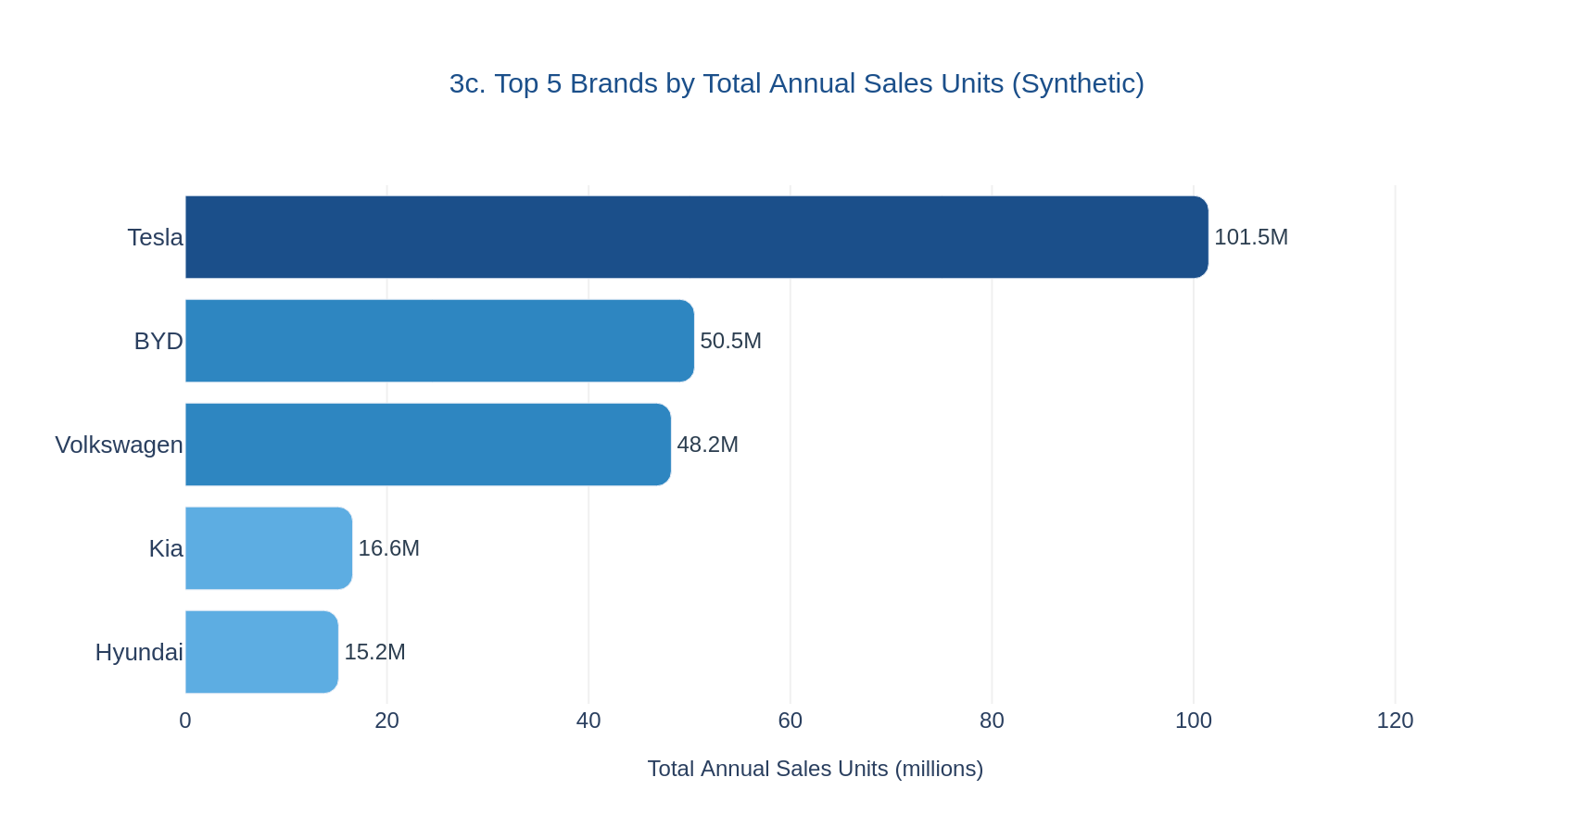
Figure 3c: Top 5 Brands by Total Annual Sales Units (synthetic sums) | Source: ev_market_2026.csv
▶ Insight: Directional ranking (Tesla > BYD > VW) aligns with real-world market leadership. Korean duo (Kia + Hyundai combined: ~31.8M) would rank second if aggregated.

3d. Average Charging Speed (kW) by Market Segment
Source: Dataset — ev_market_2026.csv
CONFIDENCE: MEDIUM
Segment | Avg Charging Speed (kW) | vs. Mid-range | Model Count
Budget | 127.7 kW | −12.7 kW | 151
Mid-range | 140.4 kW | — | 642
Premium | 146.3 kW | +5.9 kW | 712
Luxury | 195.7 kW | +55.3 kW | 495

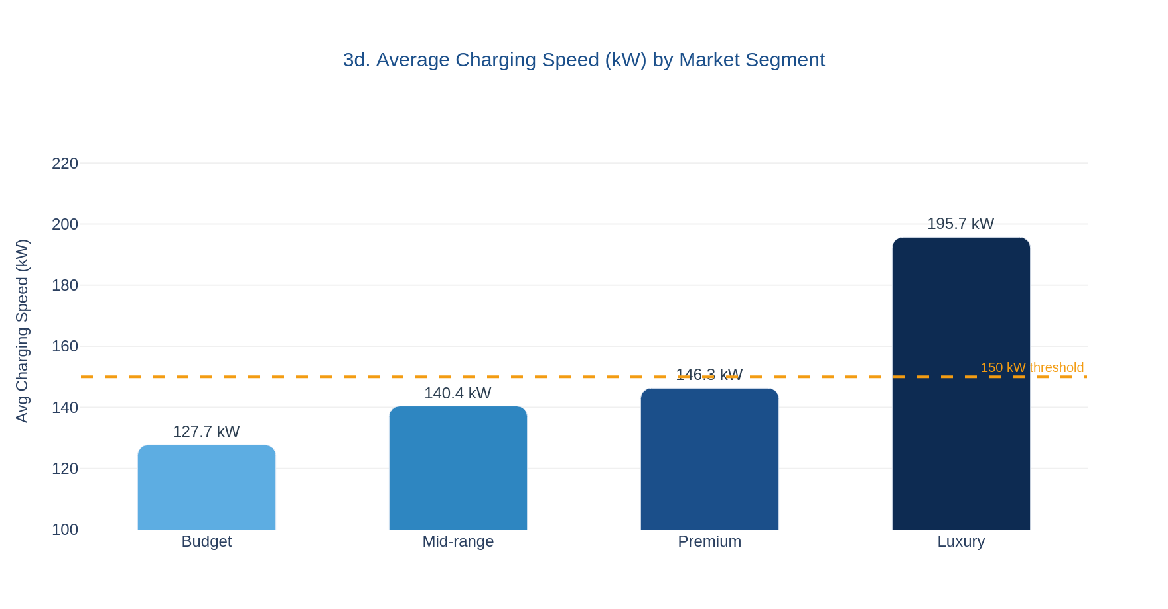
Figure 3d: Average Charging Speed (kW) by Market Segment | Source: ev_market_2026.csv (synthetic). Dashed line = 150 kW threshold.
▶ Insight: Luxury averages 195.7 kW — 40% above mid-range (140.4 kW). Offering >150 kW in a mid-range vehicle would close the gap to premium at significantly lower price, potentially differentiating on a spec that luxury buyers already expect.

Section 4: Opportunities & Risks

4.1 Opportunities
Opportunity | Evidence | Confidence
Europe-first launch | EU EV sales +30% in 2025, projected +20% in 2026; CO₂ standards provide structural tailwind. Source: Quick Research — multiple citations. | HIGH
Value positioning at $35K–$42K | Equinox EV & Ioniq 5 repricing prove demand at this floor; tax credit loss makes lower pricing essential. Source: Quick Research. | MEDIUM
300+ mi range + fast charging | Dataset shows rating uplift per range band; corroborated by 800V architecture in competitive set. Source: Dataset + Quick Research. | HIGH
Battery cost declines (~$115/kWh) ⚠️ 2024 data | Pack prices fell to ~$115/kWh by 2024, enabling 300+ mi at affordable price points. Timeliness risk: current 2026 figure may be lower. Source: Quick Research — single data point. | MEDIUM
Competitors retreating | Stellantis €22B reset; GM 43% EV sales drop creates white space. Source: Quick Research. | MEDIUM

4.2 Risks
Risk | Evidence | Confidence
US policy headwinds — tax credit repeal + tariffs | $7,500 credit terminated Oct 2025; BloombergNEF cut 14M cars from US projections through 2030. Source: Quick Research — multiple citations. | HIGH
China price war compresses margins | BYD cuts up to 34%; dozens of domestic brands competing aggressively. Source: Quick Research — multiple citations. | HIGH
Growth deceleration globally | 2026 headline growth only 3–6% YTD vs. 21% in 2025. YTD data; full year may differ. Source: Quick Research. | MEDIUM
Tesla brand + Supercharger moat | Model Y dominates on brand loyalty and charging infrastructure in Western markets. Source: Quick Research. | MEDIUM
BYD North American manufacturing via Mexico | Early reports of BYD exploring Mexico manufacturing to circumvent tariff barriers. Source: Quick Research — early reports. | LOW

Section 5: Strategic Recommendation
Based on the synthesis of external market research and dataset patterns, the following four strategic recommendations are proposed for positioning, pricing, and launching a new mid-range EV:
# | Recommendation | Supporting Evidence | Confidence
1 | Price toward $35K–$42K | Quick Research: Equinox EV & Ioniq 5 repricing prove demand at this floor; tax credit repeal makes lower pricing essential. Dataset: mid-range segment avg $50,689 (upper end to avoid). | HIGH
2 | Deliver ≥300 miles of range (table stakes) | Dataset: each range band step adds ~0.24 customer rating points. Quick Research: 300+ mi is now the entry requirement for the competitive set. | HIGH
3 | Differentiate on fast-charging (>150 kW) and software/ADAS | Dataset: mid-range avg is 140.4 kW; exceeding 150 kW closes gap to premium. Note: dataset shows charging speed varies by segment but does not demonstrate it drives ratings or sales. | MEDIUM
4 | Launch Europe first, then China; North America timed to regulatory clarity | Quick Research: Europe +30%/+20% growth with CO₂ tailwinds; North America down ~25% YTD. Sequencing is strategic judgment, not purely data-driven. | MEDIUM

Section 6: Data Quality Notes
This section flags known data quality issues that leadership should consider when interpreting the analysis.

6.1 Synthetic Dataset Discrepancies (ev_market_2026.csv)
Issue | Detail
Segment distribution mismatch | Kaggle description states Budget = 25% and Mid-range = 40% of records. Actual data shows Budget = 151 records (7.6%) and Mid-range = 642 records (32.1%) — significantly underweight on Budget. Segment-level conclusions should be treated with caution.
Customer rating mismatch | Kaggle description states an average customer rating of ~4.2. Actual computed averages range from 3.40 (Under 250 mi band) to 3.88 (Over 350 mi band), with segment averages of 3.45–3.70. No segment or band reaches 4.2.
Inflated sales totals | The annual_sales_units field produces cumulative sums in the tens of millions per brand (e.g., Tesla ~101M). These are synthetic artifacts of summing across all model-year-variant rows. Use only for directional ranking, never for magnitude comparisons.

6.2 External Research Source Conflicts
2025 global EV sales estimates vary across sources: The research report cites figures of ~20M, ~20.7M, and ~21.6M units depending on the source (IEA, BloombergNEF, industry trackers). This ~8% spread reflects differences in methodology — BEV-only vs. BEV+PHEV definitions, calendar-year cutoffs, and regional reporting lags. We use the range "20–21.6M" throughout to acknowledge this uncertainty.

6.3 Timeliness Flags
Battery pack cost (~$115/kWh): This figure is sourced from 2024 data. Battery costs have continued to decline, and the current 2026 figure may be materially lower. Treat as a conservative upper bound for cost modeling purposes.

Appendix: Methodology

Confidence Labeling
Confidence labels are applied per the rule stated on the cover page: High = two or more independent sources corroborate the claim; Medium = single credible source or synthetic dataset alone; Low = early signal, speculative, or data with known quality issues.

Dataset
ev_market_2026.csv is a synthetic Kaggle dataset containing 2,000 EV model/variant rows across 20 brands for the years 2020–2026. Fields include: price_usd, market_segment, range_miles, charging_speed_kw, annual_sales_units, and customer_rating. All figures derived from this dataset are directional patterns only and should not be cited as real-world market data.

External Research
External market findings are sourced from the report "Global EV Market 2025–2026: Mid-Range Segment Analysis and Launch Strategy," which cites primary sources including IEA Global EV Outlook 2026, BloombergNEF Electric Vehicle Outlook, and publicly reported OEM delivery figures.

