Market Intelligence Research Brief
Student Name: Rhyah Austrie Reyes
Date: November 4, 2026
Topic/Company: Global EV market, positioning, pricing, and launch strategy for a new mid-range EV

1. Research Objective
Briefly describe the business question or decision this market intelligence is intended to support.
Objective: This brief supports one decision. An EV maker wants to launch a new mid-range EV priced between $35K and $55K in 2026 to 2027, and leadership needs to know where to launch it first, how to price it, what range and charging speed it needs to compete, and how much weight each of those recommendations can carry.

2. Scope of Research
Define what was included and excluded in this research.
- Markets or industries covered: The research covers the global EV market, with most attention on Europe, China, and North America. Within that, it looks at mid-range passenger EVs priced between $35K and $55K and compares them on price, range, charging speed, customer ratings, sales, and market segment. It excludes luxury models above $55K, self-driving and software features, supply chain and manufacturing costs, willingness-to-pay modeling, and country-by-country detail within Europe.
- Competitor types included: The research includes the major carmakers selling EVs at scale, namely Tesla, BYD, Volkswagen, Hyundai and Kia, GM through Chevrolet, and Stellantis. Direct competitors are the real mid-range models these companies sell: the Tesla Model 3 and Model Y, BYD Atto 3 and Seal, Hyundai Ioniq 5, Kia EV6, VW ID.4, and Chevrolet Equinox EV. Luxury and performance brands, start-ups outside the price band, and dealers or retailers are not included.
- Timeframe considered: The external research uses full-year 2025 results and 2026 year-to-date figures, from sources published between early 2025 and October 2026. The Kaggle dataset, ev_market_2026.csv, covers model years 2020 to 2026.
- Key constraints (e.g., limited research hours): Quick Research hours were limited, so the external research was done in a single run in Fast mode. The internal dataset is synthetic. It was generated for Kaggle and has 2,000 records, so its numbers are only useful for spotting patterns. Its own description says the generator was built so that customer rating strongly correlates with range, which matters later in this brief. No consumer research was available, such as surveys or conjoint studies.

3. Research Approach
Summarize how AI-assisted research was conducted.
- Types of questions asked: The questions fell into four groups. The first was about competitors, meaning which real models sit in the mid-range and how they are priced. The second focused on the market: which regions are growing or slowing, and which policy changes or price wars could affect a launch. The third focused on the dataset: which specs and segments align with higher customer ratings. The last group checked the work, asking where the dataset and the external research agree or disagree and which insights were rated too confidently. The exact prompts are listed in Appendix A.
- How research effort was prioritized: I started with the external market picture in Quick Research, then had the agent calculate figures directly from the CSV, then compared the two, and finished with a skeptical review of each insight. To save research hours, I ran Quick Research only once in Fast mode, with one detailed objective covering five sub-questions. I set preferred sources such as the IEA, Reuters, Bloomberg, Rho Motion, EV Volumes, and CNBC, told it to avoid social media, forums, and blogs, and linked the dataset as a Quick asset. I also revised the research plan twice. The first draft had pulled competitor names from the synthetic dataset, including a "BYD Leaf 50X" that does not exist, the luxury Audi e-tron GT, and the Ford F-150 Lightning pickup, so I replaced them with the real mid-range models. The second revision asked for BEV and PHEV figures to be reported separately, gave China and Europe equal priority over North America, and asked for manufacturer and car press sources instead of Wikipedia for pricing.
- Tools used within Amazon Quick Suite: I used three Quick Suite tools. The EV Market Intelligence Space holds the dataset and every deliverable. The Market Intelligence Agent – EV Market chat agent uses that Space as its knowledge source, and its instructions tell it to say whether each piece of evidence comes from the dataset or from Quick Research, to rate confidence as High, Medium, or Low, and to say so when the data cannot answer a question. Quick Research produced the report Global EV Market 2025–2026: Mid-Range Segment Analysis and Launch Strategy, which cites 46 sources. The agent then produced the Market Analysis, the dataset tables and charts, the Reliability Evaluation, and this brief.
The Space is available at https://us-west-2.quicksight.aws.amazon.com/sn/account/UdacityQuicksightLab/spaces/cdcc1bad-b271-454a-8159-c102c86fb649.
You can open the agent at https://us-west-2.quicksight.aws.amazon.com/sn/account/UdacityQuicksightLab/embed/share/accounts/548602084193/chatagents/505534c8-a77a-441c-8f6c-e4fdeceebb42, and screenshots of all work are in the screenshots folder of this submission.

4. Key Market Insights
List 3–5 synthesized insights relevant to leadership decision-making.

Insight 1: Launch Europe first
- Insight Summary: Europe is the best place to launch a new mid-range EV. EV sales there grew about 30% in 2025 and are expected to grow another 20% in 2026, and EU CO₂ rules keep pushing carmakers toward electric. North America is the weakest market. Sales there were down about 25% in early 2026 after the $7,500 federal tax credit ended.

- Supporting Evidence or Signals: According to the Quick Research report, which draws on the IEA Global EV Outlook 2026 and BloombergNEF, EU EV sales rose 30% in 2025 and are projected to rise 20% in 2026, and about one in three new cars sold in Europe this year will be electric. EU fleet CO₂ standards give that demand a floor. In North America, EV sales fell about 4% in 2025 and were down about 25% through April 2026. The federal credit ended after September 30, 2025, and BloombergNEF has cut 14 million EVs from its US forecast through 2030. China is the biggest market, with EVs at about 55% of new car sales in 2025 and heading toward 60%, but BYD has cut prices by as much as 34%, according to CNBC. The dataset has no regional information, so it cannot support or contradict this insight.

- Why This Insight Matters: Europe combines strong growth with policies that are already law. In North America, the policy reversal makes the next couple of years harder. China offers volume, but its price war leaves little margin for a new entrant without scale.

Insight 2: Price at $35K–$42K
- Insight Summary: The Chevrolet Equinox EV at about $34,995 and the repriced Hyundai Ioniq 5 SE at about $35,000 have pushed the mid-range starting price down. Now that the US tax credit is gone, a new model needs to sit in the lower part of the band, between $35K and $42K, to stay competitive.

- Supporting Evidence or Signals: Quick Research found the Equinox EV at about $34,995 with 319 miles of range, according to KBB. Hyundai cut Ioniq 5 prices by $7,600 to $9,800, so the SE trim now starts at about $35,000, and Tesla raised Model Y Premium prices by $1,000 in mid-2026 to $45,990 for rear-wheel drive and $49,990 for all-wheel drive, according to CNBC. In the dataset, mid-range models average $50,689 across 642 models, with prices from $35,072 to $64,953, so a $35K to $42K price sits in the lower part of the segment. One signal conflicts. The report also lists the Ioniq 5 at $43,975 for the SR trim, which means the $35K price only applies to the base trim.

- Why This Insight Matters: The price floor in this segment has moved down. A model priced above $42K without a clear advantage is likely to lose buyers to the Equinox EV and the Ioniq 5. Because the $35K price only applies to one trim, though, the real competitive range may be wider than it first looks.

Insight 3: ≥300 miles of range is table stakes
- Insight Summary: Five of the six real mid-range competitors offer more than 300 miles of EPA range, so buyers can now expect about 300 miles as standard. The dataset also shows ratings rising with range, but that pattern was built into the synthetic data on purpose.

- Supporting Evidence or Signals: According to manufacturer sites, MotorTrend, and KBB, the Equinox EV gets 319 miles, the Model 3 Long Range 363, the Model Y 321, the Kia EV6 319, and the Ioniq 5 318. Only the VW ID.4, at 291 miles, falls short. In the dataset, the average customer rating is 3.40 for models under 250 miles, 3.64 for 250 to 350 miles, and 3.88 for over 350 miles, with a Pearson correlation of 0.67 between range and rating. The Kaggle description says the generator was built so that customer rating strongly correlates with range, so this correlation does not count as independent evidence.

- Why This Insight Matters: A car with less than about 300 miles of range would be behind every major competitor except the ID.4. That makes 300 miles a basic engineering requirement rather than something that sets the car apart.

Insight 4: Fast charging (>150 kW) as a differentiator
- Insight Summary: Mid-range EVs in the dataset charge at an average of 140.4 kW, compared with 195.7 kW for luxury models. Offering more than 150 kW could close the gap with premium cars without a premium price. The data shows that charging speed differs by segment, but it doesn’t show that faster charging leads to better ratings or more sales.

- Supporting Evidence or Signals: In the dataset, average charging speed is 127.7 kW for budget models, 140.4 kW for mid-range, 146.3 kW for premium, and 195.7 kW for luxury. Charging speed and rating correlate at 0.45, but once range is accounted for, charging speed matters about half as much. Quick Research shows that the Kia EV6 and Hyundai Ioniq 5 use 800V systems that charge from 10% to 80% in about 18 minutes, which reviewers at Tom's Guide and autoevolution describe as a real advantage.

- Why This Insight Matters: The gap between segments is real, and 800V charging is becoming a selling point. Before investing in charging above 150 kW, though, the company needs evidence of what buyers actually want, and this analysis doesn't provide it.

5. Visual Evidence (Optional but Recommended)
Reference any charts, dashboards, or visualizations used to support the insights.
- Chart Type: Chart 1 is a column chart titled Average Customer Rating by Range Band. Chart 2 combines columns for average price with a line for average customer rating, and is titled Average Price & Customer Rating by Market Segment. The Market Intelligence Agent built both directly from ev_market_2026.csv.

- What the visualization shows: Chart 1 shows the average rating rising from 3.40 for models under 250 miles to 3.64 for 250 to 350 miles, and 3.88 for those over 350 miles. Chart 2 shows average price climbing steeply from $29,321 for budget models to $127,340 for luxury models, while ratings only rise from 3.45 to 3.70. Mid-range models score 3.53 and premium models 3.55, almost the same even though premium models cost $30K more.

- How it supports the insight: Chart 1 supports Insight 3 visually, but because the link between range and rating was built into the data, it shows a pattern in the dataset rather than proof of buyer behavior. Chart 2 supports Insight 2. Mid-range cars in the dataset are rated about the same as premium cars, which suggests a lower price does not have to mean less satisfied buyers. Both rating axes start at 3.0 instead of 0, which makes the differences look bigger than they are. The spread in Chart 1 is only 0.48 points on a five-point scale.
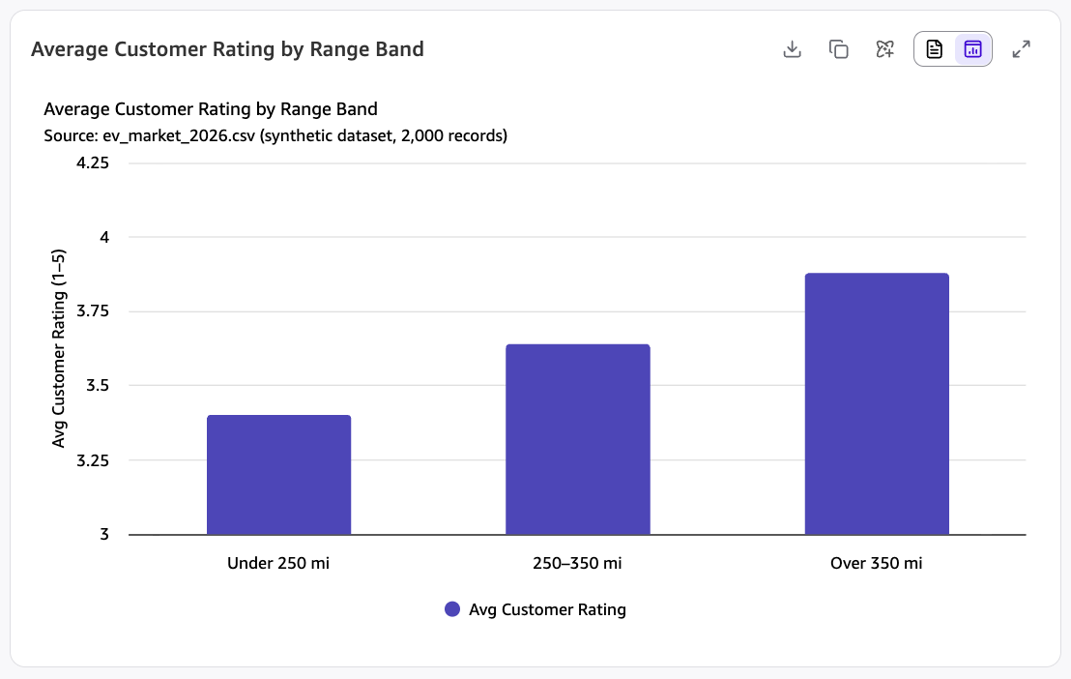
Chart 1. Average Customer Rating by Range Band, generated by the Market Intelligence Agent from the synthetic ev_market_2026.csv dataset.
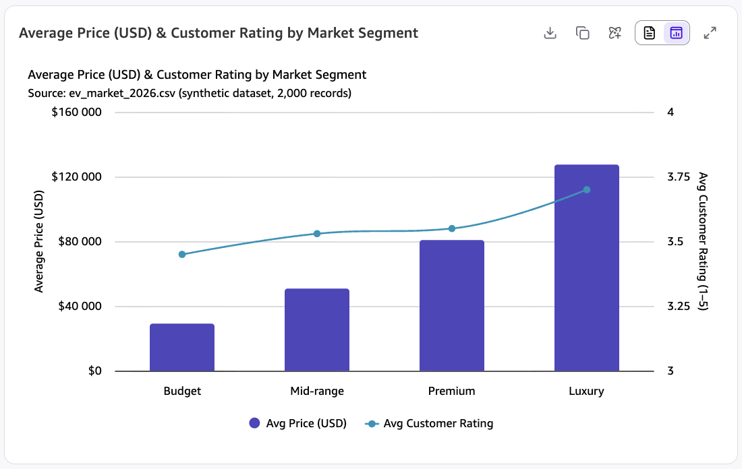
Chart 2. Average Price & Customer Rating by Market Segment, generated by the Market Intelligence Agent from the synthetic ev_market_2026.csv dataset.

6. Confidence Assessment
Evaluate the reliability of the insights using the criteria below.
- Source quality: The external evidence comes from a Quick Research report that cites 46 sources, mostly the IEA, BloombergNEF, reporting from Reuters, Bloomberg, and CNBC, and manufacturer websites. A few weaker sources such as Wikipedia and Motley Fool also appear, but none of the key figures depend on them. The internal evidence comes from a synthetic Kaggle dataset. It is useful only for patterns, and its documentation does not match the data inside it.

- Consistency across sources: The external sources agree on the overall direction. Europe is growing, North America is shrinking, China is in a price war, and 300 miles of range is now standard. Some figures differ. Estimates of 2025 global EV sales run from 20 million to 21.6 million depending on the source, and the Ioniq 5 appears at both about $35K for the SE and $43,975 for the SR. The dataset's range and rating pattern lines up with the external research only because it was designed that way.

- Timeliness of information: The external sources were published between 2025 and October 2026, including the IEA Global EV Outlook 2026 and third-quarter 2026 delivery figures, and I collected them on November 4, 2026. One figure is out of date. The battery pack price of about $115 per kWh comes from 2024. The synthetic dataset has no real collection date.

- Overall confidence level: Medium. All four insights are rated Medium. In this brief, High means at least two independent sources back the claim, Medium means it rests on one credible type of source or on the synthetic dataset alone, and Low means it is speculative or based on data with known problems. The table below breaks this down by insight.

Insight | Source Quality | Consistency Across Sources | Timeliness | Confidence
1. Launch Europe first | Strong. Several external sources, including the IEA and BloombergNEF, but nothing in the dataset | No conflicts on Europe's direction, only small differences in global 2025 totals | Current, using 2025 results, 2026 year-to-date figures, and EU rules already in force | Medium. The data is strong, but choosing a launch order is a judgment call
2. Price at $35K–$42K | Moderate. Two carmaker price points, and the dataset is synthetic | Partial. The Ioniq 5 shows two prices, and the dataset average of $50.7K is above the target | Current, using 2025 and 2026 prices | Medium. Limited evidence, and one section had wrongly rated it High before it was corrected
3. ≥300 mi table stakes | Mixed. EPA ranges are facts, but the dataset correlation was built in | The two sources seem to agree, but only because the dataset was designed that way | Current, using 2025 and 2026 model years | Medium. In practice, it rests on one type of source
4. Fast charging >150 kW | Moderate. The segment gap is clear, and 800V is cited as a feature | Partial. Neither source shows that charging speed drives purchases | Current, from 2025 and 2026 | Medium. The link to sales is assumed, not proven

7. Limitations and Risks
Document known gaps, assumptions, or areas of uncertainty.
- Missing data: There is no consumer research, such as surveys or willingness-to-pay studies, so none of the insights have direct evidence of what buyers value. There is no margin or cost model behind the $35K to $42K price, the dataset has no regional breakdown, and there is no data on how sensitive buyers are to price. The dataset's sales totals are also inflated. Tesla adds up to about 101 million units because the figure sums every model, year, and trim, compared with 1.64 million real deliveries in 2025.

- Conflicting signals: Estimates of 2025 global EV sales do not agree. The IEA says 20 million, Rho Motion 20.7 million, and EV Volumes 21.6 million, a spread of about 8% that comes mainly from whether plug-in hybrids are counted. The Ioniq 5 is listed at both about $35,000 for the SE and $43,975 for the SR. Growth in 2026 has also been weak so far at 3% to 6%, even though BEV sales jumped 24% in the second quarter.

- Potential bias or ambiguity: The synthetic data generator built in a link between range and rating, so anything taken from the dataset reflects the generator's assumptions rather than real buyers. The dataset's documentation also does not match its contents. It claims budget models make up 25% of the data and mid-range 40%, with an average rating of about 4.2, but the real figures are 7.6%, 32.1%, and 3.57. The analysis only looks at models currently on sale, so it misses lessons from EVs that failed. The AI outputs also needed two corrections: made-up competitor names in the research plan and an inconsistent confidence rating.

- Assumptions: This brief assumes that the US tax credit will not come back, that EU CO₂ rules will stay in place through the launch, that 100% tariffs will keep BYD out of the US, and that 300 miles will remain the standard among competitors. If any of these change, the conclusions would change too.

8. Strategic Implications
Explain how leadership should interpret and use this intelligence.
- What decisions could this inform?
  - Launch order. Start in Europe, treat China as a volume opportunity with a serious price war, and hold off on North America until the policy picture is clearer.
  - Pricing. Aim for $35K to $42K, and only go higher if the car has a clear and visible advantage.
  - Range. Engineer for at least 300 miles of EPA range as a basic requirement.
  - Charging. Confirm that buyers want faster charging before committing engineering money to 800V or speeds above 150 kW.

- What should not be concluded from this research?
  - It does not show that $35K to $42K is the most profitable price, because no margin, cost, or willingness-to-pay work was done.
  - It does not show that longer range makes customers happier, because the dataset correlation was built in by design.
  - It does not show that faster charging drives purchases. Its effect shrinks once range is accounted for, and the dataset lacks consumer data.
  - It does not show that a Europe-first launch is practical, because it did not study regulation, distribution, or service networks.
  - Do not quote any dataset figures as real market statistics, since the dataset is synthetic.
Recommended next steps
Priority | Action | Addresses
Immediate | Consumer study on how much buyers value range, charging speed, and price | Insights 2, 3, 4
Immediate | Margin modeling at $35K–$42K | Insight 2
Near-term | Study of what entering Europe would take, including regulation, distribution, service, and timing | Insight 1
Near-term | Get current 2026 battery pack quotes to replace the 2024 figure of about $115 per kWh | Insights 2, 3
Near-term | Cost and benefit review of 800V charging with the engineering team | Insight 4
Before launch | Monitor US tax credit and tariff policy | Insights 1, 2

9. Summary for Leadership
Provide a concise executive summary (5–7 sentences).
Executive Summary:
The mid-range EV segment between $35K and $55K is being reset by aggressive price cuts from Chevrolet and Hyundai, the end of the US $7,500 tax credit, and Europe's rise as the fastest-growing major EV market, with sales up 30% in 2025. The analysis points to four moves, which are to launch in Europe first, price between $35K and $42K, deliver at least 300 miles of range, and treat charging above 150 kW as a possible advantage. Overall confidence is Medium, as each insight rests mainly on one type of source and the synthetic dataset cannot confirm any of them on its own. The strongest signal is that five of the six main mid-range competitors already offer more than 300 miles of range. The biggest gap is the lack of consumer and margin data, so we still don't know what buyers will pay or whether the target price is profitable. Leadership can use these findings for planning, but should commission consumer research and margin modeling before committing to a launch or a major investment.

Appendix A.
Agent Configuration and Best Prompts Used
- Agent name: Market Intelligence Agent – EV Market
- Agent purpose: "You are a Market Intelligence Agent. Your job is to analyze a dataset and external market signals to produce a market analysis and a leadership-ready brief."
- Agent instructions: Focus on EV brands, pricing, segments, specs, sales, and customer ratings. Always state whether evidence comes from the dataset or external research; treat the synthetic dataset as a source of patterns rather than real figures; label each insight High, Medium, or Low; and say so when the data cannot answer a question.
- Knowledge source: The EV Market Intelligence Space, which contains ev_market_2026.csv from the Kaggle EV Market Analytics Dataset with 2,000 rows.
Prompts that produced the strongest evidence:
  - 1. Quick Research objective:
    - "As a market analyst for an EV maker planning to launch a new mid-range EV (priced about USD 35,000–55,000, targeting mainstream families and commuters), summarize the 2025–2026 global EV market to support the launch decision.
Cover: (1) total EV sales and growth in 2025 and 2026 year-to-date (BEV and PHEV, with BEV shown separately where available); (2) market share and momentum of the top brands, especially Tesla vs. BYD; (3) which regions are growing or slowing, with focus on Europe and China first and North America second; (4) the real mid-range competitive set: Tesla Model 3/Model Y, BYD Atto 3/Seal, Hyundai Ioniq 5, Kia EV6, Volkswagen ID.4 and Chevrolet Equinox EV, including prices and range; (5) key headwinds and drivers such as price wars, tariffs and subsidy changes.
Context: the attached ev_market_2026.csv is a synthetic Kaggle dataset. Use it only for patterns (e.g., range vs. customer rating, pricing by segment), not as real figures or competitor names. Use credible web sources for all real numbers, and cite every source with its date."
  - 2. Agent - Market Analysis:
    - Produce a Market Analysis for leadership.
Context: ev_market_2026.csv is a synthetic Kaggle dataset of 2,000 EV models/variants (20 brands, 2020–2026) with price, specs, segment, annual sales and customer ratings. Use it only for patterns, not real figures. The research report "Global EV Market 2025–2026: Mid-Range Segment Analysis and Launch Strategy" in this Space contains the external market research.
Goal: help an EV maker decide how to position, price and where to launch a new mid-range EV (USD 35,000–55,000).
Include these sections:
1. Competitive landscape summary (Tesla vs. BYD, other key players, the mid-range competitive set)
2. Key trends and signals (sales growth, regional dynamics, pricing)
3. Opportunities and risks
4. Supporting evidence for each point, clearly labeled as "Dataset" or "Quick Research" with the source name

From the dataset, include: average price and customer rating by market_segment; average customer_rating by range band (under 250, 250–350, over 350 miles); and the brands with the highest total annual_sales_units.
  - 3. Agent - dataset computation:
    - Compute these directly from ev_market_2026.csv (not from the research report), and show each as a table plus a bar chart:
1. Average price_usd and average customer_rating by market_segment, with the count of models.
2. Average customer_rating by range band: under 250, 250–350, and over 350 miles, with counts.
3. Top 5 brands by total annual_sales_units.
4. Average charging_speed_kw by market_segment.

  - 4. Agent - reliability review:
    - Act as a skeptical reviewer. Identify the 4 most important insights from the Market Analysis. For each insight, provide:
1. What the insight is
2. Supporting evidence, labeled Dataset vs. Quick Research, with source names
3. Source quality
4. Consistency across sources (note any conflicting figures)
5. Timeliness (date of the evidence; flag anything older than 2025)
6. Gaps, missing context, or assumptions
7. Confidence level: High / Medium / Low, with a one-line reason
8. Limitations: what cannot be concluded
Also flag these two issues found during validation:
- The pricing recommendation ($35K–$42K) is labeled MEDIUM in Key Findings and Opportunities but HIGH in Section 5. Resolve this to one consistent level using the confidence rule.
- The Hyundai Ioniq 5 price appears as both $43,975 (SR) and ~$35,000 (repriced SE trim) in the research report. Note this as a conflicting signal.
Generate this as a separate Word document titled "Reliability Evaluation".

  - 5. Agent - validation follow-up:
    - Two fixes before generating:

1. Insight 3: the Kaggle dataset description explicitly states the generator was designed so that "customer rating strongly correlates with range." The r = 0.67 correlation is therefore built into the synthetic data and is not independent evidence. Re-assess Insight 3's confidence with this in mind, and add it to Gaps and Limitations.

2. Insight 1: clarify that Medium is due to launch sequencing being strategic judgment, not because of the source count, since multiple external citations qualify under the rule.

Then generate the full Word document.

