AN INTERNSHIP REPORT
A report submitted in partial fulfilment of the requirements for the Industry Internship Program
on
SHOPSPHERE — MULTI-VENDOR SOCIAL E-COMMERCE PLATFORM
A joint project of the teams Control + Alt + Win and SEME Forces
Submitted By
REYHAAN S – 312325205176

TechPower Solutions, Vadapalani, Chennai – 600 026
in partial fulfilment for the award of the degree of
BACHELOR OF TECHNOLOGY
IN
INFORMATION TECHNOLOGY

St. JOSEPH’S COLLEGE OF ENGINEERING
(An Autonomous Institution)
St. Joseph’s Group of Institutions, OMR, Chennai 600 119
ANNA UNIVERSITY :: CHENNAI 600 025
Internship period: 18-06-2026 to 15-09-2026

DECLARATION
I, Reyhaan S (Register No. 312325205176), a student of B.Tech. Information Technology, St. Joseph’s College of Engineering, Chennai, hereby declare that this internship report entitled “ShopSphere — Multi-Vendor Social E-Commerce Platform” is a record of the internship I undertook at TechPower Solutions, Chennai, from 18 June 2026 to 15 September 2026, submitted in partial fulfilment of the requirements for the Industry Internship Program.
The project described in this report was developed jointly by the teams Control + Alt + Win and SEME Forces. My individual contribution, principally authentication, authorization, the shared login, security validation and integration, is identified in Chapter 7; the work of other team members is acknowledged as theirs. The technical descriptions, screenshots and test results in this report were prepared from the project repository and the running application, and have not been submitted elsewhere for the award of any degree.
Place: Chennai Signature of the Student
Date: ____________ REYHAAN S (312325205176)
ACKNOWLEDGEMENT
At the outset I would like to express my sincere gratitude to our beloved Chairman, Dr. Babu Manoharan, M.A., M.B.A., Ph.D., for his constant guidance and support.
I would like to express my heartfelt thanks to our respected Managing Director, Mr. B. Shashi Sekar, M.Sc., for the kind encouragement and blessings.
I wish to express my sincere thanks and gratitude to our Executive Director, Mrs. S. Jessie Priya, M.Com., for providing ample facilities in the institution.
I express my deepest gratitude and thanks to our beloved Principal, Dr. Vaddi Seshagiri Rao, M.E., M.B.A., Ph.D., F.I.E., for his inspirational ideas during the internship.
I wish to express my sincere thanks and gratitude to Dr. Heltin Genitha, M.E., (Ph.D.), Professor and Head of the Department of Information Technology, St. Joseph’s College of Engineering, for her guidance and assistance throughout the internship.
I am deeply grateful to TechPower Solutions for the opportunity to undertake an internship in MERN Stack Development, and to Mr. Gokul E, HR Manager, for coordinating the internship and supporting the interns throughout the programme.
Finally, I thank my teammates in Control + Alt + Win and SEME Forces — Sai Saran S, Mrityunjai G, Pasupathi G, Priyadharshini P and Niraimathi V — for their collaboration in building ShopSphere.
ABSTRACT
This report presents the industry internship carried out by Reyhaan S at TechPower Solutions, Chennai, from 18 June to 15 September 2026, in the domain of MERN stack development. The internship centred on ShopSphere, a multi-vendor social e-commerce platform developed jointly by the teams Control + Alt + Win and SEME Forces.
ShopSphere consists of five React 19 single-page applications — a customer storefront, a seller portal, an administrator console, a delivery-partner console and a shared login application — served by one Node.js/Express 5 API with MongoDB persistence through eleven Mongoose models. The platform implements seller onboarding with GSTIN, PAN and document validation, administrator verification and product approval, cart and checkout with server-side pricing, PIN-code-based delivery assignment, a phased order journey, cancellations, returns, notifications over Socket.io and optional Razorpay test-mode payments with HMAC signature verification.
Reyhaan’s principal responsibility was authentication, authorization and integration. The report explains the shared login, role-aware credential checking with bcrypt and timing-normalised failures, seven-day JSON Web Tokens, the safe cross-origin session hand-off, and the composable Express middleware that enforces roles, ownership and a super-administrator tier on the server. Repository evidence for his individual commits is distinguished from the work of other members.
The system was run locally for verification: all six repository test scripts passed (107 checks), and a focused set of authentication and authorization checks matched the implemented behaviour. The verification also identified limitations — notably unauthenticated order and delivery-partner read endpoints and token storage in browser storage — which are recorded with recommended enhancements.
Keywords: MERN stack, multi-vendor e-commerce, JWT, role-based access control, Express middleware, MongoDB, React.
TABLE OF CONTENTS
DECLARATION i
ACKNOWLEDGEMENT ii
ABSTRACT iii
LIST OF FIGURES AND TABLES v
1. INTRODUCTION AND COMPANY PROFILE 1
1.1 Overview of the Internship 1
1.2 Company Profile 1
1.3 Objectives of the Internship 1
1.4 Scope and Organisation of the Report 2
2. PROJECT OVERVIEW AND REQUIREMENTS 3
2.1 Problem Statement 3
2.2 Limitations Addressed and Proposed Solution 3
2.3 Joint Project Teams 3
2.4 Software Requirements and Development Environment 3
2.5 Technology Stack 4
3. SYSTEM DESIGN 5
3.1 Overall Architecture 5
3.2 Frontend-to-Backend Request Flow 6
3.3 Database Design and Data Models 6
4. FUNCTIONAL MODULES AND WORKFLOWS 7
4.1 Customer Storefront 7
4.2 Seller Portal 8
4.3 Administrator Console 8
4.4 Delivery Partner Console 8
4.5 Core Workflows 9
4.6 Payments, Notifications and Supporting Modules 10
5. AUTHENTICATION AND AUTHORIZATION IMPLEMENTATION 11
5.1 Shared Login and Role Selection 11
5.2 Login Processing on the Server 11
5.3 Cross-Portal Session Hand-off 12
5.4 Authorization Middleware 13
5.5 Password, Reset and Registration Controls 14
6. TESTING AND VERIFICATION 15
6.1 Test Environment and Approach 15
6.2 Repository Test Suites 15
6.3 Authentication and Authorization Test Cases 15
7. INDIVIDUAL CONTRIBUTION AND TEAM COLLABORATION 17
7.1 Reyhaan’s Responsibilities 17
7.2 Repository Evidence for Reyhaan’s Work 17
7.3 Team Members and Responsibilities 18
7.4 Work Allocation Summary 18
8. CHALLENGES, OUTCOMES AND LIMITATIONS 20
8.1 Challenges and Solutions 20
8.2 Project Outcomes 20
8.3 Limitations Identified 20
9. LEARNING OUTCOMES, CONCLUSION AND FUTURE ENHANCEMENTS 22
9.1 Learning Outcomes 22
9.2 Conclusion 22
9.3 Future Enhancements 22
REFERENCES 23
LIST OF FIGURES AND TABLES
Figures
Figure 3.1 Overall ShopSphere system architecture (drawn from the repository structure) 5
Figure 3.2 Principal collections and relationships (from backend/models/*.model.js) 6
Figure 4.1 Customer home page after sign-in 7
Figure 4.2 Product details page 7
Figure 4.3 Shopping cart with order summary 7
Figure 4.4 Checkout with saved addresses 7
Figure 4.5 My Orders inside the account area 7
Figure 4.6 Order tracking timeline (ORD-1021) 7
Figure 4.7 Seller dashboard (TechNova Electronics demo store) 8
Figure 4.8 Seller product and stock management 8
Figure 4.9 Seller verification queue with submitted documents 8
Figure 4.10 Product approval queue 8
Figure 4.11 Admin delivery assignment by PIN-code eligibility 9
Figure 4.12 Delivery console for a signed-in partner 9
Figure 4.13 Seller onboarding and product approval workflow 9
Figure 4.14 Order lifecycle across customer, seller, admin and delivery roles 9
Figure 5.1 Authentication flow from the shared login to a role portal 12
Figure 5.2 Shared login: role chooser (port 5177) 12
Figure 5.3 Role-specific sign-in screen 12
Figure 5.4 Generic error for an invalid password 13
Figure 5.5 Unauthenticated admin visit redirected to admin sign-in 13
Figure 5.6 Server-side authorization pipeline and rejection responses 13
Tables
Table 2.1 Software requirements and development environment (from README.md and package.json files) 3
Table 2.2 Technology stack confirmed in the repository 4
Table 5.1 Authorization guards and where they are applied 13
Table 6.1 Results of the repository test scripts (backend/test, run on 21 October 2026) 15
Table 6.2 Authentication and authorization checks (expected vs. observed) 15
Table 7.1 Authentication-related commits recorded under Reyhaan’s accounts 17
Table 7.2 Team responsibilities — Control + Alt + Win and SEME Forces (from the Task Assignment sheet) 18
Table 7.3 Recurring task areas per member in the work-allocation calendar (days allocated in brackets) 18
Table 7.4 Project phases reconstructed from repository history and the allocation workbook 19

CHAPTER 1
INTRODUCTION AND COMPANY PROFILE

1.1 Overview of the Internship
This report documents the industry internship undertaken by Reyhaan S (Register No. 312325205176), B.Tech. Information Technology, St. Joseph’s College of Engineering, Chennai, at TechPower Solutions, Chennai, from 18 June 2026 to 15 September 2026. The internship was carried out in the MERN stack domain (MongoDB, Express.js, React and Node.js) and centred on a single project: ShopSphere — a Multi-Vendor Social E-Commerce Platform, developed jointly by two student teams, Control + Alt + Win and SEME Forces.
ShopSphere connects four kinds of users — customers, sellers, platform administrators and delivery partners — through five React web applications that share one Node.js/Express API and one MongoDB database. The source code is maintained in the repository https://github.com/reyhaan07/E-Commerce [1]. Although the project was built by the combined team, this report is submitted individually. It describes the whole system so that the context is clear, and then separates Reyhaan’s own responsibility — authentication, authorization, the shared login, security validation and integration — from the work of the other members (Chapter 7).

1.2 Company Profile
TechPower Solutions is an information technology company located at #05, 1st Floor, 100 Feet Road, Vadapalani, Chennai – 600 026, Tamil Nadu (website: www.techpowersolutions.in). The organisation works in software development, technical training, industrial internships and project-based learning, with the stated aim of bridging the gap between academic education and industry requirements. Its training areas include Full Stack and MERN Stack Development, Artificial Intelligence, Machine Learning, Data Analytics, Cloud Computing, the Internet of Things, Mobile Application Development, Python, Java and Software Testing.
The company follows a structured Software Development Life Cycle (requirement analysis, design, development, testing, deployment and maintenance) for its internship projects. Internship programmes are coordinated by Mr. Gokul E, HR Manager, who handles student onboarding, training schedules and professional guidance during the internship period.

1.3 Objectives of the Internship
- Gain practical experience in full-stack web development with the MERN stack across the complete development life cycle.
- Build RESTful APIs with Node.js and Express, and model persistent data in MongoDB through Mongoose.
- Design and implement secure authentication and role-based authorization for a multi-role application using JSON Web Tokens (JWT) and bcrypt password hashing.
- Integrate several independently deployed React front-ends with a shared backend, and debug cross-application issues.
- Practise collaborative development with Git and GitHub, API testing, regression checking and technical documentation.

1.4 Scope and Organisation of the Report
The technical content of this report was verified against the repository’s main branch (commit 8f85bbd, inspected on 21 October 2026). The application was installed and run locally for this report, its automated test scripts were executed, and every screenshot was captured from that running instance (Section 6.1). Chapter 2 introduces the project and its technology; Chapter 3 presents the architecture and data model; Chapter 4 the functional modules; Chapter 5 the authentication and authorization implementation; Chapter 6 testing; Chapter 7 Reyhaan’s contribution and the team’s work allocation; Chapter 8 challenges, outcomes and limitations; and Chapter 9 learning outcomes, conclusions and future enhancements.

CHAPTER 2
PROJECT OVERVIEW AND REQUIREMENTS

2.1 Problem Statement
A marketplace with many independent sellers has to coordinate several parties around a single order: the customer who pays, the seller who packs it, an operator who approves sellers and listings and assigns couriers, and the courier who delivers it. Each party needs its own interface and must see only the data and actions appropriate to its role. ShopSphere was built to provide these role-specific interfaces over one consistent data store, with secure sign-in and enforced permissions as a core requirement rather than an afterthought.

2.2 Limitations Addressed and Proposed Solution
The repository history shows how the design evolved. In its early form (June–July 2026) each front-end carried its own login page and the backend kept orders and delivery partners in an in-memory, JSON-persisted store. The commit of 16 July 2026, “Migrate backend to MongoDB and consolidate login into a shared app”, replaced these with a MongoDB database and a single shared login application. The resulting solution has the following characteristics:
- One identity service for four roles. A shared login app authenticates every role against POST /api/login and routes the user to the correct portal.
- Server-side enforcement. Every privileged API route is guarded by composable middleware (requireAuth, requireRole, requireSelfOrAdmin, requireSuperAdmin), so hiding a page in the UI is never the only protection.
- Persistent, validated data. Eleven Mongoose models with enumerated statuses and an explicit seller status-transition table prevent invalid order states.
- Coordinated workflows. Seller verification, product approval, PIN-code-based courier assignment, delivery tracking, cancellations and returns are connected end to end, with real-time Socket.io notifications.

2.3 Joint Project Teams
ShopSphere was developed as a joint project of two teams, Control + Alt + Win and SEME Forces, comprising six students. The division of responsibilities, as recorded in the team’s work-allocation workbook, is summarised in Section 7.3.

2.4 Software Requirements and Development Environment
Table 2.1: Software requirements and development environment (from README.md and package.json files)
Item | Requirement / version used
Runtime | Node.js v20 or higher (verified on v22.22.0)
Database | MongoDB (local service at mongodb://127.0.0.1:27017/shopsphere, or a remote URI via backend/.env); verified with MongoDB 7
Package manager / scripts | npm; root scripts install:all, dev:all (concurrently runs 6 processes) and build:all
Backend configuration | backend/.env: PORT, MONGOURI, JWTSECRET, LOGINAPPURL; optional SMTP_* and Razorpay test keys
Development ports | API 5000; Admin 5173; Seller 5174; Customer 5175; Delivery 5176; Shared login 5177
Tools | Visual Studio Code, Git and GitHub, a web browser with developer tools, API test scripts in backend/test
Client | Any modern browser; each portal is a single-page application served by Vite

2.5 Technology Stack
Table 2.2: Technology stack confirmed in the repository
Layer | Technology | Use in ShopSphere
Frontend | React 19, Vite 8, React Router 7 | Five single-page applications (customer, seller, admin, delivery, shared login)
Styling / UI | Tailwind CSS 4, React Icons, Framer Motion | Shared black-and-blue design system; plain CSS in the delivery console
State / charts | Redux Toolkit, Axios, Recharts (seller portal) | Seller state store, HTTP client and analytics charts
Backend | Node.js, Express 5 | REST API with 13 route modules under /api
Database | MongoDB, Mongoose 9 | 11 schemas with validation, indexes and toJSON transforms
Security | jsonwebtoken 9, bcryptjs 3 | JWT issue/verify (7-day expiry); salted password hashing (cost 10)
Real time | Socket.io 4 (server and client) | Role and user rooms for order and notification events
Integrations | Razorpay SDK (test mode), Nodemailer | Optional online payment with HMAC signature verification; optional SMTP e-mail with console fallback
Version control | Git, GitHub | Shared repository; pull-request based merges

The commit history also records co-author trailers from an AI coding assistant on many commits, including some of Reyhaan’s; AI-assisted development was therefore part of the team’s workflow.

CHAPTER 3
SYSTEM DESIGN

3.1 Overall Architecture
ShopSphere follows a three-tier architecture (Figure 3.1). The presentation tier consists of five React applications [8] built with Vite [9], each served on its own development port and therefore on its own browser origin. All of them call the same backend over REST/JSON and open a Socket.io connection for live updates. The application tier is a single Express 5 server [5] (backend/server.js) that mounts thirteen route modules, applies authorization middleware per route and converts every unhandled error into a uniform { success: false, message } JSON response. The data tier is a MongoDB database [7] accessed only through Mongoose models [6]. Razorpay and SMTP are optional: without credentials, checkout falls back to Cash on Delivery and e-mails are written to the server console.
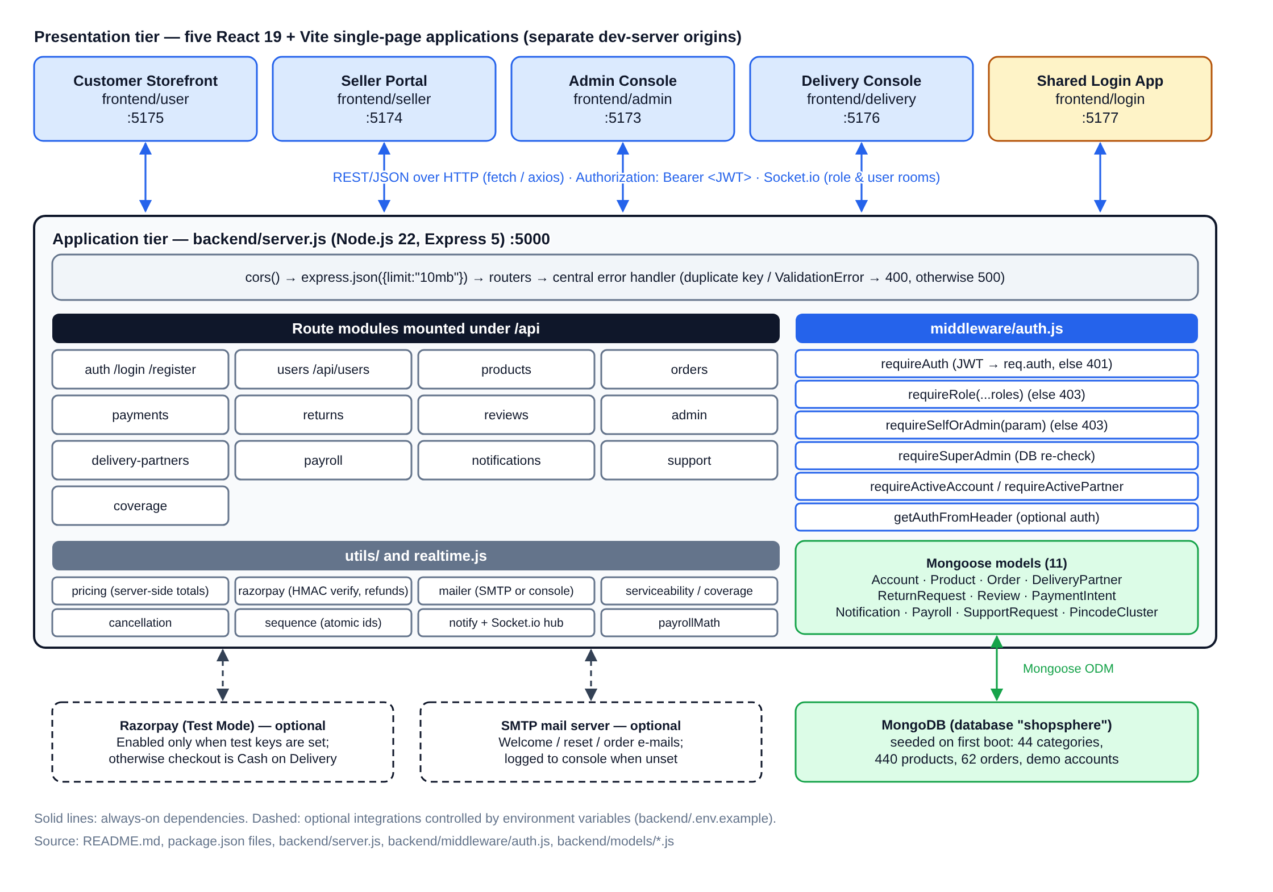
Figure 3.1: Overall ShopSphere system architecture (drawn from the repository structure)

3.2 Frontend-to-Backend Request Flow
Every portal has a small API client. The customer storefront’s apiRequest() (frontend/user/src/api/client.js) reads the saved session from localStorage, attaches Authorization: Bearer <token>, parses the JSON response and turns success: false into a thrown error that the page displays. A 401 response clears the stale session and redirects to the login with a redirect parameter so the user returns to the same page after signing in. On the server, a request passes through cors() and the JSON body parser, reaches its router, runs the route’s middleware chain (Figure 5.6) and then the handler wrapped in asyncHandler, which forwards rejected promises to the central error handler. Mongoose duplicate-key errors become 400 “That value is already in use”, validation errors become 400, and anything else becomes a generic 500 so internal details are not leaked.
Real-time updates use a Socket.io hub [10] (backend/realtime.js). Clients connect with a role and optional userId query parameter and are joined to rooms such as role:admin or user:user-1; route handlers call emitToRole and emitToUser after state changes, for example when an order is placed or a delivery status changes.

3.3 Database Design and Data Models
The database uses eleven Mongoose models (Figure 3.2). A single Account collection stores customers, sellers and administrators, distinguished by role; delivery partners are kept in a separate DeliveryPartner collection with their own account status, vehicle and document fields. Every model uses a readable business key (id, such as “user-1”, “prod-59” or “ORD-1021”) that the API and front-ends reference, generated by an atomic counter (utils/sequence.js). The toJSON transforms strip _id, __v, password hashes and reset tokens from every API response. Orders embed snapshots of item name, price and image so that order history survives a product being delisted, and record every state change in statusHistory with its phase, actor and timestamp.
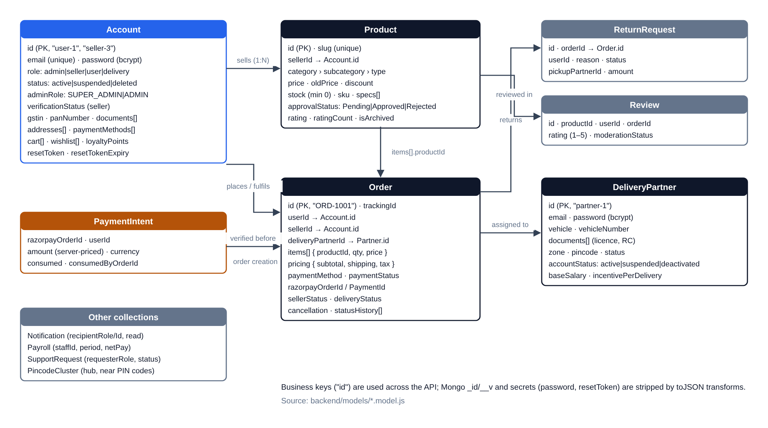
Figure 3.2: Principal collections and relationships (from backend/models/*.model.js)

CHAPTER 4
FUNCTIONAL MODULES AND WORKFLOWS
This chapter describes the modules that were confirmed in the code and exercised in the running application. The screenshots were captured on 21 October 2026 from the current main branch using the seeded demo data (no real customer data). Product photographs are loaded from an external image CDN that was not reachable from the capture environment, so image areas show placeholder or alternative text.

4.1 Customer Storefront
The storefront (frontend/user, port 5175) provides a home page with category navigation, a filterable product listing (category hierarchy, price, rating and sort), product details with specifications, a cart, a wishlist and a checkout page (Figures 4.1–4.4). Only products whose approvalStatus is “Approved” and which are not archived are returned to customers. Checkout calls POST /api/orders; the server prices the cart from the catalogue rather than trusting the browser, checks PIN-code serviceability, decrements stock, notifies the seller and administrators in real time and sends a confirmation e-mail. The account area lists the customer’s orders and links to a tracking page that renders the order journey (Figures 4.5 and 4.6). Checkout, profile, wishlist and tracking routes are wrapped in a RequireAuth component.
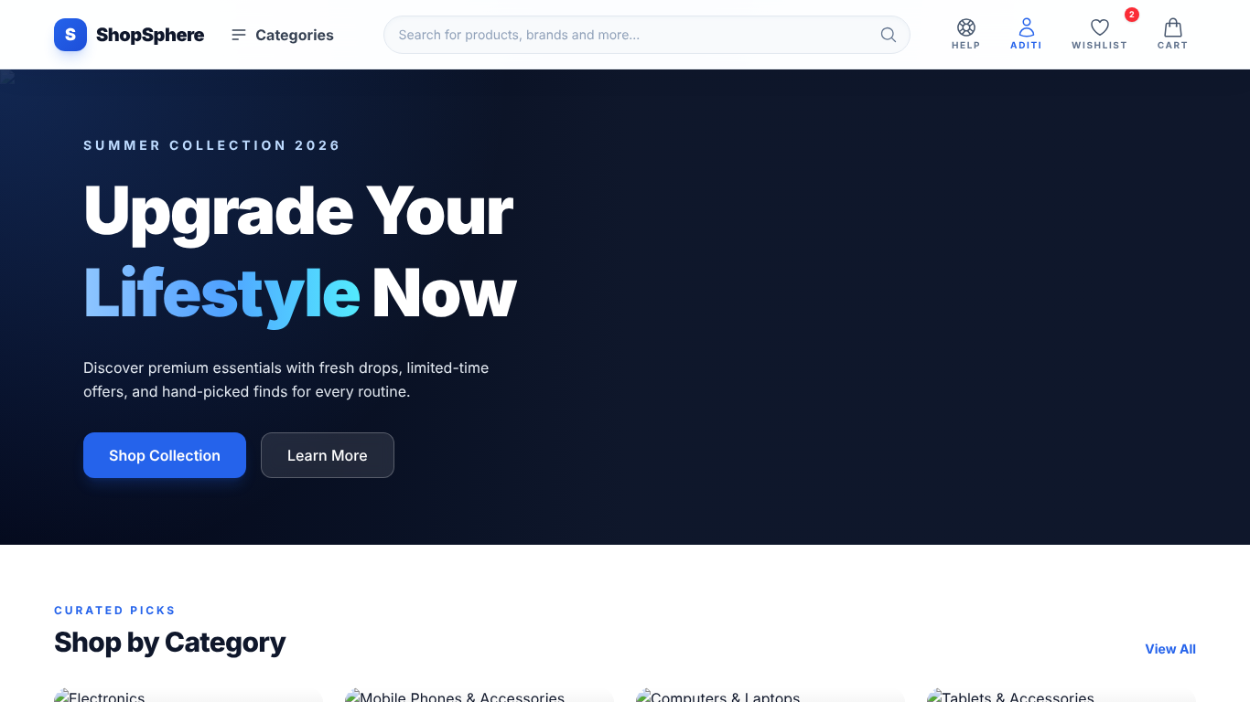  Figure 4.1: Customer home page after sign-in | 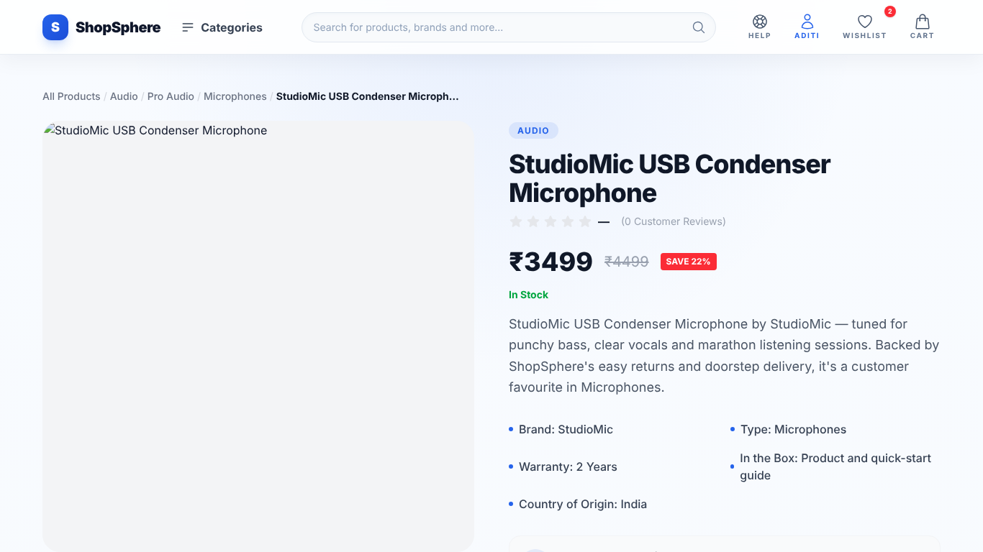  Figure 4.2: Product details page
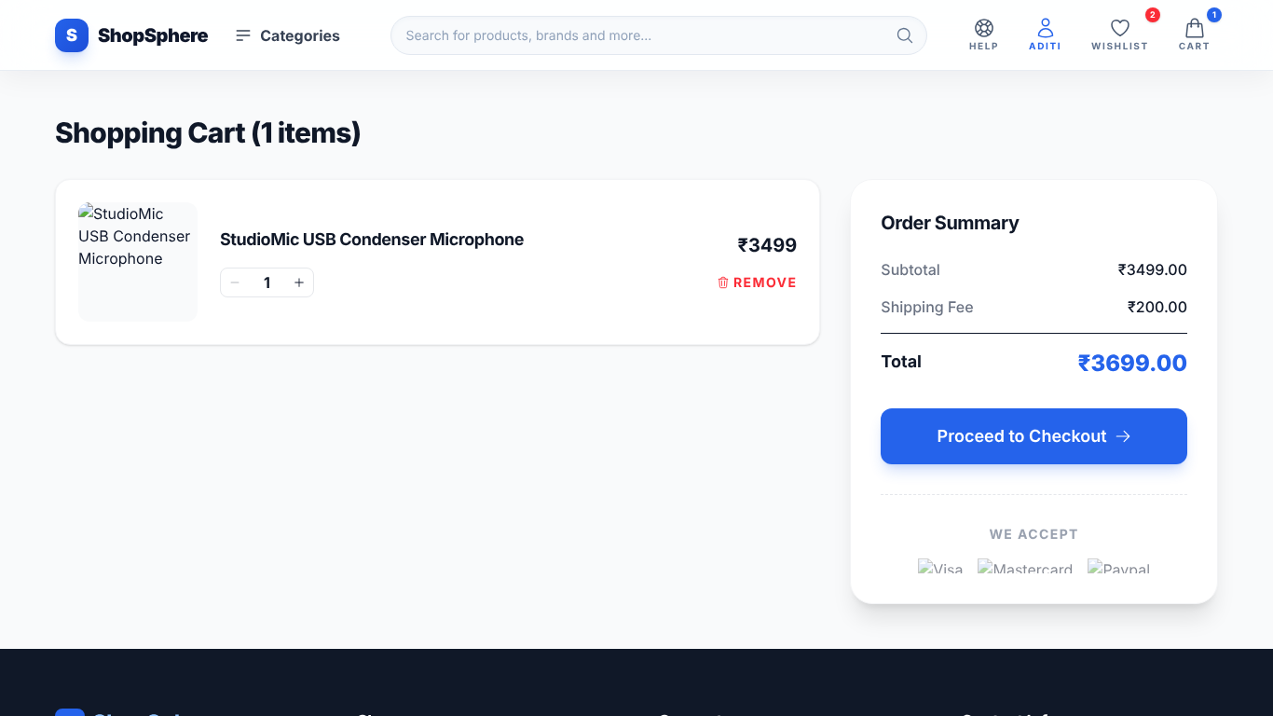  Figure 4.3: Shopping cart with order summary | 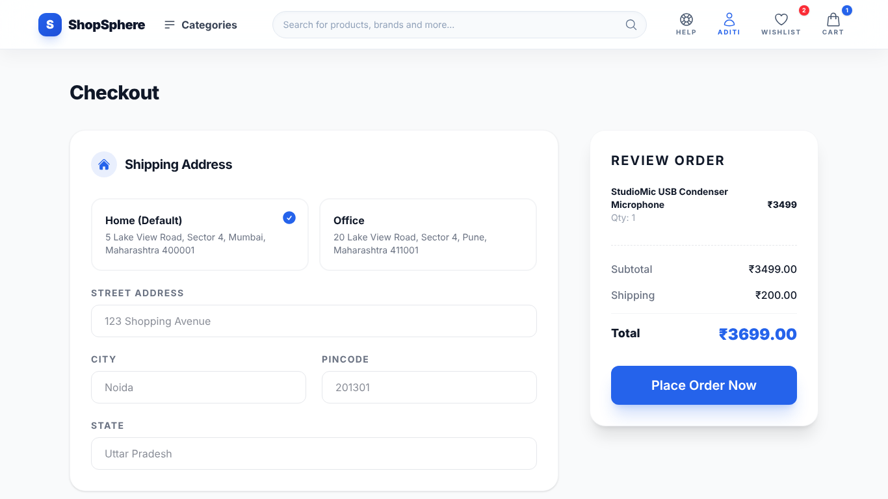  Figure 4.4: Checkout with saved addresses
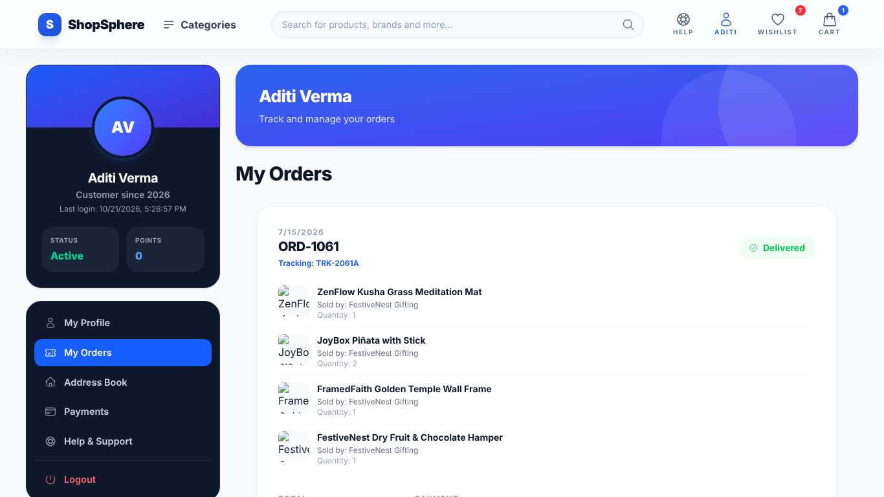  Figure 4.5: My Orders inside the account area | 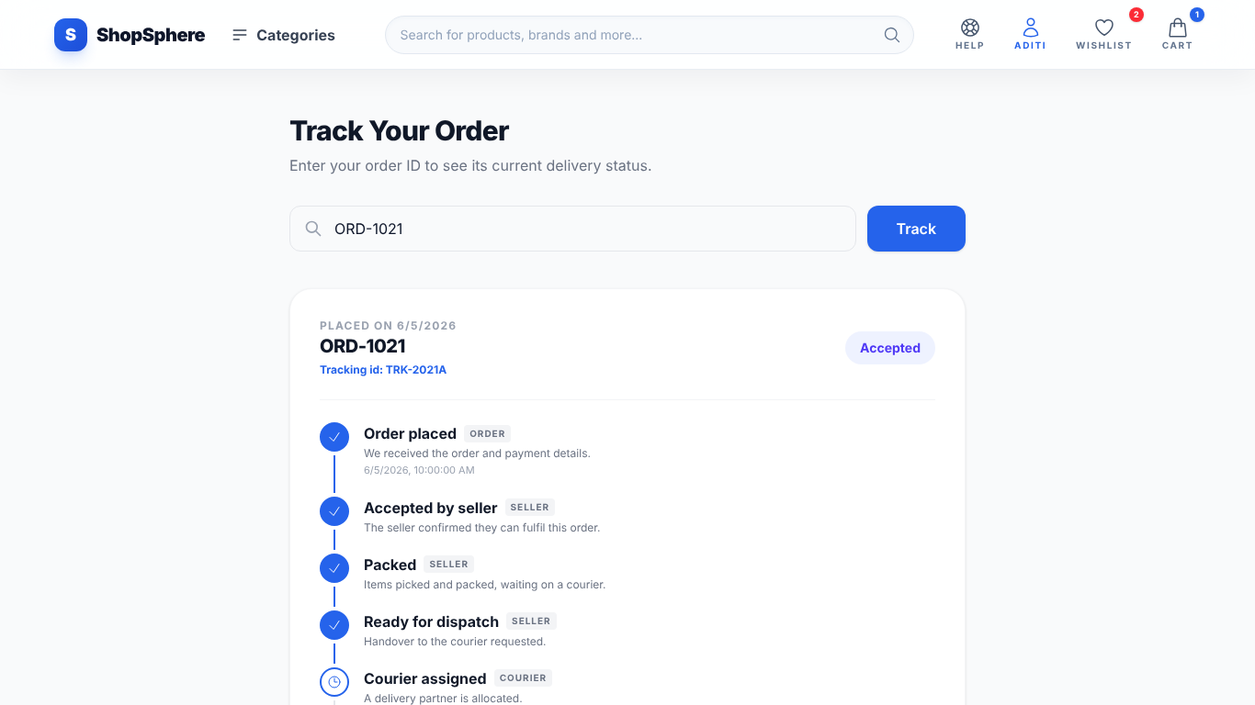  Figure 4.6: Order tracking timeline (ORD-1021)

4.2 Seller Portal
The seller portal (frontend/seller, port 5174) offers a dashboard with revenue and order statistics, product management, inventory steppers, order processing, analytics, discounts, payouts and store settings including serviceable PIN codes (Figures 4.7 and 4.8). Sellers register through POST /api/register/seller, which validates the phone number, the 15-character GSTIN and 10-character PAN formats and the four mandatory documents, and creates the account with verificationStatus: “Pending”. A seller can publish products only after an administrator verifies the store; each new listing then enters the approval queue (Figure 4.13). Seller order updates are validated against the SELLER_TRANSITIONS table, so an order cannot jump from “Processing” to “Delivered”.
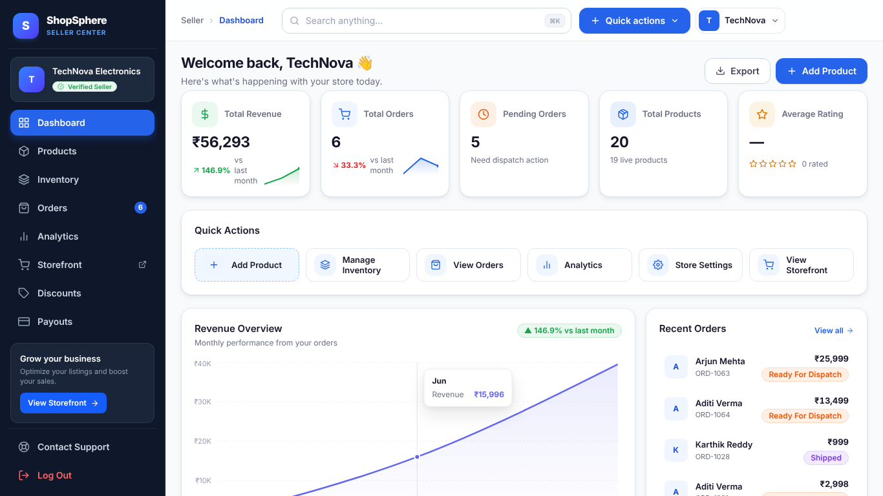  Figure 4.7: Seller dashboard (TechNova Electronics demo store) | 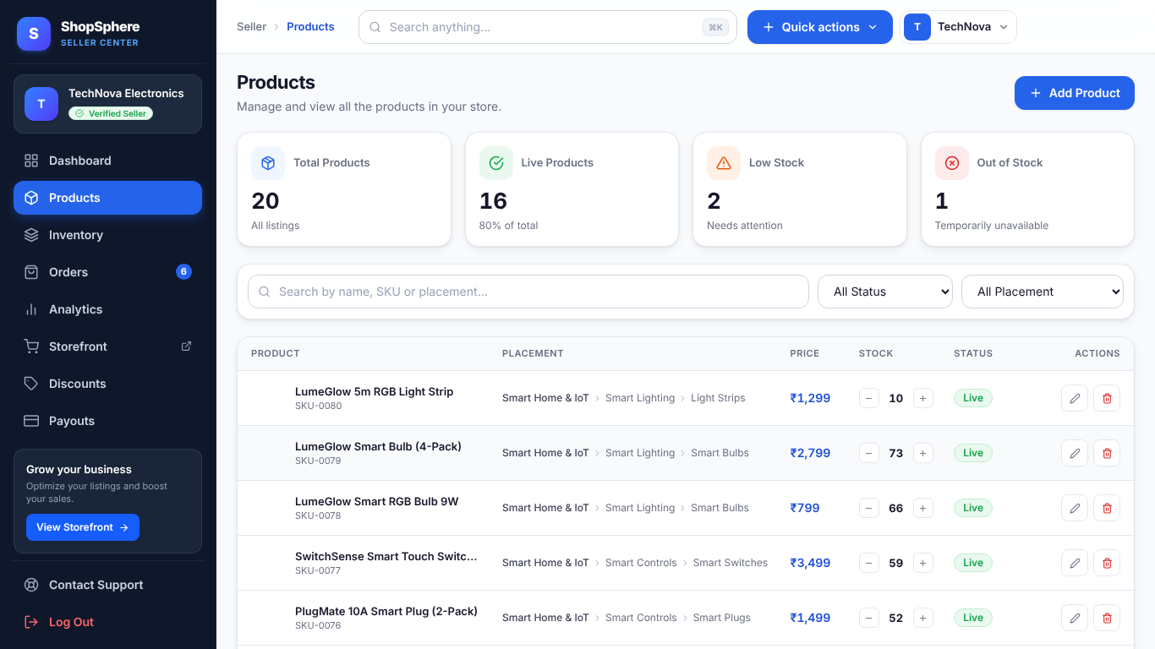  Figure 4.8: Seller product and stock management

4.3 Administrator Console
The admin console (frontend/admin, port 5173) contains the dashboard, user, seller and product management, seller verification with document review, product approval, order monitoring, refunds, delivery-partner management, delivery assignment and tracking, PIN-code coverage, payroll, support inquiries and, for super administrators only, the admin roster (Figures 4.9–4.11). The whole /api/admin router is protected by requireAuth and requireRole("admin"); the roster and payroll routes additionally require the SUPER_ADMIN tier.
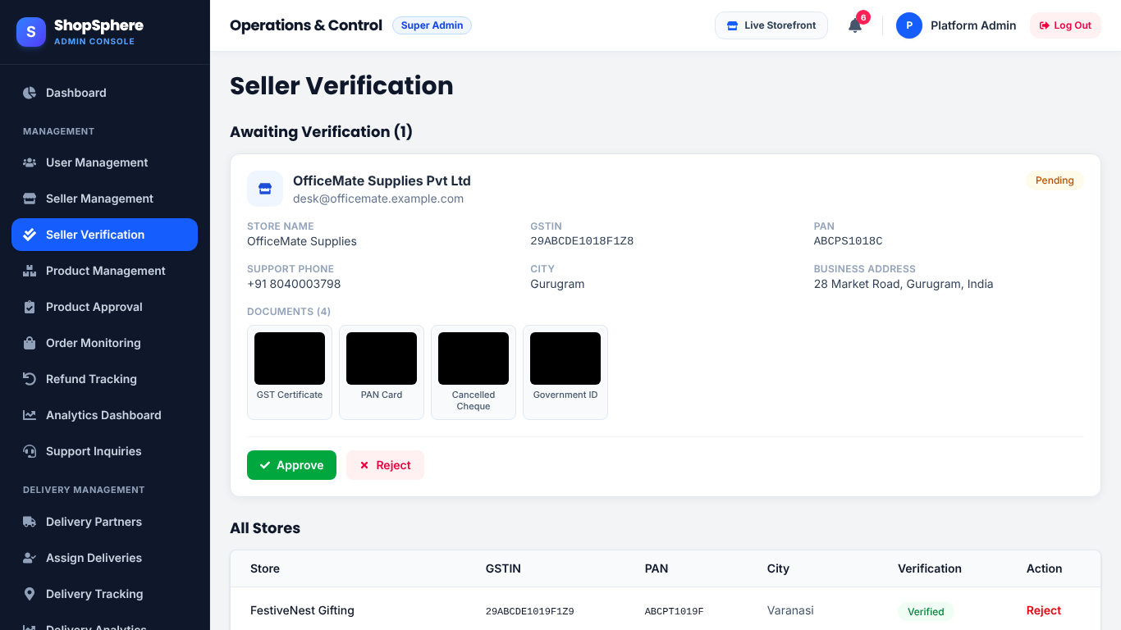  Figure 4.9: Seller verification queue with submitted documents | 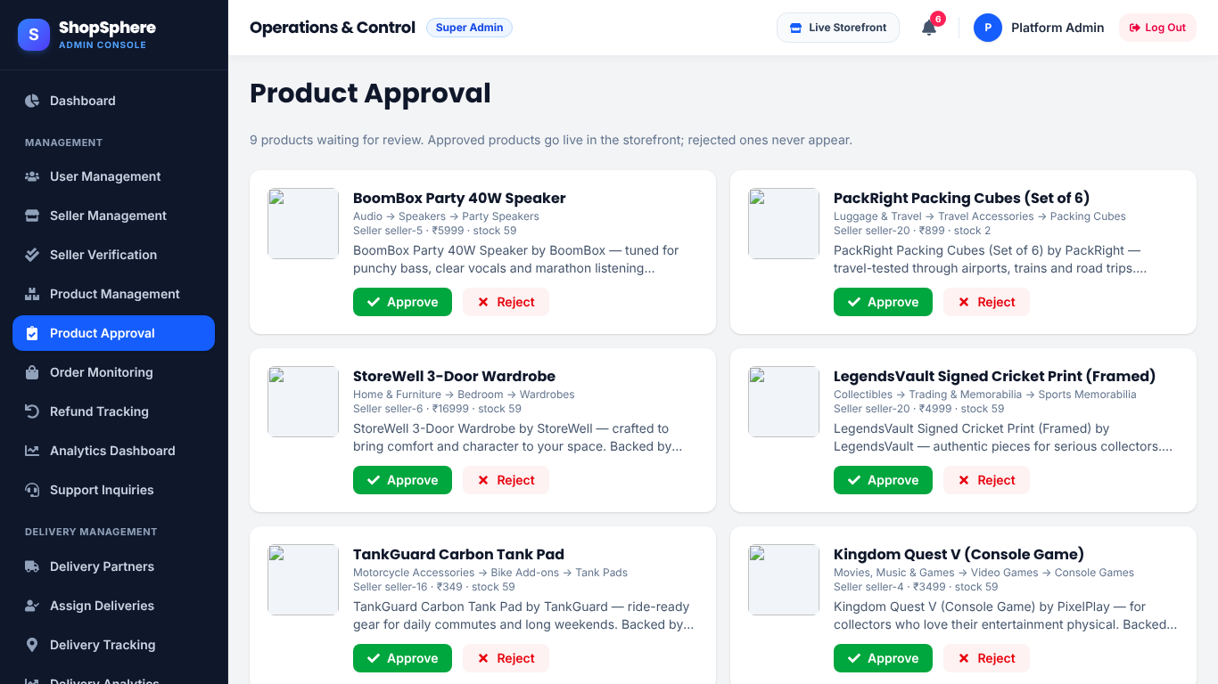  Figure 4.10: Product approval queue

4.4 Delivery Partner Console
Delivery partners use frontend/delivery (port 5176) to view assigned orders, advance each job through Accepted, Picked Up, In Transit, Out For Delivery and Delivered, handle reverse pickups for returns and review their delivery history (Figure 4.12). The administrator assigns a partner from a list of eligible partners matched by PIN-code catchment (Figure 4.11). The update endpoint checks that the partner owns the job before changing it.
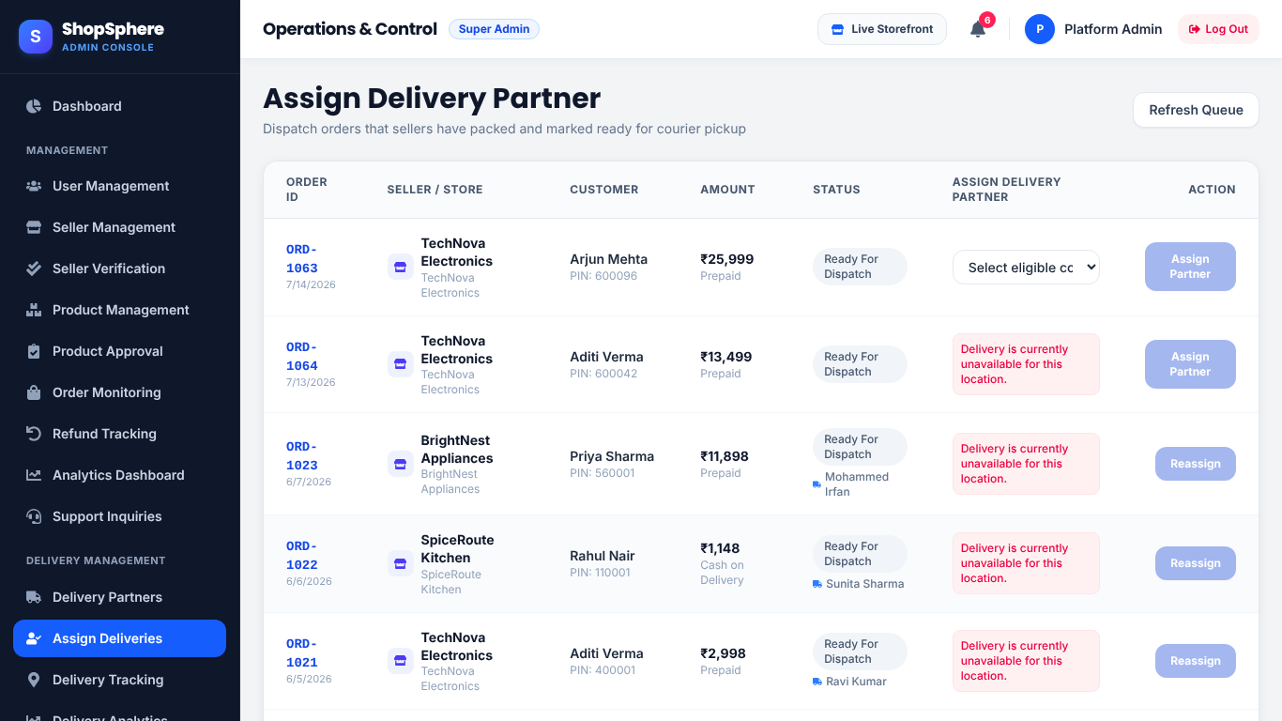  Figure 4.11: Admin delivery assignment by PIN-code eligibility | 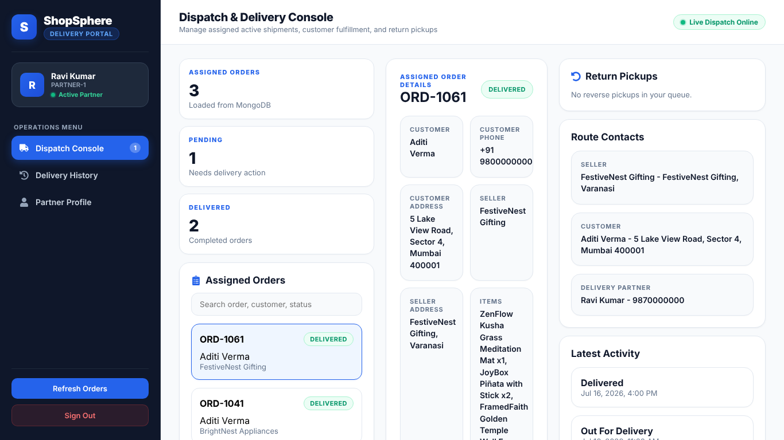  Figure 4.12: Delivery console for a signed-in partner

4.5 Core Workflows
Figure 4.13 shows the seller onboarding and product approval workflow, and Figure 4.14 the complete order lifecycle across the four roles. When a courier marks an order “Picked Up”, the server automatically moves the seller status to “Shipped”; on “Delivered” it marks the seller status delivered and, for Cash on Delivery, records the payment as paid. Cancellations before dispatch restore stock and record refunds, and returns follow a separate pipeline from request through reverse pickup and inspection to refund (routes/returns.js).
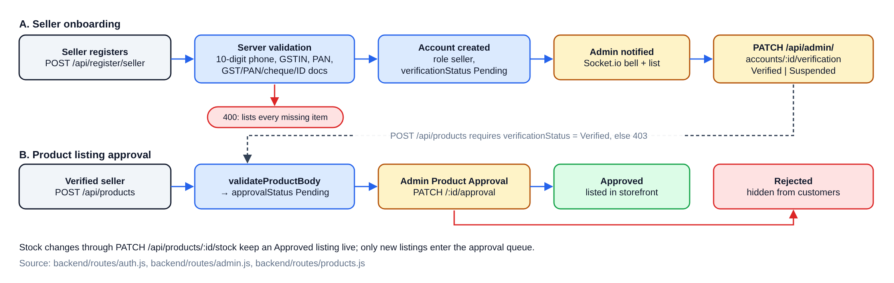
Figure 4.13: Seller onboarding and product approval workflow
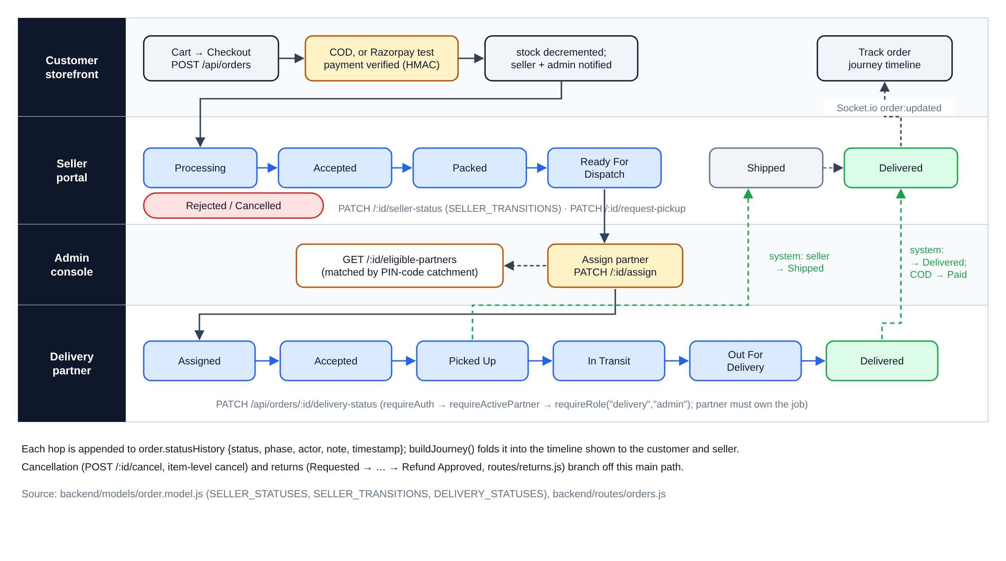
Figure 4.14: Order lifecycle across customer, seller, admin and delivery roles

4.6 Payments, Notifications and Supporting Modules
Online payment uses Razorpay in test mode only when test keys are configured. POST /api/payments/create-order prices the cart on the server and stores a PaymentIntent; order creation then verifies the Razorpay signature with HMAC-SHA256 and a constant-time comparison (crypto.timingSafeEqual) as described in Razorpay’s documentation [11], and checks that the intent’s amount matches the order total, so a payment for a smaller amount cannot be reused for a larger cart. In the environment used for this report no Razorpay keys were configured; the payment test suite confirmed that online payment is refused and Cash on Delivery works. No live or test online payment was performed for this report. Other implemented modules include in-app notifications, product reviews with moderation, support requests and payroll generation for delivery partners.

CHAPTER 5
AUTHENTICATION AND AUTHORIZATION IMPLEMENTATION
Authentication and authorization were Reyhaan’s principal area of responsibility. This chapter describes the mechanism as it exists on the current main branch. Items marked † were added in the post-internship commit 5452ea8 (20 October 2026) and are described for completeness only; Section 7.2 lists which parts of this mechanism are evidenced as Reyhaan’s work in the commit history.

5.1 Shared Login and Role Selection
The shared login application (frontend/login, port 5177) is the single sign-in entry point for all four roles. The user first chooses a role (Figure 5.2) and then signs in on a role-specific screen reached through /login/<role> or the ?role= deep link used by the other portals (Figure 5.3); a wrong password produces the generic error in Figure 5.4. The same app hosts the forgot-password and reset-password forms and links to each role’s registration page.

5.2 Login Processing on the Server
POST /api/login (backend/routes/auth.js) performs the following steps (Figure 5.1):
- Input validation. email, password and role must be strings and role must be one of admin, seller, user or delivery; otherwise the server returns 400.
- Account lookup. The account is looked up by e-mail and role, first exactly and then case-insensitively with regular-expression metacharacters escaped. The same e-mail used for a customer account therefore cannot sign in to the seller portal.
- Password verification. bcrypt.compare checks the password against the stored hash. When no account exists, the server still compares against a dummy hash so that “unknown e-mail” and “wrong password” take similar time and return the same 401 “Invalid email or password” message, which limits account enumeration, as recommended by OWASP [12].
- Account standing. A suspended or deleted account is refused with 403 and an accountStatus field, which the login screen shows as a dedicated panel instead of a credentials error†. For the delivery role, partners stored in the DeliveryPartner collection are also checked.
- Token issue. signToken() creates a JWT containing only id and role (plus adminRole for administrators), signed with JWT_SECRET (HMAC-SHA256, the library default [3]) and valid for seven days, following the JWT format of RFC 7519 [2]; lastLogin is updated and the response returns the token with the user’s id, name and e-mail.
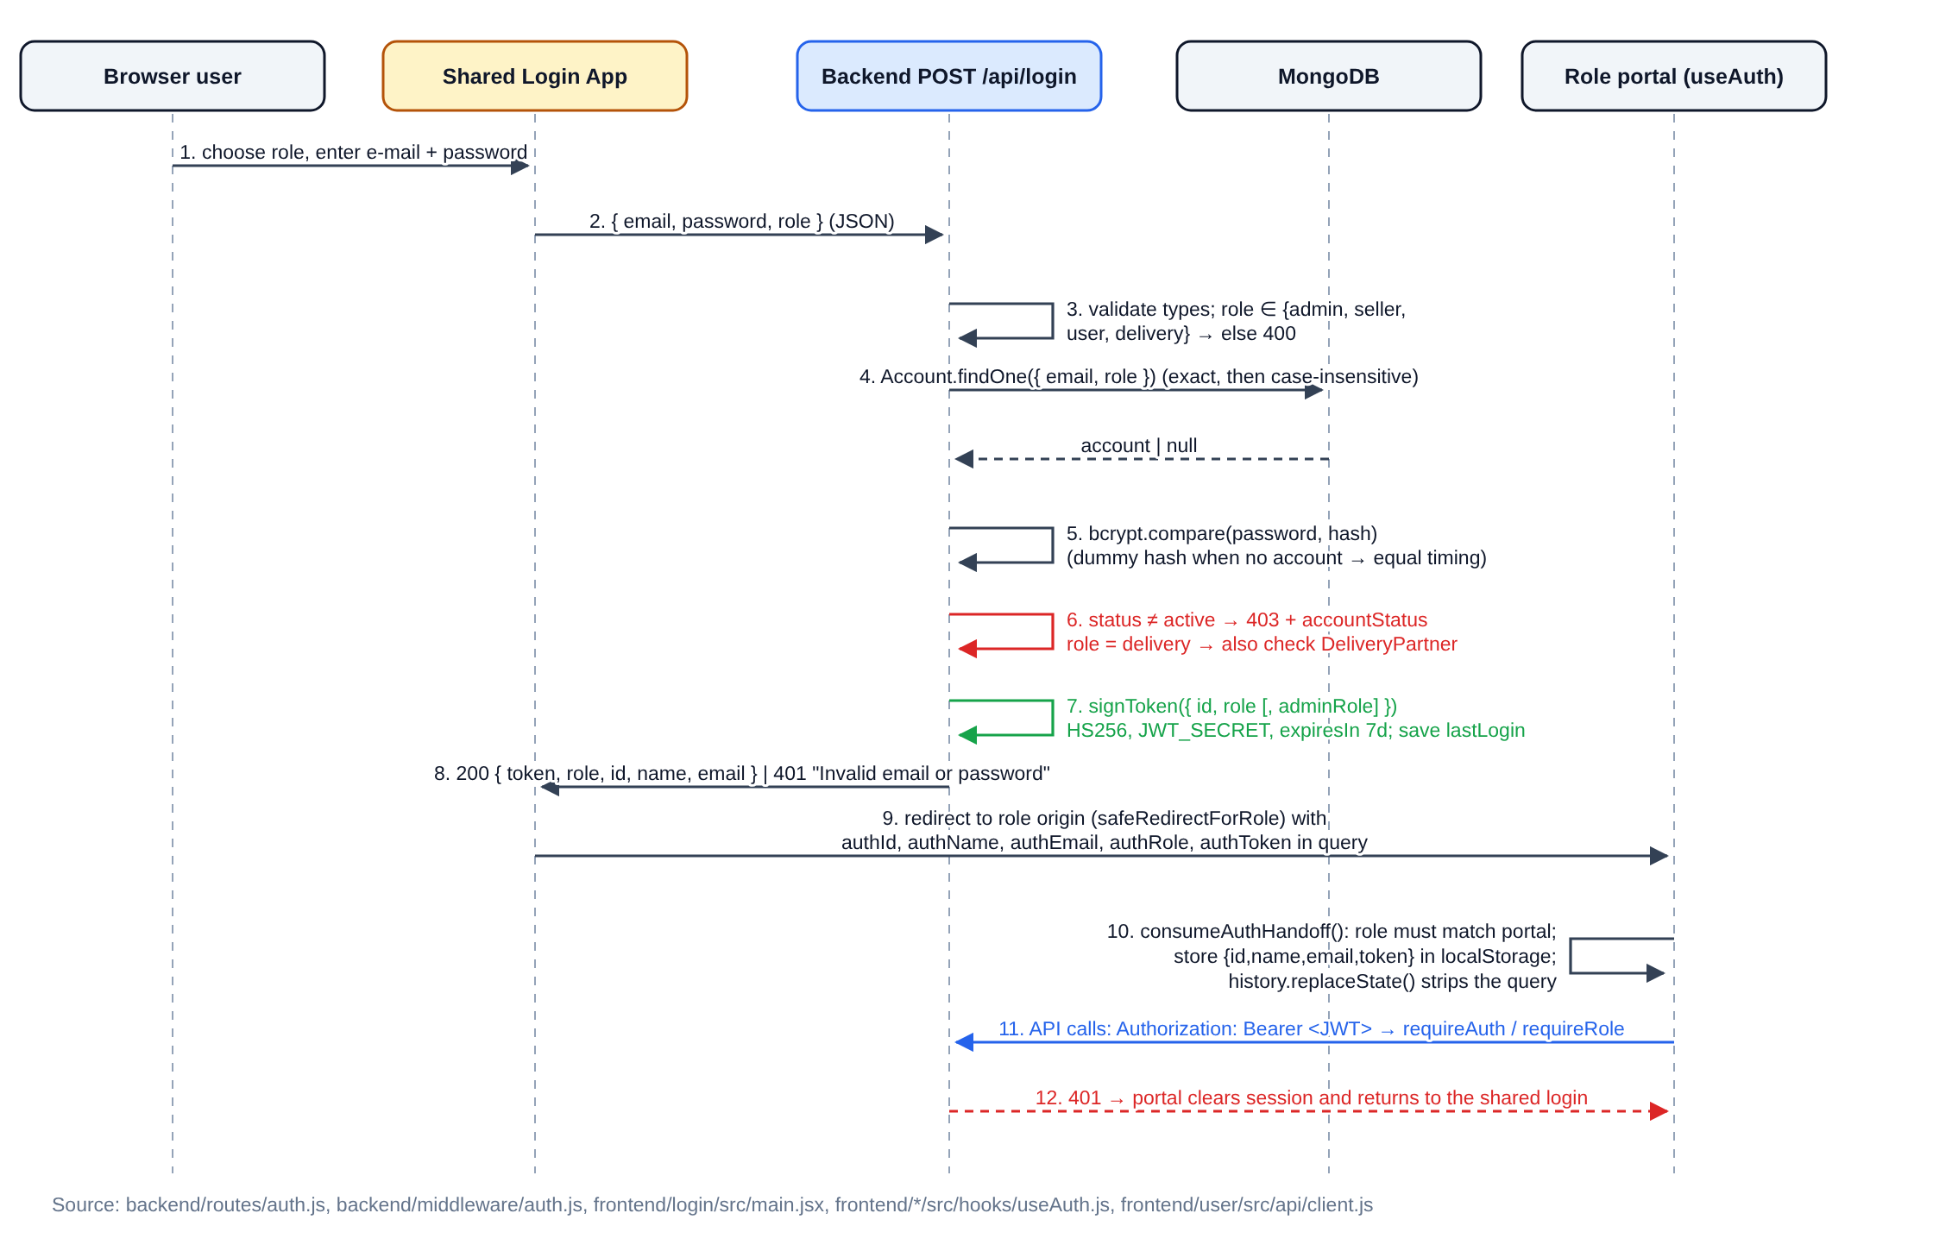
Figure 5.1: Authentication flow from the shared login to a role portal

5.3 Cross-Portal Session Hand-off
Because each portal runs on a different origin, localStorage cannot be shared between the login app and the portals. After a successful login the login app therefore builds the destination URL with safeRedirectForRole(), which accepts a redirect parameter only if its origin is the selected role’s own portal (preventing an open redirect to another site), and appends authId, authName, authEmail, authRole and authToken as query parameters. In the portal, consumeAuthHandoff() in the useAuth hook accepts the hand-off only when authRole matches the portal’s expected role, saves the session under a portal-specific key, and immediately removes the parameters from the address bar with history.replaceState(). The seller and admin portals protect their layouts with a RequireAuth component that performs a hard redirect to the shared login (?role=seller or ?role=admin with a redirect back), as Figure 5.5 shows for an unauthenticated visit to the admin dashboard.
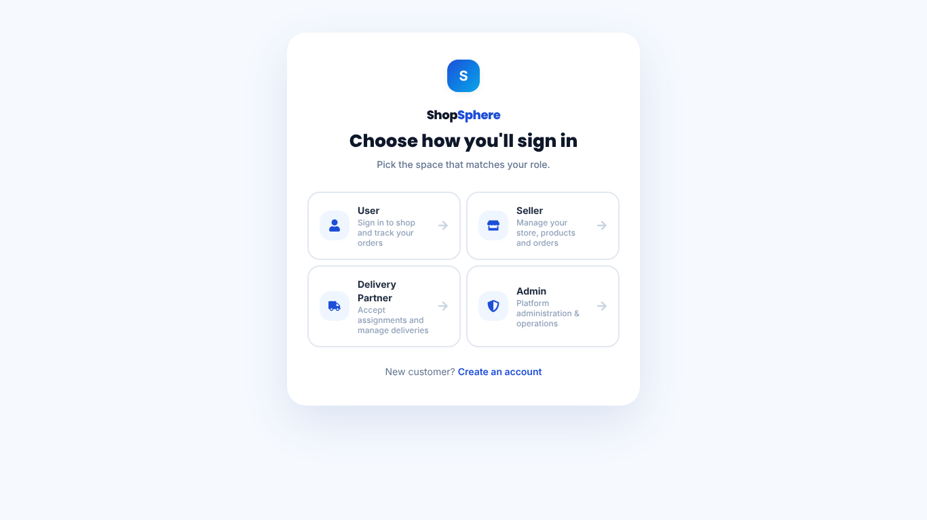  Figure 5.2: Shared login: role chooser (port 5177) | 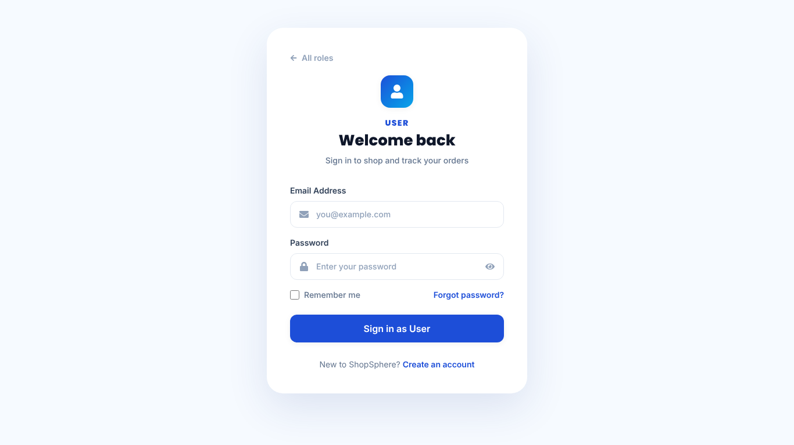  Figure 5.3: Role-specific sign-in screen
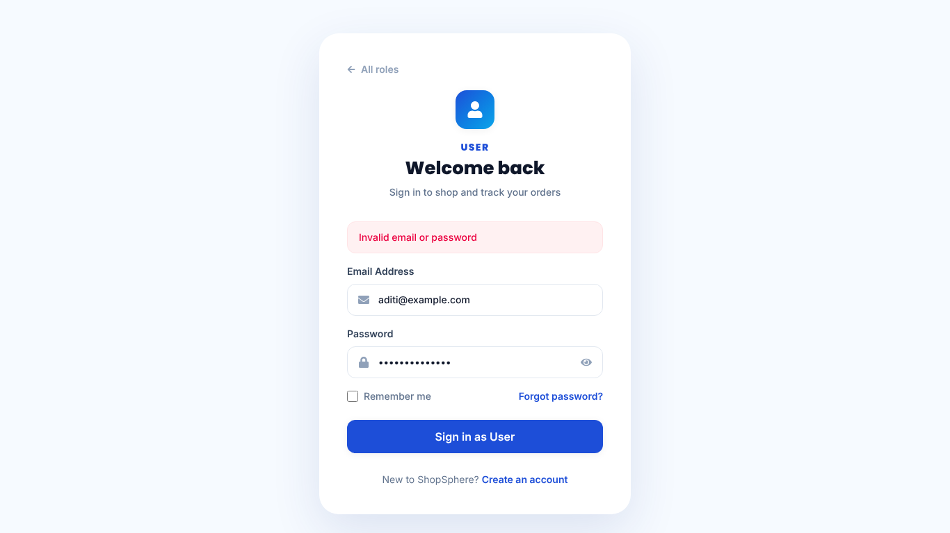  Figure 5.4: Generic error for an invalid password | 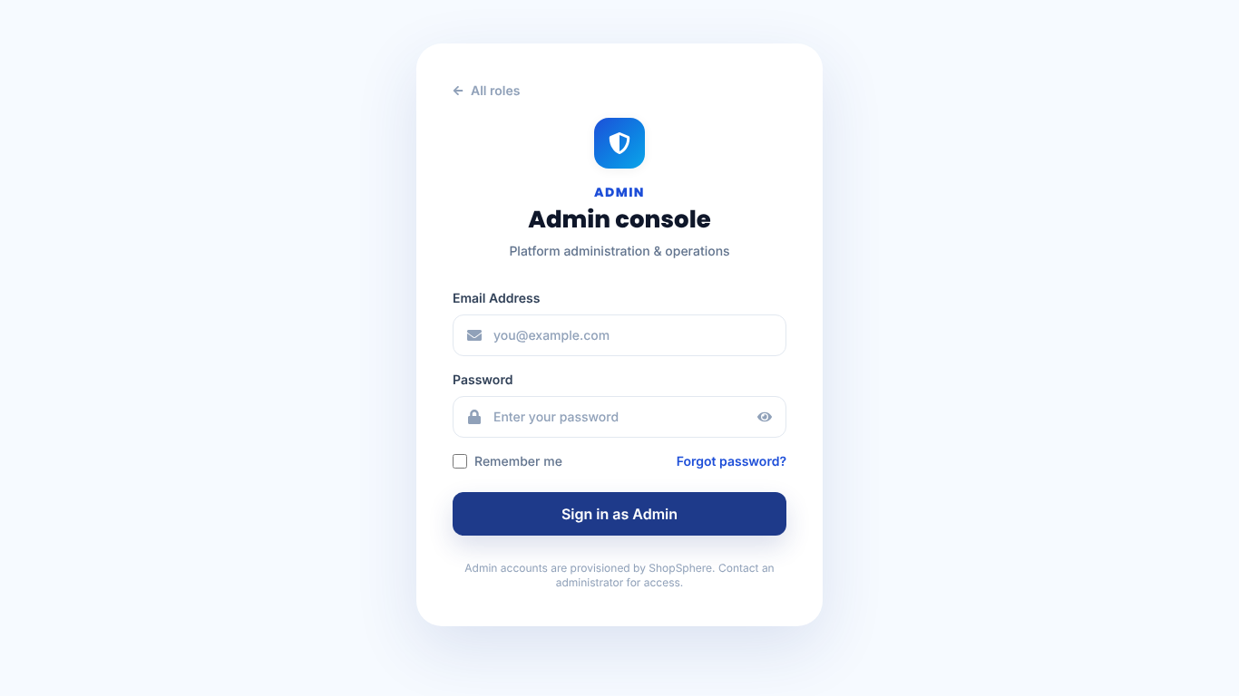  Figure 5.5: Unauthenticated admin visit redirected to admin sign-in

5.4 Authorization Middleware
Authorization is enforced on the server by small, composable middleware functions in backend/middleware/auth.js, applied per route or to a whole router (Figure 5.6 and Table 5.1). The essential pattern is shown below.
function requireAuth(req, res, next) {
const auth = getAuthFromHeader(req); // verifies "Bearer <jwt>" with JWT_SECRET
if (!auth) return res.status(401).json({ success: false,
message: "Missing or invalid Authorization header" });
req.auth = auth; // { id, role [, adminRole] }
next();
}
function requireRole(...roles) {
return (req, res, next) => roles.includes(req.auth.role) ? next()
: res.status(403).json({ success: false, message: "You don't have access to this resource" });
}
// usage: router.patch("/:id/approval", requireAuth, requireActiveAccount, requireRole("admin"), handler)

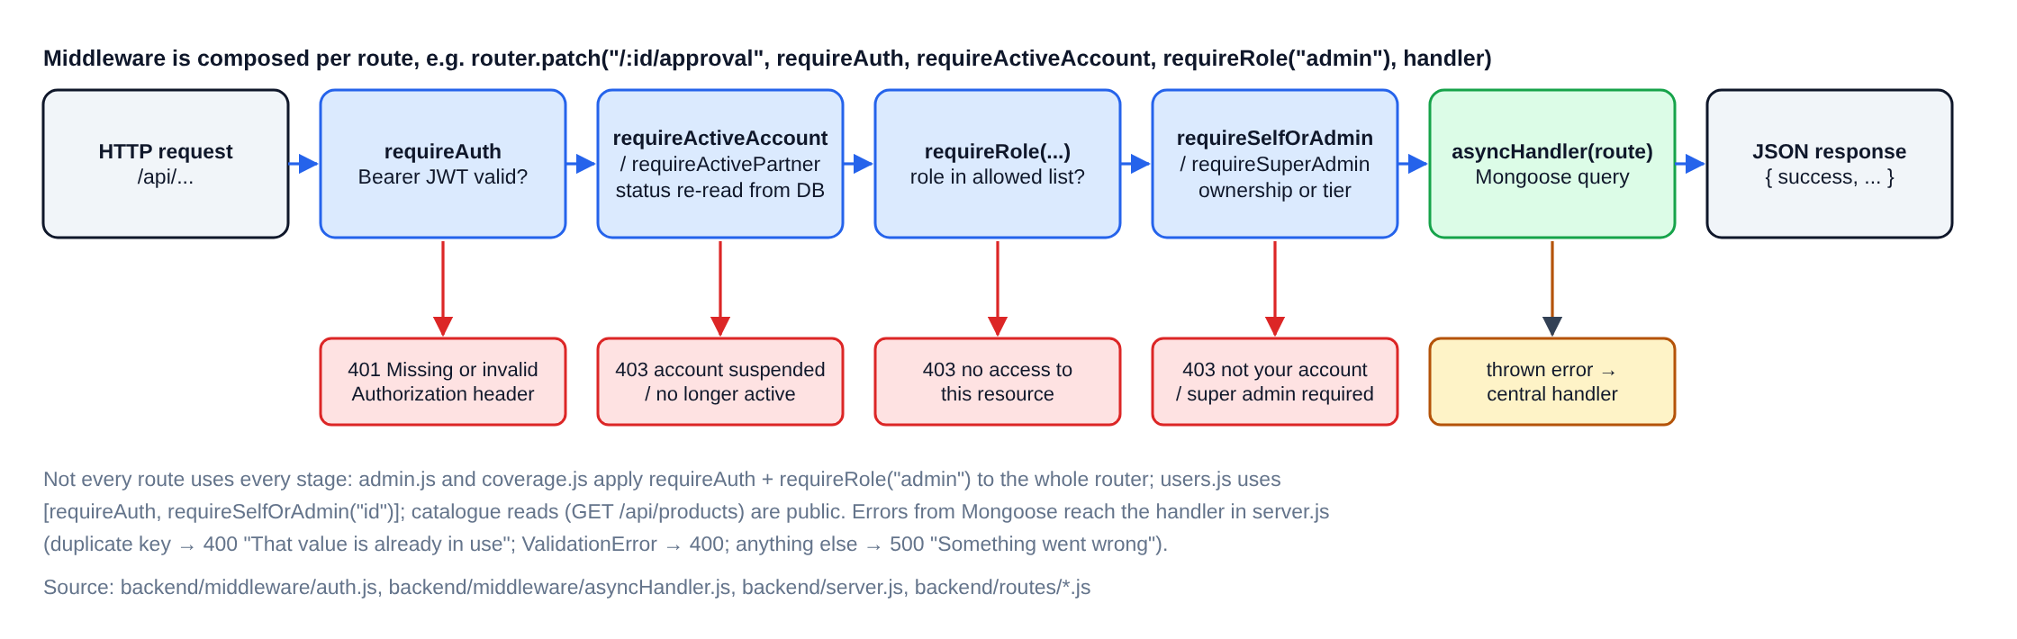
Figure 5.6: Server-side authorization pipeline and rejection responses
Table 5.1: Authorization guards and where they are applied
Guard | Behaviour | Examples of use
requireAuth | Rejects with 401 unless a valid Bearer JWT is present; sets req.auth | All private routes
requireRole(...) | 403 unless req.auth.role is in the allowed list | admin and coverage routers; product create/approve; seller-status; assignment
requireSelfOrAdmin(param) | 403 unless the caller owns the :id or is an admin | Every /api/users/:id route (profile, addresses, cart, wishlist)
requireSuperAdmin | Re-reads the caller from the database and requires an active SUPER_ADMIN† | Admin roster, payroll generation and edits
requireActiveAccount / requireActivePartner† | Re-reads account status so a suspension takes effect before the 7-day token expires | Order, product, payment and delivery updates
getAuthFromHeader | Optional authentication without failing the request | GET /api/orders?userId= (owner or admin only)
Frontend RequireAuth | Redirects unauthenticated users to the login; hides super-admin screens | Checkout, profile, seller layout, admin layout

5.5 Password, Reset and Registration Controls
- Passwords are hashed with bcrypt [4] (cost factor 10) in a Mongoose pre("save") hook, so every code path that sets a password — registration, seed data, admin reset or password reset — stores only a hash. npm run hash-passwords re-hashes any legacy plaintext password.
- Registration enforces a valid e-mail format, a minimum password length of eight characters and a 10-digit phone number, and the unique index on e-mail blocks duplicates even under concurrent requests.
- POST /api/forgot-password returns the same message whether or not the account exists; the reset token is 20 random bytes, expires after one hour and is cleared after use.
- The seeded founding administrator cannot be demoted, suspended or deleted, so the console cannot be locked out of its own roster.

CHAPTER 6
TESTING AND VERIFICATION

6.1 Test Environment and Approach
For this report the repository was cloned at commit 8f85bbd, dependencies were installed with npm install and npm run install:all, MongoDB 7 was run in a local Docker container and all six processes were started with npm run dev:all using a locally generated JWT_SECRET. Testing combined (a) the backend test scripts that ship with the repository, which call the running API and print PASS or FAIL for each check, (b) a focused authentication and authorization check written for this report, and (c) manual walkthroughs of each portal while capturing the screenshots with Playwright [14]. All tests were run on 21 October 2026, after the internship period; they verify the current code, not historical behaviour.

6.2 Repository Test Suites
Table 6.1: Results of the repository test scripts (backend/test, run on 21 October 2026)
Script | What it checks | Result
smoke.js (npm test) | Catalogue loads; login for all four roles; registration | 6 passed, 0 failed
features.js | Order journey, status transitions and related features | 24 passed, 0 failed
serviceability.test.js | PIN-code delivery serviceability rules | 17 passed, 0 failed
cancellation.js | Order and item cancellation, stock restoration, refunds | 39 passed, 0 failed
payments.js | Payment integrity in Cash-on-Delivery-only mode (no Razorpay keys) | 6 passed, 0 failed
verifychanges1to10.js | Regression checks for ten earlier change requests | 15 passed, 0 failed

The payment script reports that prepaid paths are exercised only when the server is restarted with ENABLE_MOCK_PAYMENTS=true; that mode was not run, so prepaid checkout is not claimed as tested here. There are no automated front-end tests in the repository.

6.3 Authentication and Authorization Test Cases
Table 6.2 lists the security-related checks executed against the running API with the seeded demo accounts. Each row records the expected and the observed HTTP status.
Table 6.2: Authentication and authorization checks (expected vs. observed)
ID | Scenario | Expected | Observed
A1 | Valid customer login | 200 + JWT | 200 ✔
A2 | Wrong password | 401 | 401 ✔
A3 | Unknown e-mail (same message as A2) | 401 | 401 ✔
A4 | Valid customer credentials used for the seller role | 401 | 401 ✔
A5–A6 | Missing role / invalid role value | 400 | 400 ✔
B1–B2 | GET /users/me with no token / tampered token | 401 | 401 ✔
C1–C2 | Customer or seller calls GET /admin/stats | 403 | 403 ✔
C3 | Admin calls GET /admin/stats | 200 | 200 ✔
C4–C5 | Customer approves or creates a product | 403 | 403 ✔
C6 | Delivery partner changes seller status | 403 | 403 ✔
D1 | Customer reads another user’s profile | 403 | 403 ✔
D3–D4 | Customer lists another user’s orders / no token | 403 / 401 | 403 / 401 ✔
D5 | Admin reads any user profile | 200 | 200 ✔
F1–F3 | Short password, malformed e-mail, invalid reset token | 400 | 400 ✔
G1 | Password hash absent from /users/me response | absent | absent ✔
G2–G3 | JWT payload fields and lifetime | id, role; 7 days | id, role, iat, exp; 7 days ✔
H1–H2 | GET /orders and GET /orders/:id without a token | (not restricted in code) | 200 — limitation, see 8.3

CHAPTER 7
INDIVIDUAL CONTRIBUTION AND TEAM COLLABORATION

7.1 Reyhaan’s Responsibilities
Within the joint project of Control + Alt + Win and SEME Forces, Reyhaan S was one of three main contributors, with primary ownership of authentication, authorization, the shared login, security validation and integration. In practice this covered:
- Shared login and role-based access: consolidating the separate per-app login pages into the single shared login application, the per-role login entry, and the safe redirect to each role’s portal.
- Authorization and protected routes: the super-administrator tier (requireSuperAdmin, adminRole in the token, and the hidden roster screen) and protected-route behaviour in the portals.
- Credential security: removing the e-mail OTP step from registration and adding a migration that re-hashes any plaintext password at rest.
- Integration and session handling: front-end re-authentication on 401 so customers with an expired token are sent back through the shared login and returned to their page.
- Validation and regression testing: the backend smoke test that checks login for all four roles, and repeated security and cross-portal regression checks (as allocated in the workbook).
- Documentation of the implementation and project workflows.

7.2 Repository Evidence for Reyhaan’s Work
Table 7.1 lists commits recorded under Reyhaan’s accounts (“Reyhaan S” and “reyhaan07”) that relate to his area. Commit authorship is useful evidence but is not a complete record of who did what: much of the work was discussed and tested jointly, and several commits carry AI co-author trailers.
Table 7.1: Authentication-related commits recorded under Reyhaan’s accounts
Date | Commit | Change relevant to authentication and integration
16 Jul 2026 | 631eed3 | Migrated the backend to MongoDB; replaced each app’s own login with the shared frontend/login app; added safeRedirectForRole and admin/delivery session handling
19 Jul 2026 | 3384e7b | Per-role login entry screens; seller registration and verification refinements in routes/auth.js
25 Jul 2026 | dc43a8f | Removed e-mail OTP verification and the emailVerified gate; added npm run hash-passwords migration
25 Jul 2026 | 998db43 | Added backend/test/smoke.js (login for all four roles, registration); removed dead emailVerified writes
20 Aug 2026 | e83285c | Super-admin roster routes behind requireSuperAdmin; adminRole carried in the JWT and hand-off; roster hidden from ordinary admins
22 Aug 2026 | 4c808b0 | Storefront re-authentication on 401 with redirect back to the original page

Other parts of the authentication mechanism were committed by other accounts: the original requireAuth, requireSelfOrAdmin, timing-normalised login and the URL hand-off appear first in commits by “Harini-G-07” (13 July 2026); requireRole first appears in a commit attributed to an AI coding assistant (17 July 2026); and requireActiveAccount, requireActivePartner, the database re-check in isSuperAdmin and delivery-partner self-registration were added in Sai Saran S’s commit of 20 October 2026, after the internship. These are therefore not claimed as Reyhaan’s individual work.

7.3 Team Members and Responsibilities
Table 7.2: Team responsibilities — Control + Alt + Win and SEME Forces (from the Task Assignment sheet)
Member (Reg. No.) | Level | Main responsibility
Reyhaan S (312325205176) | Main contributor | Authentication, authorization, shared login, protected routes, security validation and integration
Sai Saran S (312325205188) | Main contributor | System architecture, frontend/backend integration, API and data flow, build configuration and coordination
Mrityunjai G (312325205132) | Main contributor | Administration portal, seller and product approvals, role permissions, order and delivery administration
Pasupathi G (312325205157) | Supporting contributor | Seller portal, catalogue and inventory workflows, seller fulfilment and testing
Priyadharshini P (312325205165) | Limited support | Customer UI spot-checks, cart/checkout smoke checks, screenshot evidence
Niraimathi V (312325205141) | Light support | Occasional delivery-workflow checks, screenshots and simple QA notes

7.4 Work Allocation Summary
The team’s workbook covers 15 July 2026 to 14 September 2026, a sub-period of the internship (18 June – 15 September 2026). It allocates one recurring task per member for each of 41 working days. The workbook itself states that its daily calendar is a proposed retrospective allocation and not a verified record of attendance or completion dates; it is summarised here as a work-allocation record, not as a daily log.
Table 7.3: Recurring task areas per member in the work-allocation calendar (days allocated in brackets)
Member | Recurring task areas
Reyhaan S | Role authorization (5), API auth integration (5), protected routes (4), auth integration fixes (4), security regression (4), environment configuration (4), cross-portal verification (4), credential validation (4), token/session handling (4), final auth walkthrough (3)
Sai Saran S | Build/configuration review (5), integration test planning (5), error-handling alignment, documentation consolidation, final integration review, scope and milestones, architecture review, cart/order integration, cross-portal API checks (4 each), API/data-flow tracing (3)
Mrityunjai G | Regression pass (5), evidence preparation (5), issue verification, seller approval workflow, role permission checks, product administration, user management, status-transition checks, admin API review (4 each), order administration (3)
Pasupathi G | Seller portal orientation (5), product creation review (5), seller order handling, catalogue consistency, fulfilment status, seller validation QA, evidence capture, cross-role check, final walkthrough (4 each), seller API trace (3)
Priyadharshini P | Checkout validation (5), customer screenshots (5), cart smoke test and other customer UI spot-checks (3–4 each)
Niraimathi V | Cross-role display check (5), light regression support (5), delivery UI and journey spot-checks, report evidence and handover support (3–4 each)

Table 7.4: Project phases reconstructed from repository history and the allocation workbook
Period | Activity | Evidence
18 Jun – 14 Jul | Onboarding and MERN training; initial project set-up, common login, first backend APIs and user-account module | Commits 26 Jun – 13 Jul (other accounts)
15 – 31 Jul | MongoDB migration and shared login; full module build-out; per-role login; OTP removal and password hashing; smoke test | Commits 16 – 25 Jul; workbook
1 – 31 Aug | Super-admin tier and order journey; seller centre redesign; PIN-code delivery settings; 401 re-authentication | Commits 20 – 22 Aug; workbook
1 – 15 Sep | Regression checks, cross-portal verification, documentation and report preparation | Workbook only (no commits dated in September)
After 15 Sep | UI and data-flow enhancements merged as pull request #3 on 20 Oct 2026 | Commit 5452ea8 / 8f85bbd — outside the internship period

CHAPTER 8
CHALLENGES, OUTCOMES AND LIMITATIONS

8.1 Challenges and Solutions
The challenges below are those that are visible in the code and commit history of Reyhaan’s area.
- Sharing a login across separate origins. Each portal runs on its own port, so a session stored by the login app is invisible to the others. The solution was a one-time hand-off through redirect query parameters, accepted only for the matching role, stored per portal and immediately removed from the URL; redirect targets are restricted to the selected role’s own origin.
- Distinguishing roles for the same person. Looking up accounts by e-mail and role keeps a customer login from opening the seller or admin console, and gives each portal a clear expected role.
- Registration friction versus security. The six-digit e-mail OTP step was removed from registration (commit dc43a8f); to keep credential storage safe, a migration was added to re-hash any password not already in bcrypt format.
- Expired sessions breaking pages. An expired token used to leave customers on a raw “Missing or invalid Authorization header” message. The API client now clears the session and returns the user through the shared login to the same page.
- Graded administrator permissions. A super-administrator tier was introduced for roster management, with the UI hiding the screen and the API enforcing it independently.

8.2 Project Outcomes
The team delivered a working multi-vendor platform with five role-specific front-ends, a REST API of thirteen route modules, eleven data models and an integrated workflow from seller onboarding to delivery and returns. All six repository test scripts passed (107 checks) and the focused authentication and authorization checks matched the behaviour described in the code. For Reyhaan, the outcome was a single shared login used by all four roles, server-side role enforcement on privileged routes and a tested session-recovery path in the storefront.

8.3 Limitations Identified
The following limitations were identified while verifying the code for this report (October 2026). They are recorded so that they can be addressed, and are not claimed to have been fixed.
- Unauthenticated read endpoints. GET /api/orders (without a userId filter), GET /api/orders/:id and GET /api/delivery-partners do not require a token. Against the seeded demo data they returned customer names, addresses and phone numbers, and partner documents. These routes should require authentication and filter results by role.
- Token handling. The JWT is passed in the URL during the cross-origin hand-off and stored in localStorage, where any injected script could read it [13]. Tokens last seven days and there is no refresh-token or revocation list (the post-internship status re-check reduces, but does not remove, this risk).
- Configuration defaults. JWT_SECRET falls back to a hard-coded development value if the environment variable is missing; CORS and Socket.io accept any origin; and Socket.io rooms are joined from query parameters without verifying a token.
- No rate limiting on login, registration or password-reset endpoints, and reset tokens are stored unhashed.
- Testing scope. Prepaid (Razorpay) checkout was not exercised, there are no front-end automated tests and the backend scripts require a running server rather than an isolated test database.

CHAPTER 9
LEARNING OUTCOMES, CONCLUSION AND FUTURE ENHANCEMENTS

9.1 Learning Outcomes
- Designing token-based authentication end to end: credential validation, bcrypt hashing, JWT signing and verification, expiry, and the difference between authentication (401) and authorization (403).
- Composing Express middleware to enforce roles, ownership and permission tiers on the server, and treating client-side route guards as usability features rather than security controls.
- Integrating several React applications with one backend, including cross-origin session hand-off, safe redirects and graceful recovery from expired sessions.
- Modelling data with Mongoose (schemas, enums, indexes, transforms) and reasoning about state machines for orders.
- Testing APIs systematically with scripted checks, comparing expected and observed status codes, and reporting limitations honestly.
- Working in a six-member, two-team project with Git and GitHub, pull requests and a shared work-allocation plan.

9.2 Conclusion
The internship at TechPower Solutions provided practical experience of building a real multi-role web application with the MERN stack. ShopSphere, developed jointly by Control + Alt + Win and SEME Forces, demonstrates a complete marketplace workflow across customer, seller, administrator and delivery-partner portals. Reyhaan’s contribution centred on the shared login and on authentication and authorization: one entry point for all roles, server-enforced role and tier checks, safer credential storage and dependable session recovery. Verifying the system for this report also showed where its security can be strengthened, which forms the basis of the enhancements below.

9.3 Future Enhancements
- Require authentication and role-based filtering on the order and delivery-partner read endpoints identified in Section 8.3.
- Move session tokens to secure, HTTP-only cookies or a short-lived access token with a refresh token, and replace the URL hand-off with a one-time code exchange.
- Fail start-up when JWT_SECRET is missing, restrict CORS and Socket.io origins, and authenticate socket connections with the JWT.
- Add rate limiting and lockout on authentication endpoints, hash password-reset tokens and optionally reintroduce e-mail verification or two-factor authentication for administrators.
- Add automated front-end and isolated backend tests (for example with an in-memory MongoDB) to continuous integration, and exercise the Razorpay test-mode flow.
- Deploy the portals behind a single domain so that sessions can be shared without cross-origin hand-off.

REFERENCES
[1] R. S., S. S. S. et al., “ShopSphere — Multi-Vendor E-Commerce Platform,” GitHub repository. https://github.com/reyhaan07/E-Commerce (main branch, commit 8f85bbd; accessed 21 Oct. 2026).
[2] M. Jones, J. Bradley and N. Sakimura, “JSON Web Token (JWT),” RFC 7519, IETF, May 2015. https://www.rfc-editor.org/rfc/rfc7519
[3] Auth0, “jsonwebtoken” library documentation. https://github.com/auth0/node-jsonwebtoken
[4] D. Wirtz, “bcrypt.js” library documentation. https://github.com/dcodeIO/bcrypt.js
[5] OpenJS Foundation, “Express 5.x API Reference.” https://expressjs.com/en/5x/api.html
[6] Mongoose, “Mongoose Documentation.” https://mongoosejs.com/docs/
[7] MongoDB, Inc., “MongoDB Manual.” https://www.mongodb.com/docs/manual/
[8] Meta Open Source, “React Documentation.” https://react.dev/
[9] Vite, “Vite Guide.” https://vite.dev/guide/
[10] Socket.IO, “Socket.IO v4 Documentation.” https://socket.io/docs/v4/
[11] Razorpay, “Standard Checkout — Verify Payment Signature.” https://razorpay.com/docs/payments/payment-gateway/web-integration/standard/
[12] OWASP Foundation, “Authentication Cheat Sheet.” https://cheatsheetseries.owasp.org/cheatsheets/AuthenticationCheatSheet.html
[13] OWASP Foundation, “HTML5 Security Cheat Sheet — Local Storage.” https://cheatsheetseries.owasp.org/cheatsheets/HTML5SecurityCheat_Sheet.html
[14] Microsoft, “Playwright Documentation” (used to capture the screenshots). https://playwright.dev/

