WATER REFILLING STATION SYSTEM
(Manual Instructions)

Developed by: Arañas, Rejomar H.

BSIT - 2C

Introduction

This system is designed to make water refilling operations and transaction management much easier. By providing a digital dashboard for administrators and staff, the system replaces old paper logs with a secure, real-time solution. It helps management organize inventory efficiently while giving staff a simple way to process customer orders and generate receipts.

Significance

The Water Refilling Station Management System significantly improves the efficiency and accuracy of managing daily business operations. It helps the station owner and staff by making it much easier to handle product inventory, customer transactions, and automated payments. With better data organization and instant access to transaction information, the system supports smoother daily operations and an enhanced service experience for customers.

Benefactors:

The following groups benefit most from using this system:

A· Business Owners (Administrators)
The owners are the primary benefactors as the system provides total oversight of the station's health. With real-time sales tracking and inventory monitoring, they can make informed decisions to increase profitability and reduce stock discrepancies.

B· Station Staff (Users)
The staff benefit from a reduced manual workload. The automated calculation of subtotals and change, along with the easy-to-use search functionality for products, allows them to serve more customers with less stress and higher accuracy.

C. Customers
Customers experience a more professional and faster service. The primary benefit for them is the provision of clear, digital receipts that can be exported as PDFs, giving them confidence in the transaction and a permanent record for their own tracking.

How to Use the Program
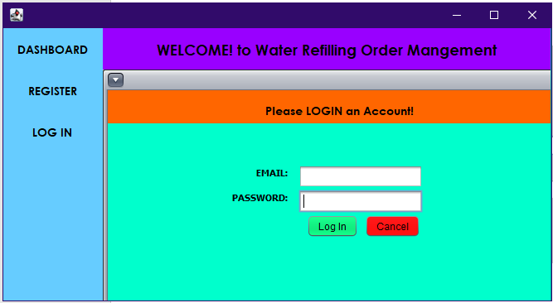

Upon running the program, you will be presented with the main log in form.

Features & Actions:

EMAIL: Enter the EMAIL you chose during registration.

Password: Enter your password (securely hashed in the system).

Login Button: Click this button to sign into the system. Upon successful login, you will be directed to your role-specific dashboard (Admin or Staff).

Create Account
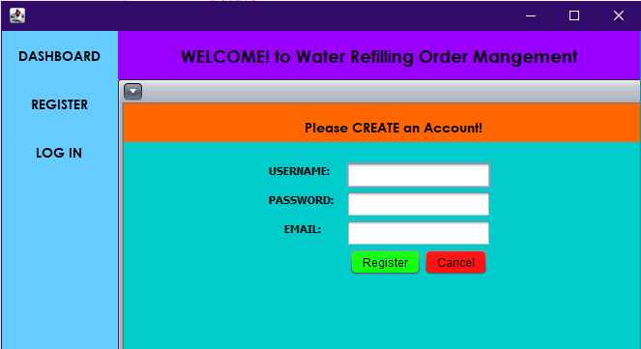

The process begins with the Create Account screen. This screen is for new users to register on the platform.

Features & Actions:

Enter Username: Type your assigned username into the first text field.

Enter Password: Type your secret password into the second field (the characters will be hidden for security).

Email: Enter a valid email address for account communication. (Email Most be Unique).

Password: Set a strong, secure password (will be hashed for security).

Register: Click this button once all fields are complete to create your account.

Note: New accounts are created with a default status (such as 'Pending' or 'Active') as defined by the system administrator to maintain security and oversight of who can access the station's records.

ADMIN DASHBOARD
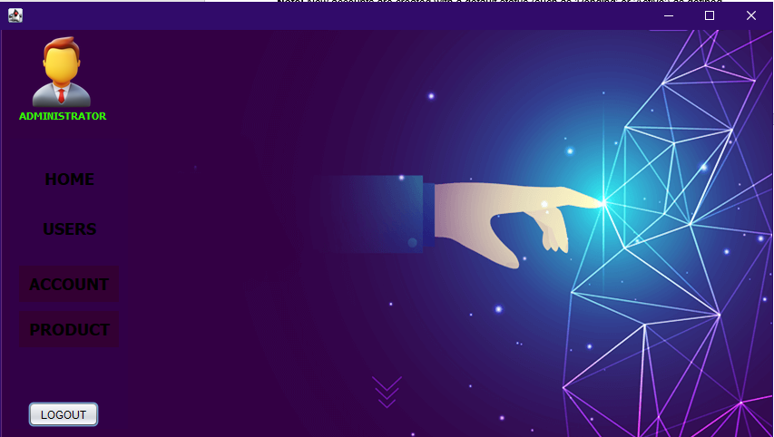

Upon successful login as an administrator, you will land on the Admin Dashboard. This is your central hub for monitoring hotel operations and managing the entire system.

Features & Actions:

1. Role Identity Indicator: View your current access level represented by the ADMINISTRATOR label and icon at the top of the sidebar.
2. Module Navigation: Click the following labels to switch between system views:
- HOME: Returns you to the main Admin Dashboard containing sales summaries and recent activity.
- USERS: Opens the user management table to review staff accounts and statuses.
- ACCOUNT: Navigates to the personal profile settings where you can update your own contact details.
- PRODUCT: Redirects to the inventory management section to track and update water container stocks and pricing.
3. Session Termination:
- Locate the "LOGOUT" button at the bottom of the sidebar.
- Click the button to securely exit your current session and return to the main login portal.

MANAGE USERS
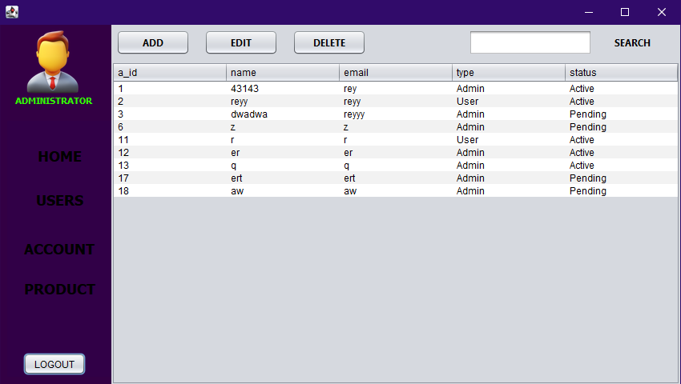

Viewing All User Accounts

When you click "USERS" from the sidebar, you will see the User Management interface. This is your control center for administering all system users.

Features & Actions:

- Account Status Oversight: View a comprehensive list of users, including their Account ID (a_id), Name, Email, Type (Admin or User), and Status (Active or Pending).
- Account Modification:
  - ADD: Open a dialog to manually register a new staff member or administrator.
  - EDIT: Select an existing user from the table to update their information or change their account status from "Pending" to "Active".
  - DELETE: Remove an account permanently from the tbl_accounts database if access is no longer required.
- Search Functionality: Use the Search field to quickly locate a specific user by their name or email address.

ADD USER ACCOUNT
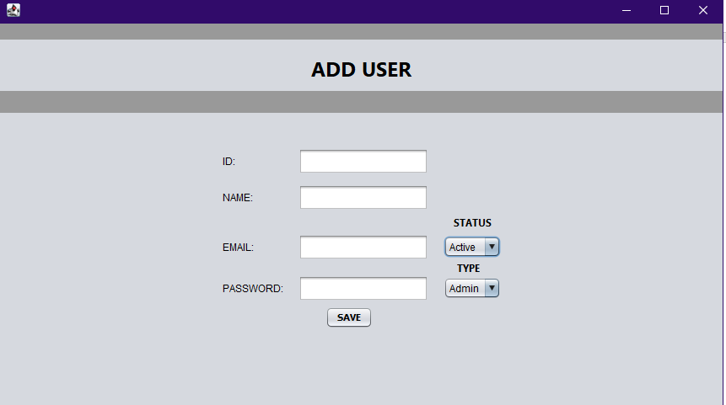

When you click the "Add" button from the USER TABLE screen, this blank entry form appears.

Features & Actions:

- Manual ID Assignment: Enter a unique identification number in the ID field. This serves as the primary key for the user in the database.
- Profile Information Entry:
  - NAME: Input the full name of the new staff member.
  - EMAIL: Provide a valid email address for account correspondence and identification.
  - PASSWORD: Assign an initial secure password for the user's first login.
- Role & Access Control:
  - STATUS Dropdown: Select between Active or Pending. Setting a user to "Active" allows immediate system access, while "Pending" holds the account for further verification.
  - TYPE Dropdown: Designate the account as either Admin (full system access) or User (standard POS and transaction access).
- Database Integration: Click the "SAVE" button to commit the new user record to the tbl_accounts table.

Note: Administrators should ensure that the assigned ID is unique. If a duplicate ID is entered, the system database will reject the entry to maintain data integrity.

EDIT USER ACCOUNT
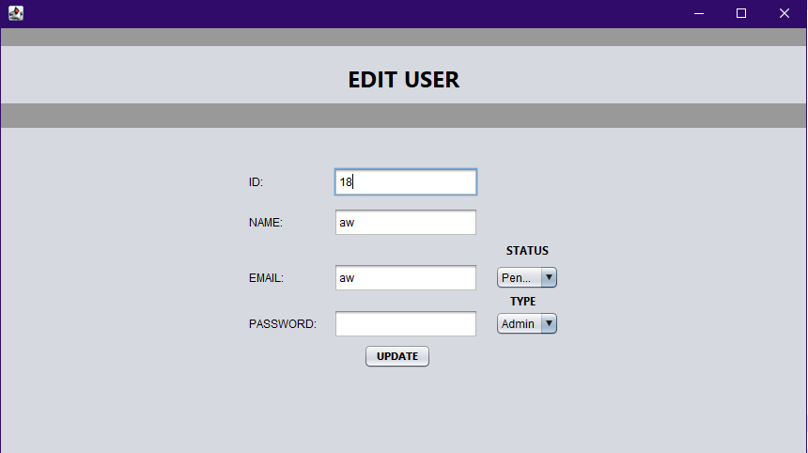

When you select an existing user and click "Edit," the form populates with their current data to ensure accuracy during updates.

Features & Actions:

- Fixed ID Reference: The ID field displays the unique identification number of the selected user. This ensures the correct record in the database is being modified.
- Information Modification:
  - NAME: Update the user's name if corrections are needed.
  - EMAIL: Modify the email address linked to the account.
  - PASSWORD: Reset or update the user's password to maintain account security.
- Permission & Status Control:
  - STATUS Dropdown: Toggle the user’s access between Active and Pending. This is the primary method for authorizing or temporarily suspending a staff member's system access.
  - TYPE Dropdown: Upgrade or downgrade a user’s role between Admin and User to adjust their level of system authority.
- Applying Changes: Click the "UPDATE" button to overwrite the previous data in the tbl_accounts database with the new information.

Note: Changes made in this module take effect immediately upon the user's next login or system refresh. It is recommended to verify the status of a user before finalizing an update.

DELETE USER ACCOUNT
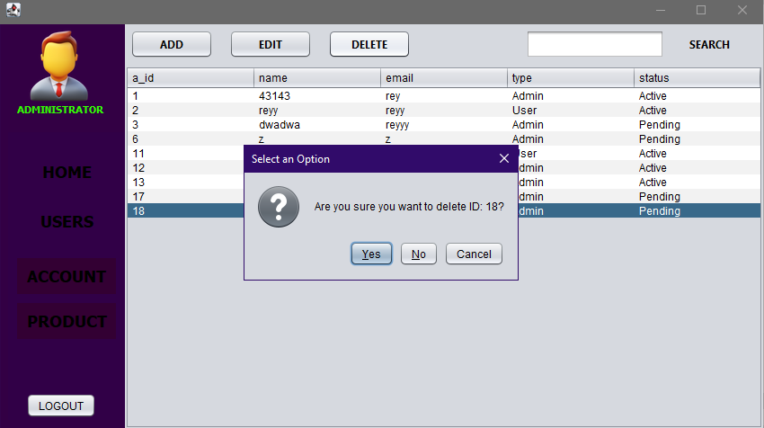

When you select a user from the table and click the "Delete" button, a confirmation dialog box appears.

Features & Actions:

- Row Selection: To remove an account, first click on the specific user row in the Users table. The selected row will be highlighted in blue.
- Targeted Deletion: Click the "DELETE" button at the top of the interface.
- Security Confirmation Dialog:
  - A "Select an Option" pop-up will appear, explicitly asking, "Are you sure you want to delete ID: [Number]?" * This feature ensures that the administrator verifies the specific Account ID before any permanent data loss occurs.
- Decision Actions:
  - Yes: Click this to permanently erase the account record from the tbl_accounts database.
  - No / Cancel: Click either of these to abort the process and keep the account data intact.

Note: Deletion is permanent. Once an account is deleted, it cannot be recovered through the software interface

MANAGE PRODUCTS
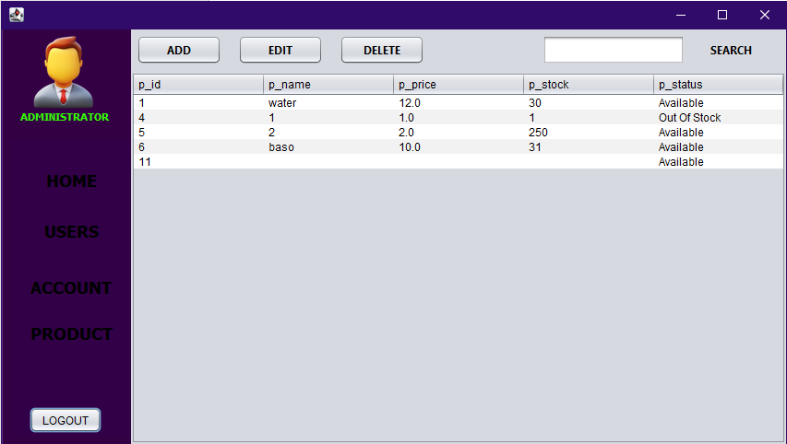

The Product module provides the Administrator with a real-time overview of all sellable items, ensuring that stock levels and pricing are always up to date.

Features & Actions:

- Inventory Data Table: Monitor the essential details of your stock across five key columns:
  - p_id: The unique identification number for each product.
  - p_name: The descriptive name of the item (e.g., "water", "baso").
  - p_price: The current retail price per unit.
  - p_stock: The exact quantity currently available in the station.
  - p_status: A quick visual indicator of availability (e.g., Available or Out of Stock).
- Inventory Search: Use the Search bar at the top right to quickly filter through the product list, especially helpful when managing a large variety of container sizes or accessories.
- Product Maintenance:
  - ADD: Click this to register a new product type into the system.
  - EDIT: Select an item from the table and click Edit to adjust its price, rename it, or update stock levels after a delivery.
  - DELETE: Use this to remove discontinued products from the active inventory list.

Note: The p_status is automatically linked to the p_stock count. If the stock reaches 1 or 0, it is good practice for the administrator to update the status to "Out of Stock" to prevent staff from processing invalid orders.

ADD PRODUCTS
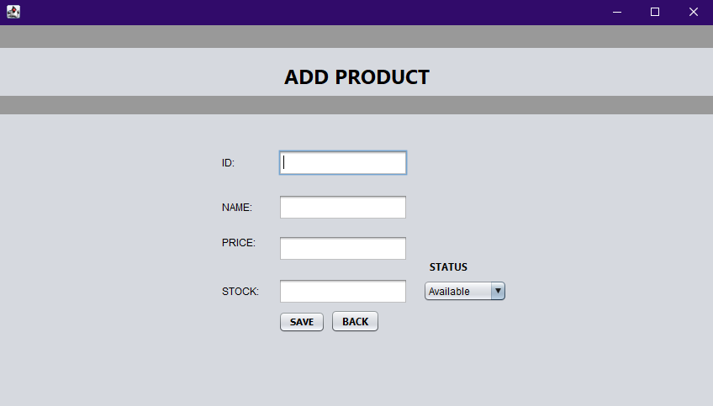

This interface allows administrators to expand the station’s offerings by registering new container types or accessories into the system.

Features & Actions:

1. Unique Product Coding: Enter a specific identification number in the ID field to serve as the product's primary database key.
2. Inventory Specification:
- NAME: Input the name of the new item (e.g., "5 Gallon Round", "Slim Container").
- PRICE: Set the retail price per unit.
- STOCK: Enter the initial quantity available for sale.
3. Availability Management: Use the STATUS dropdown to set the item's initial state:
- Available: Item is ready for sale and will appear in the transaction module.
- Out Of Stock: Item is registered but currently unavailable for purchase.
- Unavailable: Item is hidden from the standard sales view.
4. Database Submission:
- Click SAVE to commit the new product to the tbl_products table.
- Click BACK to discard the entry and return to the main Product Dashboard.

EDIT PRODUCT
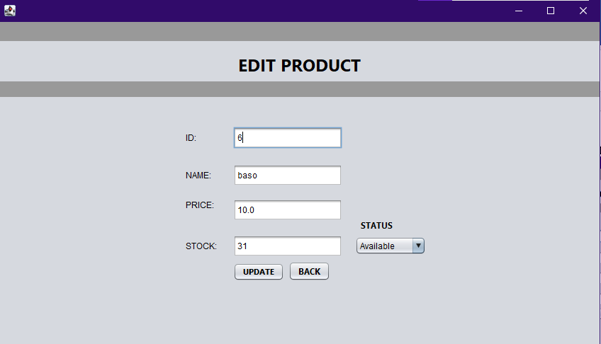

This interface is used by administrators to modify the details of existing items in the inventory, such as updating prices or restocking supplies.

Features & Actions:

1. Fixed Product Reference: The ID field displays the unique identifier of the product currently being modified, ensuring changes are applied to the correct database record.
2. Inventory Data Modification:
- NAME: Update the product description (e.g., changing "Round" to "Blue Slim").
- PRICE: Adjust the retail cost per unit to reflect market changes or promotions.
- STOCK: Manually update the quantity available after a new delivery or inventory count.
3. Availability Toggle: Use the STATUS dropdown to change the product's visibility (e.g., switching from "Available" to "Out of Stock").
4. Execution Buttons:
- Click UPDATE to save the new parameters to the tbl_products table.
- Click BACK to exit the editor without saving changes.

DELETE PRODUCT
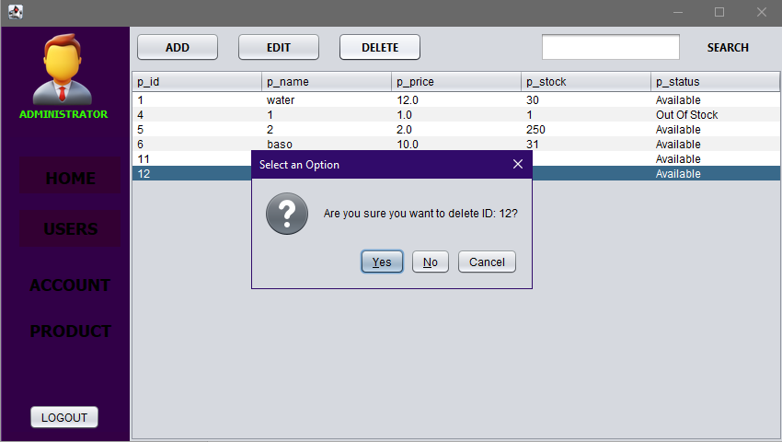

To prevent accidental data loss, the system triggers a confirmation prompt when the "Delete" button is pressed.

Features & Actions:

1 Row Selection: Navigate to the PRODUCT module and click on the specific product row (e.g., ID 11) you intend to remove.
2. Triggering Deletion: Click the DELETE button located at the top of the inventory table.
3. Verification Dialog:
- A "Select an Option" pop-up will appear with a question mark icon, asking: "Are you sure you want to delete ID: [Product ID]?".
- This step forces the administrator to double-check the product identity before the record is purged from the database.
4. Decision Actions:
- Yes: Permanently deletes the product and its stock data.
- No / Cancel: Closes the dialog and retains the product in the inventory.

ADMIN PROFILE
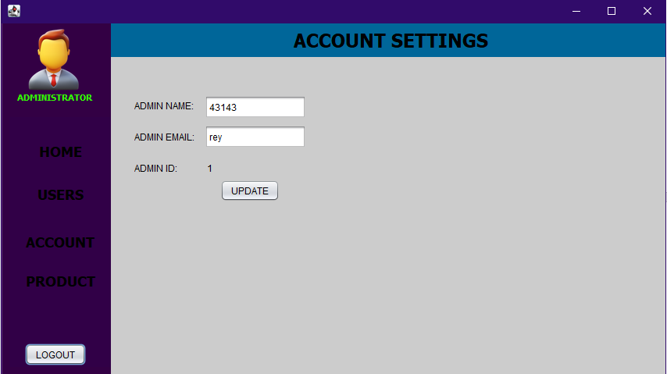

When you click on the "ACCOUNT" icon in the left sidebar, the system displays your personal administrative dashboard. This is a read-only view of your current credentials.

Features & Actions:

1. Profile Overview: View your current ADMIN ID and active ADMIN NAME and ADMIN EMAIL as recorded in the system.
2. Information Updates:
- Modify your display name and contact email directly in the text fields.
- Click the UPDATE button to synchronize these changes with your specific account in the database.
3. Global Navigation: Even while managing your profile, use the left sidebar to quickly switch back to the HOME, USERS, or PRODUCT modules.

LOGGING OUT
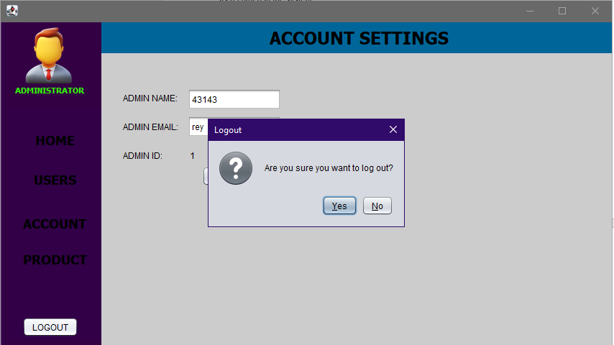

Properly exiting the application ensures that your session is closed and your data remains secure.

Features & Actions:

1. Logout Initiation: Click the LOGOUT button located at the bottom of the navigation sidebar from any administrative module.
2. Confirmation Gateway:
- A "Logout" confirmation dialog will appear, asking: "Are you sure you want to log out?".
- This prevents accidental session termination while multitasking between inventory and user management.
3. Decision Actions:
- Yes: Terminates the current session and redirects the user back to the main Login Portal.
- No: Closes the dialog and keeps the administrator logged into the current dashboard.

STAFF DASHBOARD
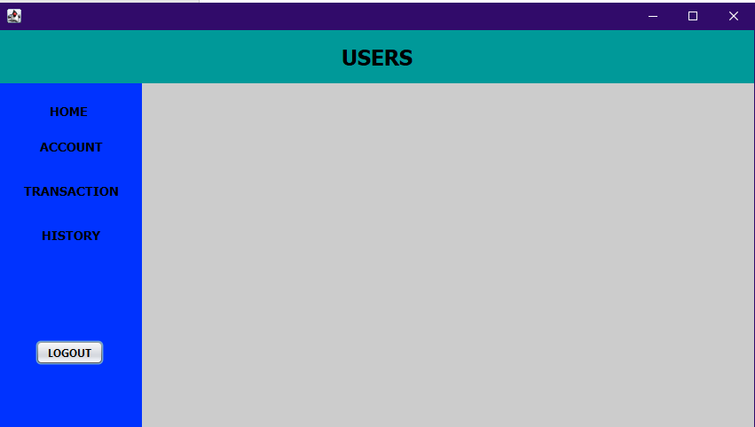

Upon successful login as a staff member, you will land on the Staff Dashboard.

Features & Actions:

1. Role Identity: The sidebar displays a permanent USERS header, confirming the standard access level for the active session.
2. Operational Navigation: Access core daily tasks via the vertical sidebar menu:
- HOME: Navigates to the main operational landing page.
- ACCOUNT: Opens the profile management screen for the logged-in staff member.
- TRANSACTION: Opens the Point of Sale (POS) interface to process new customer orders.
- HISTORY: Directs the user to the sales ledger to review past transactions.
3. Secure Session Termination: The LOGOUT button is anchored at the bottom left to ensure the workstation is secured between shifts.

MANAGE STAFF ACCOUNT
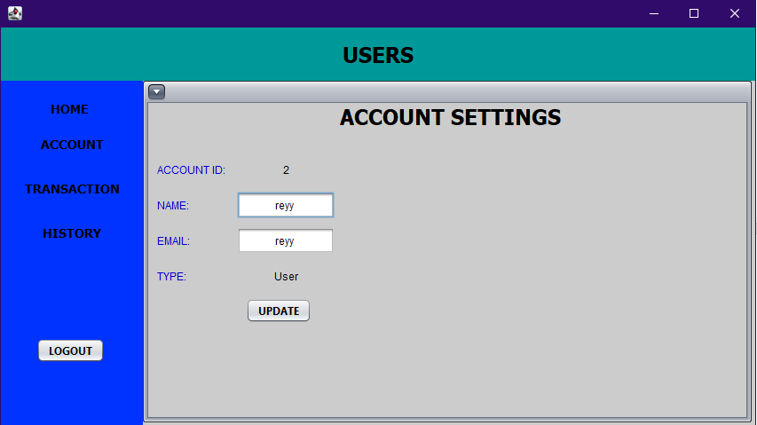

Standard staff members have the autonomy to manage their own profile details within the system to ensure their contact information is accurate.

Features & Actions:

1. Fixed Identifier: The ACCOUNT ID is a read-only field that displays the user's permanent database ID, ensuring that updates are tied to the correct record.
2. Profile Personalization:
- NAME: Staff can update their display name for better identification on transaction records.
- EMAIL: Allows for the correction or updating of the staff member's linked email address.
3. Role Visibility: The TYPE field (e.g., "User") is displayed as a non-editable label, confirming the staff member's current permission level.
4. Synchronizing Data: Click the UPDATE button to commit any changes to the server. These updates are reflected immediately across the system, including in the administrative user ledger.

TRANSACTION
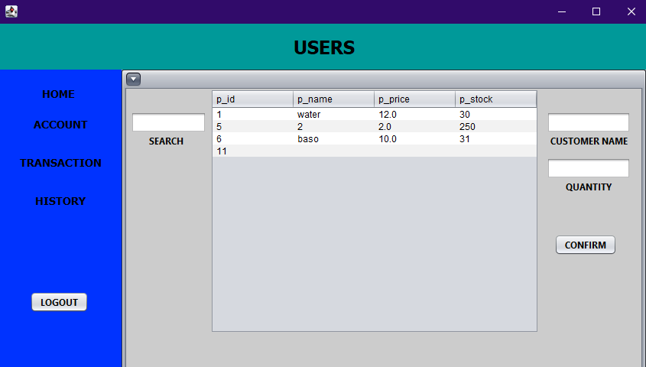

The Transaction module is the primary functional screen for staff, designed to handle fast-paced customer orders while maintaining accurate inventory records.

Features & Actions:

1. Integrated Inventory Table: View a real-time list of available products, including their unique p_id, p_name, p_price, and current p_stock levels.
2. Search Functionality: Use the SEARCH field to filter the inventory list by product name, allowing staff to quickly locate items like "water" or "baso" during busy periods.
3. Order Entry Panel:
- Customer Name: Input field for the client's name to personalize the transaction record.
- Quantity: Input field for the number of units being purchased.
4. Confirmation Action: Click the CONFIRM button to finalize the sale. This action triggers two automated background processes:
- Inventory Update: Deducts the purchased quantity from the p_stock in the database.
- Transaction Logging: Records the sale in the sales history for later revenue tracking and receipt generation.

ORDER HISTORY

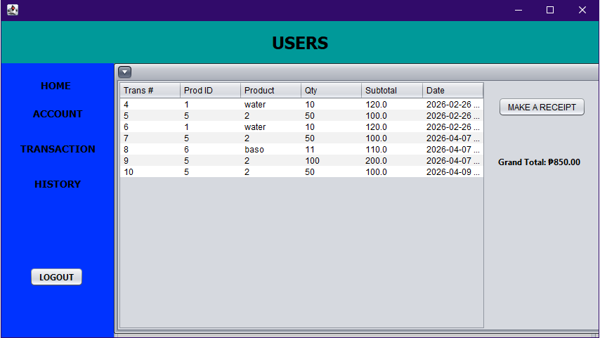
The History module provides the station personnel with a clear audit trail of all processed sales, ensuring transparency and ease of reconciliation at the end of a shift.

Features & Actions:
- Transaction Record Table: A detailed list of all completed orders, organized by six critical columns:
  - Trans #: The unique incremental transaction number.
  - Prod ID: The identification number of the item sold.
  - Product: The descriptive name of the item.
  - Qty: The total units sold in that specific transaction.
  - Subtotal: The calculated revenue for that entry (Price $\times$ Quantity).
  - Date: The timestamp of when the sale was finalized.
- Revenue Performance: The Grand Total is dynamically calculated and displayed at the bottom right. This represents the total cash-on-hand expected from the staff member's active session (e.g., ₱850.00).
- Documentation Fulfillment:
  - Select a Record: Click on any row within the history table to highlight it.
  - MAKE A RECEIPT: Click this button to generate a official receipt for the selected transaction. This typically launches a PDF preview or print dialog for the customer.

Make A Receipt
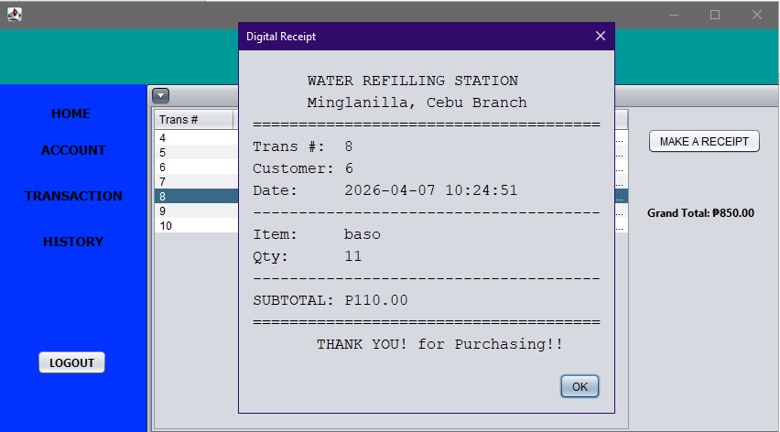

The Digital Receipt is an automated document generated upon request to provide customers with a formal record of their purchase. It extracts live data from the tbl_history database to ensure accuracy.

Features & Actions:
- Station Branding: The receipt header clearly identifies the business as WATER REFILLING STATION and specifies the branch location (e.g., Minglanilla, Cebu Branch).
- Automated Data Population:
  - Trans #: Displays the unique transaction ID for tracking.
  - Customer: Shows the name provided during the transaction process.
  - Date: Provides a precise timestamp (Date and Time) of the sale.
- Itemized Breakdown:
  - Item: Displays the specific product name (e.g., "baso").
  - Qty: Shows the quantity purchased.
  - SUBTOTAL: Displays the final price in Philippine Pesos (e.g., ₱110.00).
- Closing Action: Click the OK button to close the preview.

Receipt Export To PDF

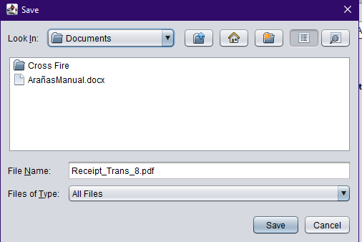

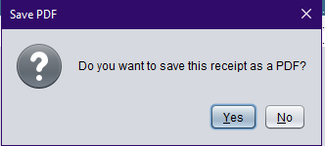

Once the operator reviews the digital receipt and clicks "OK," the system triggers the PDF generation protocol to provide a permanent, printable document for the customer.

Features & Actions:
- Export Confirmation Gateway:
  - A "Save PDF" dialog box appears with the prompt: "Do you want to save this receipt as a PDF?".
  - Yes: Triggers the system's file explorer to define a save location.
  - No: Closes the dialog and returns the staff member to the History Ledger without creating a physical file.
- File Management Interface:
  - The "Save" explorer window opens, defaulting to the system's "Documents" folder or the last used directory.
  - Automated Naming: The system pre-fills the File Name field using a standardized format (e.g., Receipt_Trans_8.pdf), ensuring easy retrieval for future audits.
  - Directory Navigation: Staff can browse existing folders (such as "ArañasManual") to organize daily sales records systematically.
- Finalizing the Export:
  - Save: Click this button to generate the PDF file using the iText library.
  - Cancel: Aborts the saving process and preserves the system state.

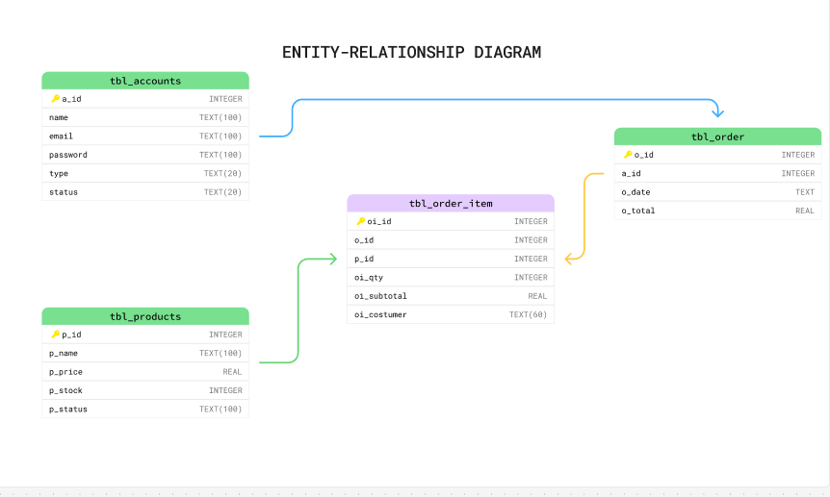

LINKS:

GITHUB - https://github.com/reyjomar12/GUI.git
FIGMA - https://www.figma.com/board/zUyDKMjHQhEPL5WIDTiwCF/Diagram-Basics--Community---Copy---Copy-?node-id=0-1&p=f&t=i5LZtbR0fXpZpEUH-0

