**SECURITY SYSTEM**

**BY:**

**Hussein El-Charif 31930723**

**Mohamad Ali Ghaddar 31930691**

System 1 link: [door lock system](https://www.tinkercad.com/things/4A93oOg3Ui9-senior/editel?sharecode=UfM-cit9vzUE6sprMKbiWrQVCL7AIDnHt2JAUJRVDrs)

Systems 2 & 3 link: [gas leak & fire alarm security systems](https://www.tinkercad.com/things/jL9ROn2rA8k-senior-fire-alarm/editel?sharecode=adqDL0L98u85oVDaMw5DZL1uslfWMb8XJsziP2Afi3g%20%20)

**This project is divided between 3 systems:**

**Door lock security system:**

**TOPIC:**

Door lock security system is a security system that checks the user credentials to allow them to access the room ahead. This system is automatic and will monitor all user’s actions on the keypad.

The door lock system is supposed to have these features:

* **Check user credentials & monitor his/her activity.**
* **Display on an LCD monitor if credentials are correct/incorrect & Display Open/Closed for door status.**
* **Provide a green light and ring the buzzer and open the door when credentials are correct.**
* **Provide red light and ring the buzzer twice when credentials are incorrect.**
* **Let the user change the password.**

The stakeholders for this system are the user and the door lock system.

**COMPONENTS:**

LCD monitor Resistors Breadboard

4x4 Keypad Piezo buzzer Wires

Arduinho uno R3 Green LED light

Micro servo Red LED light

**DFD:**

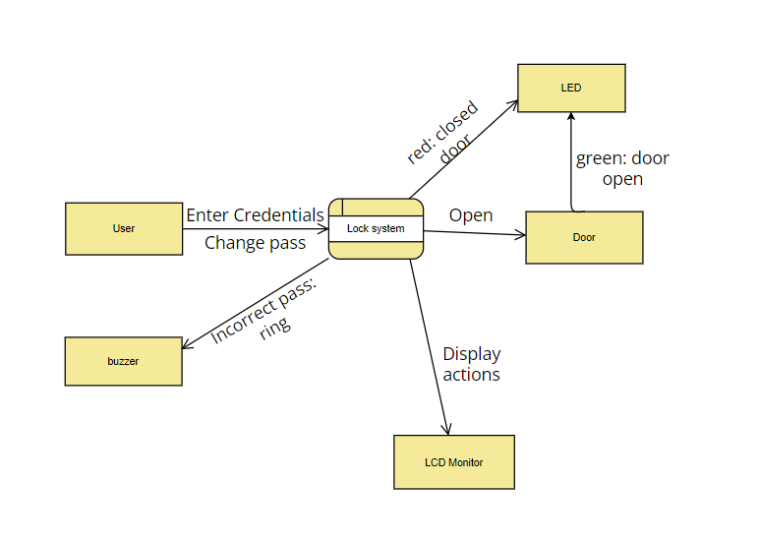

**ERD:**

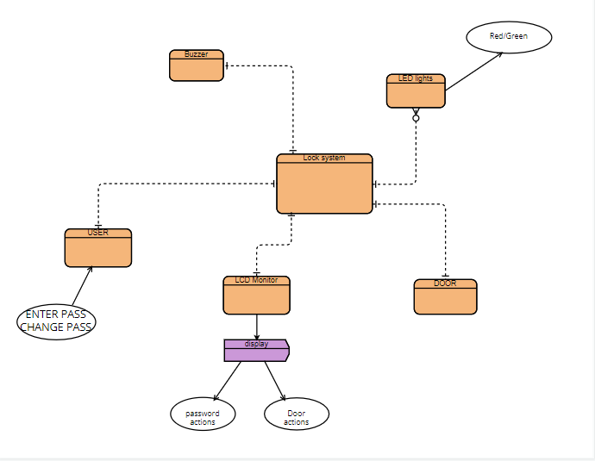

**Gas leak security system:**

**TOPIC:**

Gas leak security system which allows the user to figure out when there’s a fire by identifying smoke and/or gazes.

The system will be able to:

* Identify smoke and gazes to alert the company of a gas leak.
* Ring the buzzer when there’s a gas leak.
* Display the atmosphere pressure on an LCD monitor in parts per million

The stakeholders for this system are the gas sensor and the company.

**COMPONENTS:**

LCD monitor

Arduinho uno R3

Resistor

Piezo buzzer

Gas sensor

Breadboard

Wires

**DFD:**

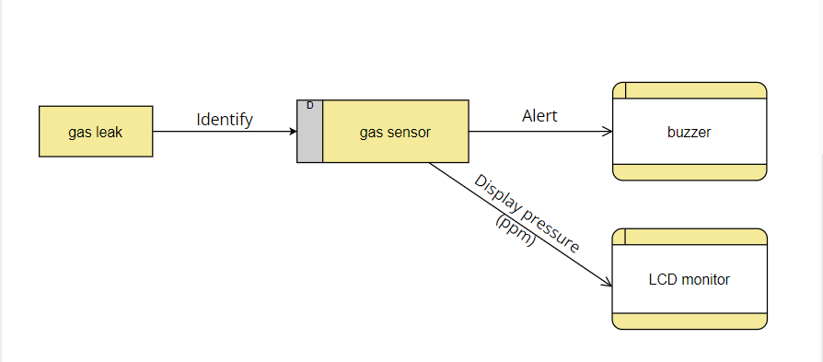

**ERD:**

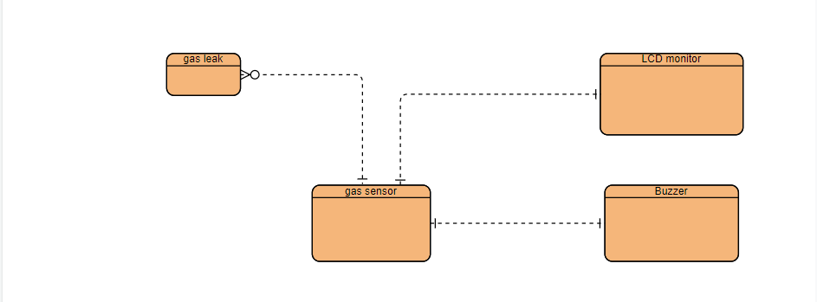

**Fire alarm security system:**

**TOPIC:**

Fire alarm security system which alarms the user of high levels of temperatures in the company’s atmosphere, it will also show the user the current temperature in Celsius.

This system will be able to:

* Show a white light when the temperature is cold.
* Show a green light when the temperature is normal.
* Show a red light and ring the buzzer when the temperature is high.
* Display the current temperature on an LCD monitor.

The stakeholders for this system are the temperature sensor and the company.

**COMPONENTS:**

LCD monitor

Arduinho uno R3

Green LED light

Red LED light

White LED light

Breadboard

Wires

Piezo Buzzer

Resistors

**DFD:**

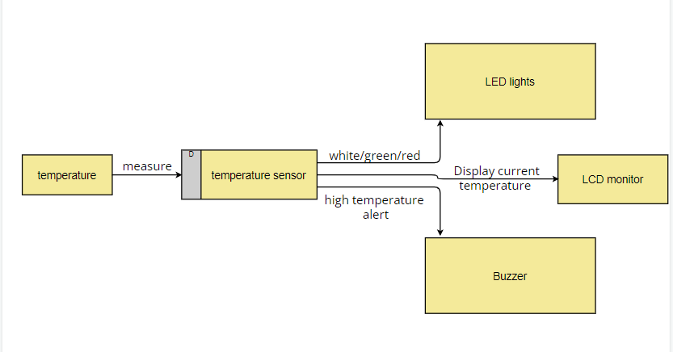

**ERD:**

