**SPEEDTEST MODULE**

# CONTENTS

## This module has the following files:

1. MODULE_SPEEDTEST.docx
2. MODULE_SPEEDTEST_MEDIA.zip

## B1. Particle Button

Create an interactive animation using CSS only. When user click the “Click Me!” Button, many particles with diffusion effect will be displayed around the button.

You can only edit the style.css file.



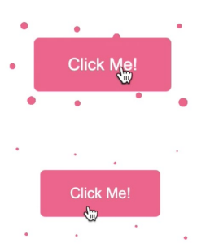



## B2: Modern layout (Easy)

Your task is to create the following layout, the posts’ width is ⅓ of the container’s on desktop screen size (>=1440px) and full width below this.

## B3. Loading Screen (Normal)

Create an animated loader using only HTML and CSS same as video.mp4. The loader animation should be looped. 4 different colors (#19A68C, #F63D3A, #FDA543, #193B48) should be used.

Screen shots:

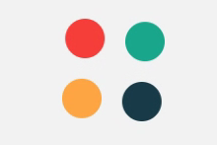  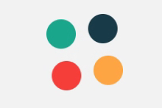 

## 

## B4. Yellow Square (Easy)

Make an animation that starts with a big yellow square, and this square turns a small red circle, the animation needs to be centered on the view and the animation needs to loop;

## 

## C1. Digital Timer

Create a digital timer, time format is: 3 digit of seconds passed, and centiseconds following it. Its max value is: “999:59”. “Start timer“ button starts, “Stop timer” button stops, “Reset timer” button stops and resets to 0 the timer.

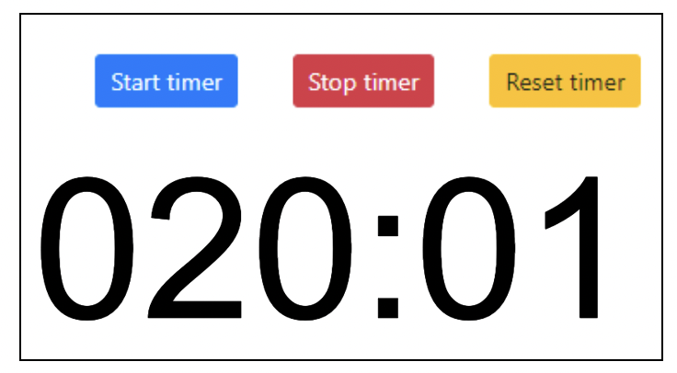

## C2. Mouse Style

Change the style of the mouse. When clicked, it should display an animation.

See **mouse.mp4** in the given folder to understand the functionality.



## C3: Color Waves (Normal)

You should develop dynamic color changing waves in this task.

· User input is validated if the inputted color is valid or not.

· If the user clicks on the first box, the other box’s color will also change, have a delay in each box.

· If the user changes its input the color wave effects still work.

You cannot use JavaScript libraries

You can only edit script.js

See the color-waves.mp4 in the given folder to understand the functionality.

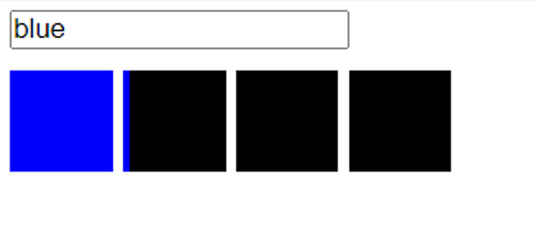

## C4. Canvas Hover

Draw a ball with border in a container of 400px height and 400px width using canvas. Make "ball" follow mouse on canvas.

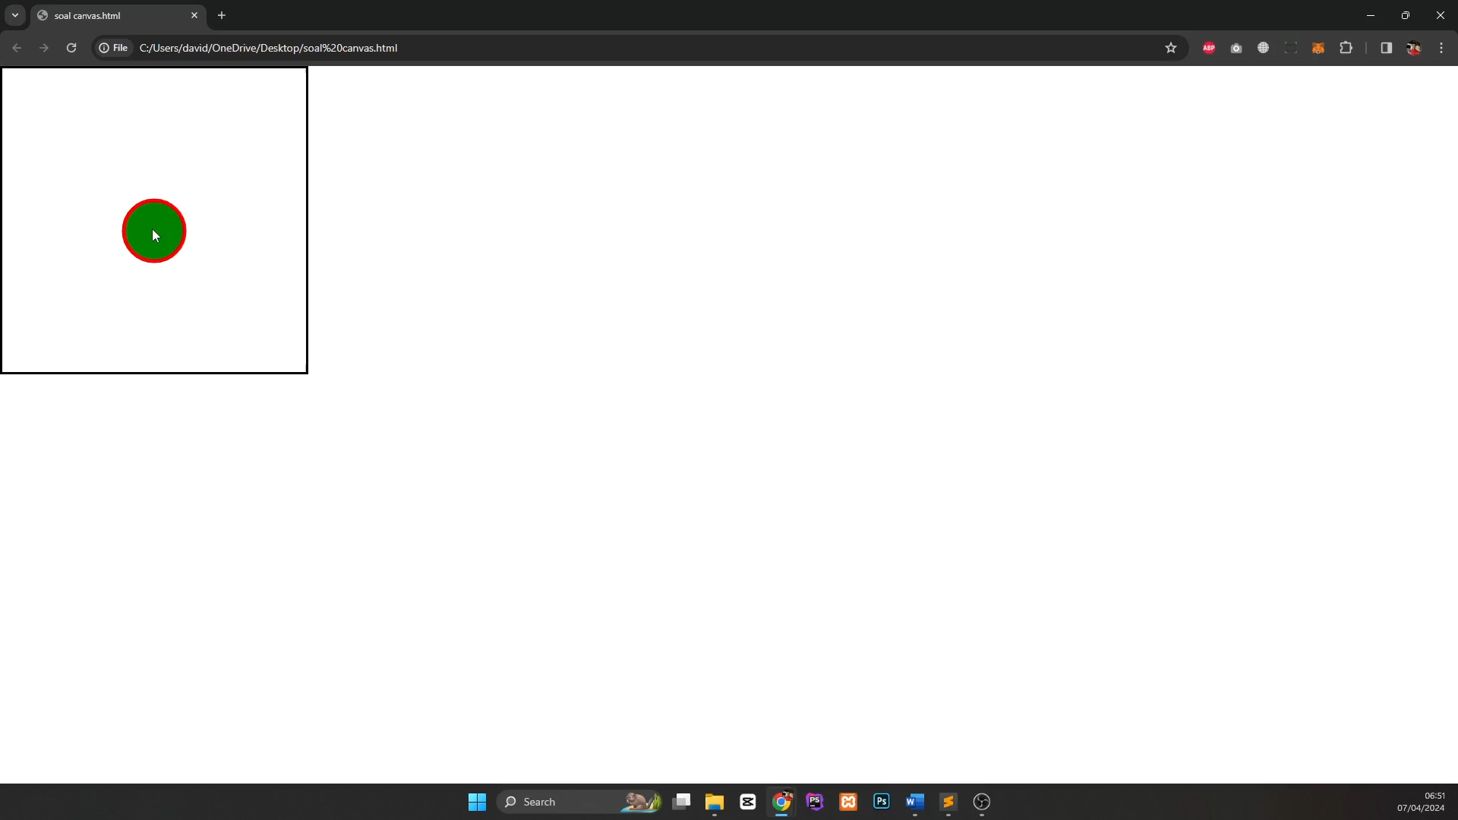 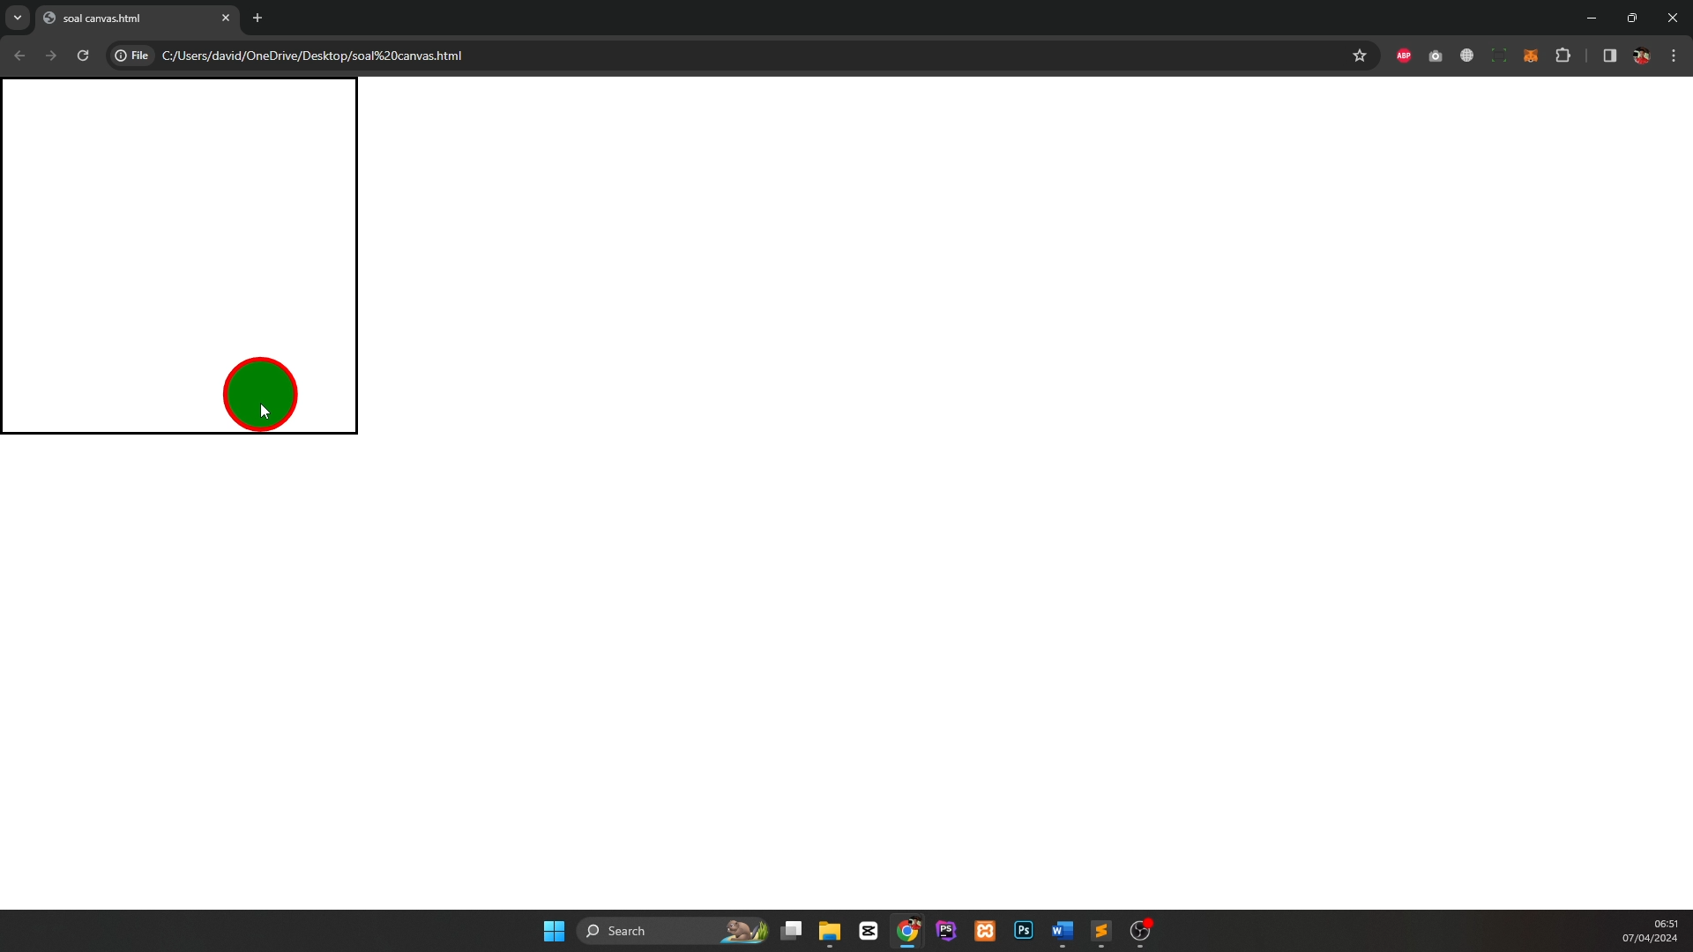

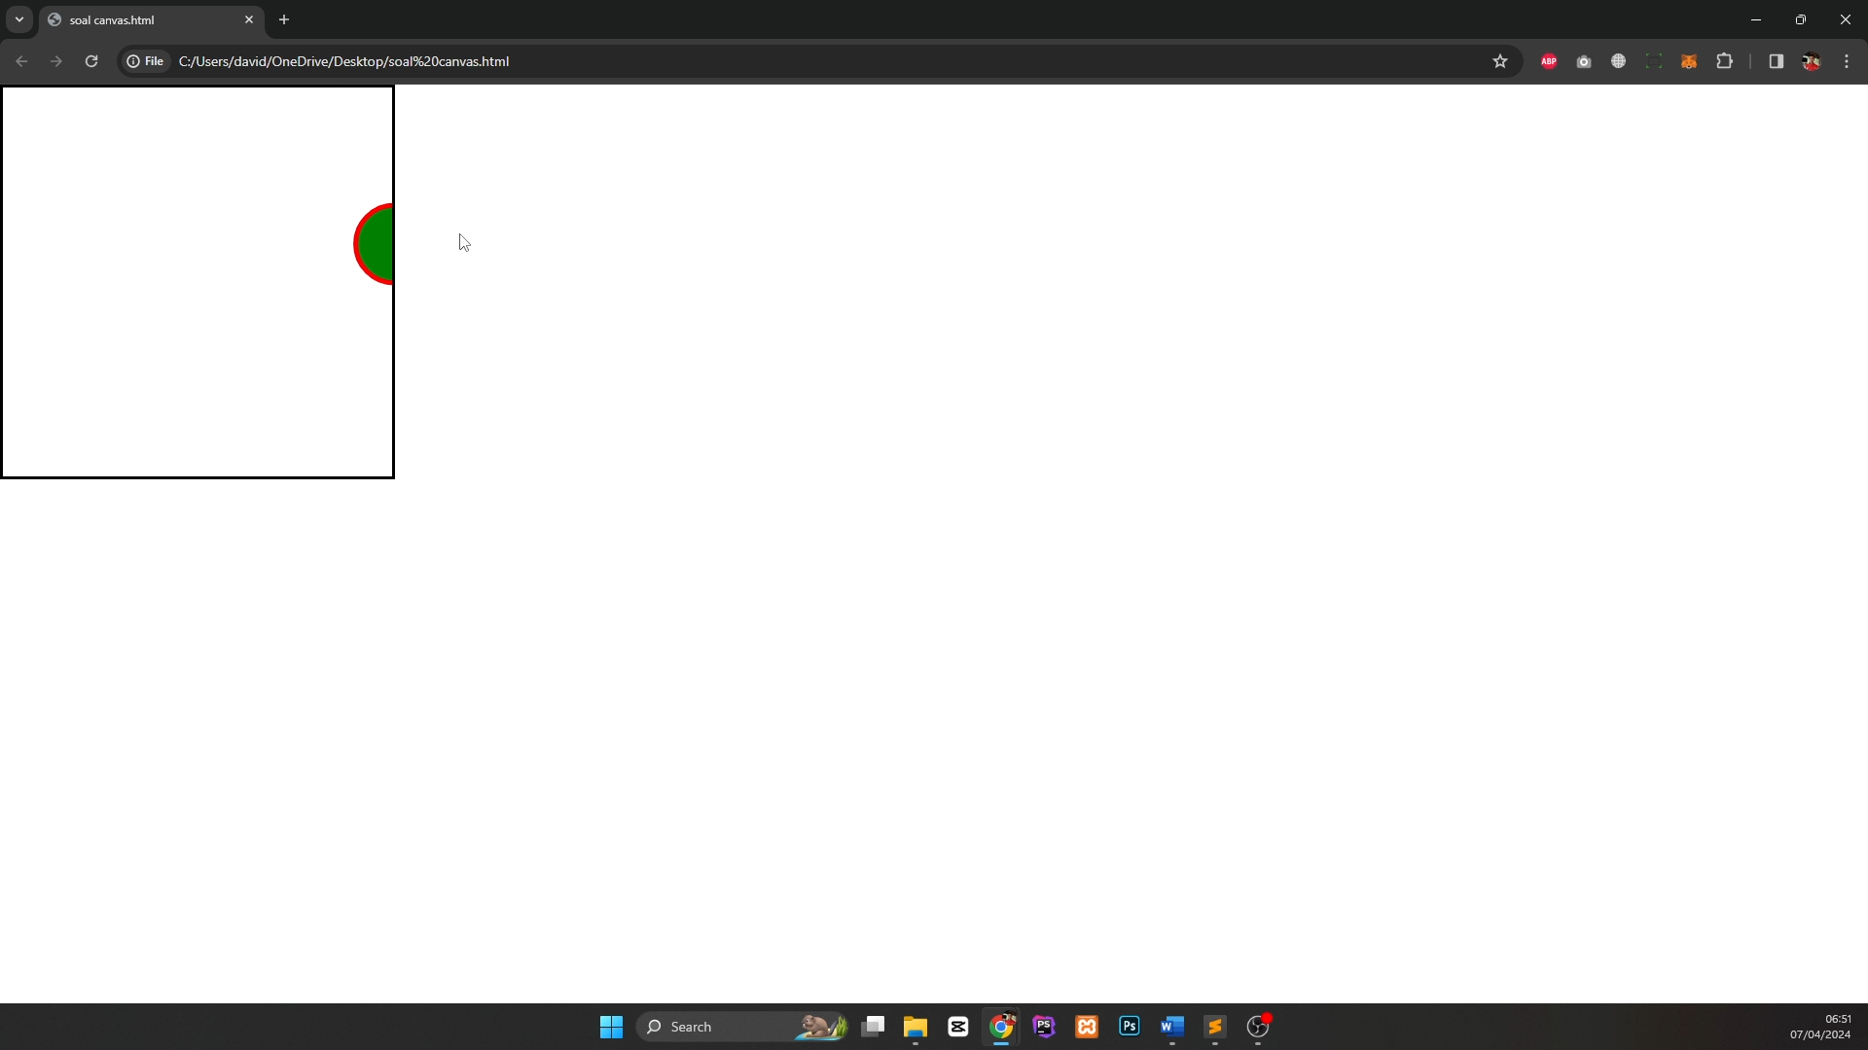

# **D1: Count Letter and Case Count (Easy)**

## You should create a form that will accept a string. After the string is submitted, within the same page, it will display the number of characters on the input box and count how many uppercase and lowercase characters there are in the string.

## 1. Cannot use Javascript

## 2. Only alphabets are considered as character.

## 

## D2. Generate File DOC

* In a form you must insert a title and then its content, when submitting the form you must download a DOC document where you can open it and view the content in the DOC file.
* The file must be called as the title of the form.
* The content must be included in the file with its respective title and paragraph.

Example video: **create_file.mp4**

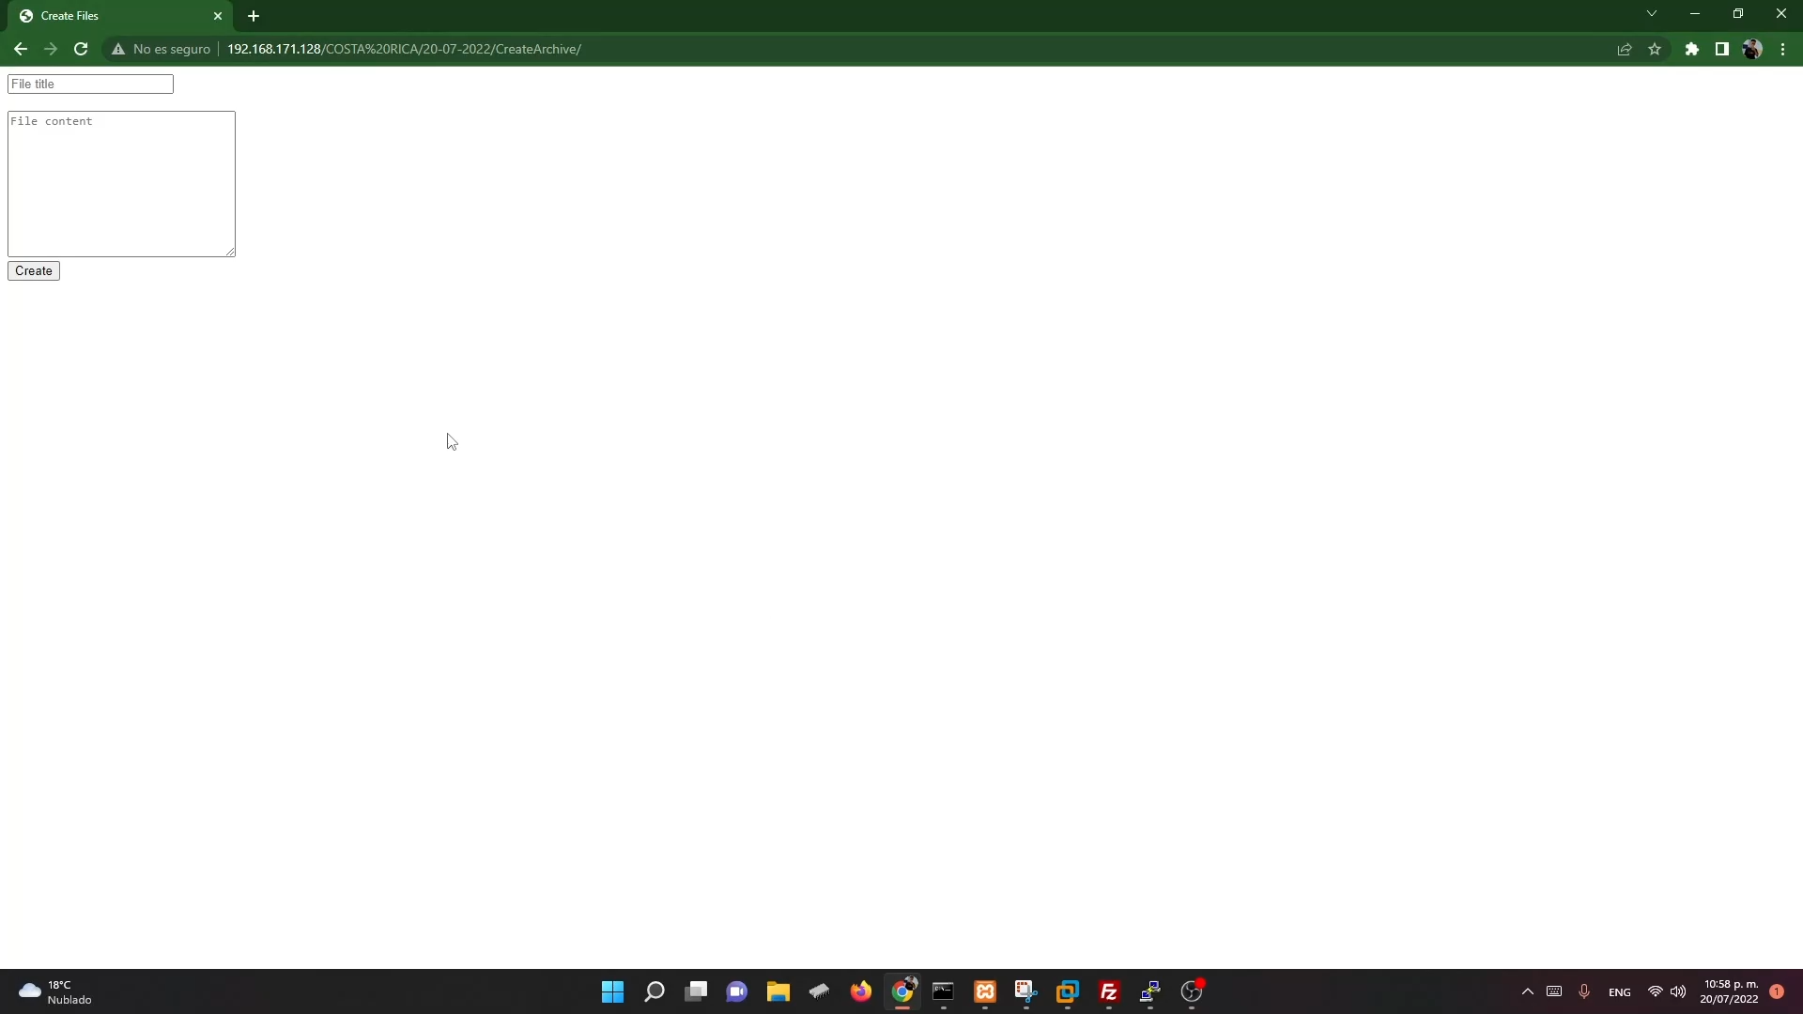  
An HTML_TO_DOC PHP class is provided.

## D3. Answer Checker

You are provided with two CSV files. One file contains the actual answers, and the other file contains the submitted answers. You are expected to develop a web page, displaying a table showing the question number, actual answer and submitted answer. At the bottom of the table, display the scores for this submission. Eg, if there are 8 correct answers and there are 10 questions. Display the score as “8/10”.

Screen shot:

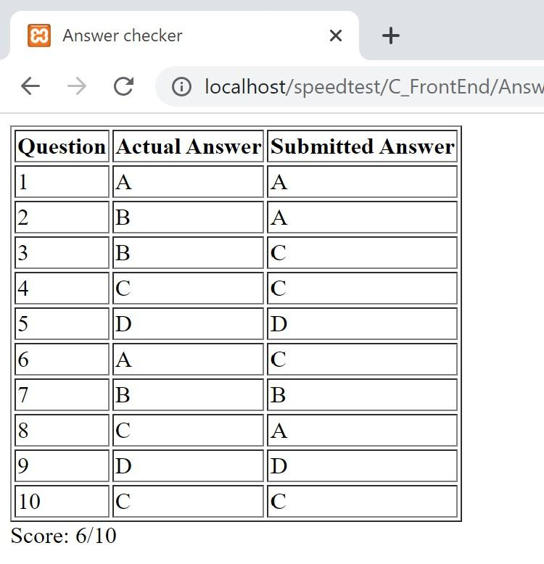

## D4. Array Manipulation

Create an array containing the numbers 1 to 40. When the file is run using index.php?factor=n, the content of the array changes to indicate which are the numbers that are multiple of n.

Example: For example index.php?factor=4

