**A PROPOSED OFFERING OF INVENTORY AND SALES LOGGING SYSTEM FOR PANDAYAN SCHOOL SUPPLIES STORE**

A Technical Documentation Presented to the

Faculty of Datamex College of Saint Adeline, Inc.

In Partial Fulfillment of the Requirements for the

Degree of Bachelor of Science in Information Technology

By:

Baquilar, Lovely

Tapitan, Reylyn

Ebona, Shiela

Tamparong, Meldrin L.

October 2025

**TECHNICAL DOCUMENTATION**

**INTRODUCTION**

The purpose of this is to provide a complete technical guide for the Inventory and Sales System developed for Pandayan school supplies store. It explains how the system was designed, how it works, and how it should be installed, configured, and maintained. The document also serves as a reference for users, developers, and future maintainers.

The Inventory and Sales System is a desktop-based application that improves sales transactions and inventory management. It is designed to record transactions, update stock levels automatically, and generate detailed sales reports. The system includes features such as product management, transaction logging, and user account security. It reduces errors from manual processes and outdated reporting methods often result in inefficiencies that affect both operations and customer service.

This technical documentation covers the functional and non-functional requirements of the system, It also includes testing methods, troubleshooting guides, and maintenance procedures. The scope ensures that anyone using this document will be able to operate, manage, and update the system effectively.

**SYSTEM OVERVIEW**

The Inventory and Sales System is a desktop-based application that help manage store operations easily and accurately. It works as a two-part system that separates the user’s side and the system’s main functions. The first is used by the manager and cashier through a simple and easy to use interface. This allows them to record sales, check inventory, and grpahsfoe daily sales.. While the Manager manage the system logic and the main processes. It also connects to the database to save and organize data properly. Through this setup, the system ensures that all transactions are recorded and stored safely, it helps improve the accuracy, speed, and reliability of daily store operations.

The system is divided into three major components: the user interface, application logic, and database. The user interface allows interaction between the user and the system, providing modules for login, inventory, and sales. The application logic processes user requests, performs data validation, and controls workflow. The database stores all critical data, including products, users, and sales records.

**Deployment architecture**

The system is installed on a single computer in Pandayan school supplies store. the database is stored on the same device, the database is stored locally on the same device, which makes the system independent of internet connectivity. This approach was chosen because it is cost-effective, easy to maintain, and ensures uninterrupted operation even if the store has unstable or no internet connection.

This deployment architecture is justified because Pandayan school supplies store requires a reliable system that can function daily without relying on external servers. At the same time, it offers easy to use for future improvements. If the Pandayan school supplies store decides to expand to more branches, the architecture can be upgraded to use a centralized or cloud-based database, allowing multiple stores to share and synchronize information in real time.

**INSTALLATION GUIDE**

The installation process ensures the system is properly set up on the store’s computer. Before installation, the hardware and software requirements must be met.

Hardware Requirements:

- MD Ryzen 5 6600H with Radeon Graphics

- Minimum 4GB RAM

- At least 16GB free disk space

- Monitor, keyboard, and mouse

Software Requirements:

- Windows 10 or later

- Visual Basic .NET 2010

- SQL Server Management Studio (SSMS)

- .NET Framework 4.8 or higher

Installation Steps:

1. Install SQL Server and SQL Server Management Studio.

2. Copy the system executable (.exe) and database file (.mdf or .accdb) to the computer.

3. Attach the database to SQL Server.

4. Open and run the system executable.

5. Log in using the default Admin credentials provided.

**CONFIGURATION GUIDE**

Detailed Instructions for Configuring the Software:

After installation, the system needs to be configured so it works according to Pandayan school supplies store operations.

Login Setup – The system includes a login feature that requires users to sign in before accessing the system. It has two types of user accounts: Manager and Cashier. The Manager has full control of the system, including managing users and settings. The Cashier account is used for daily operations such as recording sales and checking inventory.

Product Setup – Add product categories, product names, prices, and stock quantities.

Sales Module Setup – Check that sales logging is enabled so each transaction automatically updates the inventory.

Configuration File Formats and Parameters:

Database Connection File: Stores the connection string for SQL Server. It includes the database name, server path, username, and password.

Best Practices for Customization:

-Always create strong passwords for Manager and Cashier accounts to protect sales and inventory data.

-Regular update product categories and prices to keep records accurate.

-Keep a backup of the database file before making major configuration changes.

-Use clear naming conventions for products to make searching and reporting easier

This configuration helps keep the system safe and reliable for everyday use. It allows only authorized users, such as the manager and cashier to access the system. By separating their roles, it prevents unauthorized changes and keeps all records accurate. The setup also helps the system work smoothly and store information correctly. It is designed to fit the needs of Pandayan school supplies store and support its daily operations. Overall, this setup makes the system more organized, secure, and easy to manage.

**API DOCUMENTATION**

The system does not provide APIs because it is a desktop application. All tasks such as sales logging, inventory updates, and reports are handled inside the program and stored directly in the local database. It is not applicable for this system since it does not connect to outside applications. Data moves only between the program and the database in the same computer.

**Authentication and Authorization Requirements:**

Even without APIs, the system has secure login with user roles

**Manager:** Can manage user account

**Cashier:** Can manage products, inventory, users, log sales and view product availability only.

The system does not need APIs because Pandayan school supplies store uses it on a single computer in each branch. This design makes it simple, secure, and cost-effective. However, in the future, APIs may be added if the store decides to connect multiple branches or move to an online system.

**DATABASE DOCUMENTATION**

The database structure ensures all sales, inventory, and user data are organized and traceable. It consists of four main tables: Products, Sales Transactions, Users, and Inventory Logs.

-Products Table: Contains ProductID, ProductName, Category, Quantity, Price, Markup, and RetailPrice.

-Sales Transactions Table: Records each sale with TransactionID, ProductID, Quantity, TotalCost, Date, and UserID.

-Users Table: Includes Username, Password, and Role.

-Inventory Logs Table: Tracks stock-in and stock-out with LogID, ProductID, QuantityChanged, Date, and UserID.

Relationships: One product can appear in multiple sales. Each sale and inventory log is linked to the responsible user, ensuring accountability. Regular backups of the database protect against data loss and system failures.

**Description of Database Tables, Fields, and Relationships:**

**Products Table**

ProductID – unique ID for each product

ProductName – name of the item

Category – type of product

Quantity – current stock available

Price – selling price

Markup – profit margin added to cost

RetailPrice – final price after markup

**Sales Transactions Table**

TransactionID – unique ID for each sale

ProductID – product sold

Quantity – number of items sold

TotalCost – total amount paid

Date – date of transaction

UserID – admin who processed the sale

**Users Table**

Role – type of user (Admin/staff)

Username – login name

Password – encrypted password

**Inventory Logs Table**

LogID – unique ID for each stock entry

ProductID – item updated

Quantity Changed – amount added or removed

Date – date of stock update

UserID – user who made the change

**Data Migration and Backup Procedures:**

**Data Migration:** If the Pandayan School Supplies Store moves from manual records, all product lists and stock quantities should be entered into the Products table during the setup. Old sales data can also be added as historical records if needed. This process helps keep all past and current information of Pandayan organized in one place. During migration, the system is also improved to make data entry faster and more accurate. These improvements ensure that the system runs smoothly and support better tracking of sales and inventory.

**Backup Procedures:**

-Perform weekly database backups by copying the SQL database file.

-Store backups in an external hard drive or cloud storage for safety.

-Before updating or modifying the system, always create a backup to prevent data loss.

This database design is simple but effective for Pandayan School Supplies Store. It ensures accurate record-keeping, easy tracking of sales and stock, and accountability for user actions. Regular backups and migration steps protect the store from data loss and help maintain smooth operations.

**USER MANUAL**

The Inventory and Sales System is designed to be simple, and easy for users to operate. It provides a straightforward interface where users can log in, manage products, record sales, and view important reports from the main menu. The system is built to support the users such as manager and cashier each having specific access levels to maintain data security and proper workflow. Manager users can manage products, adjust inventory, add or remove users, and generate reports, while cashier are responsible for logging sales and checking product availability. This setup ensures that each user performs their assigned tasks efficiently without affecting with other system functions. The organized layout and easy navigation help reduce human errors and make the store’s daily operations faster and more accurate. Overall, the system improves productivity and supports Pandayan school supplies store in maintaining accurate sales and inventory records.

Steps to start using the system:

-Open the system by double-clicking the application icon.

-Chosse the role and enter your username, password to log in.

-Once logged in, choose a module from the main dashboard such as total sales, transanction count, sales and also recent transanction

-Perform the needed task such as adding a product, logging a sale,

-Always log out after using the system to keep data secure.

**User Interface Descriptions and Navigation Guidelines**

**Login Page:** Allows users to enter credentials. Only manager and cashier can access the system.

**Dashboard:** Displays an overview of current stock levels, total sales, and low-stock alerts, transaction count, sales and also recent transaction

**Product Module:** Used to add, update, or delete product information.

**Sales Module:** Used to record each sale. The system automatically updates stock after a transaction.

**Inventory Logs:** Shows all stock movements, including stock-in and stock-out entries.

**Common Tasks and Workflows**

For Manager Users:

- Add, update, or delete product details including name, category, quantity, price, and selling price.

- Manage user accounts by creating, editing, or removing staff logins and assigning roles.

- Adjust stock levels manually for restocking or correction purposes.

- Generate daily, weekly, and monthly sales and inventory reports for business monitoring.

- Monitor dashboard data such as total sales, inventory alerts, and recent transactions.

For Cashier Users:

Log in securely using assigned credentials.

- Search and select products to record customer sales accurately

- Enter the quantity sold, confirm the transaction, and process payments.

- Automatically update inventory after every completed sale.

- View available stock levels and transaction history to assist customers efficiently.

**TROUBLESHOOTING GUIDE**

**Common Issues and Error Messages**

**Login Failed:** Appears when the username or password is incorrect.

**Database Connection Error:** Happens when the system cannot connect to the SQL Server database.

**System Freezes or Becomes Slow:** May occur if there are too many open programs or the computer has low memory.

**Missing Product or Record:** Happens when a product was deleted or not properly saved.

**Report Not Generating:** Occurs when there is no data available for the selected date range or if the database connection is interrupted.

**Troubleshooting Steps and Resolutions**

**Login Failed:** Check that Caps Lock is off and type the correct username and password. If the problem continues, contact the manager to reset your account.

**Database Connection Error:** Ensure the SQL Server service is running. Verify that the database name and connection string in the settings file are correct.

**System Freezes or Becomes Slow:** Close unused applications, restart the system, and check that your computer meets the minimum system requirements.

**Missing Product or Record:** Review the product list or inventory logs. Only admins can restore or re-enter deleted data.

**Report Not Generating:** Make sure the selected date range has recorded transactions. If not, choose another period or check that the database is updated.

**Contact Information for Technical Support:** If the problem cannot be solved using the steps above, users can contact the system developer or assigned IT support team.

**CODE DOCUMENTATION**

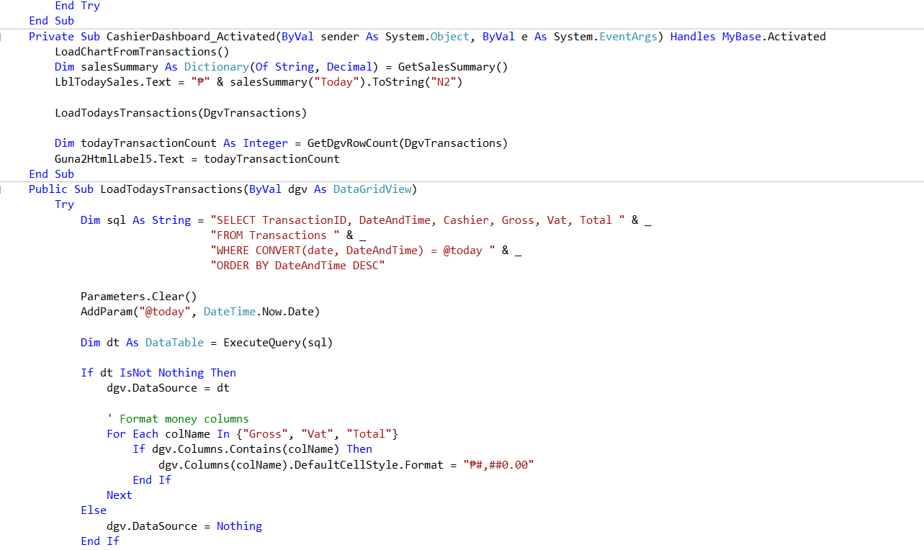

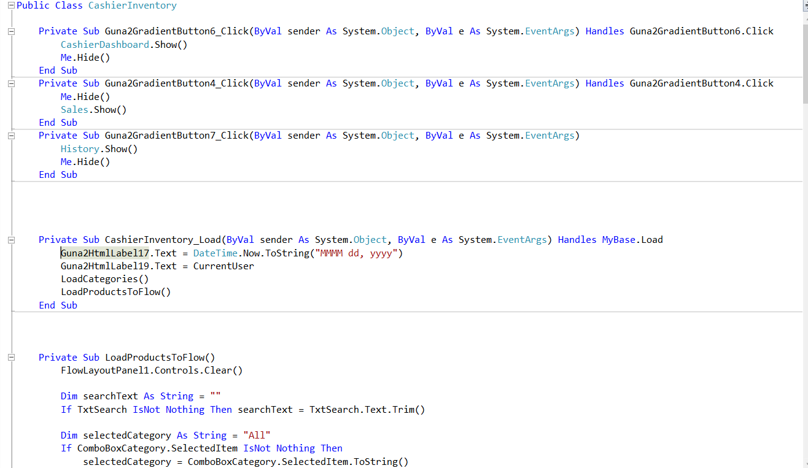

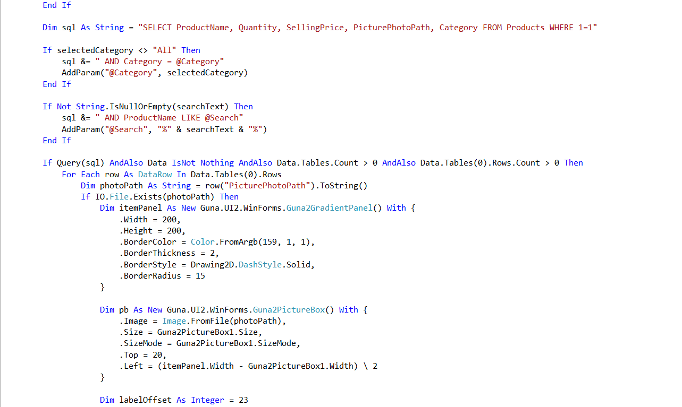

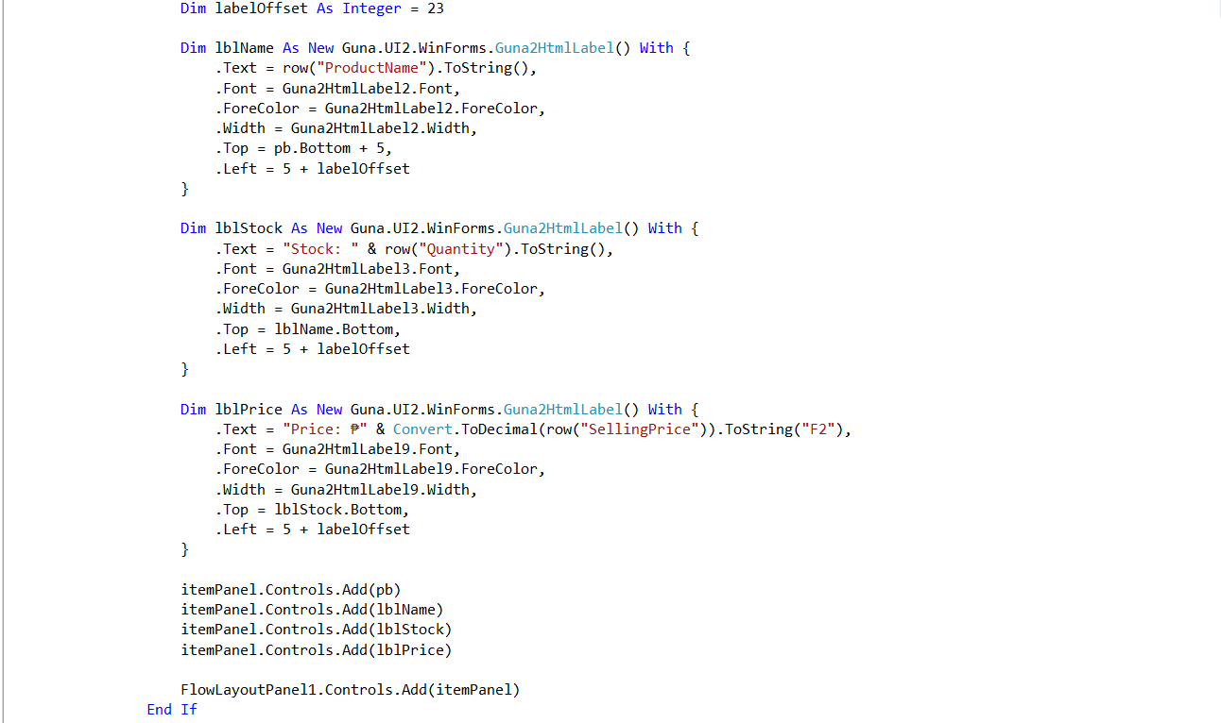

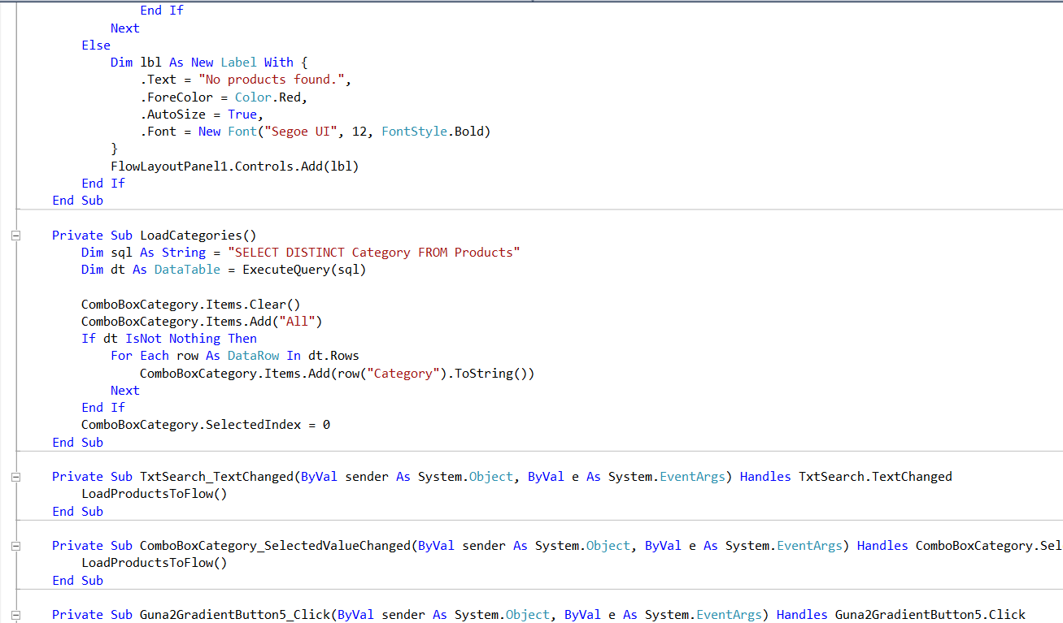

History(Cashier)

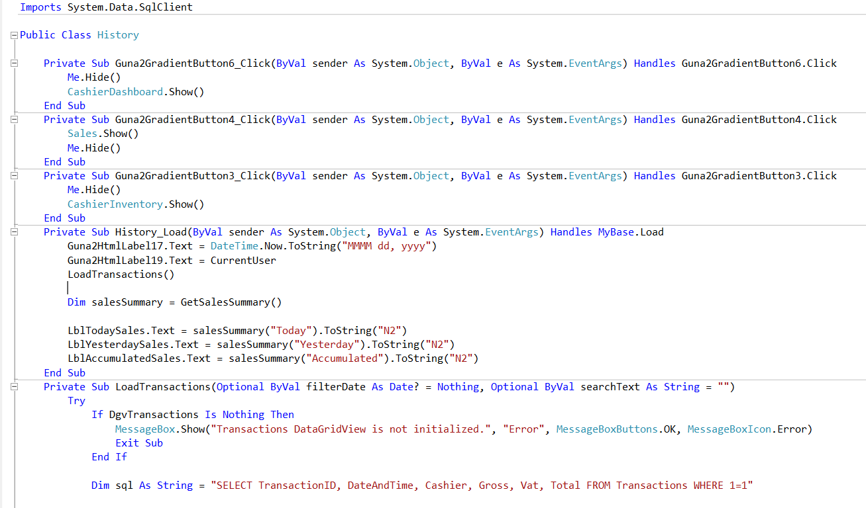

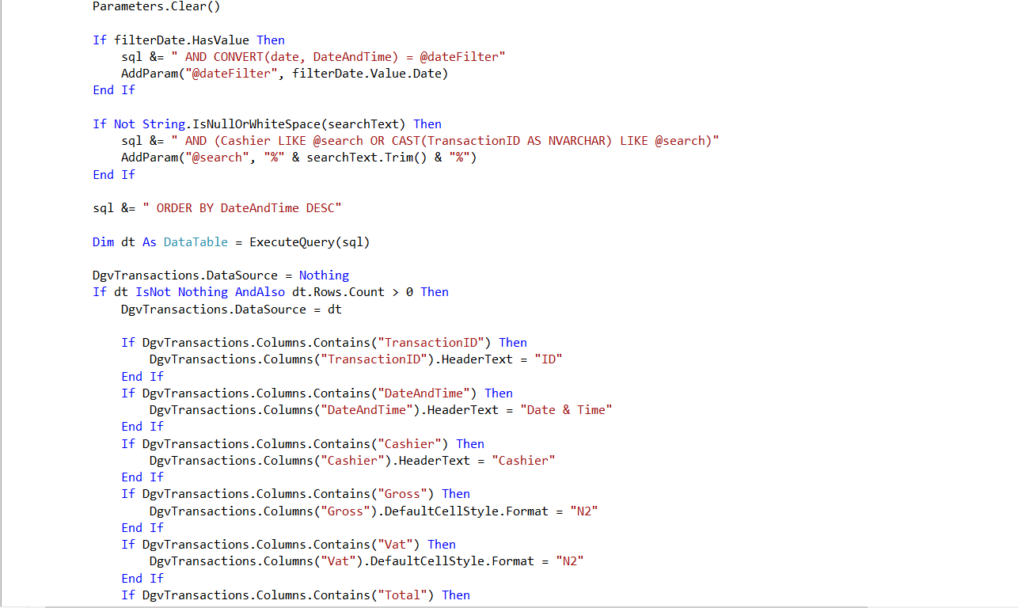

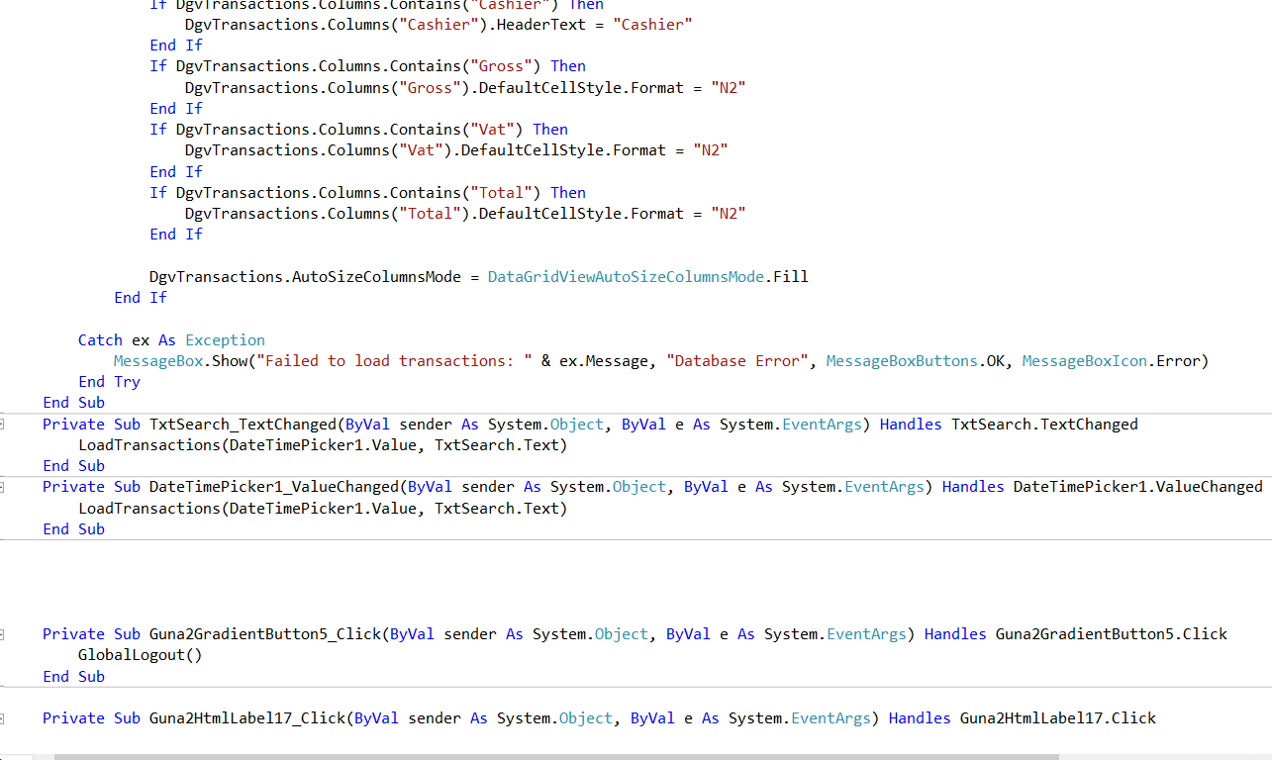

**Quantity(cashier)**

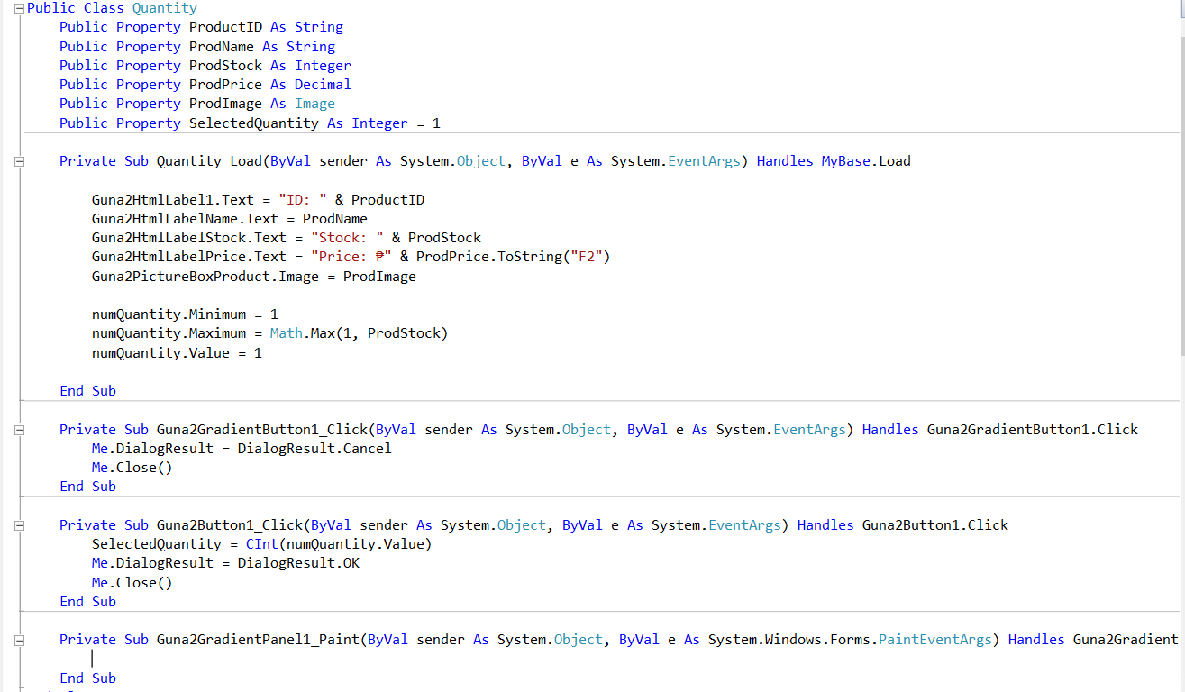

## TESTING DOCUMENTATION

**Test Plan (Objectives and Strategies)**  
 The goal of testing is to ensure that the Inventory and Sales System functions correctly, accurately, and efficiently before full use in Pandayan school supplies store. The testing strategy includes unit testing, integration testing, and user acceptance testing to verify that all modules work properly and that the system meets user needs.

**Test Cases**

**Functional Tests:**

Check login authentication for manager and cashier accounts.

Verify product add, updates, and delete.

Confirm that sales automatically reduce stock in inventory.

**Non-Functional Tests:**

System performance when handling many records.

Data accuracy during continuous sales operations.

System stability during power interruptions or restarts.

**Test Results and Defect Reports**  
 During testing, all major functions worked as expected. Minor issues such as slow report loading and display alignment were corrected. Final testing confirmed that the system is stable, accurate, and ready for deployment at Pandayan school supplies store

## ****MAINTENANCE GUIDE****

**Procedures for Maintaining and Updating the Software**

-Perform **weekly database backups** to protect data.

-Check for **software updates** and apply patches as needed.

-Clean up unnecessary data to keep performance fast.

**Version Control and Release Management Practices**  
Each software version should be labeled with a version number (e.g., v1.0, v1.1). Updates should be documented, including new features or bug fixes. Old versions should be archived to keep track of changes.

**Guidelines for Handling Bug Fixes and Enhancements**

-Record the issue and its cause in a maintenance log.

-Test the fix in a safe environment before applying it to the live system.

-Update the documentation after any modification.

**REVISION HISTORY**

*Table 3. Revision history*

|  |  |  |
| --- | --- | --- |
| August 10, 2025 | Introduction, Client Information, Project scope. | Revision of the consistent format and parts of the document follow the same structure, style, and layout. |
| August 12, 2025 | Project Approach, Project Team, Project timeline. | Revision of not consistent font, and figure table, fix the simply words. |
| August 16,2025 | Project Resources, Risk Management, Communication Plan. | Revision of the Format, fix the words that are deeply, creating tables. |
| August 22,2025 | Project Governance, Approval, Appendix. | Fixing the words are deeply. |

**APPENDIX**

Smart Digital. (n.d.). The importance of keeping a business inventory log. Smart Digital. Retrieved September 10, 2025, from [https://smartdigital.net/the-importance-of-keeping-a-business-inventory-log/](https://smartdigital.net/the-importance-of-keeping-a-business-inventory-log/?fbclid=IwZXh0bgNhZW0CMTAAYnJpZBExUkJDdHhvZmVQNXM1dmV0dgEez8TM_qPtddf_TTHI-3LX4k71qs6EJK1TLWPSc0oJsfmaXjaw3aJ-MOah49c_aem_E7Dr-IggZZ6JVSn9q4z4HQ)

Maurer, S. (2025, April 1). How to keep accurate inventory records? MRPeasy Blog. Retrieved September 10, 2025, from [https://www.mrpeasy.com/blog/inventory-records/](https://www.mrpeasy.com/blog/inventory-records/?fbclid=IwZXh0bgNhZW0CMTAAYnJpZBExUkJDdHhvZmVQNXM1dmV0dgEeuiCAfqWAvRFIgqvDqToGw7wYkdVCvxhKln1maoRiSv7YiiRyAse5zI5scY4_aem_WZupd3AJ0bnbbaOrvx_aFg)

Hayes, A. (2024, June 27). Inventory Management: Definition, How It Works, Methods & Examples. Investopedia. Retrieved September 10, 2025, from [https://www.investopedia.com/terms/i/inventory-management.asp](https://www.investopedia.com/terms/i/inventory-management.asp?fbclid=IwZXh0bgNhZW0CMTAAYnJpZBExUkJDdHhvZmVQNXM1dmV0dgEeuwH4-i8Cwi1K9e5GObSn6oB-9CO7LtdcBWo4JRr45xVjvj6juMyuqgXdJOY_aem_u01rAtsiAg4T0_iybCyVTA)

Cheng, X. (2024, January 5). Research on the Inventory Management in the Modern Business. Advances in Economics, Management and Political Sciences, 60, 1–8. Retrieved September 10, 2025[https://www.ewadirect.com/proceedings/aemps/article/view/8237](https://www.ewadirect.com/proceedings/aemps/article/view/8237?fbclid=IwZXh0bgNhZW0CMTAAYnJpZBExUkJDdHhvZmVQNXM1dmV0dgEetAsXN5CwbHpWHJZCBB1EydnQM5KIjjnsjFPbrPYS9FUrg515q6NW0vm5gvw_aem_61jvQXb3-DjOWFrsLXT7KQ)

Maitra, S. (2024, February 15). A System-Dynamic Based Simulation and Bayesian Optimization for Inventory Management [Preprint]. arXiv. <https://doi.org/10.48550/arXiv.2402.10975>

Projects Inventory. (2024, September 5). Scope of online inventory management for school’s final year project. ProjectsInventory.com. Retrieved from https://projectsinventory.com/scope-of-online-inventory-management-for-schools-final-year-project/

MRPeasy. (2024, April 1). How to keep accurate inventory records? MRPeasy Blog. Retrieved from <https://www.mrpeasy.com/blog/inventory-records/>

NetSuite. (2025, July). What is inventory management? Benefits, types, & techniques. NetSuite. Retrieved from <https://www.netsuite.com/portal/resource/articles/inventory-management/inventory-management.shtml>

Smart Digital. (2025, September 10). The importance of keeping a business inventory log. Smart Digital. Retrieved from <https://smartdigital.net/the-importance-of-keeping-a-business-inventory-log/>