https://taxcalculatorphilippines.com/

SSS Computation

Use SSS Contribution table

For monthly salary map to SSS contribution table then divide it to two

**1. PhilHealth contribution table in 2021 for employees and employers.**

https://filipiknow.net/philhealth-contribution/#:~:text=Since%20the%202021%20premium%20rate%20is%203.5%25%2C%20your,You%20don%E2%80%99t%20have%20to%20pay%20this%20in%20full.

PhilHealth

Monthly salary * 3% (based on 2020 contribution rate) then divide it two

**Employee or employer share = (Monthly basic salary x 0.035) / 2**

Ex: 27,413.39 x 3% = 822.40 / 2 = 411.20 for both EE and ER

Kinsenas: 411.20 / 2 = 205.6

The monthly contribution for employees earning Php 10,000 and below is fixed at Php 350. Meanwhile, those earning Php 70,000 and above have a fixed monthly contribution of Php 2,450.

Take note that the salary ceiling of Php 70,000 in 2021 will continue to increase by an increment of Php 10,000 a year until it reaches Php 100,000 in 2024.

# Pag-IBIG Contribution

1,500 and below – 1%

1,501 – 5,000 – 2% - 100 pesos for both EE and ER

## Income tax

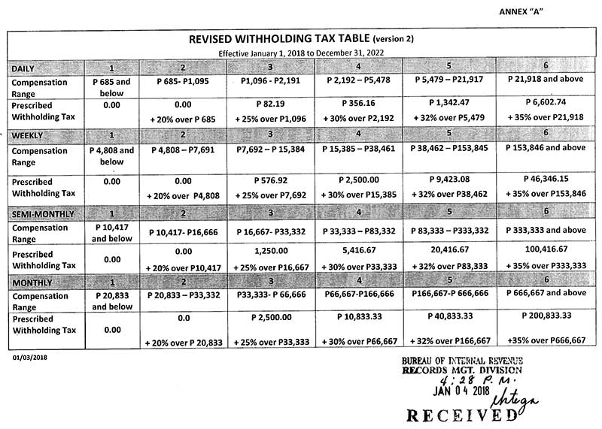

SSS: ₱1,125.00

PhilHealth: ₱375

Pag-IBIG: ₱100

Total Deductions = SSS + PhilHealth + Pag-IBIG

= ₱1,125.00 + ₱375 + ₱100

= ₱1,600

Taxable Income = Monthly Salary - Total Deductions

= ₱25,000 - ₱1,600

= ₱23,400

Base on what's on the column 2, our "Prescribed Minimum Withholding Tax" is ₱0.00 + 20% over Compensation Level (CL). Relax, this is relatively easy to compute.

Let's break this one by one.

First we have fixed ₱0.00 tax. Other salary bracket got ₱2,500, ₱10,833.33, ₱40,833.33, ₱200,833.33. That's a lot of money, I would cry if that's my monthly tax.

Second we have "+ 20% over Compensation Level (CL)".

What is "Compensation Level"? In our example, it's ₱20,833. Take a look at the Compensation Level row of the left side. (I just wanted you to look to understand it, nothing special here.)

What's the meaning of "20% over Compensation Level"? It means that we have to subtract first our taxable income to the compensation level, then get the 20% of that.

20% over Compensation Level = (Taxable Income - Compensation Level) x 20%

= (₱23,400 - ₱20,833) x 20%

= ₱2,567 x 20%

= ₱513.4

So we got the "20% over Compensation Level". It's time to get the real income tax.

Base on the tax table, our income tax would be:

Income Tax = ₱0.00 + 20% over Compensation Level (CL)

= ₱0.00 + ₱513.4

= ₱513.4

Voila! **₱513.4** is our income tax.

PhilHealth = 27,413.39 x 3% = 822.40 / 2 = 411.20

SSS = 27,413.39 - ₱1,125.000

PagIbig – 100

27,413.39 – (411.20 + 1125 + 100)

27,413.39 - 1636.2 = 25, 777.19

Income tax = 25,777.19 – 20,833

4,944.19 x 20% = 988.838 Monthly income tax

Then divide it to 2