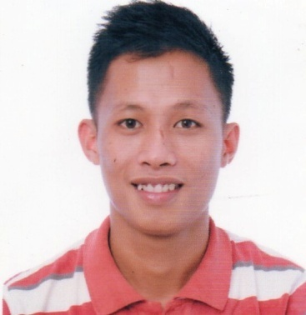**Ryan Paculba Tingcang**

10 r. Landon St., Cogon, Ramos, Cebu City 6000

Mobile: 09353599584

Email: [yanextingz24@yahoo.com](mailto:yanextingz24@yahoo.com)

**Objective:**

* To be one of the partner and effective instrument for the growth and development of the company.

**EDUCATIONAL BACKGROUND:**

**Tertiary:** Siquijor State College 2010 - 2014

Larena, Siquijor

Bachelor of Science in

Business Administration

Gen. Mngt.

ABC-BSBA Executive President (S.Y. 2013-2014)

**Secondary:**  Saint Vincent Academy 2006 – 2010

North Poblacion, Larena, Siquijor

**Elementary:**  Ponong Elementary School 2000- 2006

Ponong, Larena, Siquijor

**PERSONAL INFORMATION:**

**Status:** Single

**Date of Birth:** August 17, 1993

**Place of Birth:** Balolong, Enrique Villanueva, Siquijor

**Citizenship:** Filipino

**Religion:** Roman Catholic

**Skills:** Able to learn quickly, good leadership and managerial skills, good marketing skill, can easily adjust to the different situations, have smooth interpersonal relationship, good communication skills, can work well with less supervision, computer literate (MS Word, Excel, PowerPoint)

**Worked Experience:**

* Network Marketer -Nutratech Global International Inc. Dec.2013 – March 2014
* Distributor -Lifepharm Global Network Incorporated July 2013 up to present
* Utility Worker -Local Government Unit of LarenaApril, 2013- May, 2013
* Utility Worker -Local Government Unit of Larena April, 2012- May, 2012
* Casual Employee - DOLE-TUPAD (LGU-LARENA) Nov. 17-Dec.12, 2014
* ESL Instructor - Cebu International Academy July 18 – Sept.25, 2014

**SEMINARS ATTENDED:**

Proper Food Handling and Sanitation

Held at Mezzanine of the CBM Office

Siquijor State College – Larena, Siquijor

September 22, 2013

Leadership, Entrepreneurial and Values Orientation

Seminar Workshop for Food Terminal Operators

Held in Royal Suites Inn.,Bantayan, Dumaguete City

Dumaguete City, Negros Oriental, Philippines

October 10-11, 2013

Seminar Workshop on the Role of Supervisor in the Workplace

Held at Mezzanine of the CBM Office

Siquijor State College – Larena, Siquijor

November 6, 2013

Seminar Workshop on Developing, Managing and Leading People

Held at Mezzanine of the CBM Office

Siquijor State College – Larena, Siquijor

November 6, 2013

Seminar Workshop on Leadership Ability and Qualities

Held at Mezzanine of the CBM Office

Siquijor State College – Larena, Siquijor

November 7, 2013

Seminar Workshop on Incentives to Work and Obtaining Discipline

Held at Mezzanine of the CBM Office

Siquijor State College – Larena, Siquijor

November 13, 2013

Seminar Workshop on Personnel Selection and Effective Interviewing

Held at Mezzanine of the CBM Office

Siquijor State College – Larena, Siquijor

November 11, 2013

Pre- OJT Orientation Seminar

Held at Audio Visual Room

Siquijor State College

Larena, Siquijor

November 22, 2013

Chain of Confidence (Tupperware)”

Held at YanzKainan

Siquijor, Siquijor

November 23, 2013

Field Exposure and Technical Exchange

Held in Bohol, Philippines

December 15-18, 2013

**References:**

Hon. Basilia S. Manosa Mr. Harry P. Calimpon

Barangay Captain Operations Manager

Cabulihan, Larena, Siquijor Villa Shipping Lines Inc.

09153891122 09154826146

Dave S. Mamhot, DBA, Ph.D. Mr. Ranny P. Calimpon

Associate Professor II Administrative Officer

Siquijor State College Lavynjex Mines Inc.

09278433683 09169167787

Mrs. Bernadith S. Bunado Mrs. Pamela T. Anqui

DA PATCO HEAD Business Owner

DA PATCO Siquijor Zo and El Enterprises

09053897951 09177024547

I certified that the above statements are true and correct.

**RYAN P. TINGCANG**

Applicant