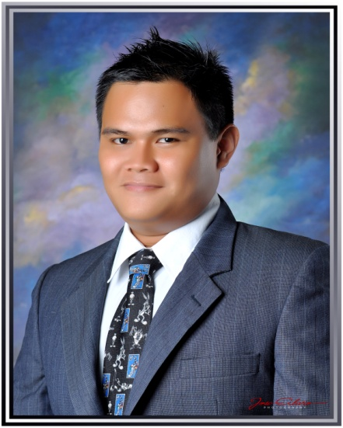**GAMALIEL P. MAYOL**

Plaridel st., Umapad

Mandaue City, Cebu

Contact Number: 0922-9533545

Email: [maymay_gamz@yahoo.com](mailto:maymay_gamz@yahoo.com)

**POSITION APPLIED: MANAGEMENT TRAINEE**

**OBJECTIVE:** To be able to find a job that is relevant to my knowledge, skills and that is related to my educational background.

**QUALIFICATIONS:**

* Has a strong leadership skills
* Work well with less supervision
* Skilled at learning new concepts quickly while working well under pressure
* Can type 40WPM
* Knowledgeable in Microsoft office applications

**WORK EXPERIENCE:**

Service Crew / Production Controller / Kitchen Staff

Jollibee Oriente – (Gold Store 2011)

Colon st., corner Pelaez st., Cebu City

Colonnade Mall Building

From: November 24, 2009 to March 31, 2015

**PERSONAL DATA:**

Age : 24 years old

Birthday : September 18, 1990

Gender : Male

Status : Single

Citizenship : Filipino

Height : 5’5”

Weight : 78 kg’s.

**EDUCATIONAL BACKGROUND:**

College:

Graduate: Bachelor of Science in Business Administration

Major in Financial Management

University Of Visayas

Colon st., Cebu City

June 14, 2012 – March 18, 2015

1st year college level

Bachelor of Science in Mechanical Engineering

Cebu Technological University

M.J. Cuenco Ave., Cebu City

June 18,2007- March 30, 2008

Elementary:

Mandaue City Comprehensive National High School

High School

Plaridel st., Reclamation Area, Mandaue City

June 2003 – March 30, 2007

High School:

Mandaue City Elementary School

Elementary School

Ouano St., Mandaue City

June 1997- March 30, 2003

**SEMINARS AND TRAININGS ATTENDED:**

PRODUCT CONTROLLERS MINDSET PROGRAM

July 28, 2014

Jollibee Country Mall

Regional Business Unit – District 1

FINANCE LEADERS CONGRESS

July 11, 2014

University of Cebu – Lapu-lapu and Mandaue

Junior Confederation of Finance Associations – Philippines

MODERN MANNERS for TODAY’S BUSINESS WORLD

February 23, 2013

University of Visayas - Main

College of Business Administration

WE VALUE, WE TRAIN. WE EMPOWER through LEADERSHIP-

October 3, 2010

Family Park

Jollibee Oriente

**AFFILIATIONS:**

PRESIDENT

Junior Financial Executive (JFINEX) UV-CHAPTER

College of Business Administation

University of Visayas- main

2014 - 2015

BOARD OF DIRECTOR

Council of Leaders – College of Business Administration

University Of Visayas - main

2014 – 2015

**CHARACTER REFERENCE:**

**Javier L. Andojar**

Restaurant Manager

Jollibee-Oriente Branch, JFC

255-7454

**Jenny Mae Fernandez**

Crew Trainer Manager / Shift Manager

Jollibee-Oriente Branch, JFC

255-7454

**Mark Oliver Diokno**

Supply Administrative Officer

Naval, NAFORCEN-Central Visayas

09321726491