COLINA, IRIS D.

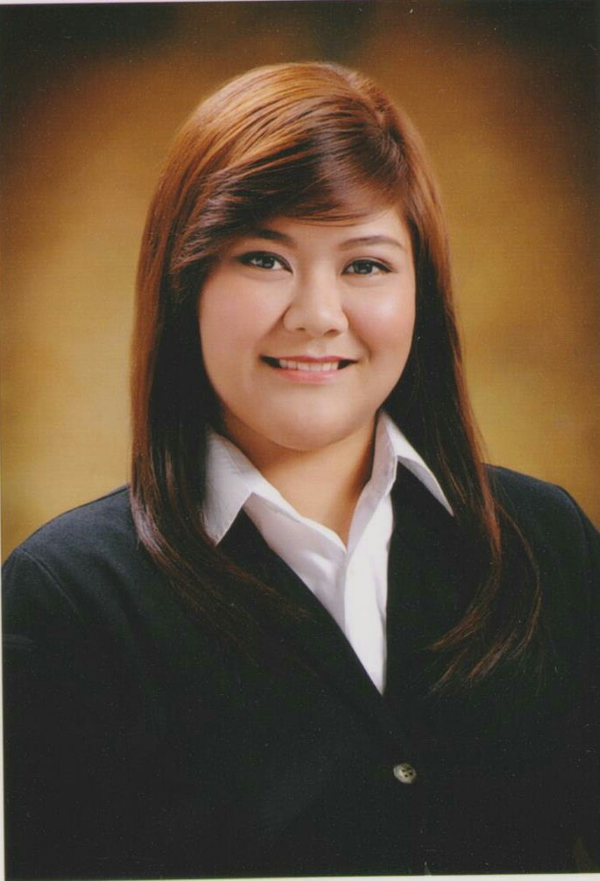

Email add: [Iwish_25@yahoo.com](mailto:Iwish_25@yahoo.com)

Contact #: 09335074771

**Objectives:** To be able to work in a career oriented and challenging environment that promotes personal growth, and uplifts personal development.

**PERSONAL INFORMATION**

**Address:** 264 F. llamas St. Punta Princes, Cebu City

**Birthday :**   August 25, 1993

**Birthplace :**  Cebu City, Cebu

**AGE:** 21

**Gender:**  Female

**Civil Status:**  Single

**Religion:**  Roman Catholic

**Language Spoken:** English , Tagalog , Cebuano

**Mother:** Rowena D. Colina

**Occupation:**  Businesswoman

**Father:**  Rey Q. Colina

**Occupation:** Civil Engineer

**EDUCATIONAL BACKGROUND**

Primary: Jose Zurbito Sr. Elementary School ( 2001- 2006)

Quezon St. Masbate City

Secondary: Masbate National Comprehensive High School ( 2006- 2010)

Quezon St. Masbate City

Tertiary: Bachelor of Science in Business Administration major in Marketing

University of San Carlos (2010 – 2014)

P. Del Rosario St. Cebu City

**SKILLS**

* Computer Literate: Microsoft Office
* Good Customer Service
* Good Interpersonal Skills

**SEMINARS AND TRAININGS**

* “Jump Start, Success!: Paving the Way to goals” – 2011
* 1st Student Marketing Convention,

*Glocalized Marketing: Modern Day Cebuano Business Icons* - 2011

* 2nd Student Marketing Convention , STRATMARK CEBU 2012

*Glocalized Marketing Mash-Up: Hybrid for the New Breed* 2012

* 1st COMEPP REGIONAL CONVENTION

“Rethinking leadership: Preparing Future Leaders and Managers in a Borderless World” - 2012

* Realty Options: “how to make Millions in Real Estate starting Zero or minimal Capital" - 2012
* 1st Student Human Resource Development Management Convention

“Glocalized People Management: Strategic Business Partnership” - 2013

* 3rd Student Marketing Convention

“Glocalized Marketing: MARCOM, a Magnet for success in Business”-2013

**REFERENCE**

**Mr. Allan Luzano**

Part-time Professor, School of Business and Economics department

Manager of McDonalds

**09396296368**

**Joan Marie T. Quinanola, CPA**

SGV Associates

Punta Princesa, Cebu City

#09175926893