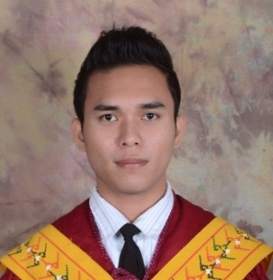
Robby Boy Cantiveros Dumanon
P-2 Rizal Brgy. Banza, Butuan City
Agusan del Norte, Philippines
Contact Number: +639109702824
E-mail Address: iamrobbyboy@gmail.com

OBJECTIVES
- To impart some skills, knowledge, or wisdom that would be a big help to an organization.
- To earn a harmonious relationship within an organization.
- To learn some new knowledge or wisdom from an organization in order to become an effective and efficient employee in the future.

PERSONAL DATA
Date of Birth : April 11, 1992
Place of Birth : Butuan City, Philippines
Civil Status : Single
Gender : Male
Nationality : Filipino

EDUCATIONAL BACKGROUND
College: Mindanao State University- Main Campus
Marawi City, Lanao del Sur
Diploma, April 9, 2014
Course: BSBA- Management

WORK EXPERIENCE
- Encoder/Administrative Assistant II (Nov. 5, 2014-Dec. 31 2014)
-DSWD Field Office Caraga Region- Sustainable Livelihood Program
(R. Palma St., Butuan City)
- Encoding backlogs (SP/CB, Participants, SKA, MFI, Self-funded, PPA, Employed)
- Clerical works

CERTIFICATIONS
- CSE-PPT (Professional)- Oct. 26, 2014- Passer
SEMINARS/TRAININGS
- OJT at PAG-IBIG Fund Butuan Branch. (April-May 2013)
- Fourth Young Executives Business Management Convention. (March 8-9, 2014)
- Third Young Executives Business Management Convention. (March 2-3, 2013)
- 1st Junior Leadership Volunteering Program on Good Governance and Social Responsibility. (September 15, 2013)
- Seminar on Taxation, Land Reform and Cooperatives. (July 11, 2012)

AFFILIATIONS
- Member, Junior Executive Club (JEC)
- Member, Junior People Management Association of the Philippines (JPMAP)

SKILLS
- Computer literate (Microsoft Word, Publisher, Powerpoint and Excel)
- Strong work ethics
- Flexibility/Adaptability

REFERENCES:

Mr. Simel Adam Amplayo
PDO II/Monitoring and Evaluation
DSWD Field Office Caraga Region- SLP, Butuan City
Contact No. +09101742047

Prof. Amerah B. Guro
Chairperson, Management Department, CBAA
Mindanao State University- Main Campus, Marawi City
Contact No. +639494561319

Dr. Sonayah D. Guimba-Basher
Faculty, Management Department, CBAA
Mindanao State University- Main Campus, Marawi City
Contact No. +639088668176

