Jet Saber Game Design Document (GDD)



***‘Placing a 9-3-7 on what looks to be a space ninja. Please Advise.’*** – Reymond Pamelar

This page: Table of Contents and Team Member Listing

|  |  |  |
| --- | --- | --- |
| Table of Contents  [1 Game Overview](https://n-xovwktmtjsnaxyc2mwes2xu7pohqedmdm6zjw5q-2lu-script.googleusercontent.com/userCodeAppPanel)  [2 High Concept](https://n-xovwktmtjsnaxyc2mwes2xu7pohqedmdm6zjw5q-2lu-script.googleusercontent.com/userCodeAppPanel)  [3 Unique Selling Points](https://n-xovwktmtjsnaxyc2mwes2xu7pohqedmdm6zjw5q-2lu-script.googleusercontent.com/userCodeAppPanel)  [4 Platform Minimum Requirements](https://n-xovwktmtjsnaxyc2mwes2xu7pohqedmdm6zjw5q-2lu-script.googleusercontent.com/userCodeAppPanel)  [5 Competitors / Similar Titles](https://n-xovwktmtjsnaxyc2mwes2xu7pohqedmdm6zjw5q-2lu-script.googleusercontent.com/userCodeAppPanel)  [6 Synopsis](https://n-xovwktmtjsnaxyc2mwes2xu7pohqedmdm6zjw5q-2lu-script.googleusercontent.com/userCodeAppPanel)  [7 Game Objectives](https://n-xovwktmtjsnaxyc2mwes2xu7pohqedmdm6zjw5q-2lu-script.googleusercontent.com/userCodeAppPanel)  [8 Game Rules](https://n-xovwktmtjsnaxyc2mwes2xu7pohqedmdm6zjw5q-2lu-script.googleusercontent.com/userCodeAppPanel)  [9 Game Structure](https://n-xovwktmtjsnaxyc2mwes2xu7pohqedmdm6zjw5q-2lu-script.googleusercontent.com/userCodeAppPanel)  [10 Game Play](https://n-xovwktmtjsnaxyc2mwes2xu7pohqedmdm6zjw5q-2lu-script.googleusercontent.com/userCodeAppPanel)  [10.1 Game Controls](https://n-xovwktmtjsnaxyc2mwes2xu7pohqedmdm6zjw5q-2lu-script.googleusercontent.com/userCodeAppPanel)  [10.2 Game Camera](https://n-xovwktmtjsnaxyc2mwes2xu7pohqedmdm6zjw5q-2lu-script.googleusercontent.com/userCodeAppPanel)  [10.2.1 HUD](https://n-xovwktmtjsnaxyc2mwes2xu7pohqedmdm6zjw5q-2lu-script.googleusercontent.com/userCodeAppPanel)  [10.2.2 Maps](https://n-xovwktmtjsnaxyc2mwes2xu7pohqedmdm6zjw5q-2lu-script.googleusercontent.com/userCodeAppPanel)  [11 Players](https://n-xovwktmtjsnaxyc2mwes2xu7pohqedmdm6zjw5q-2lu-script.googleusercontent.com/userCodeAppPanel)  [11.1 Characters](https://n-xovwktmtjsnaxyc2mwes2xu7pohqedmdm6zjw5q-2lu-script.googleusercontent.com/userCodeAppPanel)  [11.2 Metrics](https://n-xovwktmtjsnaxyc2mwes2xu7pohqedmdm6zjw5q-2lu-script.googleusercontent.com/userCodeAppPanel)  [11.3 States](https://n-xovwktmtjsnaxyc2mwes2xu7pohqedmdm6zjw5q-2lu-script.googleusercontent.com/userCodeAppPanel)  [11.4 Weapons](https://n-xovwktmtjsnaxyc2mwes2xu7pohqedmdm6zjw5q-2lu-script.googleusercontent.com/userCodeAppPanel)  [12 Player Line-up](https://n-xovwktmtjsnaxyc2mwes2xu7pohqedmdm6zjw5q-2lu-script.googleusercontent.com/userCodeAppPanel)  [13 NPC](https://n-xovwktmtjsnaxyc2mwes2xu7pohqedmdm6zjw5q-2lu-script.googleusercontent.com/userCodeAppPanel)  [13.1 Enemies](https://n-xovwktmtjsnaxyc2mwes2xu7pohqedmdm6zjw5q-2lu-script.googleusercontent.com/userCodeAppPanel)  [13.1.1 Enemy States](https://n-xovwktmtjsnaxyc2mwes2xu7pohqedmdm6zjw5q-2lu-script.googleusercontent.com/userCodeAppPanel)  [13.1.2 Enemy Spawn Points](https://n-xovwktmtjsnaxyc2mwes2xu7pohqedmdm6zjw5q-2lu-script.googleusercontent.com/userCodeAppPanel)  [13.2 Allies / Companions](https://n-xovwktmtjsnaxyc2mwes2xu7pohqedmdm6zjw5q-2lu-script.googleusercontent.com/userCodeAppPanel)  [13.2.1 Ally States](https://n-xovwktmtjsnaxyc2mwes2xu7pohqedmdm6zjw5q-2lu-script.googleusercontent.com/userCodeAppPanel)  [13.2.2 Ally Spawn Points](https://n-xovwktmtjsnaxyc2mwes2xu7pohqedmdm6zjw5q-2lu-script.googleusercontent.com/userCodeAppPanel)  [14 Art](https://n-xovwktmtjsnaxyc2mwes2xu7pohqedmdm6zjw5q-2lu-script.googleusercontent.com/userCodeAppPanel)  [14.1 Setting](https://n-xovwktmtjsnaxyc2mwes2xu7pohqedmdm6zjw5q-2lu-script.googleusercontent.com/userCodeAppPanel)  [14.2 Level Design](https://n-xovwktmtjsnaxyc2mwes2xu7pohqedmdm6zjw5q-2lu-script.googleusercontent.com/userCodeAppPanel)  [14.3 Audio](https://n-xovwktmtjsnaxyc2mwes2xu7pohqedmdm6zjw5q-2lu-script.googleusercontent.com/userCodeAppPanel)  [15 Procedurally Generated Content](https://n-xovwktmtjsnaxyc2mwes2xu7pohqedmdm6zjw5q-2lu-script.googleusercontent.com/userCodeAppPanel)  [15.1 Environment](https://n-xovwktmtjsnaxyc2mwes2xu7pohqedmdm6zjw5q-2lu-script.googleusercontent.com/userCodeAppPanel)  [15.2 Levels](https://n-xovwktmtjsnaxyc2mwes2xu7pohqedmdm6zjw5q-2lu-script.googleusercontent.com/userCodeAppPanel)  [15.3 Artificial Intelligence NPC](https://n-xovwktmtjsnaxyc2mwes2xu7pohqedmdm6zjw5q-2lu-script.googleusercontent.com/userCodeAppPanel)  [15.4 Visual Arts](https://n-xovwktmtjsnaxyc2mwes2xu7pohqedmdm6zjw5q-2lu-script.googleusercontent.com/userCodeAppPanel)  [15.5 Audio](https://n-xovwktmtjsnaxyc2mwes2xu7pohqedmdm6zjw5q-2lu-script.googleusercontent.com/userCodeAppPanel)  [15.6 Minimum Viable Product (MPV)](https://n-xovwktmtjsnaxyc2mwes2xu7pohqedmdm6zjw5q-2lu-script.googleusercontent.com/userCodeAppPanel)  [16 Wish List](https://n-xovwktmtjsnaxyc2mwes2xu7pohqedmdm6zjw5q-2lu-script.googleusercontent.com/userCodeAppPanel)   |  | | --- | |  | | Game Development Team Members    PRODUCER  Reymond Pamelar    PRODUCTION MANAGER  Reymond Pamelar    PRODUCTION COORDINATOR  Reymond Pamelar  GAME DESIGNERS  Reymond Pamelar  SYSTEMS/IT COORDINATOR  Reymond Pamelar  PROGRAMMERS  Reymond Pamelar  TECHNICAL ARTISTS  Reymond Pamelar  AUDIO ENGINEERS  Reymond Pamelar  UX TESTERS  Reymond Pamelar |

|  |
| --- |
|  |

# 1 Game Overview

Title: Jet Saber

Platform: PC

Genre: Side scrolling, Rhythm

Rating: (10+) ESRB

Target: Casual gamer (aging from 12 - 30)

Release date: November, 2020

Publisher: X-Rey Entertainment

Description: This section describes the high level overview of your game. Put as much detail into this section as you can. This should contain your elevator pitch and more details to capture the attention and get the reader to want to play your game.

Jet Saber is a side scroller, combined with rhythm mechanics, that allows the Player to control Ryzer, a cyborg-ninja. Utilizing Ryzer’s agile movements and attacks, the player must avoid lasers and destroy corporate drones on beat. Keeping Ryzer’s health up allows the player to continue through the whole level. Lasers and missed attacks on drones will deplete his health. However, destroying drones will add to his health and will also add to the score. Additionally, destroying multiple drones consecutively without missing will add multipliers to the score.

# 2 High Concept

Jet Saber places the player atop the skyscrapers of a futuristic Cyber City as they are on a single-handed fight against big corporations. Each level’s music corresponds to timing of in-game events. Destroy drones with your Sonic-saber on beat to add to your score and health. Destroy them consecutively to gain multipliers! Maneuver through the air like a smooth criminal! Utilize Ryzer’s Jet-Powered boots to avoid dangerous lasers! Ultimately, keep Ryzer’s health up to dash through the levels!

# 3 Unique Selling Points

* Cyberpunk-like setting
* Musically driven
* Combination of player movement and rhythmic timing to provide interesting gameplay
* Stunning 2D visuals

# 4 Platform Minimum Requirements

PC

OS: Windows

Graphics card: DX9 (shader model 2.0) capabilities;

Generally everything made since 2004 should work

# 5 Competitors / Similar Titles

* Jetpack Joyride

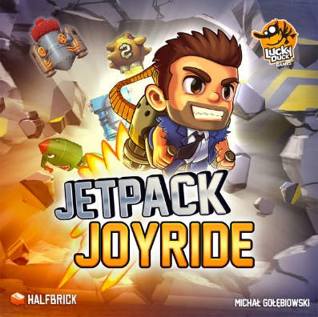

* Beat saber

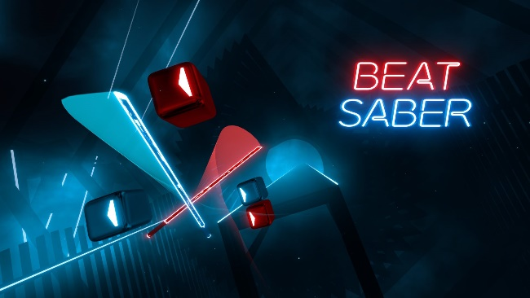

# 6 Synopsis

Ryzer was once a dying man who lost his memory; at least he was, until Sky Tech resurrected him through cybernetic enhancements of the mind and of the body. He decided to devote his life to this corporation as an agent to do their bidding. Upon completing many missions, he has earned also earned their trust. One day, he is tasked to destroy a group of individuals who have been attempting to hack Sky Tech databases. Ryzer swiftly completes the job, as he usually does, only to find that the now dead ‘hackers’ were some of his old allies. Infuriated, he is now on a new mission. This time, to eliminate his so-called ‘guardian angel’.

# 7 Game Objectives

* Destroy direction-labeled blocks on time to gain points, multipliers, and to avoid health loss
* Avoid Lasers
* Survive through the whole level while keeping Ryzer’s health above zero

# 8 Game Rules

* The player can only move Ryzer up and down. Throughout a level, lasers will spawn and will deal damage over time if the player is within it. Drones that correspond to the arrow keys will move from right to left, eventually reaching an arrow key UI. Once the drone is in the vicinity of the key, this indicates to the player that they must attack it for once it leaves the key, it will attack him. Points are gained by hitting drones on time. Consecutive hits without missing will allow multipliers to task into effect. The player must survive with health above zero or the game will end.

# 9 Game Structure

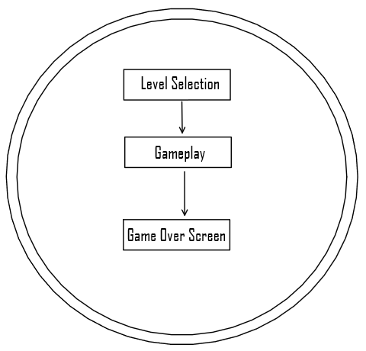

# 10 Game Play

## 10.1 Game Controls

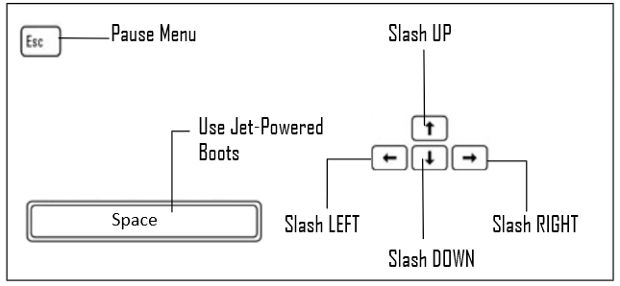

## 10.2 Game Camera

* The camera projection is always projected orthographically.
  + The camera follows the character as they move to the right.
  + The sunset background is attached to the camera but also animates to the left to create the illusion of moving

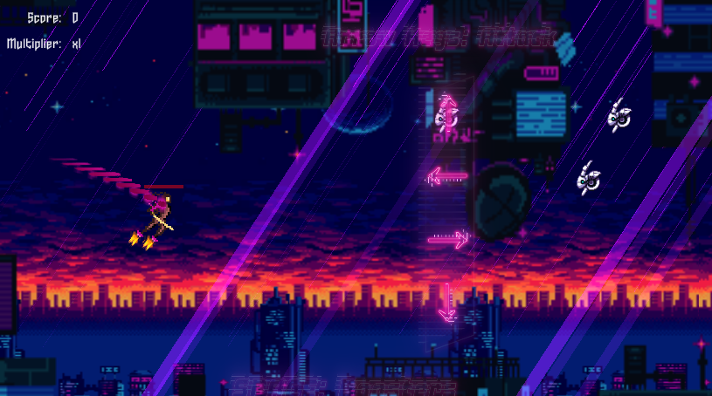

### 10.2.1 HUD

* Score and multiplier
  + Score:
    - Indicates the accumulated points throughout the level session.
  + Multiplier:
    - Displays how much the points that are gained will be multiplied by

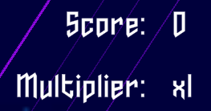

* Health Bar:
  + Displays the amount of health that the player has.



* Arrows:
  + Represent the arrow keys that can be pressed by the player. Pressing one of the arrows allows the player to attack toward that arrow
  + 

### 10.2.2 Maps

* All maps have the same layout
  + Layout:
    - 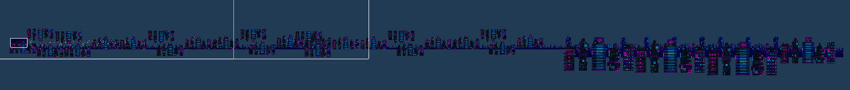

# 11 Players

## 11.1 Characters

* Ryzer
  + A cybernetically enhanced human saved by a corporation from his death. They utilized him to eliminate his old allies. Now equipped with the truth, Ryzer plans to eliminate the corporation that not only saved him but also kept the truth from him.



## 11.2 Metrics

* Max Health: 100
* Jet-Force: 50
* Attack Damage: Instant-Kill
* Time to attack: Instant

## 11.3 States

* Idle:
  + A looped animation that where the player is in standing stance but slightly moving
* Attack:
  + A quick animation that activates when a player presses an arrow key. Ryzer will swing his sword in place but also send an after-image (doing the same animation) in the direction toward the arrow pressed.

## 11.4 Weapons

* Sonic Saber: While slashing, it will send an after image in the direction of the arrow key pressed.

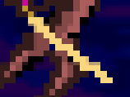

# 12 Player Line-up

* N/A

# 13 NPC

## 13.1 Enemies

* Drones
  + Drones are attacked on beat with the music of the level.
  + Damage if missed: 10HP
  + Health gained if hit: 5HP



### 13.1.1 Enemy States

* Drone :
  + Idle:
    - The idle drone does not animate but will move towards their respective arrow key.
  + death:
    - An eliminated drone will explode

### 13.1.2 Enemy Spawn Points

* Drones
  + Preplaced throughout the level depending on the beat of the music

## 13.2 Allies / Companions

* N/A

### 13.2.1 Ally States

* N/A

### 13.2.2 Ally Spawn Points

* N/A

# 14 Art

## 14.1 Setting

* Cyber City:
  + Cyber City is a place that has made a name for itself, becoming the tech capital of the world. Technology is embedded into every aspect of the lives of its citizens. As a result of overpopulation, the city is extremely condensed hence, the abundance of large buildings attributing to its verticality.

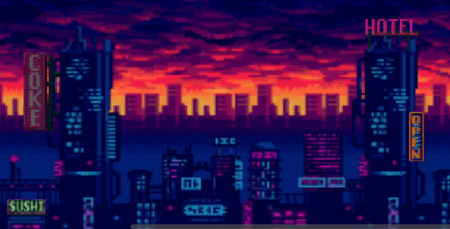

## 14.2 Level Design

* Every level has the same layer layout
  + City sunset as farthest background
  + Small buildings for the far background
  + Large, up-close buildings for the closes background
* Levels have color filters depending on the difficulty of the level
  + No filter
    - Difficult: Easy

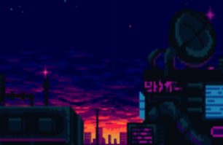

* + Yellow and black filter
    - Difficulty: Medium
    - 
  + Red filter
    - Difficulty: Hard
    - 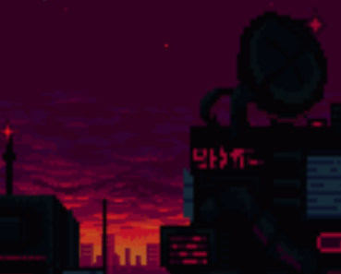
* Lasers
  + Lasers are activated on que of the music and deals damage over time to the player. Three exclamation marks will indicate to the player that a laser is spawning
  + Damage over time, if in vicinity: 0.3 HP



* + Activated animation:
    - A fired laser that continues for 4 seconds
  + Spawning:
    - Spawned depending on the beat of the music

## 14.3 Audio

|  |  |  |
| --- | --- | --- |
| Name | Category | Description |
| 16 Retrospect | Background music | Plays during main menu |
| Arex&#039;s Beat | Level Music | Plays during level 1 |
| WiFi Trasherino | Level Music | Plays during level 2 |
| Are You With Us | Level Music | Player during level 3 |
| drone dash | FX | Cutscene |
| drone fly up | FX | Cutscene |
| HUH | FX | Cutscene |
| I GUESS ITS TIME | FX | Cutscene |
| Ryzer Dash | FX | Cutscene |
| Ryzer Damaged | FX | Ryzer losing health |
| Ryzer Slash | FX | Plays when Ryzer hits a drone |

# 15 Procedurally Generated Content

## 15.1 Environment

N/A

## 15.2 Levels

N/A

## 15.3 Artificial Intelligence NPC

N/A

## 15.4 Visual Arts

N/A

## 15.5 Audio

N/A

# 16 Minimum Viable Product (MPV)

* One level and song
* Built for the PC platform

# 17 Wish List

* Add more music and levels
* Add a ‘create mode’ with importing a player’s songs
  + Allow players to create their own drone and laser spawn times for their own music
* Add a procedurally generated map
* Add a procedurally generated spawning of drones and lasers when importing songs
* Add a multiplayer option
  + Multiple drone spawn layout for different players but both players play on the same map
* Add a variety of enemies and also boss enemies to substitute drones

# 18 Bibliography

Ansimuz. (2019, January 29). Warped City. Retrieved October 27, 2020, from https://opengameart.org/content/warped-city

M. Placzek(2020 October 29) JetControls [Source code]. https://www.raywenderlich.com/5458-how-to-make-a-game-like-jetpack-joyride-in-unity-2d-part-1

Ryzer [Personal Animation]. (2020, October 29).

Ryzer idle [Personal Animation]. (2020, October 29).

Ryzer Slash Right[Personal Animation]. (2020, October 29).

Ryzer Slash Left[Personal Animation]. (2020, October 29).

Ryzer Slash Up[Personal Animation]. (2020, October 29).

Ryzer Slash Down[Personal Animation]. (2020, October 29).

Kein, V. (2018, March 01). Arex's Beat. Retrieved November 7, 2020, from https://opengameart.org/content/arexs-beat

Vandalorum. (2017, November 08). Hiphop / Old School / Chill Themes. Retrieved November 10, 2020, from https://opengameart.org/content/hiphop-old-school-chill-themes

Inscription GIF Animation of Letters Scattering into Shards. (n.d.). Retrieved November 10, 2020, from https://en.textdrom.com/shatterize/shattering-text-effect-animation.html

S. Price(2020 November 11) UIManager_Simple [Class code].

Brackeys(2020 November 11) PauseManager [Source code]. https://www.youtube.com/watch?v=JivuXdrIHK0&ab_channel=Brackeys

Ryzer Damaged[Personal Sound]. (2020, November 14).

drone dash[Personal Sound]. (2020, November 14).

drone fly up[Personal Sound]. (2020, November 14).

HUH[Personal Sound]. (2020, November 14).

I GUESS ITS TIME[Personal Sound]. (2020, November 14).

Ryzer dash[Personal Sound]. (2020, November 14).

Alexander. (2017, June 15). Storm Sound: Free Sounds From Orange Free Sounds. Retrieved November 14, 2020, from http://www.orangefreesounds.com/storm-sound/

Sudocolon. (2016, June 17). WiFi Trasherino. Retrieved November 15, 2020, from https://opengameart.org/content/wifi-trasherino

Wontolla. (2016, September 23). Are You With Us? Retrieved November 15, 2020, from https://opengameart.org/content/are-you-with-us

Ryzer Standing Up[Personal Animation]. (2020, October 29).