Reynaldi Noer Rizki

140810160010

Tugas Praktikum Modul 2

1. Studi Kasus 1

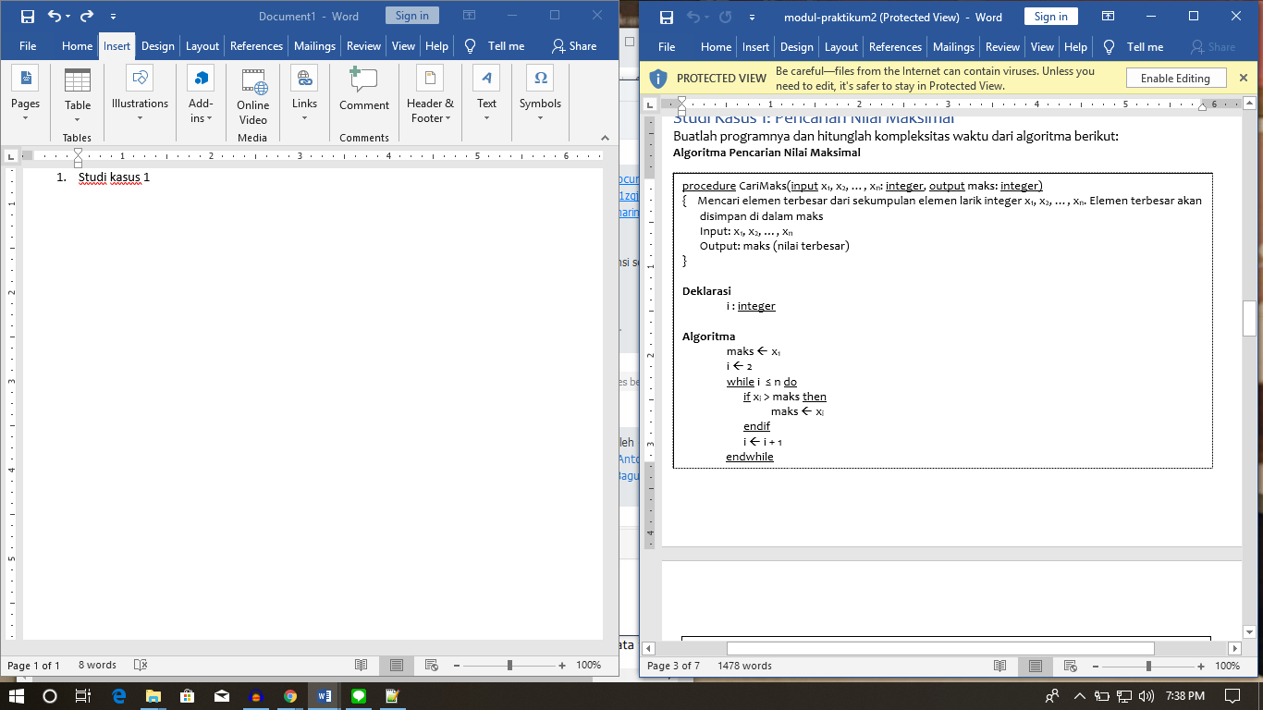

Jawaban :

maks 🡨 x1 1 kali

I 🡨 2 1 kali

maks 🡨 xi n kali

i 🡨 i + 1 n kali

𝑇(𝑛) = 1 + 1 + 𝑛 + 𝑛 = 2𝑛 + 2

1. Studi Kasus 2

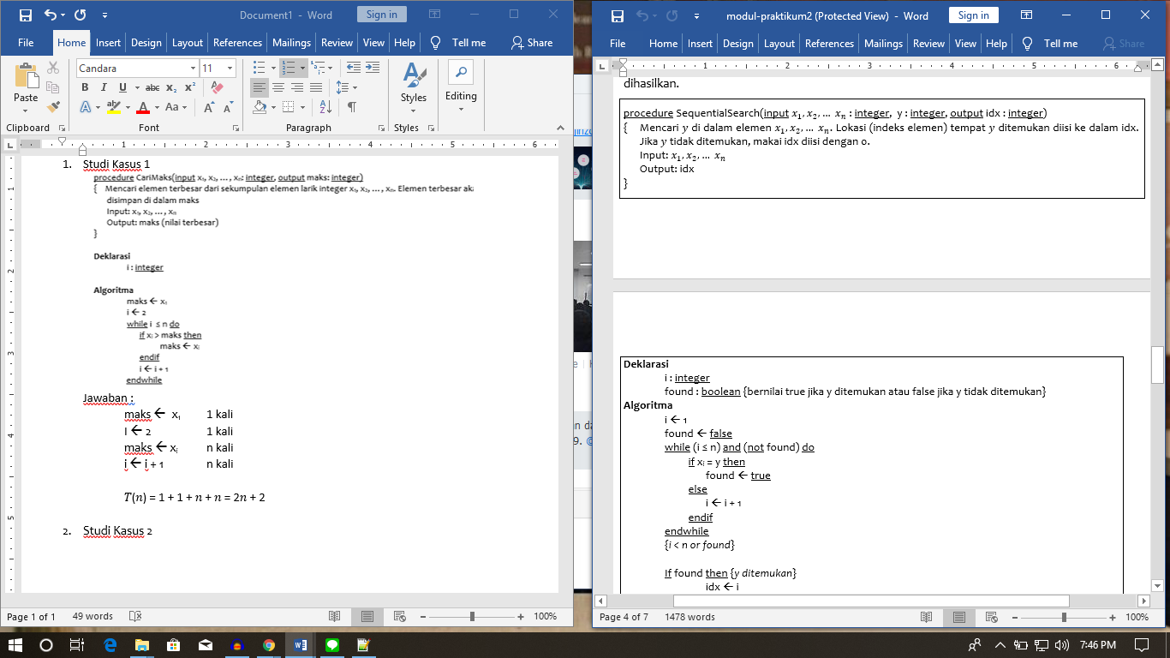

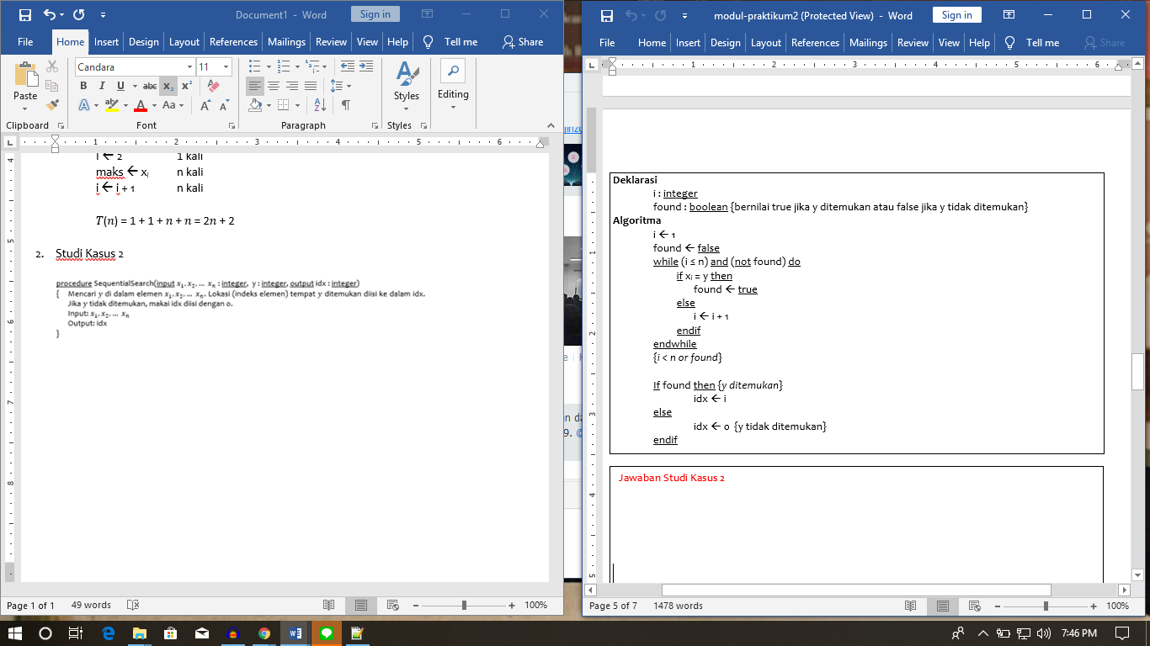

Jawaban :

**Best Case**

i 🡨 1 1 kali

found 🡨 false 1 kali

found 🡨 true 1 kali

idx 🡨 i 1 kali

𝑇𝑚𝑖𝑛(𝑛) = 1 +1 + 1+ 1 = 4

**Average Case**

i 🡨 1 1 kali

found 🡨 false 1 kali

i 🡨 i + 1 ½ n kali

found 🡨 true 1 kali

idx 🡨 i 1 kali

𝑇𝑎𝑣𝑔(𝑛) = 1+ 1 + $\frac{1}{2}$ 𝑛 + 1 +1 = $\frac{1}{2}$ 𝑛 + 4

**Worst Case**

i 🡨 1 1 kali

found 🡨 false 1 kali

i 🡨 i + 1 n kali

found 🡨 true 1 kali

idx 🡨 i 1 kali

𝑇𝑚𝑎𝑥(𝑛) = 1+ 1 + 𝑛 + 1 +1 = 𝑛 + 4

1. Studi Kasus 3

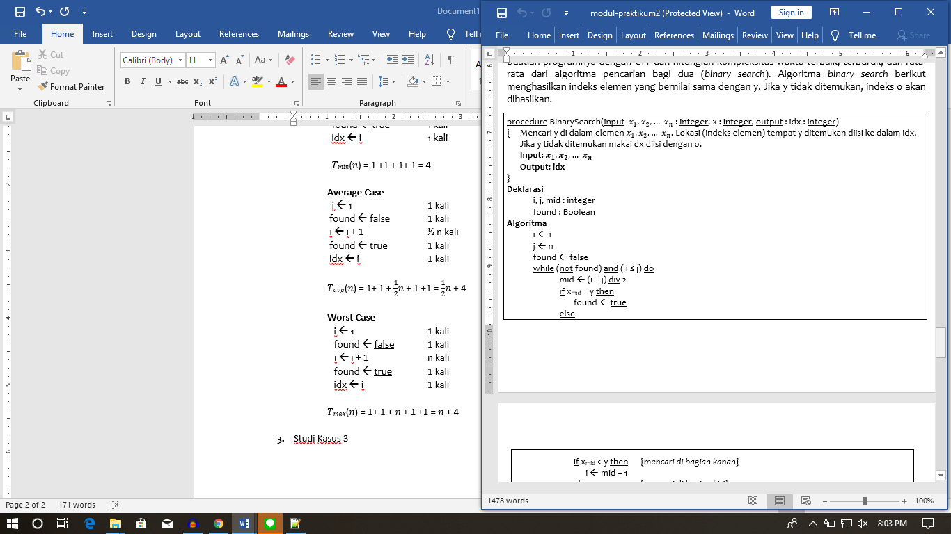

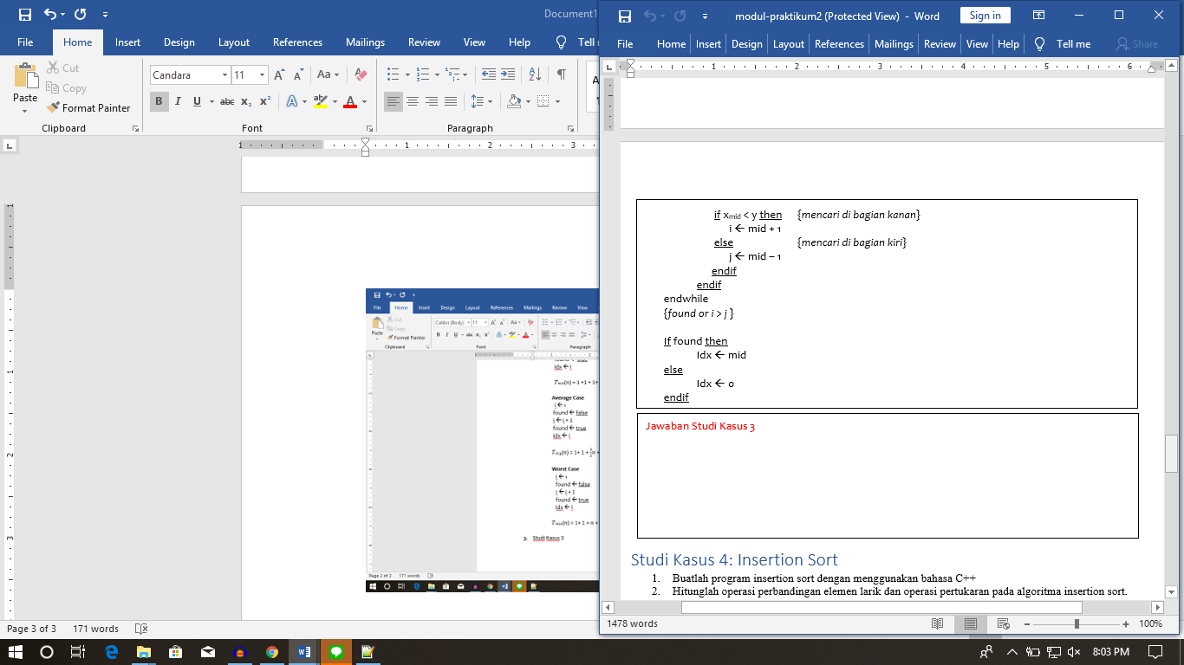

**Jawaban :**

**Best Case**

i 🡨 1 1 kali

j 🡨 n 1 kali

found 🡨 false 1 kali

mid 🡨 (i + j) div 2 1 kali

found 🡨 true 1 kali

Idx 🡨 mid 1 kali

𝑇𝑚𝑖𝑛(𝑛) = 1 +1 + 1+ 1 + 1+ 1 = 6

**Average Case :**

i 🡨 1 1 kali

j 🡨 n 1 kali

found 🡨 false 1 kali

mid 🡨 (i + j) div 2 ½ n + 1 kali

i 🡨 mid + 1 or j 🡨 mid – 1 ½ n kali

found 🡨 true 1 kali

Idx 🡨 mid 1 kali

𝑇𝑎𝑣𝑔(𝑛) = 1+ 1 +1 + $\frac{1}{2}$ 𝑛 +1 + $\frac{1}{2}$ 𝑛 +1 + 1 = 𝑛 + 6

**Worst Case**

i 🡨 1 1 kali

j 🡨 n 1 kali

found 🡨 false 1 kali

mid 🡨 (i + j) div 2 n + 1 kali

i 🡨 mid + 1 or j 🡨 mid – 1 n kali

found 🡨 true 1 kali

Idx 🡨 mid 1 kali

𝑇𝑚𝑎𝑥(𝑛) = 1+ 1 + 1+ 𝑛 +1 + 𝑛 +1 + 1 = 2𝑛 + 6

1. **Studi Kasus 4**

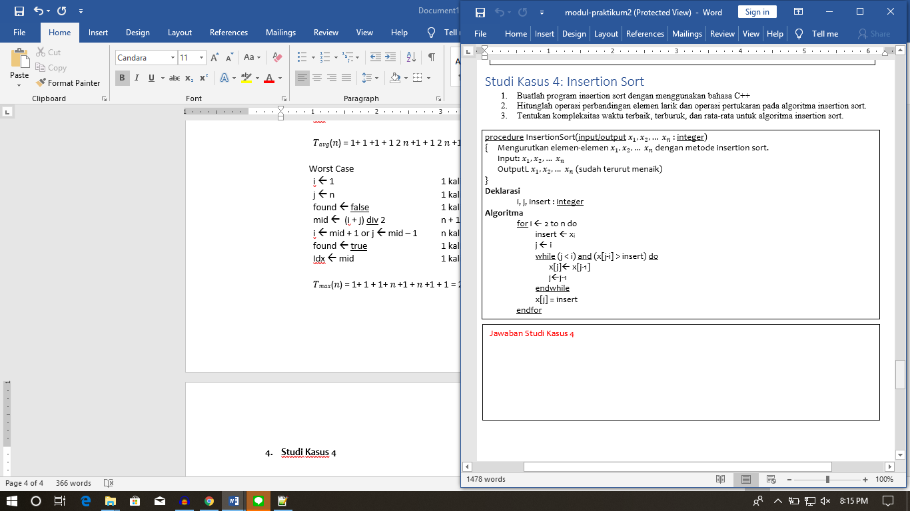

**Jawaban :**

**Best Case**

for i 🡨 2 to n do 1 kali

insert 🡨 xi n kali

j 🡨 i n kali

x[j] = insert n kali

𝑇𝑚𝑖𝑛(𝑛) = 1 +𝑛 + 𝑛 +𝑛 = 3𝑛 + 1

**Average Case**

for i 🡨 2 to n do 1 kali

insert 🡨 xi n kali

j 🡨 i n kali

x[j] 🡨 x[j-1] n * ½ n kali

j🡨j-1 n * ½ n kali

x[j] = insert n kali

𝑇𝑎𝑣𝑔(𝑛) = 1+ 𝑛 + 𝑛 + 𝑛2 + 𝑛2 + 𝑛 = 𝑛2 + 3𝑛 + 1

**Worst Case**

for i 🡨 2 to n do 1 kali

insert 🡨 xi n kali

j 🡨 i n kali

x[j] 🡨 x[j-1] n * n kali

j🡨j-1 n * n kali

x[j] = insert n kali

𝑇𝑚𝑎𝑥(𝑛) = 1+ 𝑛 + 𝑛 + 𝑛2 + 𝑛2 + 𝑛 = 2𝑛2 + 3𝑛 + 1

1. Studi Kasus 5

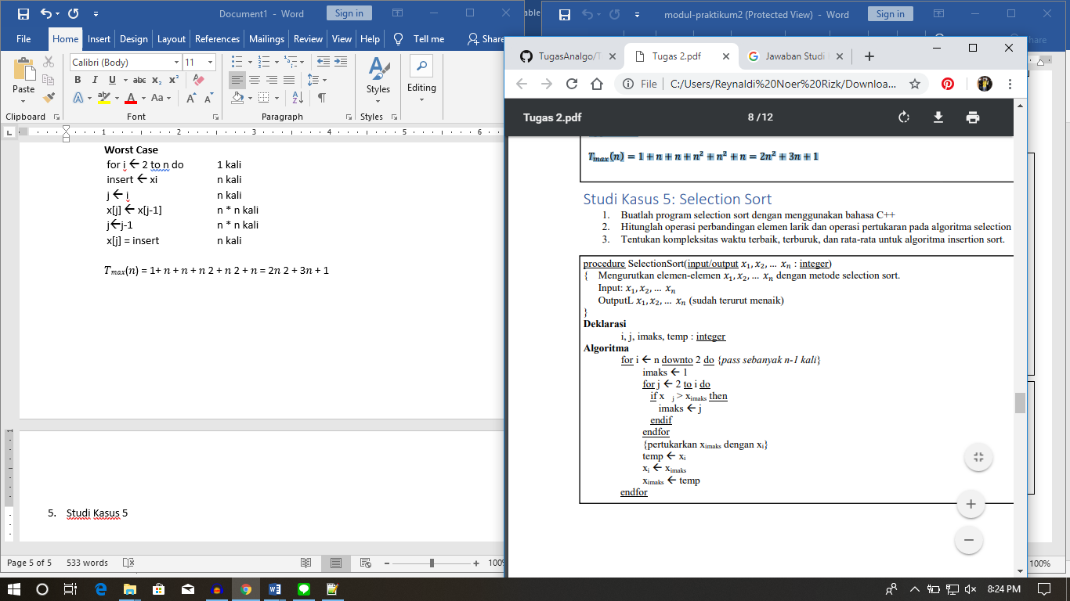

Jawaban :

**Best Case**

for i 🡨 n down to 2 do 1 kali

imaks 🡨 1 n kali

for j 🡨 2 to i do n kali

imaks 🡨 j n*1 kali

temp 🡨 xi n kali

xi 🡨 ximaks  n kali

ximaks 🡨 temp n kali

𝑇𝑚𝑖𝑛(𝑛) = 1 +𝑛 + 𝑛 +𝑛 ∗ 1 +𝑛 + 𝑛 +𝑛 = 6𝑛 + 1

**Average Case**

for i 🡨 n downto 2 do 1 kali

imaks 🡨 1 n kali

for j 🡨 2 to i do n kali

imaks 🡨 j n * ½ n kali

temp 🡨 xi n kali

xi 🡨 ximaks n kali

ximaks 🡨 temp n kali

𝑇𝑎𝑣𝑔(𝑛) = 1+ 𝑛 + 𝑛 + 𝑛2 + 𝑛 +𝑛 + 𝑛 = 𝑛2 +5𝑛 + 1

**Worst Case**

for i 🡨 n downto 2 do 1 kali

imaks 🡨 1 n kali

for j 🡨 2 to i do n kali

imaks 🡨 j n * n kali

temp 🡨 xi n kali

xi 🡨 ximaks n kali

ximaks 🡨 temp n kali

𝑇𝑚𝑎𝑥(𝑛) = 1+ 𝑛 + 𝑛 + 𝑛2 + 𝑛 +𝑛 + 𝑛 = 𝑛2 +5𝑛 + 1