Team Members:

Abdurrahman Darvesh, Alex Burch, Roderick Reynolds, Rodney Kirkendoll, Serena Leung

Project Description and Outline:

Our client is a real estate developer interested in figuring out which market to invest in that will have the highest growth potential. We will look at population growth over the course of five years, income, and poverty levels.

Research Questions to Answer:

Which market had the highest recent growth in per square foot prices? Which market had the least amount of growth?

**Hypotheses:**

Null hypothesis: There is no relationship between population growth or income and price growth.

Alternative hypothesis:

* Cities that have the highest population growth will have the highest price growth potential.
* Cities that have higher income levels correspond to real estate with higher prices.

Datasets to be used:

Census Data 2012 to 2017:

* Fields: Zip Code, Population, Median Age, Household Income, Per Capita Income, Poverty count, Poverty Rate
* Summary Statistics for 2017:

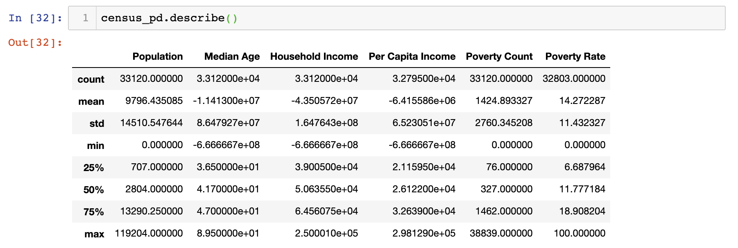

* Summary Statistics for 2016:

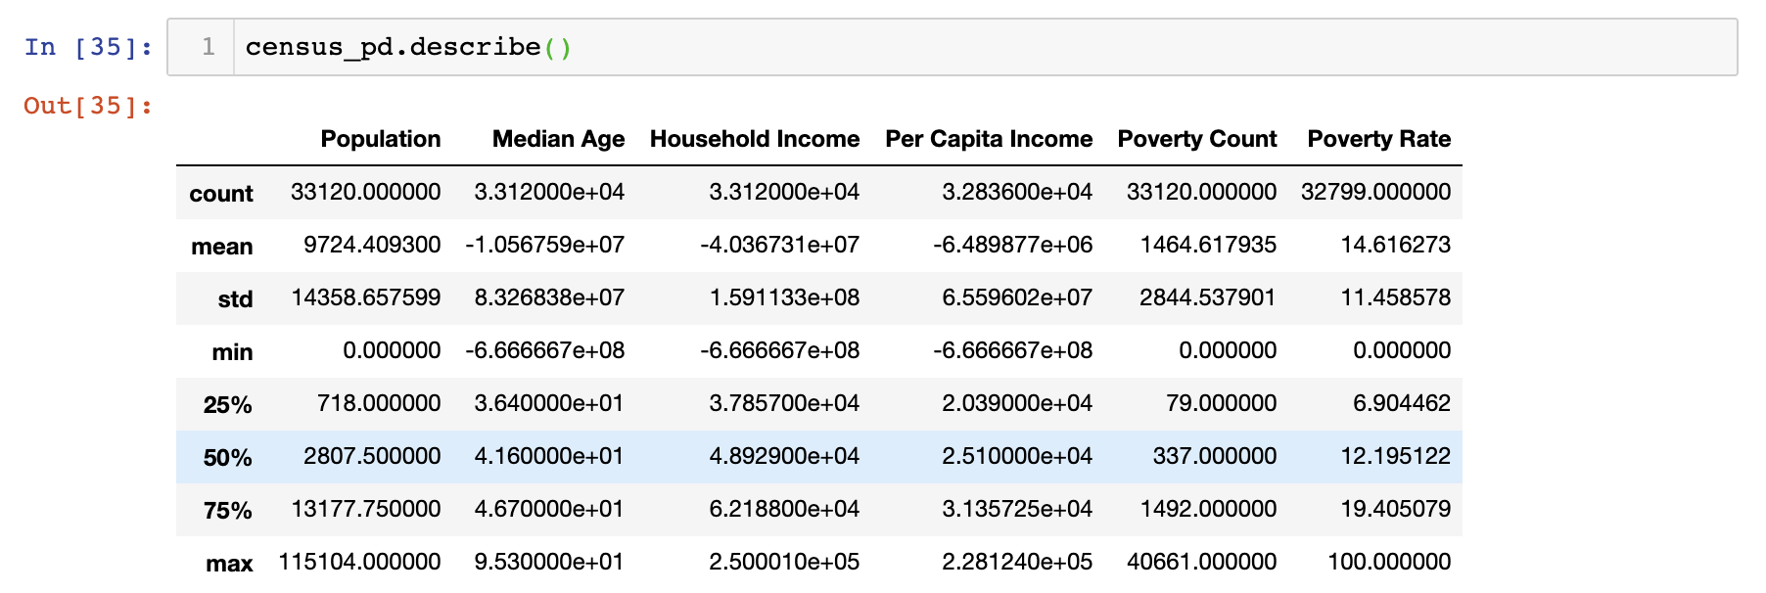

* Summary Statistics 2015:

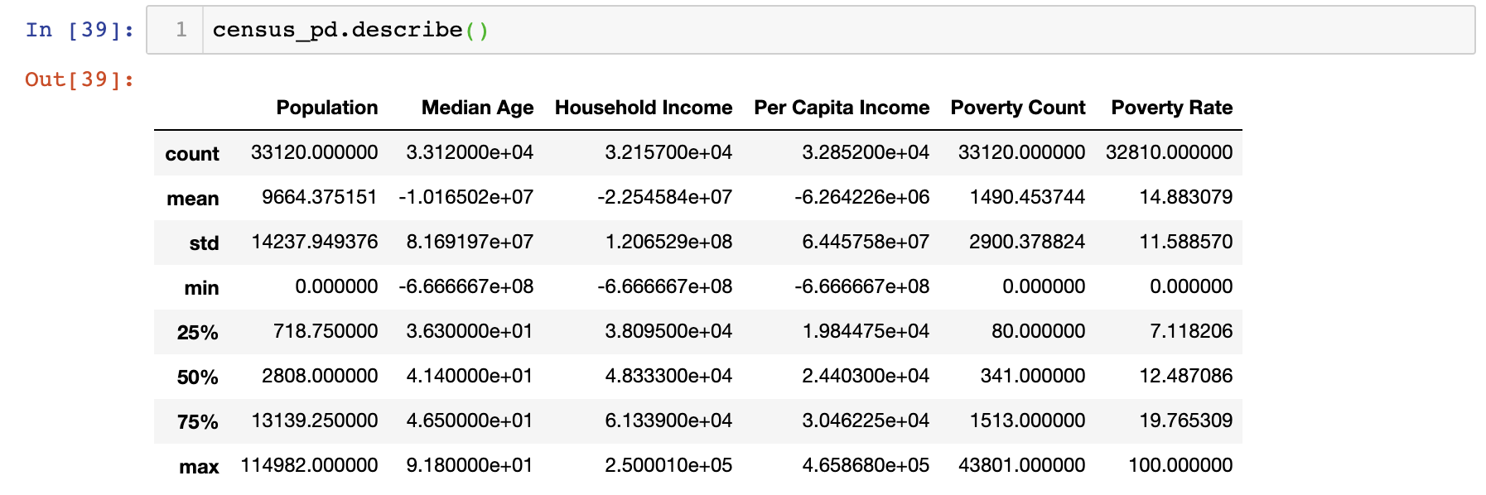

* Summary Statistics 2014:

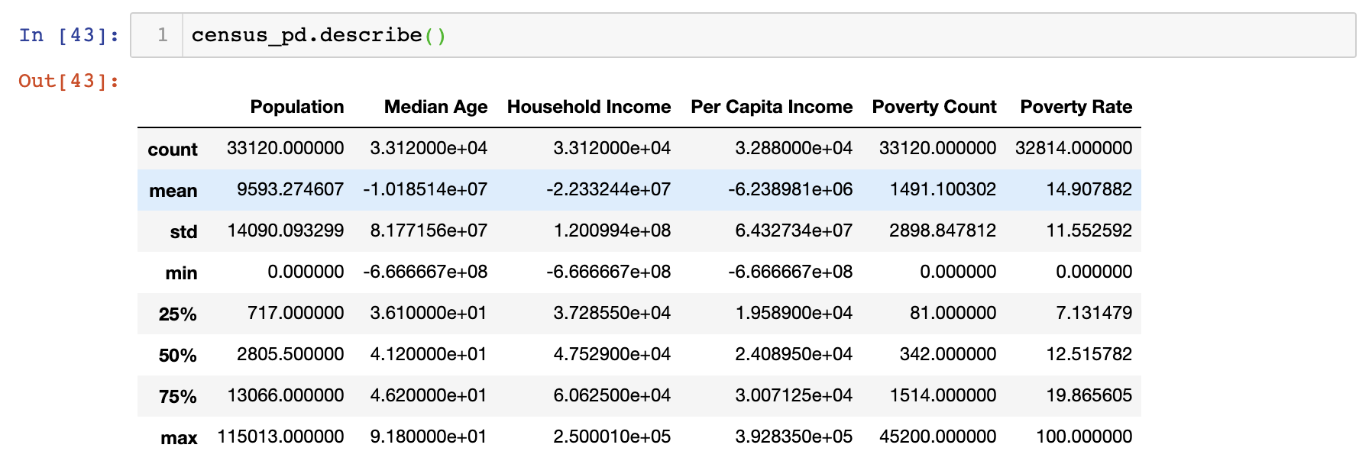

* Summary Statistics 2013:

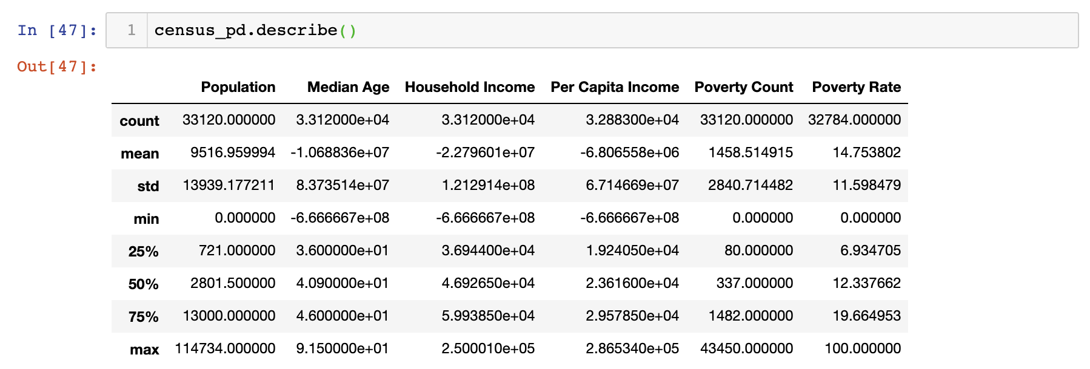

* Summary Statistics 2012:

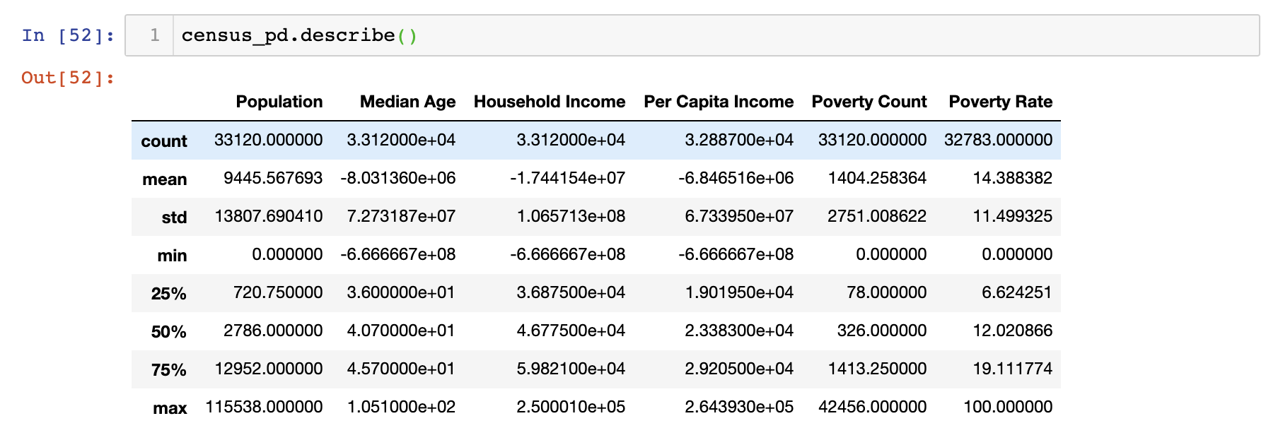

Home Value: Median Price Per Square Foot by Zip code 1996 to July 2019

* Fields: City, State, Metropolitan area, county, rank, average square foot value per month
* Summary Statistics:

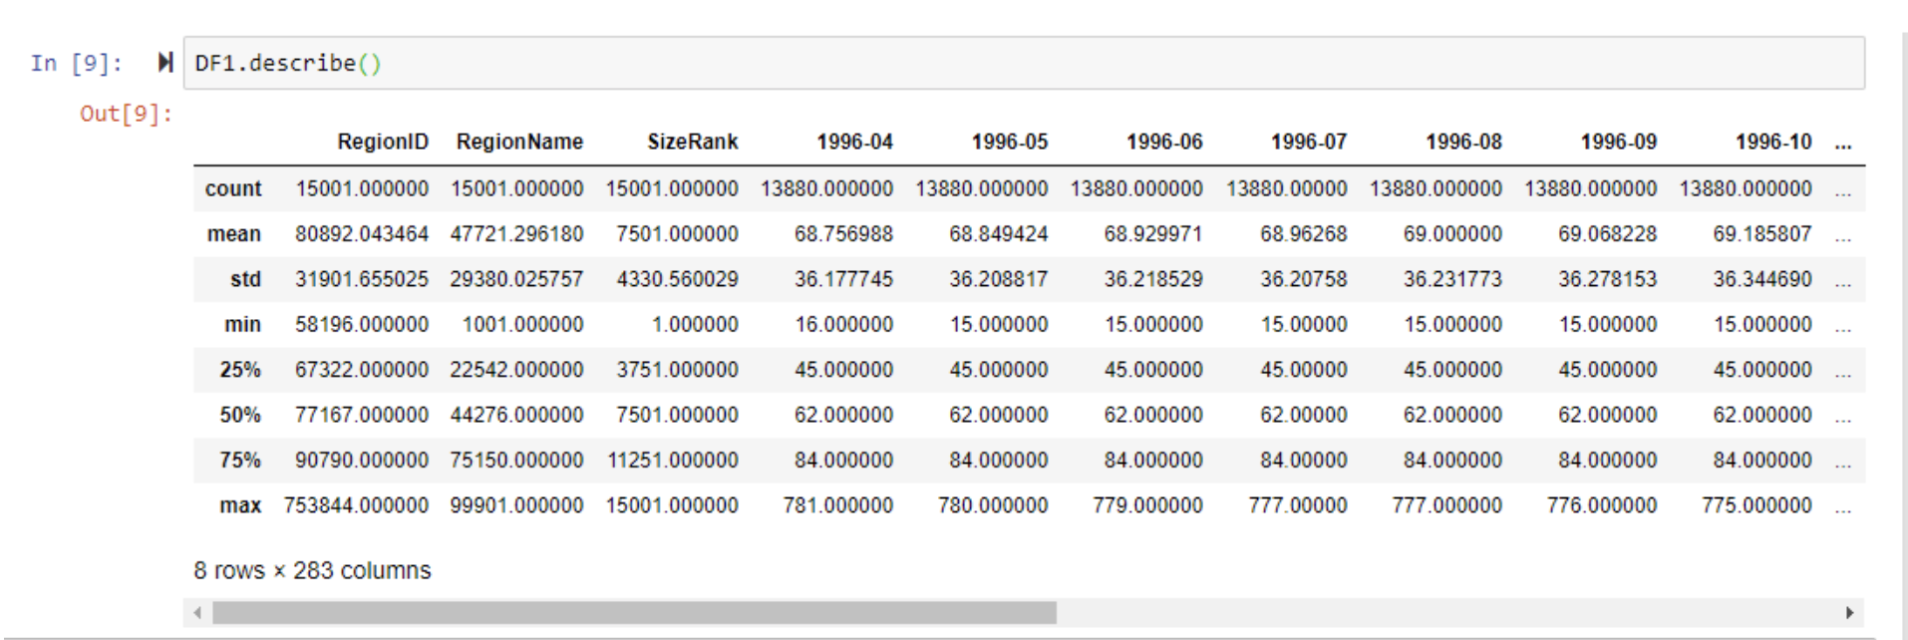

Rough breakout of tasks:

1. Extract
   1. Download multiple data files
2. Transform
   1. Clean data
      1. Merge census files together
   2. Summarize
      1. Calculate average square foot price by year
   3. Filter
3. Load
   1. Load into SQL database