**CS1 Task 9 – SmokeStop**

**Model of the software architecture**

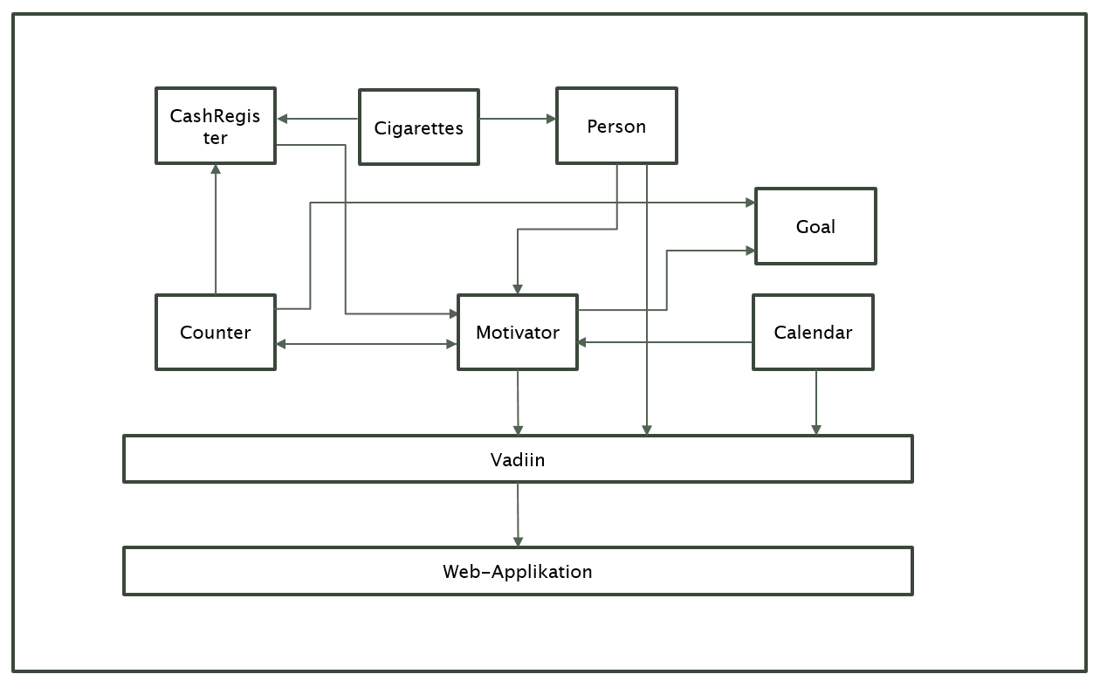

**System Requirements**

Functional Requirements

* SmokeStop is a Web application, which should help reduce smoking step by step
* The smoker can define his final goal as well as his daily goals
* SmokeStop support the smoker with different motivators
* SmokeStop notified the user, if the final target is reached
* Daily goals will be defined by week
* If the daily goal is exceeded, SmokeStop will message you
* Data is stored in a database
* The use can change his information any time

Non-functional Requirements

* The Application should not stock as well when many users are online
* Each user choose an username and create his own password
* SmokeStop has no critical data, expect of name, first name and age. But the data should not be accessible.
* Avoid errors by using Exceptions

Domain Requirement

* The user has to be a smoker
* Use a computer
* Internet connection
* Registration and Login
* Indicate how many cigarettes he smokes daily
* Define a final goal as well as a daily goal

**Architectural design pattern – MVC**

We have chosen the MVC design pattern because of:

* SmokeStop is a Web application
* Data is used from different classes
* SmokeStop has three several displays