

<https://coolors.co/397367-63ccca-5da399-42858c-35393c>

<link rel="preconnect" href="https://fonts.googleapis.com">

<link rel="preconnect" href="https://fonts.gstatic.com" crossorigin>

<link href="https://fonts.googleapis.com/css2?family=PT+Sans:wght@400;700&display=swap" rel="stylesheet">

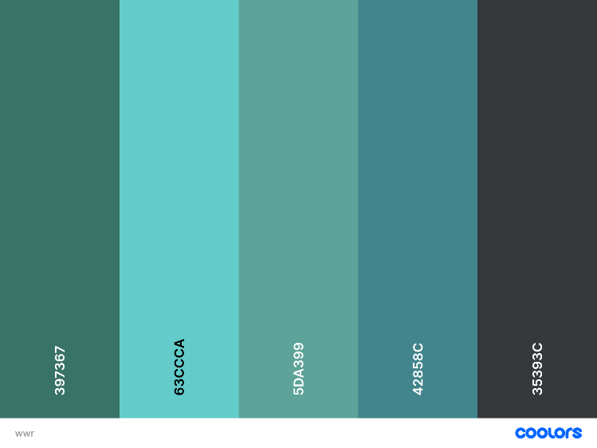

primary-color - #397367

secondary-color - #63CCCA

accent1-color - #5DA399

accent2-color - #42858C

heading-font

text-font

<link rel="preconnect" href="https://fonts.googleapis.com">

<link rel="preconnect" href="https://fonts.gstatic.com" crossorigin>

<link href="https://fonts.googleapis.com/css2?family=Kanit:wght@100;400&family=PT+Sans&display=swap" rel="stylesheet">

In the CSS sheet

Under file base.css

\*{box-sizing: border-box;}

body {

font-family: "Kanit", sans-serif;

font-weight: 400;

}

h1 {

font-weight: 100;

}