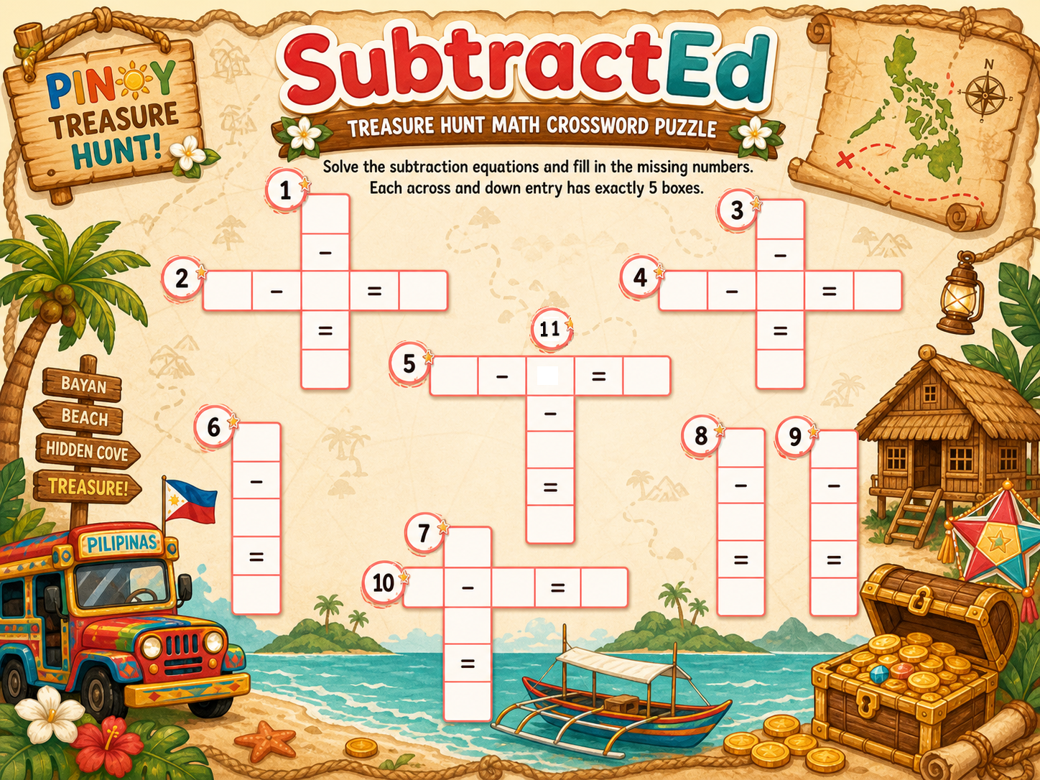Kini po ang sa Enrichment Activity, naa po sa drive ang background. This is a crossword puzzle po bali 6 ka ing ani sir.

For the 1st na ing ani sir, kini ang mga equations.
No. | Equation
1 | 15−?=9
2 | 12−?=6
3 | 18−?=13
4 | 14−?=9
5 | 20−?=10
11 | ?−3=7
6 | 17−8=?
7 | 15−4=?
8 | 21−9=?
9 | 14−6=?
10 | 13−5=?
Teacher's Answer Key:
- 6
- 6
- 5
- 5
- 10
- 9
- 11
- 12
- 8
- 8
- 10

An may question mark po is mao na ang blank sa box na need I fill out sa students.
Naa pud mo pop up nga correct or incorrect sa screen sir if right or wrong ila respectively.
Then mu green pud ang 5 na boxes if nakatama na sila.
Like This:
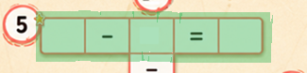
For 2nd Level (same boxes ghapon po)
No. | Equation
1 | 4−?=−8
2 | 7−?=−5
3 | 2−?=−13
4 | 6−?=−9
5 | 3−?=−5
11 | ?−11=−3
6 | 5-14=?
7 | 1-10=?
8 | 9-20=?
9 | 4-18=?
10 | 8-15=?
Teacher's Answer Key (Negative Integer Focus)
- 12
- 12
- 15
- 15
- 8
- -9
- -9
- -11
- -14
- -7
- 8
3rd Level
No. | Equation
1 | −4−?=−14
2 | −8−?=−18
3 | −5−?=−12
4 | −12−?=−19
5 | −9−?=−15
11 | ?−4=−10
6 | -15 - 5 = ?
7 | -3 -9=?
8 | -20 - 10 =?
9 | -7 - 13=?
10 | -11-4=?
Teacher's Answer Key (Negative Minuend Focus)
- 10
- 10
- 7
- 7
- 6
- -20
- -12
- -30
- -20
- -15
- -6
4th Level
No. | Equation
1 | 5−(?)=13
2 | 12−(?)=20
3 | 4−(?)=15
4 | 9−(?)=20
5 | 10−(?)=16
11 | (?)−(−3)=−3
6 | 7-(-5)=?
7 | 15-(-10)=?
8 | 3-(-9)=?
9 | 20-(-4)=?
10 | 8-(-12)=?
Teacher's Answer Key
- -8
- -8
- -11
- -11
- -6
- 12
- 25
- 12
- 24
- 20
- -6
5th Level
No. | Equation
1 | −5−(?)=7
2 | −2−(?)=10
3 | −3−(?)=12
4 | −6−(?)=9
5 | −4−(?)=4
11 | (?)−(−5)=−3
6 | -10-(-18)=?
7 | -1-(-11)=?
8 | -7-(-20)=?
9 | -4-(-14)=?
10 | -11-(-16)=?

Teacher's Answer Key (Double Negative Focus)
- -12
- -12
- -15
- -15
- -8
- 8
- 10
- 13
- 10
- 5
- -8
6th level
No. | Equation
1 | −10−(?)=−15
2 | −5−(?)=−20
3 | −12−(?)=−18
4 | −2−(?)=−28
5 | −8−(?)=−12
11 | (?)−(−5)=−15
6 | -3-(-10)=?
7 | -11-(-15)=?
8 | -6-(-20)=?
9 | -1-(-12)=?
10 | -9-(-14)=?
Teacher's Answer Key
- -25
- -25
- -30
- -30
- -20
- -7
- -4
- -14
- -11
- -5
- -20

