*Please make the questions bigger, then the direction font color to black
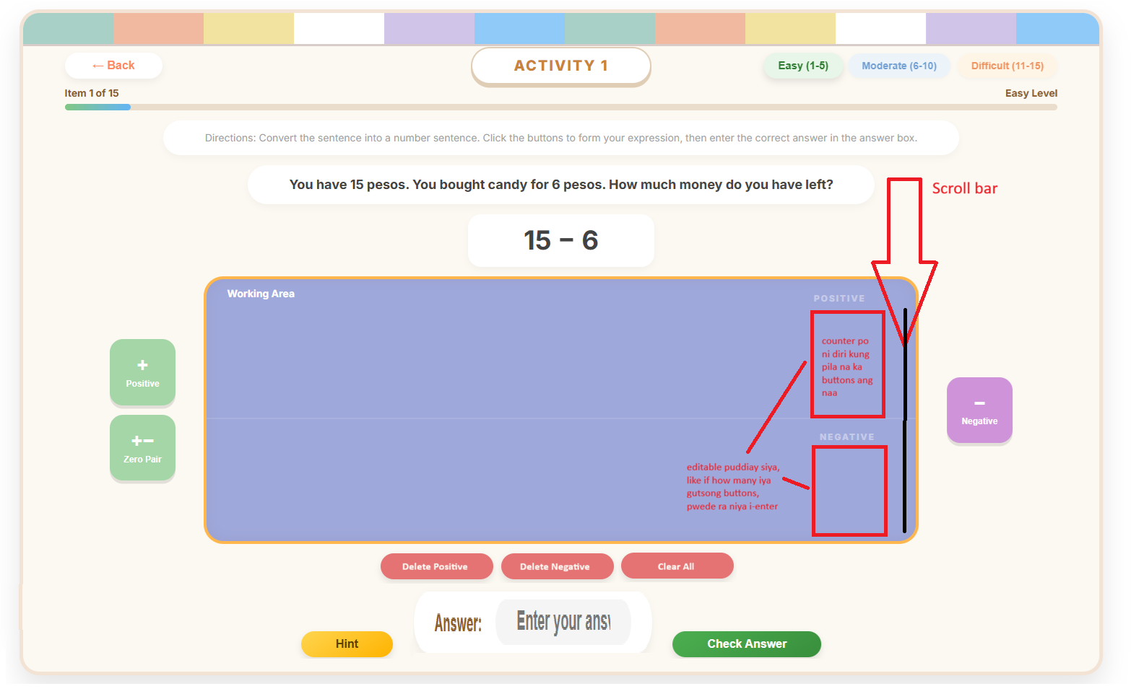
Ang red squares po ha positive and negative mao po na ang counters nga magshow pila na po kabuok ang mga buttons para dili na sila mag manual counting.
Editable pud siya, pwede ra po itype ang number then mugawas na ang mga buttons.
Add scroll bar rin po para ma scroll nila if hindi na magkasya sa working area
I added new buttons
Delete positive = delete one positive button
Delete negative = delete one negative button
Clear all = remove all the buttons in the Working Area
In Difficult, remove nalang po ang number sentence na space
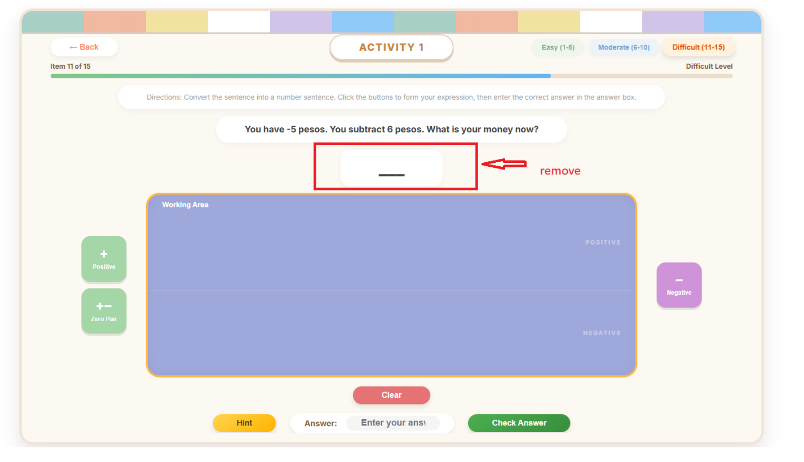

Questions

Easy:
Question 1:
You have 15 pesos. You bought a piece of turon for 9 pesos. How much is left?
Number Sentence: 15 - 9 = ?
Hint: Subtract the smaller amount from what you have.
Question 2:
A tricycle has 12 seats. 7 passengers are already inside. How many seats are still empty?
Number Sentence: 12 - 7 = ?
Hint: Subtract the passengers from the total seats.
Question 3:
You have 5 pesos in your pocket, but you need to pay 12 pesos for a jeepney fare. If you give all your money, how much is your "utang" (debt)?
Number Sentence: 5 - 12 = ?
Hint: Since you spend more than you have, the result will be negative.
Question 4:
A vendor has 8 sticks of banana cue. A customer wants to buy 15 sticks. How many more sticks does the vendor need to cook?
Number Sentence: 8 - 15 = ?
Hint: Subtracting a larger number results in a negative value representing what is "missing."
Question 5:
Your phone has 3 pesos of load. You sent a text that costs 10 pesos using emergency load. What is your new balance?
Number Sentence: 3 - 10 = ?
Hint: Your balance will go below zero.

Moderate:
Question 1:
You owe your brother 18 pesos. He takes away 10 pesos of your debt. What is your new balance?
Number Sentence: -18 - (-10) = ?
Hint: Subtracting a debt makes you owe less. It is the same as adding to your balance!

Question 2:
A freezer is set at -15°C. You decrease the coldness by 6 degrees. What is the new temperature?
Number Sentence: -15 - (-6) = ?
Hint: When you subtract a negative temperature, the freezer gets warmer and moves closer to zero.

Question 3:
A diver is 20 meters below sea level (-20). He reduces his depth by 15 meters. Where is he now?
Number Sentence: -20 - (-15) = ?
Hint: Subtracting a negative depth means the diver is rising toward the surface.

Question 4
Your GCash utang is 12 pesos. The bank removes a 5-peso penalty from your account. What is your balance now?
Number Sentence: -12 - (-5) = ?
Hint: Removing a "minus" from your account makes your balance more positive!
Question 5:
A basketball team has a score deficit of -14. The referee cancels a 4-point penalty against them. What is their new deficit?
Number Sentence: -14 - (-4) = ?
Hint: When you subtract a penalty, the score improves (gets closer to zero).

Difficult:
Question 1:
You have 6 pesos, but you need to pay a debt of -14 pesos (subtracting a negative). What is your total value now?
Number Sentence: 6 - (-14) = ?
Question 2:
It is 10°C in Baguio. The temperature "drops" by 18 degrees. What is the new temperature?
Number Sentence: 10 - 18 = ?
Question 3:
You owe the store 5 pesos (-5). You then buy a snack worth 12 pesos on credit. What is your total debt?
Number Sentence: -5 - 12 = ?
Question 4:
A fish is swimming at -3 meters. It dives down another 15 meters. What is its new depth?
Number Sentence: -3 - 15 = ?
Question 5:
A student has a score of -8 in a game. They get another 12 points deducted for a mistake. What is the final score?
Number Sentence: -8 - 12 = ?

