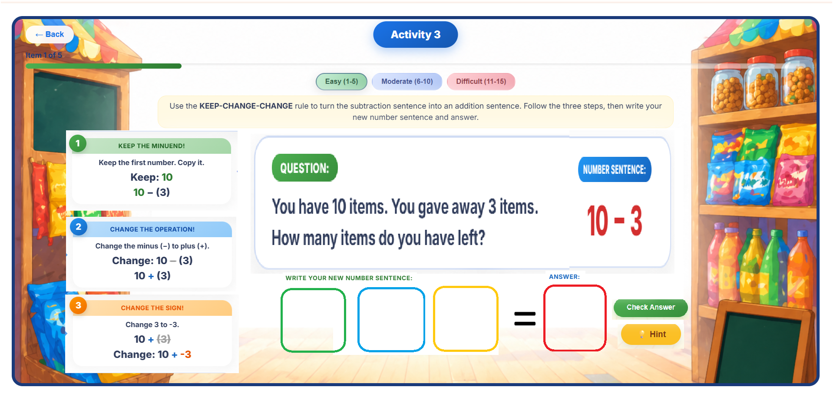
Gipare arrange po ini sir, dapat daw dako kase an questions as well as the answer.
So if they click the green square, kay mahilight liwat po an step one, same as if I click red, mahilight lat po an blue.
Sa Difficult round sir kay wa naman steps as well as number sentence ing ani ang iyang makita, pero wala ni siya hint po.
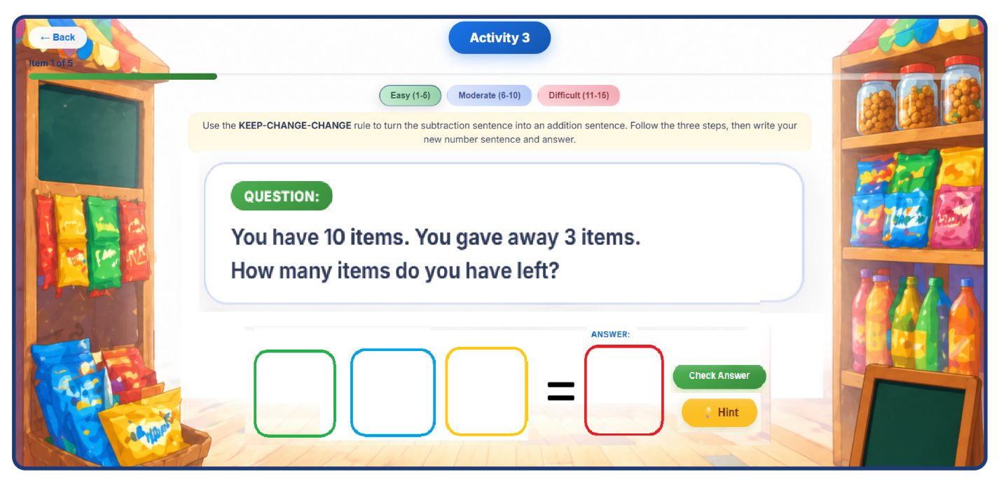
Sa moderate naman:
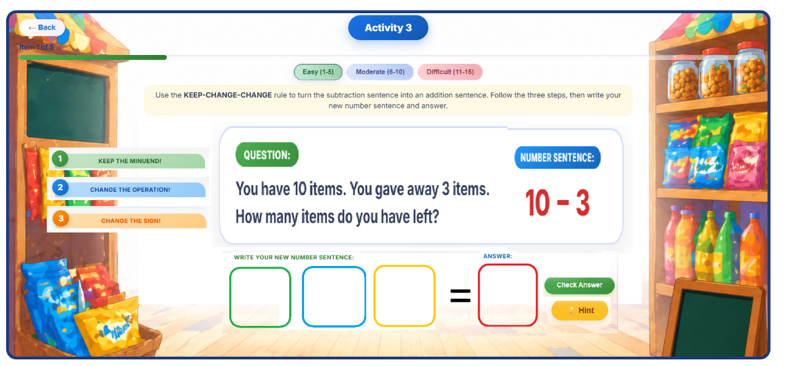

I revised some questions po, and some, I swapped.

Easy:
Question 1:
You have 10 pesos. You bought one isaw for 3 pesos. How much is left?
Number Sentence: 10 - 3 = ?
Hint: Remember to subtract the smaller number from the bigger one.
Incorrect Answer Pop-up:
"Not Quite! Let's Try Again!
You need to subtract 3 from 10. Try again!"
[Button: Got it! I'll Try Again]
Question 2:
A Jeepney has 7 passengers. 5 people got off at the plaza. How many remain?
Number Sentence: 7 - 5 = ?
Hint: Subtract the second number from the first.
Incorrect Answer Pop-up:
"Oops! Almost there!
Remember, 7 - 5 is the operation you're trying to solve. Try again!"
[Button: Got it! I'll Try Again]
Question 3:
You have 4 pesos, but a pack of Clover chips costs 8 pesos. If you pay what you have, how much do you still owe?
Number Sentence: 4 - 8 = ?
Hint: When the minuend is smaller, the result will be negative (debt).
Incorrect Answer Pop-up:
"Oops! Looks like you missed the sign.
Try again and remember, the result will be negative!"
[Button: Got it! I'll Try Again]
Question 4:
A street vendor has 3 ripe mangoes. A customer wants to buy 5. How many more mangoes does the vendor need?
Number Sentence: 3 - 5 = ?
Hint: A smaller number minus a bigger one will result in a negative number.
Incorrect Answer Pop-up:
"Not Quite! Let's Try Again!
When subtracting a larger number from a smaller one, you get a negative result. Try again!"
[Button: Got it! I'll Try Again]
Question 5:
You have 2 load credits. You sent a promo text worth 6 credits. What is your new balance?
Number Sentence: 2 - 6 = ?
Hint: Always check if the second number is larger. You’ll get a negative result.
Incorrect Answer Pop-up:
"Oops! Remember to think about the negative result when the second number is larger. Try again!"
[Button: Got it! I'll Try Again]

Moderate:
Question 1:
You owe the canteen 15 pesos. The owner gives you an 8-peso discount. What is your remaining debt?
Number Sentence: -15 - (-8) = ?
Hint: Think of subtracting a negative number (removing debt) as adding the positive value.
Incorrect Answer Pop-up:
"Not Quite! Let's Try Again!
When subtracting a negative number, remember to add its positive counterpart. Try again!"
[Button: Got it! I'll Try Again]
Question 2:
You owe a friend 10 pesos. You returned 6 pesos today. How much do you still owe?
Number Sentence: -10 - (-6) = ?
Hint: Subtracting a negative means you are moving closer to zero from a negative start.
Incorrect Answer Pop-up:
"Oops! Looks like you missed the result's sign.
When subtracting a negative number from a negative, the value becomes less negative. Try again!"
[Button: Got it! I'll Try Again]
Question 3:
A vendor has a 20-peso loss. After a small sale, the loss is reduced by 15 pesos. What is the final loss?
Number Sentence: -20 - (-15) = ?
Hint: Removing a larger debt value from a smaller one keeps the result negative but closer to zero.
Incorrect Answer Pop-up:
"Oops! Remember, you are reducing the debt. The result should be less negative. Try again!"
[Button: Got it! I'll Try Again]
Question 4:
A basket of calamansi is 25 grams underweight. You add 5 grams. How far from the target weight is it now?
Number Sentence: -25 - (-5) = ?
Hint: When subtracting a negative number, remember to add the absolute value.
Incorrect Answer Pop-up:
"Oops! Almost there!
You need to add the value when "subtracting" a negative. Try again!"
[Button: Got it! I'll Try Again]
Question 5:
You have 30 pesos debt in GCash. You refund a 12-peso error. What is your balance?
Number Sentence: -30 - (-12) = ?
Hint: When subtracting a negative number, you actually add the absolute value.
Incorrect Answer Pop-up:
"Not Quite! Let's Try Again!
When subtracting a negative number, remember to add. Try again!"
[Button: Got it! I'll Try Again]

Difficult:
Question 1:
Your game score is 15. The leader removes your 6-point penalty. What is your new score?
Number Sentence: 15 - (-6) = ?
Hint: Subtracting a negative is like adding. Removing a penalty makes your score higher.
Incorrect Answer Pop-up:
"Not Quite! Let's Try Again!
Taking away a penalty is a good thing! It makes your score go up. Try again!"
[Button: Got it! I'll Try Again]
Question 2:
A tricycle driver owes 100 pesos for gas. He then borrows 150 pesos more for lunch. What is his total debt?
Number Sentence: -100 - 150 = ?
Hint: When subtracting a positive number from a negative number, the result will be more negative.
Incorrect Answer Pop-up:
"Oops! Almost there!
Remember, subtracting a positive number from a negative number makes the result more negative. Try again!"
[Button: Got it! I'll Try Again]
Question 3:
A student owes 300 pesos for a class t-shirt and another 500 pesos for a field trip. What is the total "utang"?
Number Sentence: -300 - 500 = ?
Hint: A negative number minus a positive number results in a more negative value.
Incorrect Answer Pop-up:
"Oops! Looks like you missed the sign.
Subtracting a positive number from a negative one results in a more negative value. Try again!"
[Button: Got it! I'll Try Again]
Question 4:
A farmer has a loan of 1,000 pesos. He takes an additional loan of 2,500 pesos for seeds. How much is his total loan?
Number Sentence: -1000 - 2500 = ?
Hint: When subtracting a positive number from a negative, you will end up with a more negative result.
Incorrect Answer Pop-up:
"Oops! You need to remember that subtracting a positive number from a negative results in a more negative outcome. Try again!"
[Button: Got it! I'll Try Again]
Question 5:
A sari-sari store's loss is 800. If they spend another 1,200 on repairs, what is the total loss?
Number Sentence: -800 - 1200 = ?
Hint: Think about how subtracting a larger positive number from a negative number will give a result that's even more negative.
Incorrect Answer Pop-up:
"Not quite! Let's try again.
When subtracting a positive number from a negative number, the result becomes more negative. Try again!"
[Button: Got it! I'll Try Again]

