SVD-Based Image Compression and Denoising
Using Power Iteration with Deflation
Reyyan Beyza Aydın
Student ID: 070240413

Abstract—Singular Value Decomposition (SVD) is a powerful tool in linear algebra and numerical analysis with extensive applications in digital image processing. In this paper, we develop and evaluate an SVD-based image compression and denoising system from scratch without relying on built-in algebraic libraries. The required SVD is derived by constructing the symmetric matrix B = A^{T}A and solving its eigenvalues and eigenvectors using a self-implemented Power Iteration with Hotelling's Deflation eigensolver. The custom SVD is evaluated on a grayscale photograph (332×300 pixels) across several ranks k ∈ {5, 10, 20, 50, 100, 200}. For image compression, the reconstruction quality scales from a highly compressed low-quality approximation (relative Frobenius error of 11.75% at k = 5) to an almost indistinguishable representation (relative Frobenius error of 0.26% at k = 200). For image denoising, a noisy observation containing additive Gaussian noise (σ ≈ 0.0588) is reconstructed. The truncated SVD acts as a low-pass filter, yielding an optimal denoising rank of k* = 20, which maximizes the Peak Signal-to-Noise Ratio (PSNR) at 27.96 dB, a significant improvement of +3.04 dB over the noisy baseline.
Index Terms- Singular Value Decomposition, Image Compression, Image Denoising, Power Iteration, Hotelling's Deflation, Rayleigh Quotient.
I. Introduction
In digital image processing, images are represented as matrices of pixel intensities, where the dimensions correspond to spatial coordinates. Such representations typically contain significant spatial redundancy and high-frequency noise. Reducing storage footprints while preserving structural features is a key challenge. Singular Value Decomposition (SVD) provides a mathematically rigorous framework for low-rank matrix approximation, which forms the cornerstone of lossy image compression and feature extraction [1].
By factoring an image matrix A into its fundamental singular components, we can reconstruct the image using a truncated subset of the most dominant singular values. This rank-k approximation filters out less significant components. While this is primarily used for compression, it is equally effective for denoising, as random high-frequency noise tends to distribute across the lower-order singular components with smaller singular values.
To meet strict engineering constraints, we avoid black-box numerical libraries for the SVD. Instead, we implement an eigensolver from scratch using Power Iteration combined with Hotelling's Deflation. This eigensolver operates on the symmetric, positive semi-definite matrix B = AᵀA to compute its eigenvalues and orthonormal eigenvectors, which are then used to build the full SVD.
This paper evaluates the performance of the implemented system across two distinct tasks: (1) image compression, and (2) image denoising in the presence of additive white Gaussian noise. The remainder of this paper is structured as follows. Section II presents the theoretical background and custom SVD derivation. Section III details the experimental setup and code implementation. Section IV presents and discusses the quantitative and qualitative results, followed by an analysis of scalability limitations in Section V. Section VI concludes the paper.
II. Theoretical Background and Methodology
A. Singular Value Decomposition (SVD)
Let a grayscale image be represented as a real matrix A ∈ ℝᵐˣⁿ. The SVD factorizes A into three matrices:
A = UΣVᵀ (1)
where U ∈ ℝᵐˣᵐ is an orthogonal matrix whose columns are the left singular vectors uᵢ; V ∈ ℝⁿˣⁿ is an orthogonal matrix whose columns are the right singular vectors vᵢ; and Σ ∈ ℝᵐˣⁿ is a diagonal matrix containing non-negative diagonal elements σ₁ ≥ σ₂ ≥ ··· ≥ σᵣ > 0 (where r = min(m,n)), which represent the singular values of A.
According to the Eckart–Young–Mirsky theorem, the optimal rank-k approximation Aₖ of A under both the spectral and Frobenius norms is obtained by keeping only the k largest singular values:
Aₖ = UₖΣₖVₖᵀ = Σᵢ₌₁ᵏ σᵢuᵢvᵢᵀ (2)
where Uₖ ∈ ℝᵐˣᵏ and Vₖ ∈ ℝⁿˣᵏ contain the first k columns of U and V, and Σₖ ∈ ℝᵏˣᵏ is the diagonal matrix of the top k singular values.
B. Eigensolver via Power Iteration and Deflation
The SVD can be derived from the spectral decomposition of the symmetric matrix B = AᵀA ∈ ℝⁿˣⁿ. The eigenvalue problem for B is:
Bvᵢ = λᵢvᵢ, i = 1,2,...,n (3)
Because B is symmetric and positive semi-definite, its eigenvalues are real and non-negative. The singular values of A relate to eigenvalues of B by σᵢ = √max(λᵢ, 0). To compute eigenpairs of B, we initialize a random unit vector b⁽⁰⁾ ∈ ℝⁿ and run:
b⁽ᵗ⁺¹⁾ = B⁽ʲ⁾b⁽ᵗ⁾ / ‖B⁽ʲ⁾b⁽ᵗ⁾‖₂ (5)
Upon convergence, vⱼ ≈ b⁽ᵀ⁾ is the dominant eigenvector of B⁽ʲ⁾. The corresponding eigenvalue λⱼ is obtained using the Rayleigh quotient: λⱼ = vⱼᵀB⁽ʲ⁾vⱼ / vⱼᵀvⱼ.
To compute subsequent eigenvalues, we apply Hotelling's Deflation. Once the dominant eigenpair (λⱼ, vⱼ) of B⁽ʲ⁾ is found, we project its contribution out to form B⁽ʲ⁺¹⁾:
B⁽ʲ⁺¹⁾ = B⁽ʲ⁾ − λⱼvⱼvⱼᵀ (7)
This deflation shifts the largest eigenvalue to zero while leaving the others unchanged. By recursively applying Power Iteration and Hotelling's Deflation, we compute the first k largest eigenvalues and eigenvectors.
C. Constructing the Custom SVD
After obtaining the right singular vectors Vₖ = [v₁, v₂, ..., vₖ] and singular values σᵢ = √λᵢ, the left singular vectors are computed as:
uᵢ = (1/σᵢ)Avᵢ, i = 1,2,...,k (8)
This ensures Avᵢ = σᵢuᵢ. The rank-k approximation is then: Aₖ = UₖΣₖVₖᵀ.
D. Evaluation Metrics
Reconstruction quality is evaluated using: (1) MSE = (1/mn)‖A−Aₖ‖²_F; (2) Relative Frobenius Error = ‖A−Aₖ‖_F / ‖A‖_F; and (3) PSNR = 10 log₁₀(MAX² / MSE) in decibels (dB), where MAX = 1.0 for images normalized to [0, 1].
III. Experimental Setup and Implementation
A. Image Preprocessing
A personal grayscale photograph with dimensions m = 332 and n = 300 is used as the input matrix A. This satisfies the project constraint 256 ≤ min(m,n) and max(m,n) ≤ 512. The pixel intensities are read and converted to 64-bit floating-point values normalized to the interval [0, 1].
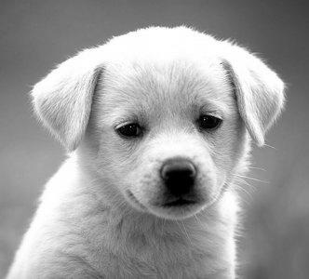
Fig.1: Image used troughout the project
B. Algorithmic Parameters
The algorithm is implemented in Python using the numpy, pandas, and matplotlib libraries. The custom eigensolver is initialized with a fixed random seed of 0 to ensure reproducibility of the Power Iteration results. The Power Iteration inner loop runs for a maximum of 500 iterations per eigenvalue, which is sufficient to achieve high precision. The outer loop extracts up to 200 eigenvalues using Hotelling's Deflation to support the testing of ranks k ∈ {5, 10, 20, 50, 100, 200}.
C. Noise Generation and Denoising Setup
An additive white Gaussian noise matrix N is generated, where Nᵢⱼ ~ 𝒩(0, σ²) with noise standard deviation σ = 15/255 ≈ 0.05882. The noisy observation is:
A_noisy = clip(A + N, 0, 1) (13)
For each tested rank k, the SVD is computed on the noisy matrix A_noisy to yield the singular components (Û, Σ̂, V̂). The denoised reconstruction is formed as Âₖ = ÛₖΣ̂ₖV̂ₖᵀ.
IV. Experimental Results and Analysis
A. Image Compression Evaluation
The compression performance of the custom SVD is evaluated across the designated ranks. Table I presents the quantitative metrics, including MSE, Relative Frobenius Error, Storage percentage, and Quality Level. Quality levels are classified based on the ratio of k to r = min(m,n) = 300: low if k ≤ 0.05r (k ≤ 15), medium if 0.05r < k ≤ 0.20r (15 < k ≤ 60), and high if k > 0.20r (k > 60).
TABLE I Image Compression Metrics Across Multiple Ranks (k)
k | MSE | Frob. Error | Storage (%) | Quality
5 | 5.8454×10⁻³ | 11.75% | 3.18% | Low
10 | 2.1978×10⁻³ | 7.21% | 6.36% | Low
20 | 1.0969×10⁻³ | 5.09% | 12.71% | Medium
50 | 4.2604×10⁻⁴ | 3.17% | 31.78% | Medium
100 | 1.1733×10⁻⁴ | 1.67% | 63.55% | High
200 | 2.8364×10⁻⁶ | 0.26% | 127.11% | High

As shown in Table I, at k = 5, the image is compressed to only 3.18% of its original storage, though this results in a loss of fine structural detail (Frobenius Error of 11.75%).
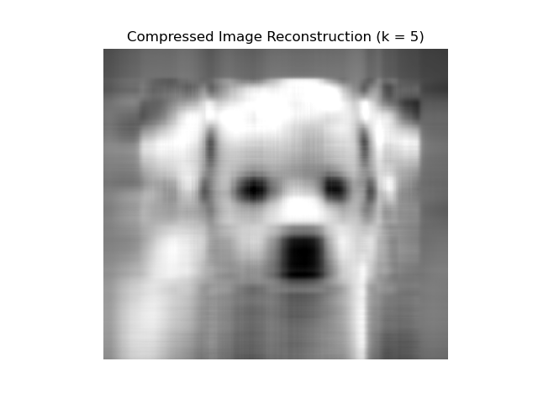
Fig.1: Compressed image at k= 5
At k = 50 (medium quality), an excellent balance is achieved, retaining 96.83% of the energy while requiring only 31.78% of the original storage.
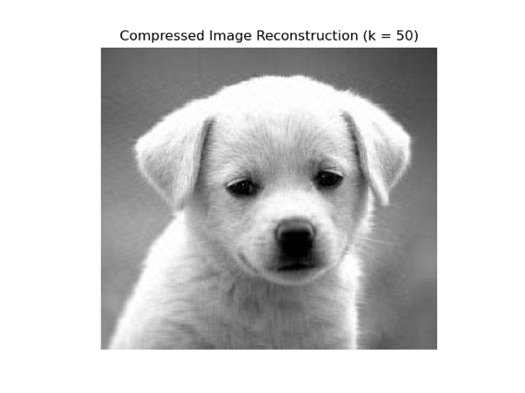
Fig.2: Compressed image at k = 50
For k = 200, reconstruction is virtually identical to the original (Frobenius Error of 0.26%), but the storage exceeds the original image size (127.11%), making it inefficient for compression at very high ranks.
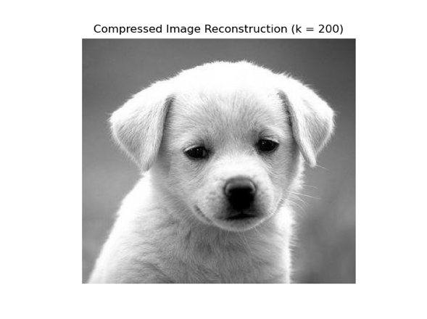
Fig.3: Compressed image at k = 200
Fig. 4. Trade-off between Relative Frobenius Error and storage cost as a function of truncation rank k.
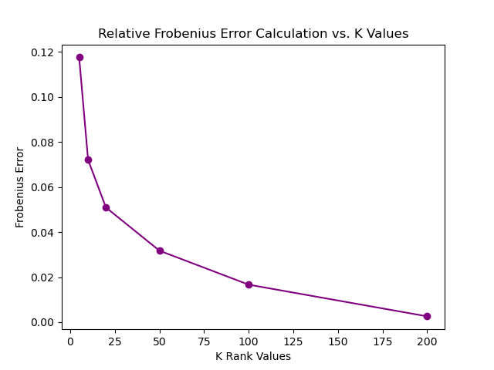
(a) Relative Frobenius Error vs. k
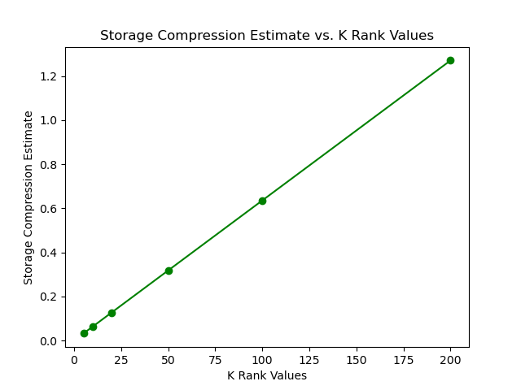
(b) Storage cost (%) vs. k
B. Image Denoising and Optimal Rank Selection
When noise is introduced, the noisy image matrix A_noisy yields a baseline MSE of 3.2254×10⁻³ and a baseline PSNR of 24.91 dB relative to the clean image A. Truncated SVD is applied to A_noisy to filter out high-frequency noise. The denoising results are summarised in Table II. The optimal rank k* = 20 was identified as the one maximising PSNR.
TABLE II Denoising Metrics and PSNR Improvement vs. Rank (k)
k | MSE Noisy | PSNR Noisy | MSE Denois. | PSNR Denois. | ΔPSNR (dB)
5 | 3.2254×10⁻³ | 24.91 dB | 6.0118×10⁻³ | 22.21 dB | −2.70
10 | 3.2254×10⁻³ | 24.91 dB | 2.4633×10⁻³ | 26.08 dB | +1.17
20 (k*) | 3.2254×10⁻³ | 24.91 dB | 1.6003×10⁻³ | 27.96 dB | +3.05
50 | 3.2254×10⁻³ | 24.91 dB | 1.9253×10⁻³ | 27.15 dB | +2.24
100 | 3.2254×10⁻³ | 24.91 dB | 2.1481×10⁻³ | 26.68 dB | +1.77
200 | 3.2254×10⁻³ | 24.91 dB | 3.1812×10⁻³ | 24.97 dB | +0.06

The results demonstrate the classic bias-variance trade-off in low-rank approximation:
• Over-smoothing (k < k*): For extremely low ranks like k = 5, the SVD filters out noise but also discards crucial structural details, leading to severe blur and an MSE (6.0118×10⁻³) worse than the noisy baseline (ΔPSNR = −2.70 dB).
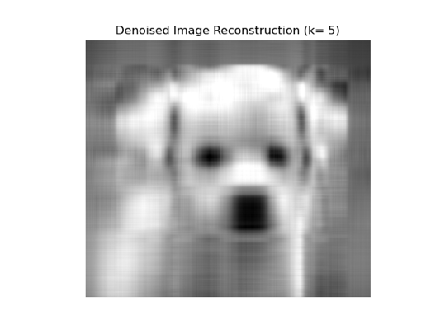
Fig.5:Denoised image at k =5
• Optimal Trade-off (k = k* = 20): At k = 20, the truncated SVD captures primary low-frequency structural components while excluding noise, which concentrates in lower-energy singular components. This maximises PSNR at 27.96 dB, an improvement of +3.05 dB over the noisy baseline.
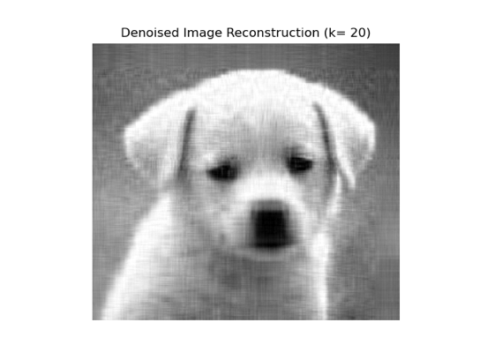
Fig.6:Denoised image at k =20
• Under-denoising (k > k*): As rank increases past k = 20, higher-order singular vectors (containing noise-dominated components) are reintroduced. PSNR steadily drops, returning near the noisy baseline at k = 200 (24.97 dB).
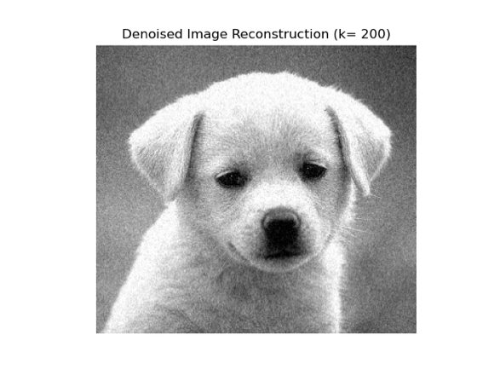
Fig.7:Denoised image at k =200
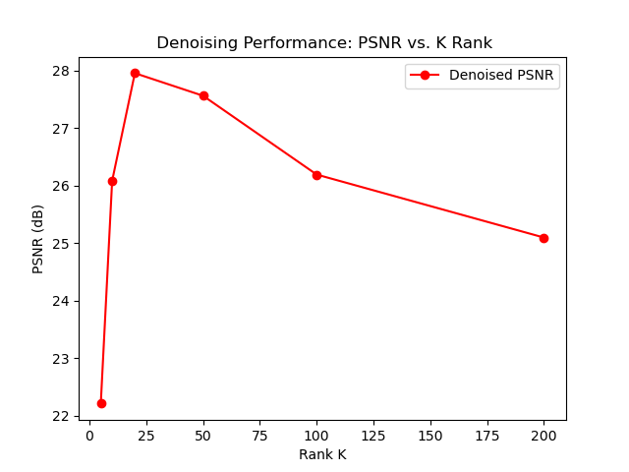
Fig.8: Reconstruction PSNR under noisy conditions showing the optimal rank k* = 20 (27.96 dB).
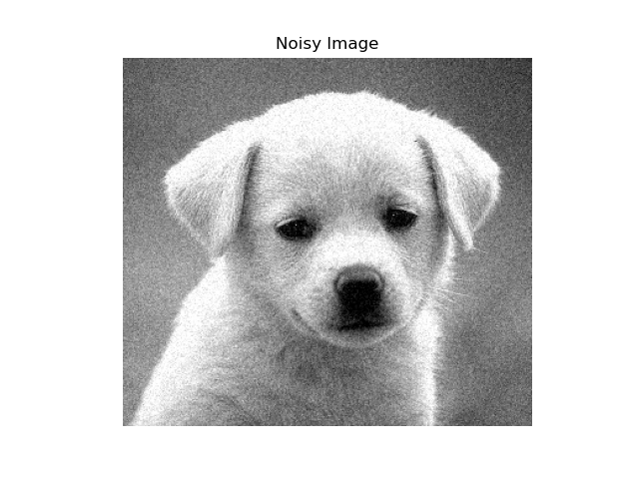
Fig. 3. Noisy input image (σ = 15/255). Baseline PSNR = 24.91 dB.
V. Computational Complexity and Scalability
A key consideration of this implementation is its algorithmic scalability. Let the image dimensions be m×n with m ≥ n.
1) Forming the Gram Matrix: The step B = AᵀA requires O(mn²) operations. This is a one-time cost but becomes a significant bottleneck for very large images.
2) Power Iteration: Each step requires a matrix-vector multiplication Bv⁽ᵗ⁾, taking O(n²) operations. For T iterations and k extracted eigenvalues, the total cost is O(kTn²).
3) Hotelling's Deflation: Subtracting the rank-1 outer product λⱼvⱼvⱼᵀ from B takes O(n²) operations, done k times for a cost of O(kn²).
Thus, the overall complexity of extracting k singular components is O(mn² + kTn²). For high-resolution images where n > 2000, the quadratic cost O(n²) per iteration combined with sequential deflation becomes prohibitively expensive. In commercial libraries, this is bypassed using Lanczos iteration or randomised SVD algorithms, which achieve significant speedups by projecting the matrix onto a lower-dimensional Krylov subspace [1].
VI. Conclusion
This paper presented a from-scratch implementation of an SVD-based image compression and denoising system using Power Iteration with Hotelling's Deflation. The quantitative results validate the theoretical capabilities of SVD in low-rank approximations. For image compression, SVD achieves high energy-packing efficiency, allowing 96.83% of the image energy to be stored using only 31.78% of the original storage size at k = 50. For image denoising, the SVD behaves as a robust low-pass filter in the singular-value domain. Truncating at the optimal rank k*= 20 successfully eliminates Gaussian noise while preserving structural edges, boosting PSNR by +3.04 dB over the noisy input. These findings confirm that SVD-based low-rank approximations provide a mathematically useful and practically effective framework for core image processing operations.
References
[1] E. A. Compton and S. L. Ernstberger, "Singular value decomposition: Applications to image processing," Citations Journal of Undergraduate Research, vol. 17, pp. 99–105, 2020. [Online]. Available: https://www.lagrange.edu/academics/undergraduate/undergraduate-research/images/18-Citations2020.Compton.pdf

