Fragmentation with SQL server

In this exercise, we suppose that we have 2 sites: Beirut and Tripoli. Hence, you should create 2 DB: BEIRUT and TRIPOLI. We want to manipulate different types of fragmentation.
Write the queries in each scenario A and B
- Create an Horizontal Fragmentation of 2 fragments:
[EMP1(salary <30000) and EMP2(salary>=30000)]

- Find the Name(Fname,Minit,Lname) of male employees.
Select fname,minit,lname
from emp1
where sex=’M’
UNION
Select fname,minit,lname
from emp2
where sex=’M’
- Find the name of employees with a salary > 35000
Select fname, minit, lname
from emp2
where salary >35000
- Find the name of employees working at DNO = 5 or DNO=4
Select fname,minit,lname
from emp1
where (DNO=4 OR DNO=5)
UNION
Select fname,minit,lname
from emp2
where (DNO=4 OR DNO=5)
- Find the average salary of all employees
Select avg(salary)
from ( select salary from emp1
UNION
select salary from emp2 )as RES

- Find the highest salary
Select MAX(salary)
from emp2
- Find the total number of employees
Select COUNT(ssn)
from ( select ssn from emp1
UNION
select ssn from emp2 )as RES
- Find the ssn of the employee having the highest salary.
Select ssn
from emp2
where salary = (select max(salary) from emp2)
- Find the name of the employee having the lowest ssn
Select fname,lname
from (select * from empl UNION select * from emp2)
where ssn =(select min(ssn) from (select ssn from emp1
union select ssn from emp2))

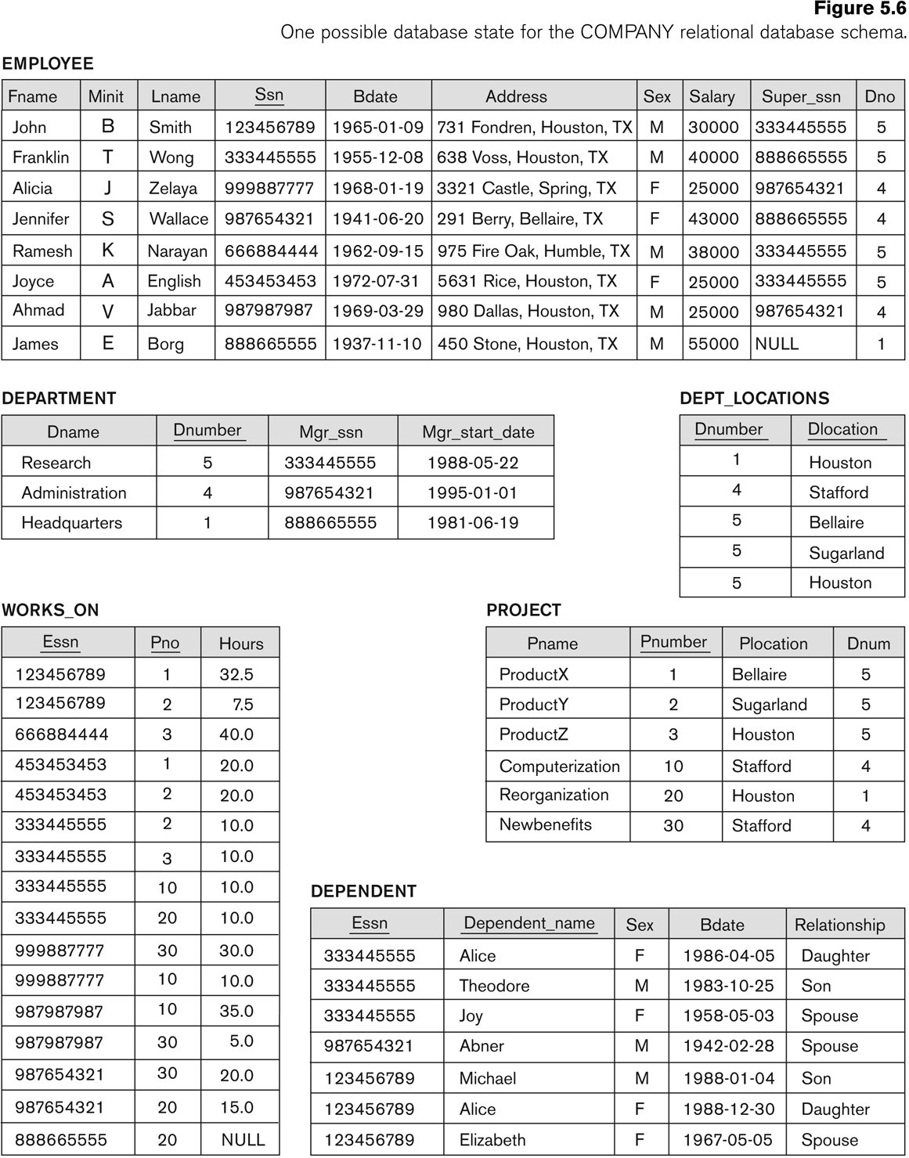

- Create 1 Vertical Fragmentation 2 fragments : EMP1(Fname,minit,Lname,ssn,Bdate) and EMP2(ssn,Address,sex, salary,superssn,dno) ]
- Find the Name(Fname,Minit,Lname) of male employees.
Select fname,minit,lname
from emp1,emp2
where sex=’M’
and emp1.ssn=emp2.ssn
- Find the name of employees with a salary > 35000
Select fname,minit,lname
from emp1,emp2
where salary>35000
and emp1.ssn=emp2.ssn

- Find the name of employees working at DNO = 5 or DNO=4
Select fname,minit,lname
from emp1,emp2
where emp1.ssn=emp2.ssn
and (DNO=4 OR DNO=5)

- Find the average salary of all employees
Select avg(salary)
from emp2
- Find the highest salary
Select MAX(salary)
from emp2
- Find the total number of employees
Select COUNT(ssn)
from emp1

- Find the ssn of the employee having the highest salary.
Select ssn
from emp2
where salary =(select max(salary) from emp2)
- Find the full name of the employee having the highest salary.
Select fname,minit,lname
from emp1,emp2
where emp1.ssn=emp2.ssn
and salary =(select max(salary) from emp2)

- Find the name of the employee having the lowest ssn
Select fname,lname
from emp1
where ssn =(select min(ssn) from emp1)

