LAMPIRAN
- Daily Report 04 Juni 2020
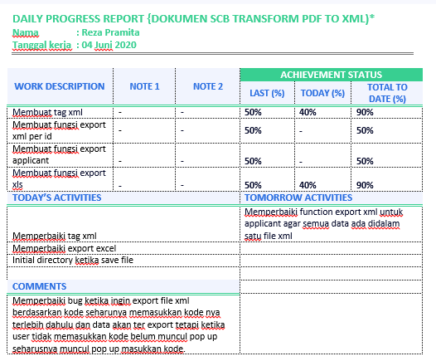

- Daily Report 24 Juli 2020
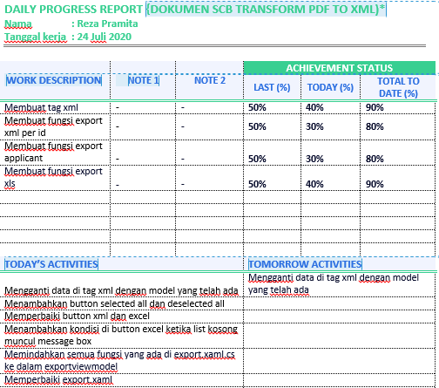
- Daily Report 25 Juli 2020
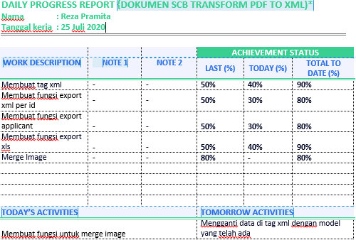
- Daily Report 19 Agustus 2020
