This is the link

<https://reza76.streamlit.app/>

Gool:

1. Choosing Stories based on value of delivery as number as leaders number
2. Numbers of SSA members in a Store based on
   1. Value of Delivery of the chosen stories.
   2. Nearest members to the stores.
3. Customization travel(km) of members.

Potential for improvement:

1. Learning that which suppliers are more trustable and which one needs to be more under control.

Input Members Name, emails and Adress

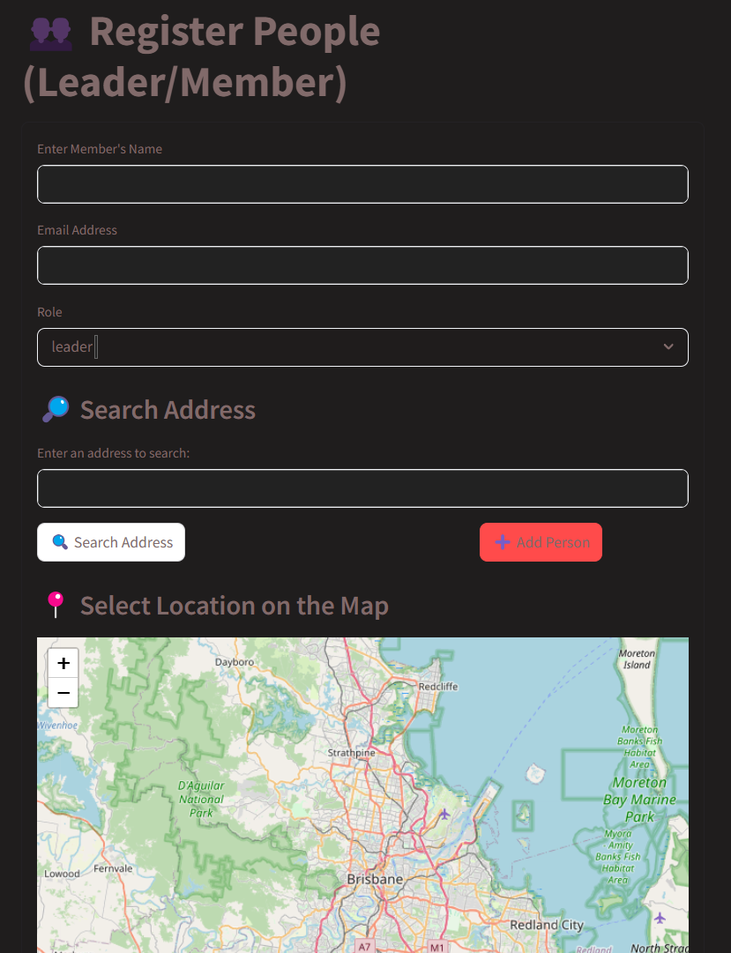

This is for inputting stories addresses.

Inputting the value of delivery

**Distance from Home to the chosen Store (km)**

