The final report will be prepared in the "CountSummary" sheet. In this sheet, the most complicated column is "Non SSA Supplier."

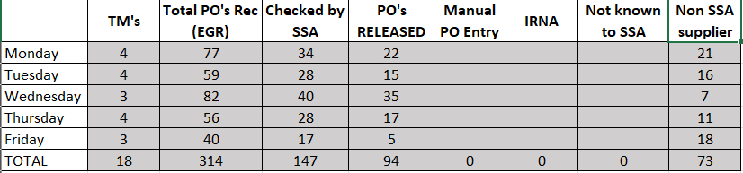

**How it works:**

This file is comprised of four main parts:

Part-1 “Mondy”, “Tuesday”, “Wednesday”, “Thursday” and “Friday”.



Part-2 “monData”, “tueData”, “wedData”, “thuData” and “friData”.



Part-3 “dynCells”.



Part-4 “CountSummary”.



**Steps:**

1. Users will copy data from the Bunnings system and paste it into the sheets of Part-1 everyday at the end of the work time.
2. Part-2 will search for "Txxx," "Cxxx," and "Jxxx" in the first column of Part-1, and for "JAMES," "TIMBER," "NURSERY," "NURSERIES," and "NURSERIES" in the second column. If even one of these terms is present, it indicates that the item was not scanned by SSA.
3. Part-3 involves the creation of variables.
4. The counting process involves data from both Part-1 and Part-2.