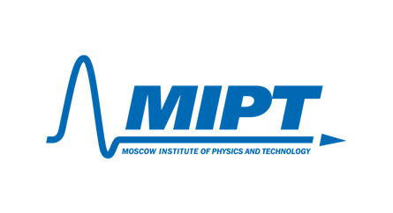
Moscow Institute of Physics and Technology
9 Institutskiy per., Dolgoprudny, Moscow Region, 141700, Russian Federation
Email: info@mipt.ru Website: https://mipt.ru Tel: +7 (495) 408-45-54
Dr. Mahdi Akhloumadi Email: akhloumadi.m@mipt.ru Tel: +7 (985) 731-46-52
Letter of Recommendation

Dear Admissions Committee,

I am writing this letter of recommendation for Reza Aliasgari Renani, whom I have had the pleasure of tutoring for the past two years. I am a professor at the Moscow Institute of Physics and Technology and the Skolkovo Institute of Science and Technology. I also have experience teaching in various universities in Iran and the Russian Federation. I teach theoretical and analytical mechanics, attitude determination, and control, in which Reza participated and was an exemplary student.

In my time working with Reza, he has shown to have an unparalleled level of commitment to his academic pursuits. He obtained excellent marks for our courses and performed remarkably well under the intense curriculum designed by MIPT to make studies as challenging as possible for students. I have been particularly impressed with his willingness to go further than the course requirements and his ability to use various software tools to bring innovative and new ideas to our class. He demonstrated a great passion for showing and sharing his results with other students during our lectures. His way of presenting materials through envisioning various theories using simulation helped clarify complex concepts and enhance other students' comprehension of the subject. Reza's main strength is his knowledge of various programming languages and CAD software. In particular, he demonstrated a high proficiency in MATLAB and has developed multiple apps independently for his research work.

He also has close to one year of experience of doing research work on CubeSat satellites at the Laboratory of Modeling of Mechanical Systems and Processes and on metal-oxide-semiconductor at the Institute of Microelectronics Technology, Russian Academy of Sciences. This level of involvement in some of the best laboratories in the country is very impressive for an undergraduate student, which is a clear sign of his dedication to his pursuit of excellence in research and academia.

Based on my experience working with Reza, I highly recommend him for the graduate program at Purdue University. He is perfectly capable of transitioning from aerospace to electrical engineering and using his knowledge in both areas to be involved and committed to your esteemed graduate school laboratories. His unique background can bring invaluable and unique insights.

If there are additional information required, please contact me at: akhloumadi.m@mipt.ru

Sincerely,
25.11.2023
Mahdi Akhloumadi, PhD
Associate Professor, Moscow Institute of Physics and Technology

