# Point of Sales (POS) System

## Scenario

Similar to the system in a supermarket, I am given to make a POS system that is similar but a smaller version of it. Like any other place there are always the two kind of people and in this case it is the administrator and the cashier.

On the administrator he/she gets option that are excluded from the cashier which are the access to add/remove users, display user list and to show the complete product summary of the sales.

On the other side the cashier gets the option to logout, exit the program and show the receipt. But these can be accessed by the admin’s as well.

# Algorithm

The following is the algorithm for the POS system.

* Once the program is started as usual a dialog box appears in which the username and the password is asked to type in.
* If it is username and the password is cashier then an option **(Option 01)** menu appears that have the options to:
  + Enter the Item – This is where you input the item in which it asks for three thing which are Name, Price and quantity. After that it shows the receipt which contains all the three thing and the amount paid, balance and total. Then you can add more or go back to the option menu.
  + Logout – logout the user and go backs to the display to enter the username and the password.
  + Exit the Program – Stops the program
* And if the username and the password is the admin then it has an option **(Option 02)** these:
  + Add the User – Once the admin is logged in, he/she gets the option to add another user, it can be an admin or a cashier.
  + Remove the User. – Similar to the add part, this is where he/she can remove the user likewise it can be admin or cashier.
  + Enter the Item – Same as I mentioned in the cashier part.
  + Display the User list – this options shows the user list, but first you must choose whether the admin (A) or the cashier (C) is to be shown.
  + Display the whole product summary – Since so many items are being added we must keep track of it and this option does that. It shows the whole summary which contains the name of the item, price, quantity and below it shows the total quantity and the total price.
  + Logout - Same as the cashier option.
  + Exit the program – Stops the program

## Code done in IDE

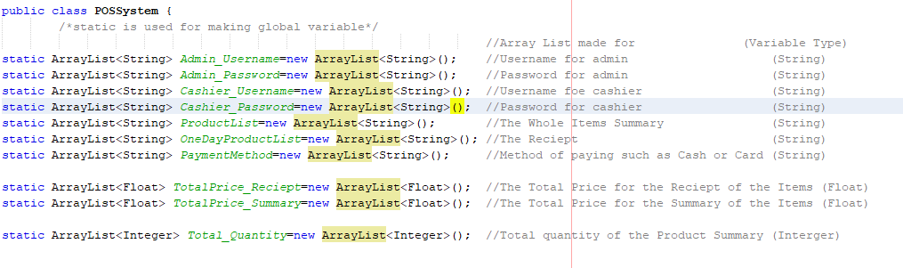

Figure 1

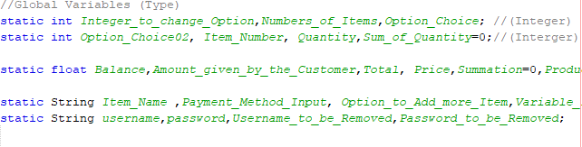

Figure 2

As you know the scenario of the program the first thing as you can tell is that array list must be created and so I did. Also since many method will use the same variable I had to make some variables as global hence the static part.

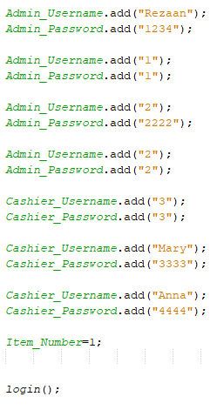

Figure 3

These are the predefined username and password for both the cashier and the admin. Once that line is analyzed the login method is started. And goes to the below image which ask for the username and the password.

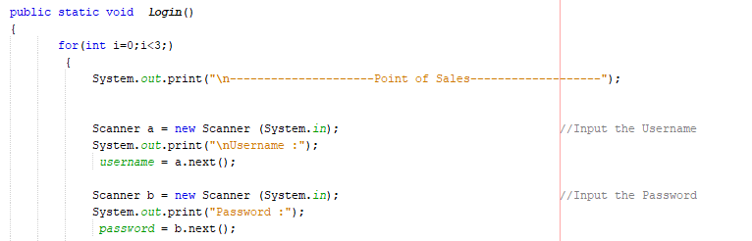

Figure 4

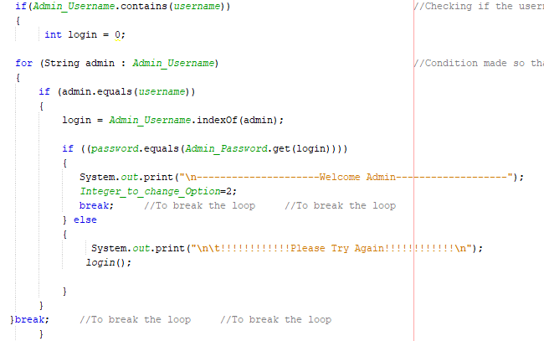

Figure 5

Once entered it check for the username in the adminuser name array and then checks the password for by matching to a specific user name. For instance of you put the username of user1 and the password of user2 it will show the text as wrong.

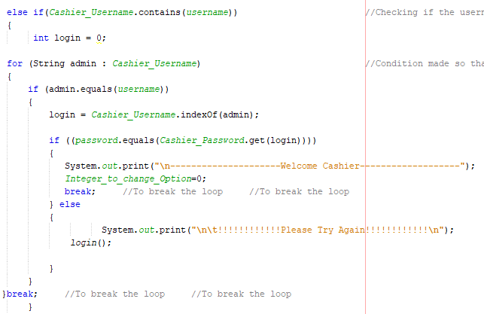

Figure 6

The same thing but now it’s for the cashier.

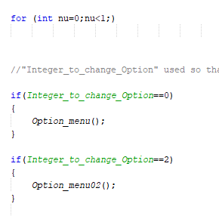

Figure 7

Once the login part is done then it goes to the option menu, but now here the admin has more options than the cashier as I said in the scenario so two option menu must be made. Therefor I made a variable that allows it.

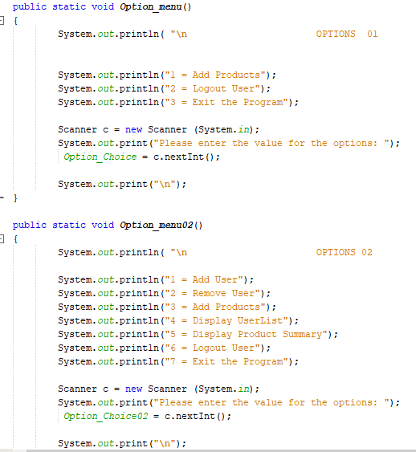

Figure 8

In figure above as you can see there are two option one is for the cashier and the other below it is for the admin (Optionmenu 02). Since the common option have the same function let me explain the excluded ones first.

### Add User

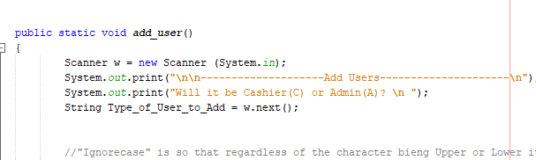

Figure 9

Initially it ask for the type of the users that are to be added.

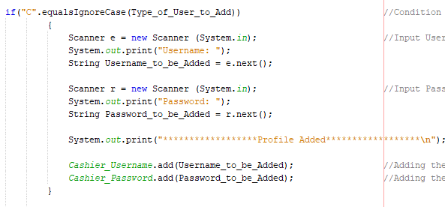

Figure 10

When the input is for the cashier then the username and the password of the cashier is asked. And then it is removed from both the arraylist of the cashier by the function “add()”.

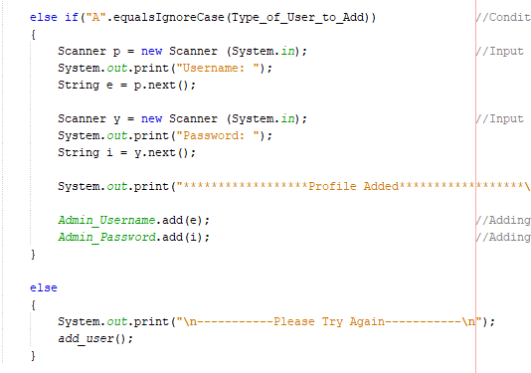

Figure 11

The sane thing applies for when the admin is inputted to add. And if neither are selected then the else condition applies and it goes back to the add user method. After the adding is done it goes back to the option menu.

### Remove User

Like the add user part it ask for the type of the user. And if it is the admin it removes and if the cashier is selected it remove the cashier both which are done by the function “remove()”. But in the admin part you can see a bit of changes. That is because if the logged user enter his/her name to remove then it goes back to the login menu.

As for the cashier it normal because only the admin can remove the user.

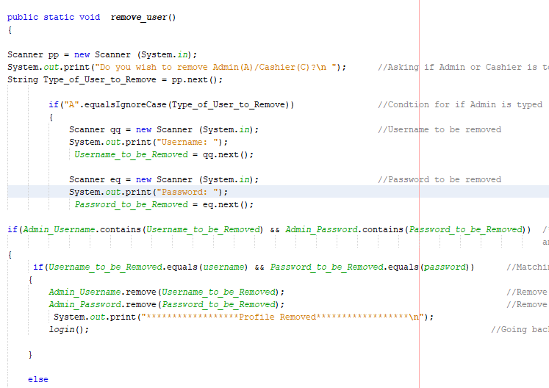

Figure 12

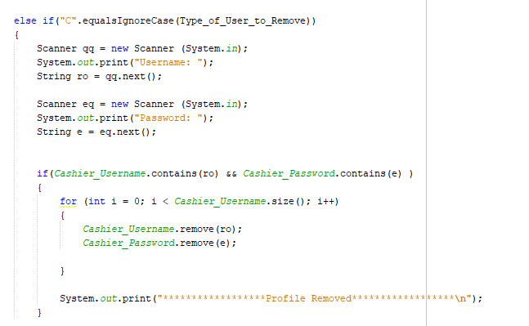

Figure 13

### Product Summary

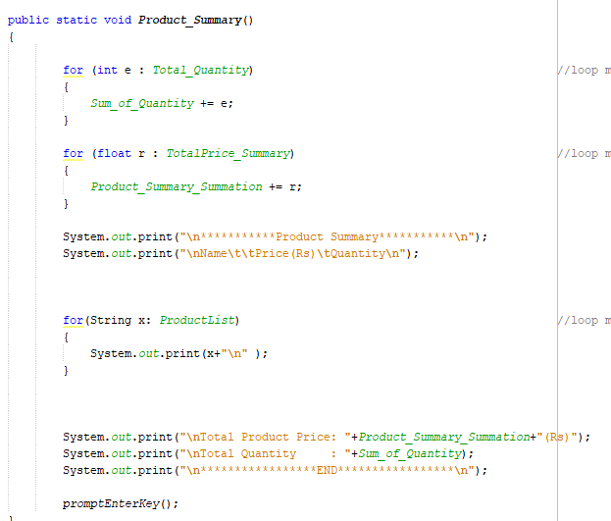

Figure 14

Another Option that the admin has is to display the total summary of the product. This where when the items are all added it sums up the price and the quantity by for loop I have inserted. And as for the name of the item as you can see the third for loop is used to take the element from the arraylist and assign it to the string and print it so that it shoes as a word rather than a set of the array with a squared bracket.

### Display Userlist

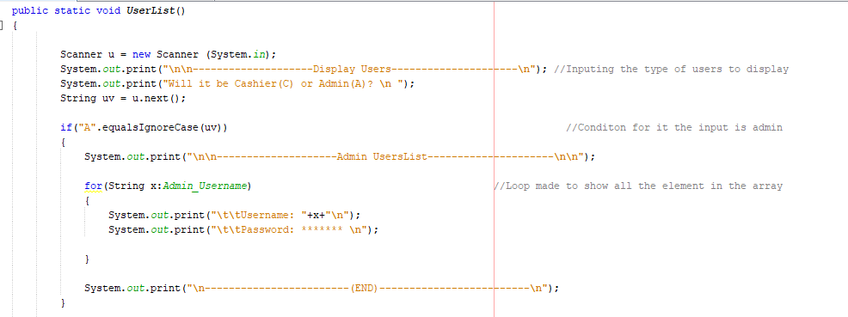

Figure 15

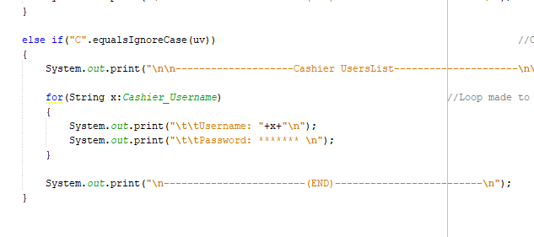

Figure 16

And the final extras that the admin can use is to display the userlist. Like the add and remove this also ask for the type of users. If it is for the admin then it print the element as string by the for loop inside until all are printed. And if the cashier is selected it does the same.

### COMMON

Now these are the same for both the admin and the cashier.

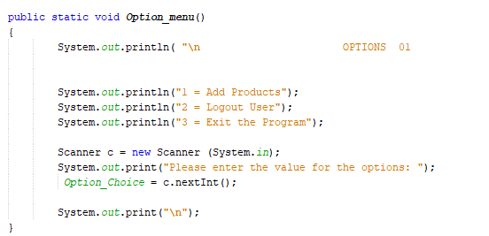

Figure 17

The above is the option for the cahier and as you can tell the remaining of the admin’s option is the cashier option or on the other hand the upgrade version. But first how does it go to the specific options.

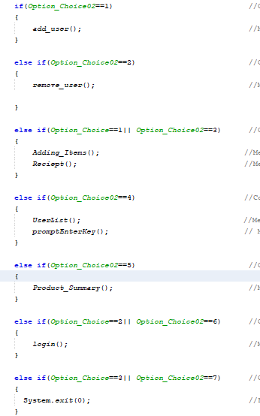

Figure 18

The above image show how I used a variable to go to the options in the menu. I used the two input and made if conditions. For when there are the common ones I used “or” function and for the exception ones it’s normally done.

**Add Product**

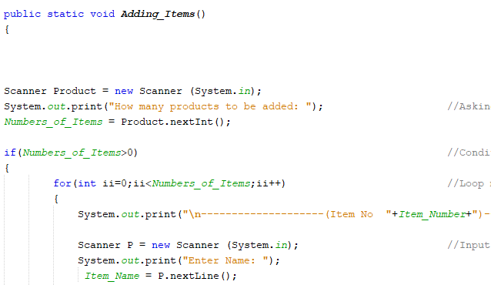

Figure 19

The system askes for the number of items that are being added. So that there is no need to get messages of “to continue or exit” every time a single item is finished. So by the amount you enter it does the loop and once that is done and only then the message to add more comes. And the “if” condition is made so that if anything zero is typed then the system does go further.

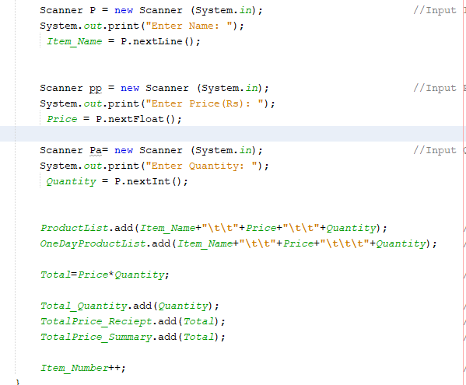

Figure 20

In the adding list you are asked for item name, price and the quantity. Name uses String, Price uses float and the quantity uses int. and these three are added to the array that of both the receipt and the summary array. But since they must be arranged the total variable is made to multiply the price with the quantity.

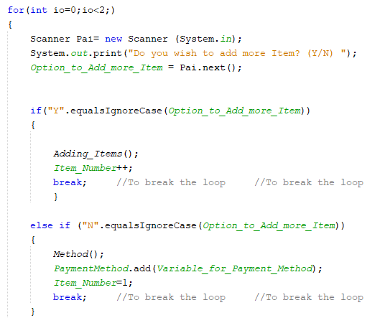

Figure 21

Once those three are added the question comes to continue or not. If the yes option is made then as you can see the method “Adding_Items()”name is typed and the if the answer is NO then it goes to the method “Method()” which ask the for the payment method (Image Below).

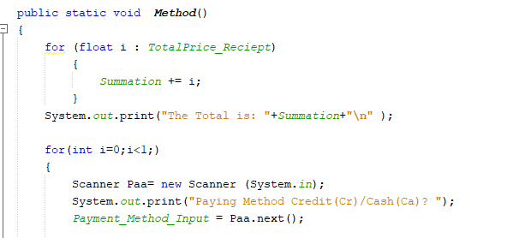

Figure 22

The method is where it asks for paying with cash or credit. An above it is where it shows total for that item batch.

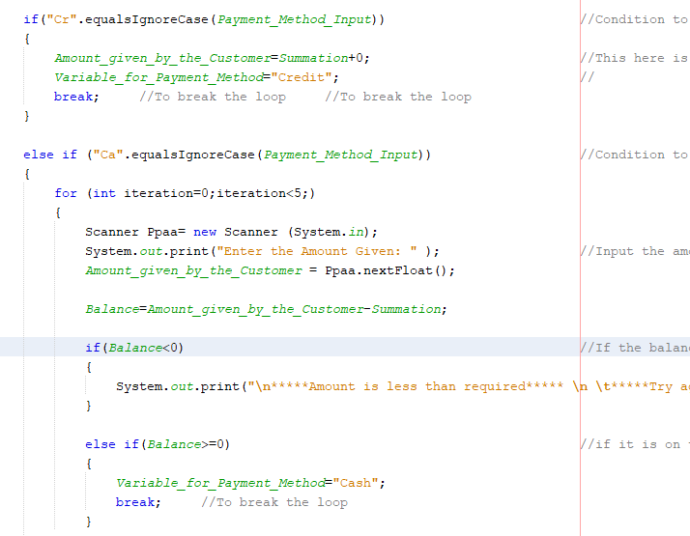

Figure 23

When the credit is the choice then the amount given is made equal to the total hence the balance is zero. And if the cash it the choice then the amount give is reduced by the total and the balance is the remainder. But there are two if condition made so that if the balance is negative then the amount given is asked again to input.

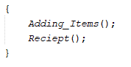

Figure 24

Once the Adding item is done it automatically goes to the receipt method that show the details.

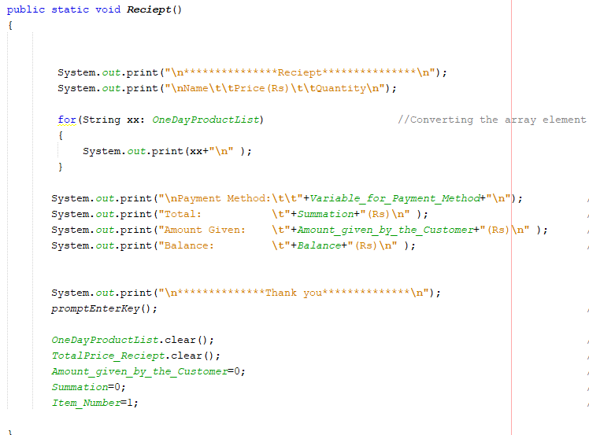

Figure 25

In the Reciept method it shows all the item that are added with the name, price and quantity. And it does it in a simple way by the loop because all were added to this arraylist(OneDayProductList) remember. Below that it shows the method of paying, total, amount given by the customer and the balance to be given.

Now once it is done the next batch of items must be added but if that happen the previous once will be added, and that’s why the “clear()” is used to clean it. as for the variable “clear” can’t be used so all are initialized to zero.

**Logout and Exit**

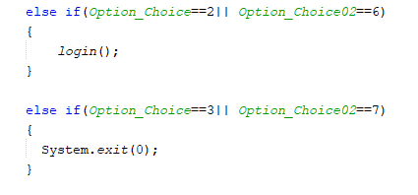

Figure 26

The first is the logout user where the method “login()” is used so it goes back to the login menu and for the exit program “System.exit(0)” is used to get the zero to the main method which ends the program.