# Chapter-1: Introduction

**Description of Organisation**

The OVERSEAS TRAVELS company is one of the Airline Reservation Company in India. It has number of branches, which are spread over the country or the world. So person wants to reserve his/her ticket and he/she has to contact at nearest Overseas Travels branch. The Airline Reservation System (ARS) provides an interface to schedule flights and reservations for an airline that services. Its responsibility is to keep track of system users, customers, Airbus information, flight information and cancellation. The functionality of the ARS is broken into various primary groups.

Customer reservation information and user were added, deleted and updated in the implementation phase to account for the way we decide to implement security. User keeps track of the username, password information and customer reservation information link provides a link between the customers’ reservation information and login table.

* From the very beginning human being used to search for flight. After a long research human being has discovered flight that has become a part of OVERSEAS Group’s life.

* Gradually the airline witnessed new route additions, increased flight frequencies and passenger lists. Today OVERSEAS TRAVELS PVT. LTD. To offer passenger the very best in the skies, **OVERSEAS GROUP** constantly upgrades its in-flight facilities.
* Expanding the network as a part of its expansion schedule, OVERSEAS Group has collaborated with several international & domestic carries to offers its passenger’s convenience all the way.
* OVERSEAS Group’s crew and staff are well trained to attend to all passenger’s needs always and in OVERSEAS Group’s efforts to provide passenger with exclusive care and comforts all the way.

**Data Collection**

A fact gathering study was undertaken to study the activities involved in the various aspect of the existing computerized system. We had visited various person of the company. The existing system was studied by means of

Interviews

Record Reviews

Interviews:

User interviews were conducted to retrieve the qualitative information. These interviews, which were unstructured, provided opportunity to gather information from the respondents who involved in the process for a long time.

These interviews provided information such as:

* Activities involved in process of reservation processing involving fare, other services, flight information, flight schedule information, airbus, various reports are generated using existing system.
* Type & frequency of forms and reports.
* Limitation of Existing system.

Record Reviews:

To gather details about the Airlines Reservation, many kinds of records & reports were reviewed. This study covered.

* Standard Operating Procedure.
* Forms and reports generated by existing manual system.
* Document flow (Input / Output) of the system.

### HARDWARE AND SOFTWARE CONFIGURATION

The Hardware and Software Configuration for the proposed system is given below.

Hardware Configuration:-

For the successful run of the proposed system the required stand alone Personal Computer with, minimum hardware required to run the system is as below.

|  |  |
| --- | --- |
| Hardware | Minimum Requirement |
| Processor | Pentium 2 |
| Hard disk | 4 GB |
| RAM | 64 MB |
| Dot Matrix Printer | 16 Pin |

Software Configuration:-

The minimum Software required by the system is follows.

1. ORACLE as Back End.
2. Visual Basic 6.0 as Front End

The reason for selecting ORACLE and Visual Basic as tools are as follows.

Features of ORACLE : -

It is a high performance, full tolerant relational database management System especially designed for large database application.

It offers following benefits:

* It eliminates all parent-child relationships and instead represented all data in the database as simple row/column tables of data values.
* Flexibility in data modeling.
* Easy for accessing data.
* Each table is an independent entity and there is no physical relationship between tables.
* Reduce data storage and redundancy.
* Independent of physical storage and logical data design.
* It has wide level data manipulation language (SQL).
* Most data management system based on the relational model has a built-in support for query languages like ANSI SQL or QBE (Query By Example). These queries are simple English constructs that allow adhoc data manipulation from a table.
* Deferred writing at commits to improve transaction performance.
* Security and control.
* It has a rollback command for recreating the database to its most recent safe point. Grant and revoke limits access to information down to row and column level. Views are valuable features for limiting access to the primary tackles in the database.
* Professional ORACLE starts the DBMS (Database Management System) in the extended memory, so more main memory is available for other applications.
* Relational model of data management is based on set theory. Built-in query language is designed in the RDBMS, so that it can manipulate sets of data (one or more tuples).
* User interface used with relational models is non-procedural because only what needs to be done is specified and not how it has to be done. Using any of the other methods, you have not only to specify what need to be done but how it has to be done as well.

Features of Visual Basic 6.0 : -

Visual Basic provides complete set of tools to simplify rapid application Development.

* It provides a vital link to graphical environment and allows you to develop applications based on standard windows features: Dialog boxes, Command buttons, Pull down menus, Scroll Bars, Selection lists etc. It also allows creating robust applications that fully make use of the graphical user interface.
* ActiveX Data Objects (ADO) and OLE DB replace the Open database connectivity (ODBC) API as the preferred method for accessing shared file and client/server databases.
* Internet techniques such as Dynamic HTML (DHML), Extensible markup language (XML), Active server pages (ASP) and ActiveX documents offer browser-based alternatives for displaying and updating data.
* Extensions to Visual Basic class modules assist in writing middle-tier DLLs for Microsoft transaction server 2.0.
* A multitude of wizards and other graphical tools aid developers new to Visual Basic.
* Visual Basic is an event driven programming language.
* Visual Basic allows you to adopt more of parallel approach, with independent sections of code for each option that the user may select. This is known as Event driven programming language.
* Data Environment Designer (DED).
* Drag and drop form generation.
* Data view window.
* ADO Data Control (ADODC).
* ADO-compliant data-bound controls.
* Hierarchical record sets and the Flex Grid Control.
* Data report design.
* Data form wizards.
* Format objects.
* Data repeater control.
* Data source classes and data building.
* MTS transaction Mode property of Class modules.
* Visual data tools (VDTS).
* SQL editor.
* Component creation.
* Language.
* Packaging and Deployment wizard.
* The integrated development environment.
* Data object wizard.

# Chapter-2: System Analysis

# INTRODUCTION TO EXISTING SYSTEM

The Company follows a manual system for maintaining the Airline Reservation System.

* Whenever any requisition comes to the Counter to issue a ticket the firstly the Ticket Capacity checked whether the required quantity of the ticket is present or not. If the required tickets is present then issue a ticket and update the reservation information and an entry is done to the Ticket Issue Register.
* The day-to-day entries are made manually into the book that has gotten all the relevant entries.
* Check the Ticket Quantity regularly whether any ticket is not in, if so then Ticket Issue process is cancelled. In the same way Ticket cancellation is followed. If Fare is increased or decreased then changes into Fare Book. If New Flight is introduced then entry on relevant book, that process applies to Flight-Schedule, Airbus, and Branch.
* At the end of the year or when an intermediate report is needed then prepare the report is required.

# LIMITATIONS OF THE EXISTING SYSTEM

The Existing system includes problems like lack of time consuming, accuracy, high cost, security problems, etc.

There are many problems in existing systems like:

* Time and speed
* Man power
* High cost
* Security
* Complexity
* Maintenance
* Accuracy
* Storing
* Records might get lost or be insufficient due to manual errors.
* Maintaining and managing data is very costly and time consuming, because there are many documents that have to be maintained by each branch and copies have to be transferred to relative branches.
* Transfer of information within the branches is costly and time consuming.

# INTRODUCTION TO PROPOSED SYSTEM

There are many activities that can be computerized in this widely spread organization. The current context is related to maintain the ticket Reservation-Cancel ticket. The important reason is to make-work easy. No need to search a Flight register for entry or any other transaction.

Computerization of this must fulfilled the requirements of working staff due to effective work of computer in terms of efficiency, speed, accuracy, storage capacity and quickness.

Even though it is costly, it is recommended the computerization of the ticket issue process.

# OBJECTIVES OF PROPOSED SYSTEM

* Manual work has to be reduced.
* Get accuracy.
* Result to be received very quickly.
* It uses concept of user friendliness.
* It provides using of multiple applications at a time.
* Increase security, speed, storing and accuracy.
* Customer services can not only be satisfied but also enhanced to the extent that one can obtain or cancel a reservation from any branch for any route at any given time.
* To speed up the operation.
* Managing and maintaining data becomes easier.
* Provide convenience to travelers.
* It decreases manpower and high cost.

# FEATURES OF PROPOSED SYSTEM

* Manual work has to be reduced and Result to be received quickly.
* To speed up the operation and Decrease manpower, high cost.
* Increase security, speed, storing and accuracy.
* The customers have to face only one person at the booking counter for obtain the reservation.
* Managing and maintaining data becomes easier and cost effective due to very high amount and reliability of storage space available in the proposed system.
* It provides support for queries through out all the branches at any given time at a very high speed, saving a lot of time.
* The system has been developed under **Microsoft Visual Basic 6.0** as a Front-End tool and **Oracle 8.0** as a Back-End tool.

# ADVANTAGES OF PROPOSED SYSTEM

* The proposed system due to computerized is much faster in reservation process, cancellation process and transactions.
* Transfer of information from various branches would become easier and faster.
* Managing and maintaining data becomes easier and cost effective due to very high amount and reliability of storage space available in the proposed system.
* Customer services can not only be satisfied but also enhanced to the extent that one can obtain or cancel a reservation from any given time.

## LIMITATIONS FOR PROPOSED SYSTEM

* The main limitation of system is if any plane that not stop in a particular destination that have not been included in airline reservation system.
* Per ticket only one other services are included at a time.
* Passenger cannot transfer his/her reservation from one flight to another flight.

# TABLE DESIGN

Table design contains all the tables required to store the required information which are stated below:

**1. TABLE NAME: AIRBUS**

|  |  |  |
| --- | --- | --- |
| **Fields** | **Data Type** | **Size** |
| Airbusno | Varchar2 | (5) |
| First_cap | Number | (3) |
| Bus_cap | Number | (3) |
| Eco_cap | Number | (3) |
| First_wl_cap | Number | (3) |
| Bus_wl_cap | Number | (3) |
| Eco_wl_cap | Number | (3) |

1. **TABLE NAME: FARE**

|  |  |  |
| --- | --- | --- |
| **Fields** | **Data Type** | **Size** |
| Route_code | Char | (7) |
| Airbusno | Varchar2 | (5) |
| First_fare | Number | (8) |
| Bus_fare | Number | (8) |
| Eco_fare | Number | (8) |

**3. TABLE NAME: SERVICE**

|  |  |  |
| --- | --- | --- |
| **Fields** | **Data Type** | **Size** |
| Ss_code | Char | (4) |
| Ss_desc | Varchar2 | (15) |
| Ss_fare | Number | (5) |

**4 . TABLE NAME : CONTROL**

|  |  |  |
| --- | --- | --- |
| **Fields** | **Data Type** | **Size** |
| Air_tax | Number | (4) |
| Excess_bg_limit | Number | (3) |
| First_bg_limit | Number | (3) |
| Bus_bg_limit | Number | (3) |
| Eco_bg_limit | Number | (3) |
| Canc_deduc_12 | Number | (3) |
| Canc_deduc_6 | Number | (3) |
| Canc_deduc_3 | Number | (3) |

**5. TABLE NAME: CANCELLATION**

|  |  |  |
| --- | --- | --- |
| **Fields** | **Data Type** | **Size** |
| PNR | Number | (5) |
| Flight_no | Varchar2 | (7) |
| Flight_date | Date |  |
| Class | Char | (1) |
| Reserv_date | Date |  |
| Pass_name | Varchar2 | (20) |
| Pass_add | Varchar2 | (100) |
| Passport_no | Number | (8) |
| Ss_code | Varchar2 | (4) |
| Cancel_date | Date |  |
| Total_fare | Number | (8,2) |
| Branch_code | Varchar2 | (4) |
| Route_code | Char | (7) |
| Tot_fare | Number | (8,2) |
| Flight_type | Char | (1) |
| Pass_status | Varchar2 | (15) |
| Canc_amt | Number | (8,2) |

**6. TABLE NAME: BRANCH**

|  |  |  |
| --- | --- | --- |
| **Fields** | **Data Type** | **Size** |
| Branch_code | Varchar2 | (4) |
| Add1 | Varchar2 | (20) |
| Add2 | Varchar2 | (20) |
| City | Varchar2 | (15) |
| Telephone | Number | (8) |

**7. TABLE NAME: RESERVATION**

|  |  |  |
| --- | --- | --- |
| **Fields** | **Data Type** | **Size** |
| PNR | Number | (5) |
| Flight_no | Varchar2 | (7) |
| Flight_date | Date |  |
| Class | Char | (1) |
| Reserv_date | Date |  |
| Pass_name | Varchar2 | (20) |
| Pass_add | Varchar2 | (100) |
| Passport_no | Number | (8) |
| Ss_code | Varchar2 | (4) |
| Pass_status | Char | (15) |
| Route_code | Char | (7) |
| Total_fare | Number | (8,2) |
| Branch_code | Varchar2 | (4) |
| Flight_type | Char | (1) |
| Tot_fare | Number | (8,2) |
| Canc_flag | Char | (1) |

**8. TABLE NAME: FLIGHT**

|  |  |  |
| --- | --- | --- |
| **Fields** | **Data Type** | **Size** |
| Flight_no | Varchar2 | (7) |
| Flight_date | Date |  |
| First_bk_seats | Number | (3) |
| Bus_bk_seats | Number | (3) |
| Eco_bk_seats | Number | (3) |

**9. TABLE NAME: LOGIN**

|  |  |  |
| --- | --- | --- |
| **Fields** | **Data Type** | **Size** |
| User_id | Varchar2 | (15) |
| Password | Varchar2 | (15) |

**10. TABLE NAME: FLIGHT_SCH**

|  |  |  |
| --- | --- | --- |
| Fields | **Data Type** | **Size** |
| Flight_no | Varchar2 | (7) |
| Airbusno | Varchar2 | (5) |
| Airbus_nm | Varchar2 | (20) |
| Route_code | Varchar2 | (7) |
| Deprt_time | Char | (5) |
| Journey_hrs | Char | (5) |
| Flight_day1 | Number | (1) |
| Flight_day2 | Number | (1) |

**11. TABLE NAME: ROUTE**

|  |  |  |
| --- | --- | --- |
| **Fields** | **Data Type** | **Size** |
| Route_code | Varchar2 | (7) |
| Route_desc | Varchar2 | (25) |
| Origin | Varchar2 | (15) |
| Destination | Varchar2 | (15) |

# Chapter-3: Systems Requirement Specification (SRS)

##### **DATA FLOW DIAGRAM**

As information moves through software, it is modified by a series of transformations. A Data Flow Diagram (DFD) is a graphical technique that depicts information flow and the transformations that are applied as data move from input to output. The data flow diagram is know as a data flow graph or a bubble chart.

The Data Flow Diagram may be used to representation a system or software at any level of abstraction. In fact, DFDs may be used partitioned into levels that represent increasing information flow and functional detail. Therefore, the DFD provides a mechanism for functional modeling as information flow modeling.

The Data Flow Diagram (DFD) serves two purposes:

1) To provide an indication of how data are transformed as they move through

the system and

2) To depict the functions that transform the data flow.

The DFD provides additional information that is used during the analysis of

the information domain and serves as a basis for the modeling of function.

A Level 0 DFD also called as fundamental system model or a context model, represents the entire software element as a single bubble with input and output data indicated by incoming and outgoing arrows respectively. Additional processes and information flow paths are represented as the level 0 is partitioned to reveal details. Each of the proves represents at level 1 is sub function of the overall system depicted in the context model. Each of the process may be refined are layered to depict more detail. Information continuity must be maintained in every layer, that is input and output to each refinement must remain the same.

### CONTEXT DIAGRAM FOR AIRLINE RESERVATION SYSTEM

Request for flight availability

# PASSENGER

Reservation particulars

Verification reply & tickets

Acknowledgement (availability of seats available or not)

## BOOKING OFFICER

### 1-LEVEL DATA FLOW DIAGRAM

Flight

Retrieve flight details

**PASSENGER**

Reservation file

Money, visa & passport

**PASSENGER**

Add new details

Flight information

Airbus information

Ticket

Enquiry

Fare information

Retrieve flight schedule information

Airbus

Fare

Flight_sch

Ticket, visa & passport

Route

information

Route

Retrieve passenger details

Cancel passenger information

Reservation file

Cancellation file

Delete passenger information

Passenger details

Report

**2-LEVEL DIAGRAM FOR PROCESS 2.0**

Money

**PASSENGER**

Money, visa & passport

**PASSENGER**

Add information about passenger

Reservation file

Reservation file

Request for other services

Add information about passenger

Add information

**PASSENGER**

Other service details

Add information of other services

Reservation file

Service file

**2-LEVEL PROCESS FOR PROCESS 3.0**

Enquiry for cancellation process

Cancellation

Add cancel information

Check for valid information

Cancel or invalid

# PASSENGER

Delete

Passenger information

Cancel within 3,6 or 12 days

control

Reservation file

# DATA DICTIONARY

Data Dictionary is a store of information about the data in database. The dictionary defines the name, description, source of data, users of data, and keywords in data, formula to derive the data, specification and such other details. Data dictionary brings common understanding of the data in the organization. RDBMS provides software to create the dictionary. Use of data dictionary enforces the standards of processing, usage’s application and documentation in the organization.

Data Dictionaries are an integral component of structured analysis, since data flow diagram by them do not fully describe the information about the system. The data dictionary provides additional information about the system.

A data dictionary is a catalogue – a repository – of the elements in a system. These elements center on data the way they are structured to meet user requirements and organization needs. In a data dictionary, a list of all the elements composing the data flowing through a system is included. If a project team member wants to know the definition of a data item name or the contents of a particular data flow, the information will be available in the data dictionary. Descriptions of all data used in the system are given in a data dictionary.

**Analysts use Data Dictionary for five important reasons.**

1) To manage the detail in large systems.

2) To communicate a common meaning for all system elements.

3) To document the features of the system.

4) To facilitate analysis of the details in order to evaluate characteristics and

determine where system changes should be made.

5) To locate errors and omissions in the system.

###### **Data Dictionary :-**

**1.) Table Name : AIRBUS**

Description : This table stores Airbus Information

Primary Key : Airbusno

Foreign Key : -

|  |  |  |  |  |  |
| --- | --- | --- | --- | --- | --- |
| **Sr No** | **Fields** | **Data Type** | **Size** | **Constraints** | **Description** |
| 1 | Airbusno | Varchar2 | (5) | Primary Key | Airbus no start with “AI” |
| 2 | First_cap | Number | (3) | NOT NULL | First Class Capacity |
| 3 | Bus_cap | Number | (3) | NOT NULL | Business Class Capacity |
| 4 | Eco_cap | Number | (3) | NOT NULL | Economic Class Capacity |
| 5 | First_wl_cap | Number | (3) |  | First Class’s Waiting List Capacity |
| 6 | Bus_wl_cap | Number | (3) |  | Business Class’s Waiting List Capacity |
| 7 | Eco_wl_cap | Number | (3) |  | Economic Class’s Waiting Capacity |

**2.) Table Name : FARE**

Description : This table stores Fare Information

Primary Key : -

Foreign Key : Airbus (Airbusno) , Route(Route_code)

|  |  |  |  |  |  |
| --- | --- | --- | --- | --- | --- |
| **Sr No** | **Fields** | **Data Type** | **Size** | **Constraints** | **Description** |
| 1 | Route_code | Char | (7) | Composite primary Key | Flight’s Route Code |
| 2 | Airbusno | Varchar2 | (5) | Composite primary key | Airbusno |
| 3 | First_fare | Number | (8) | Not Null | First Class Fare |
| 4 | Bus_fare | Number | (8) | Not Null | Business Class Fare |
| 5 | Eco_fare | Number | (8) | Not Null | Economic Class Fare |

**3.) Table Name : SERVICE**

Description : This table Stores Service Information

Primary Key : ss_code

Foreign Key : -

|  |  |  |  |  |  |
| --- | --- | --- | --- | --- | --- |
| **Sr No** | **Fields** | **Data Type** | **Size** | **Constraints** | **Description** |
| 1 | Ss_code | Char | (4) | Primary Key | Service Code |
| 2 | Ss_desc | Varchar2 | (15) | Not Null | Service Description |
| 3 | Ss_fare | Number | (5) | Not Null | Service Fare |

**4.)** **Table Name : CONTROL**

Description : This table Stores Control Information

Primary Key : -

Foreign Key : -

|  |  |  |  |  |  |
| --- | --- | --- | --- | --- | --- |
| **Sr No** | **Fields** | **Data Type** | **Size** | **Constraints** | **Description** |
| 1 | Air_tax | Number | (4) | Not Null | Fixed Air Tax |
| 2 | Excess_bg_limit | Number | (3) | Not Null | Per Extra Bag charge |
| 3 | First_bg_limit | Number | (3) | Not Null | First Class’s Bag Limit |
| 4 | Bus_bg_limit | Number | (3) | Not Null | Business Class’s Bag Limit |
| 5 | Eco_bg_limit | Number | (3) | Not Null | Economic Class’s Bag Limit |
| 6 | Canc_deduc_12 | Number | (3) | Not Null | Cancel deduction charge for 7-12 days |
| 7 | Canc_deduc_6 | Number | (3) | Not Null | Cancel deduction charge for 4-6 days |
| 8 | Canc_deduc_3 | Number | (3) | Not Null | Cancel deduction charge for 0-3 days |

**5.) Table Name : CANCELLATION**

Description : This table Stores Cancelled Ticket Information

Primary Key : -

Foreign Key : Reservation (PNR), Flight_sch (Flight_no),

Branch(Branch_code), Service(ss_code),

Route(Route_code)

|  |  |  |  |  |  |
| --- | --- | --- | --- | --- | --- |
| **Sr No** | **Fields** | **Data Type** | **Size** | **Constraints** | **Description** |
| 1 | PNR | Number | (5) | Not Null, FK | PNR for Reservation Ticket |
| 2 | Flight_no | Varchar2 | (7) | Not Null, FK | Flight_no from Flight_sch table |
| 3 | Flight_date | Date |  |  | Flight Date information |
| 4 | Class | Char | (1) | Not Null | Class’s Abbreviation ‘F’ for First Class, ’B’ for Business Class, ’E’ for Economic Class |
| 5 | Reserv_date | Date |  | Not Null | Ticket’s Reservation Date |
| 6 | Pass_name | Varchar2 | (20) | Not Null | Passenger’s Name |
| 7 | Pass_add | Varchar2 | (100) | Not Null | Passenger’s Address |
| 8 | Passport_no | Number | (8) | Not Null | Passenger’s Passport No |
| 9 | Ss_code | Varchar2 | (4) | FK | Service code from service table |
| 10 | Canc_amt | Number | (8,2) | - | Cancel amount |
| 11 | Total_fare | Number | (8,2) | Not Null | Total Fare |
| 12 | Branch_code | Varchar2 | (4) | FK | Branch code from Branch Table |
| 13 | Flight_type | Char | (1) | Not Null | Flight type Abbreviation ‘I’ for International, ’D’ for Domestic flight |
| 14 | Pass_status | Char | (1) |  | Passenger’s status ‘W’ for waiting, ’C’ for Confirm |
| 15 | Route_code | Char | (7) | Not null, FK | Flight’s route code |
| 16 | Tot_fare | Number | (8,2) | Not null | Total amount |
| 17 | Cancel_date | Date |  | Not null | Cancellation date |

**6) Table Name : RESERVATION**

Description : This table Stores Ticket Reservation Information

Primary Key : PNR

Foreign Key : Flight_sch(Flight_no),Branch(Branch_code),

Service(ss_code), Route(route_code)

|  |  |  |  |  |  |
| --- | --- | --- | --- | --- | --- |
| **Sr No** | **Fields** | **Data Type** | **Size** | **Constraints** | **Description** |
| 1 | PNR | Number | (5) | Not Null, FK | PNR for Reservation Ticket |
| 2 | Flight_no | Varchar2 | (7) | Not Null, FK | Flight_no from Flight_sch table |
| 3 | Flight_date | Date |  |  | Flight Date information |
| 4 | Class | Char | (1) | Not Null | Class’s Abbreviation ‘F’ for First Class, ’B’ for Business Class, ’E’ for Economic Class |
| 5 | Reserv_date | Date |  | Not Null | Ticket’s Reservation Date |
| 6 | Pass_name | Varchar2 | (20) | Not Null | Passenger’s Name |
| 7 | Pass_add | Varchar2 | (100) | Not Null | Passenger’s Address |
| 8 | Passport_no | Number | (8) | Not Null | Passenger’s Passport No |
| 9 | Ss_code | Varchar2 | (4) | FK | Service code from service table |
| 10 | Canc_flag | Char | (1) | - | Cancel amount |
| 11 | Total_fare | Number | (8,2) | Not Null | Total Fare |
| 12 | Branch_code | Varchar2 | (4) | FK | Branch code from Branch Table |
| 13 | Flight_type | Char | (1) | Not Null | Flight type Abbreviation ‘I’ for International, ’D’ for Domestic flight |
| 14 | Pass_status | Char | (1) |  | Passenger’s status ‘W’ for waiting, ’C’ for Confirm |
| 15 | Route_code | Char | (7) | Not null, FK | Flight’s route code |
| 16 | Tot_fare | Number | (8,2) | Not null | Total amount |

**7) Table Name : BRANCH**

Description : This table Stores Branch Information

Primary Key : Branch_code

Foreign Key : -

|  |  |  |  |  |  |
| --- | --- | --- | --- | --- | --- |
| **Sr No** | **Fields** | **Data Type** | **Size** | **Constraints** | **Description** |
| 1 | Branch_code | Varchar2 | (4) | Primary Key | Branch Code |
| 2 | Add1 | Varchar2 | (20) | Not Null | Branch’s Address1 |
| 3 | Add2 | Varchar2 | (20) |  | Branch’s Addess2 |
| 4 | City | Varchar2 | (15) | Not Null | Branch’s City |
| 5 | Telephone | Number | (8) |  | Branch’s Telephone no |

**8.) Table Name : FLIGHT**

Description : This table Stores Flight Information

Primary Key : -

Foreign Key : Flight_sch(Flight_no)

|  |  |  |  |  |  |
| --- | --- | --- | --- | --- | --- |
| **Sr No** | **Fields** | **Data Type** | **Size** | **Constraints** | **Description** |
| 1 | Flight_no | Varchar2 | (7) | FK, Not Null | Flight Number |
| 2 | Flight_date | Date |  |  | Flight Date |
| 3 | First_bk_seats | Number | (3) |  | First Class’s  booking seats |
| 4 | Bus_bk_seats | Number | (3) |  | Business Class’s booking seats |
| 5 | Eco_bk_seats | Number | (3) |  | Economic Class’s booking seats |

**9.) Table Name : FLIGHT_SCH**

Description : This table Stores Flight Schedule Information

Primary Key : Flight_no

Foreign Key : Airbus (Airbusno), Fare (Route_code)

|  |  |  |  |  |  |
| --- | --- | --- | --- | --- | --- |
| **Sr No** | **Fields** | **Data Type** | **Size** | **Constraints** | **Description** |
| 1 | Flight_no | Varchar2 | (7) | Primary Key | Flight Number |
| 2 | Airbusno | Varchar2 | (5) | FK, Not Null | Airbus Number |
| 3 | Airbus_nm | Varchar2 | (20) | Not Null | Airbus name |
| 4 | Route_code | Varchar2 | (7) | FK, Not Null | Flight’s Route code |
| 5 | Deprt_time | Char | (5) | Not Null | Departure Time |
| 6 | Journey_hrs | Char | (5) | Not Null | Journey Hours |
| 7 | Flight_day1 | Number | (1) | Not Null | Flight Day1 |
| 8 | Flight_day2 | Number | (1) |  | Flight Day2 |

**10.) Table Name : ROUTE**

Description : This table Stores Route information.

Primary Key : Route_code

Foreign Key : -

|  |  |  |  |  |  |
| --- | --- | --- | --- | --- | --- |
| **Sr No** | **Fields** | **Data Type** | **Size** | **Constraints** | **Description** |
| 1 | Route_code | Char | (7) | PK | Flight’s Route code |
| 2 | Route_desc | Varchar2 | (25) | Not null | Flight’s Route description |
| 3 | Origin | Varchar2 | (15) | Not null | Flight’s origin |
| 4 | Destination | Varchar2 | (15) | Not null | Flight’s destination |

**11.) Table Name : LOGIN**

Description : This table Stores Username and Password information.

Primary Key : User_id

Foreign Key : -

|  |  |  |  |  |  |
| --- | --- | --- | --- | --- | --- |
| **Sr No** | **Fields** | **Data Type** | **Size** | **Constraints** | **Description** |
| 1 | User_id | Varchar2 | (15) | Primary key | Username |
| 2 | Password | Varchar2 | (15) | Not Null | Password |

# Chapter-4: System Design

**SPLASH SCREEN :**



This is a WellCome Screen of Airline Reservation System. When the user starts the application from the program group, then splash screen is displayed.

LOGIN FORM:-

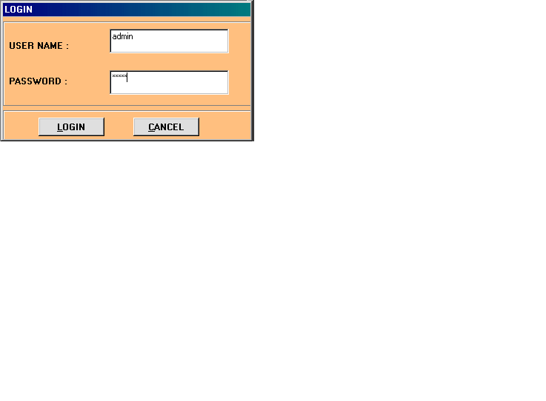

This screen is used for data security purpose. The login screen is used for authentication purpose. The login screen asks the user to enter the username and password. When the system is installed then after the splash screen, in the login screen the user must be created first. The admin user only creates another user. In my system username and password must be 15 character. To enter in the system first user has to enter with following user name and password.

User name : admin

Password : sujal

**MAIN SCREEN OF AIRLINE RESERVATION SYSETM :**

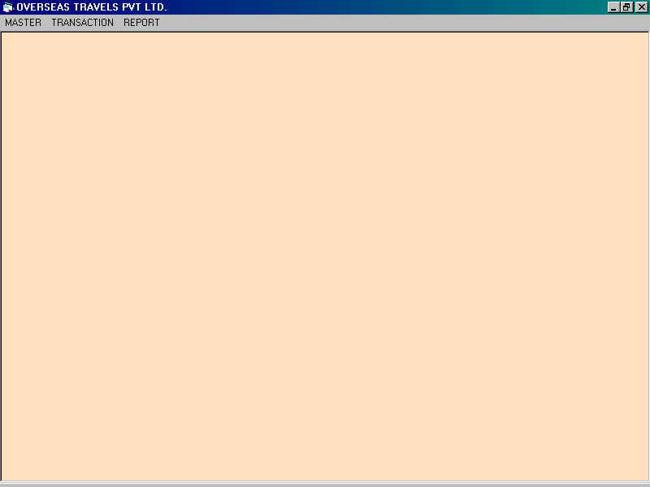

The following screen is the main screen of my Airline Reservation System. From here the user can perform desire operations. Actually it is a menu-based screen so user can perform operations by selecting then from the menu or submenu. Depending on the type of user whether he or she is “admin” or other user the particular rights are given.

**MASTER MENU :**

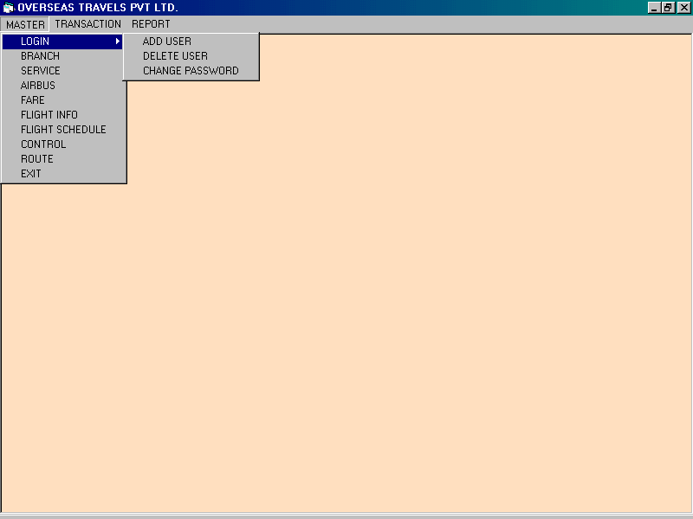

The following figure shows the “Master Menu “ of the system. The master menu contains options like Login, Branch, Service, Airbus, Fare, Flight Info, Flight schedule, Control, Route information and Exit from the menu. By selecting the desired option the associated form will be shown.

**TRANSACTION MENU :**

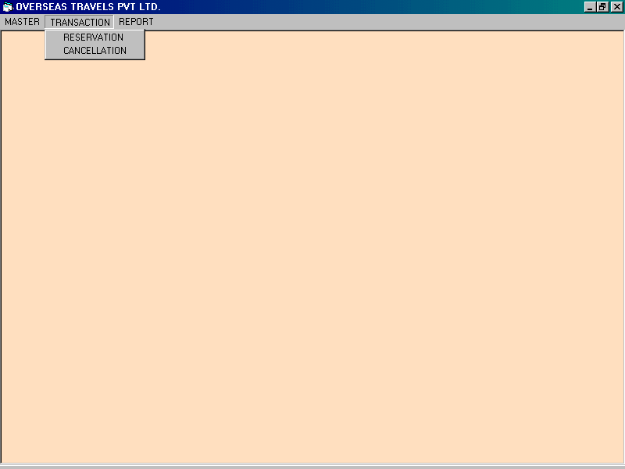

The following figure shows the “Transaction Menu” of the system. The transaction menu contains options like Reservation and Cancellation of tickets. By selecting the desired option the associated form will be shown.

**REPORT MENU :**

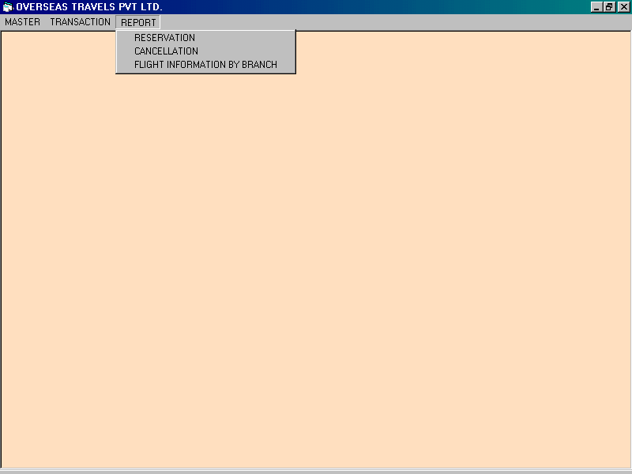

The following figure shows the “Report Menu” of the system. The report menu contains options like Reservation Report, Cancellation Report, Flight information by Branch. By selecting the desired option the associated report will be shown.

**ADD USER FORM :**

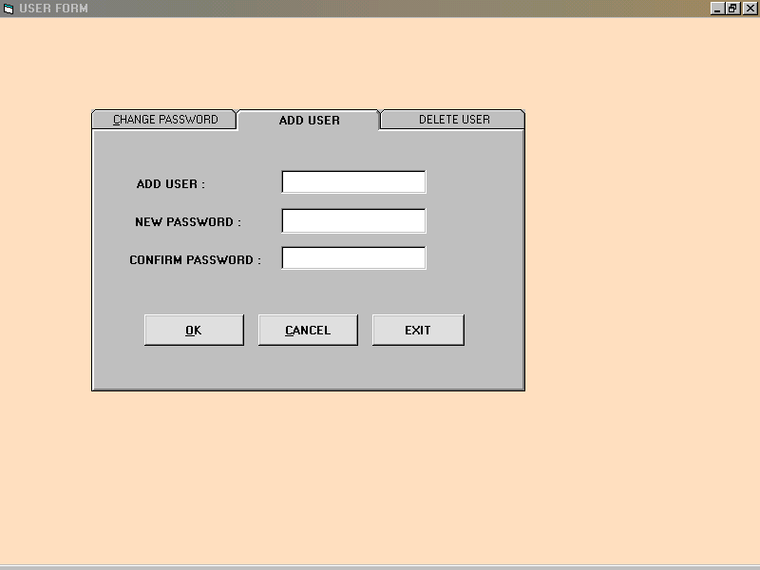

This form is used to create new user. Only admin user can create new user. In this form enter username and password with confirmation password. And than click on “OK” button. After press on click button small message box will be displayed like “CREATE USER”.

**CHANGE PASSWORD FORM :**

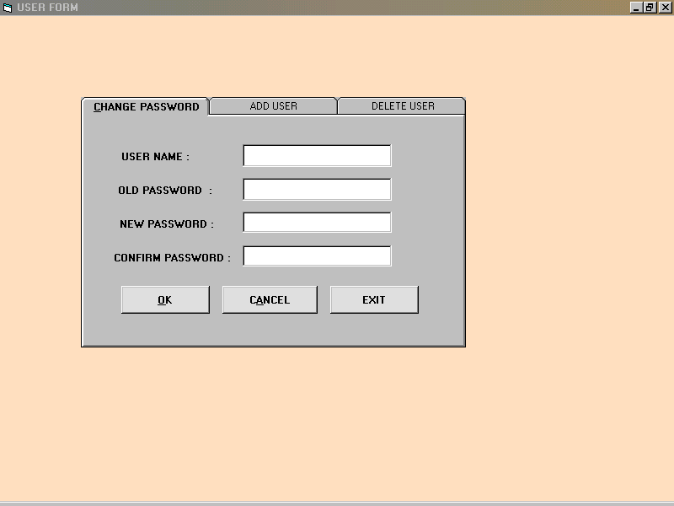

This form is used to change password of the user.To change password username of the user will be entered. Old password of the user will be entered after display old password enter new password and confirm password and then press “OK” button after click on ok button small message box will be displayed like “ Password Has Been Changed”.

**DELETE USER FORM :**

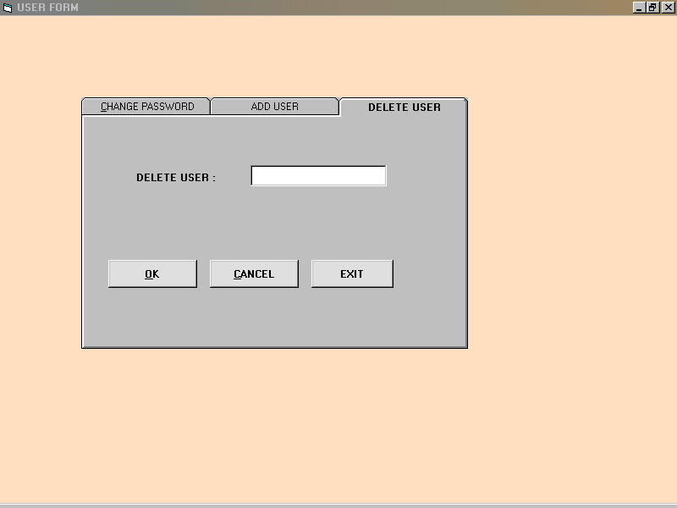

This form is used to delete the user. Enter the username of the user which you want to delete. Only admin user can delete the user. After press on “OK” button small message box will be displayed like “User is Deleted”.

**BRANCH INFORMATION FORM :**

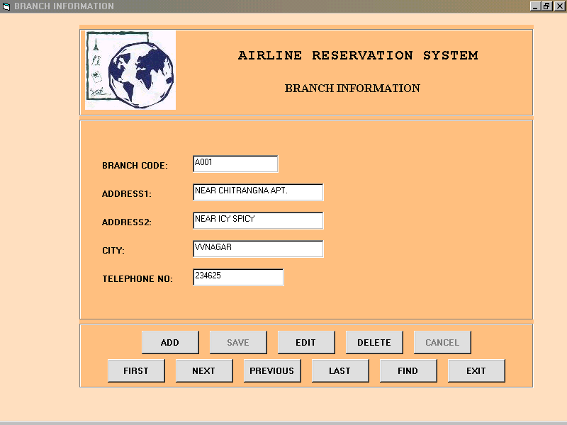

The following form shows the branch information of Airline Reservation System. This form is used to show the information of branch, selecting for reserve ticket. This form is also used to process according to user’s choice on branch information table. In this form ADD, DELETE, SAVE, EDIT, CANCEL, FIND, FIRST, NEXT, PREVIOUS, LAST AND EXIT following operations can be performed.

**SERVICE INFORMATION FORM :**

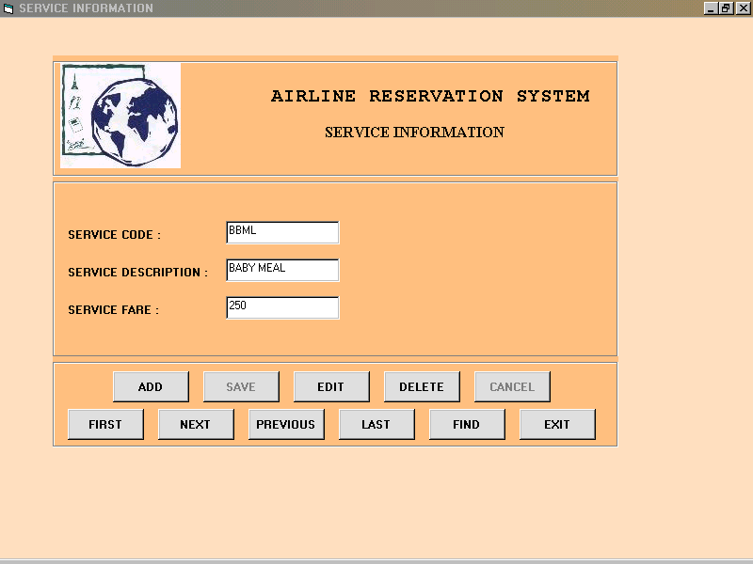

The following form shows the “Service Information “ of the system. This form is used to select any extra other services of the system. At a time only one service is used to reserve the ticket. In this form ADD, DELETE, SAVE, EDIT, CANCEL, FIND, FIRST, NEXT, PREVIOUS, LAST, FIND AND EXIT following operation can be performed.

**AIRBUS INFORMATION FORM :**

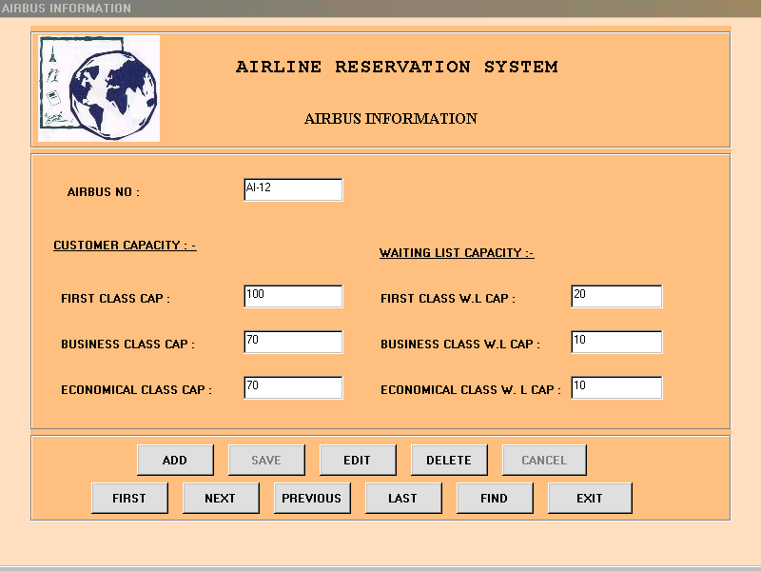

This form shows the Airbus Information of the system. This form is used to shows the capacity of first class, business class , economic class and also the waiting list capacity of the first class, business class and economic class. When you press on save button after adding a record a fare information form will be opened to add fare information.

**FARE INFORMATION FORM :**

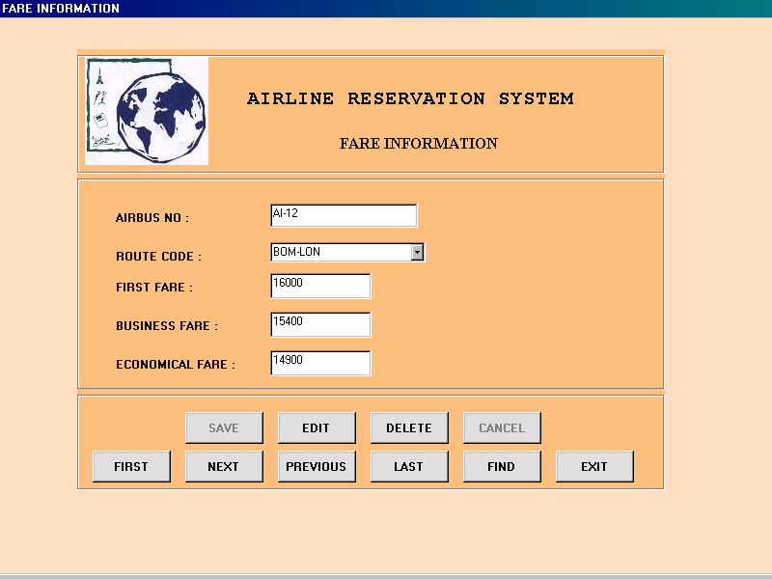

This form shows the fare information of the system. In which route code is to be select and through route code fare can be shown. To add fare information in first class fare, business class fare and economic class fare information. In this form SAVE, EDIT, DELETE, CANCEL, FIRST, NEXT, PREVIOUS, LAST, FIND AND EXIT the following operations can be performed.

**FLIGHT INFORMATION FORM :**

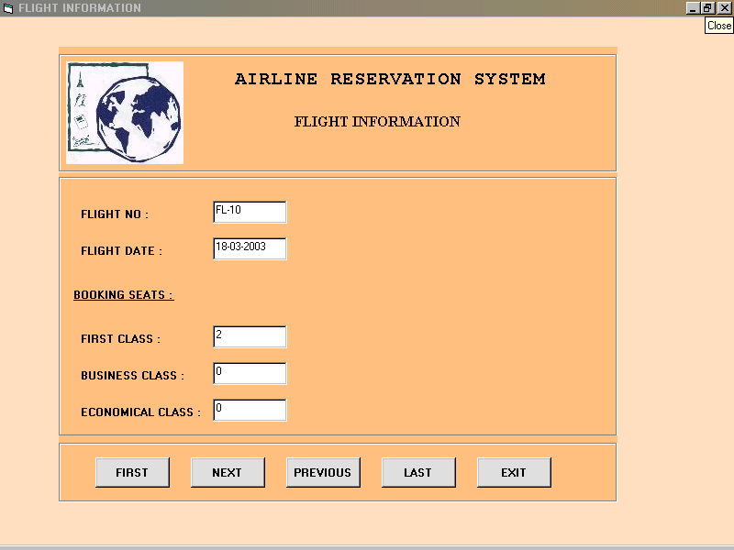

This form shows the flight information by particular flight no and flight date.This form automatically operate after reserving the ticket. If the ticket is confirmed then the record will be insert into the flight information, but whether the ticket is not confirmed then the record will not inserted into the flight information form. If two ticket is confirmed with same flight no and flight date and class then it will increment by 1 in booking seats. This form is used to show the flight information.

**FLIGHT SCHEDULE INFORMATION FORM :**

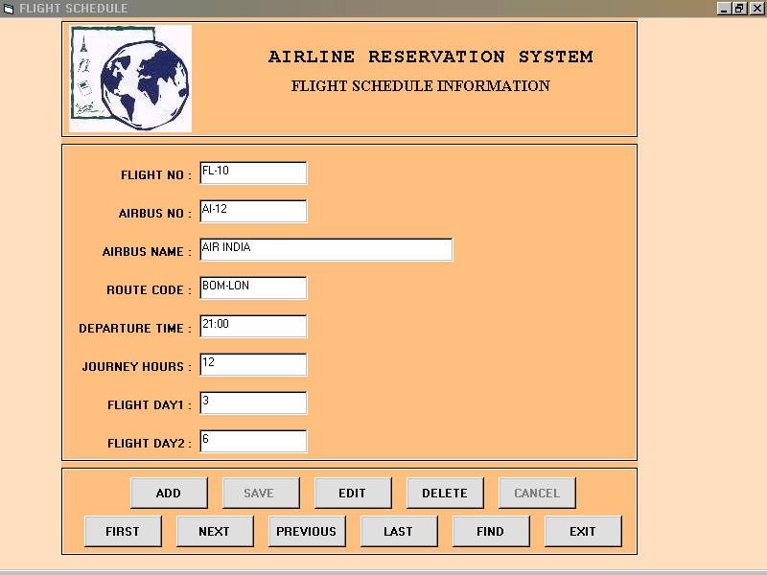

This form shows the flight schedule information. This form used for the flight no and the name of the airbus. It is also used to show the departure time and journey hours of the flight. And it will also shows that in week in which day the flight is gone. Using the route code it will shows the departure time, journey hours flight day1 and flight day2 of that flight.

**CONTROL INFORMATION FORM :**

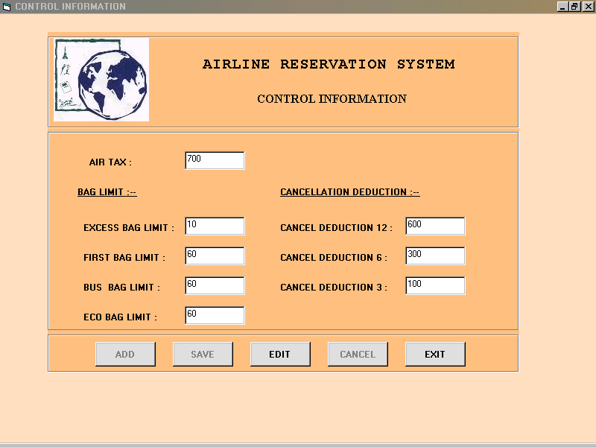

This form shows the control information of the system. In which Air tax, bag limit and cancellation deduction will be displayed. Air tax will be directly calculate in reservation form. And cancellation deduction within 12, 6 and 3 days will directly calculate when you cancel the ticket and cancellation amount will be calculated. Air tax will be Rs.700 fixed for every flight.

**ROUTE INFORMATION FORM :**

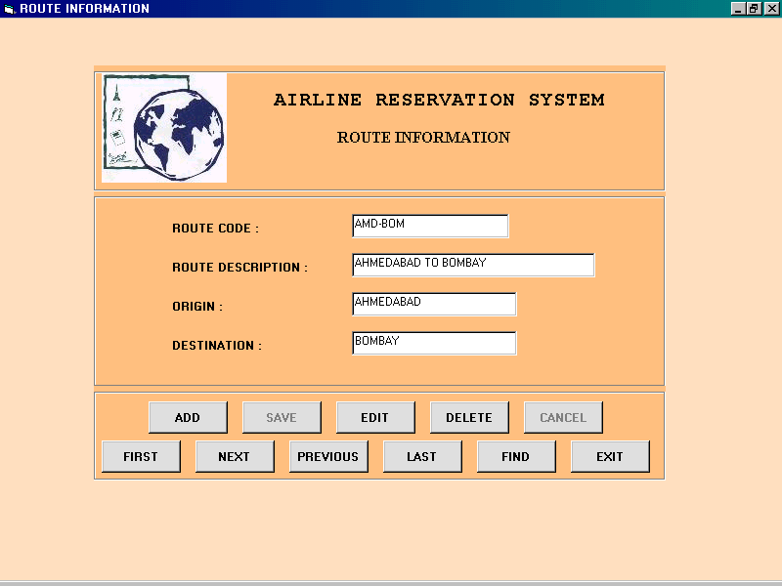

This form shows the route information of the flight. In this form route code, route description, origin and destination will be displayed. From where flight’s origin and the place where the flight is gone. In this form ADD, DELETE, EDIT, SAVE, CANCEL, FIRST, NEXT, LAST, PREVIOUS, FIND AND EXIT following operations will be performed.

**FLIGHT LIST FORM :**

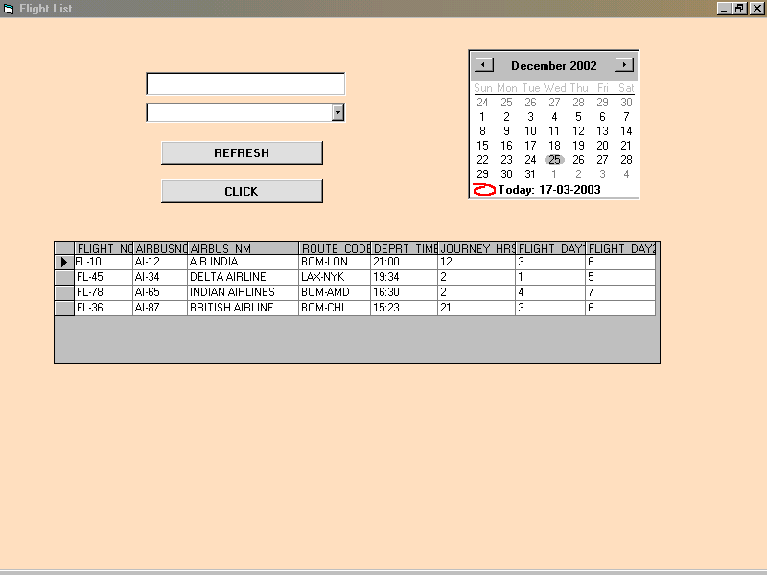  
 This form shows the flight list of the system. It shows with the whole information of the flight schedule information form. Select the date and route code and then press on “click” button and the flight list will be displayed and select the flight list.

**RESERVATION FORM :**

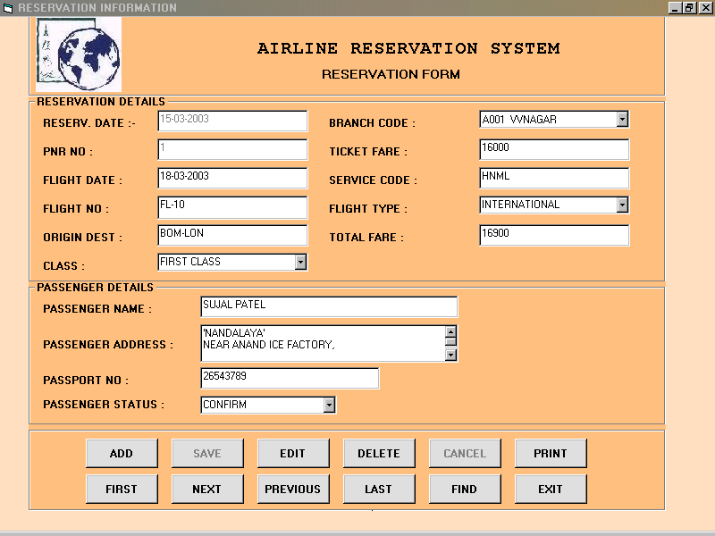

This form is used to reserve ticket. This form shows the reservation information. PNR number is auto generate number. In this form ticket fare which will comes from the fare table. And when you select class it’s fare will insert into ticket fare. And for flight no press “F1” key for flight list and service code. In total fare ticket fare, air tax and service fare will be calculated automatically. passenger information will be inserted and in passenger status if the status is confirm then the information of flight will be added in to flight information table, otherwise status is waiting then information will not be added into information table. In this form ADD, DELETE, EDIT, SAVE, CANCEL, FIRST, NEXT, PREVIOUS, LAST, FIND, PRINT, and EXIT following operation will be performed.

**CANCELLATION FORM :**

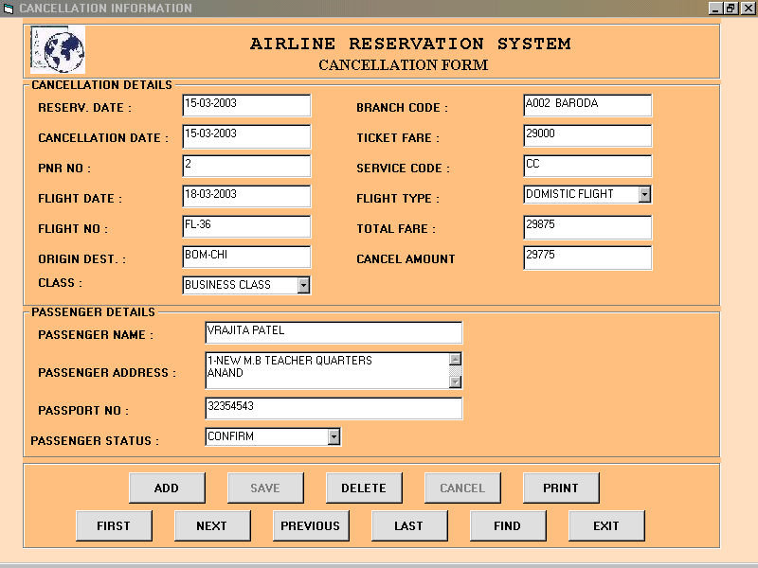

This form is used to cancel the reserved ticket. When you press on add button small box is displayed like “Enter PNR number: - “ and enter the pnr number from the reservation form. And if you press on save button and press yes then ticket is cancelled. In find button you enter pnr number of reserved ticket it display the message like “NO SUCH PNR”. In cancel amount field direct cancel amount will be calculated.

**RESERVATION REPORT :**

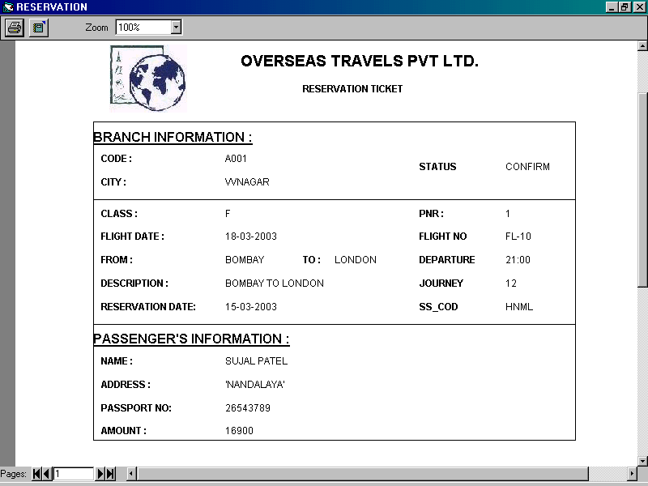

This report shows the reservation report of the reservation ticket.

**CANCELLATION REPORT :**

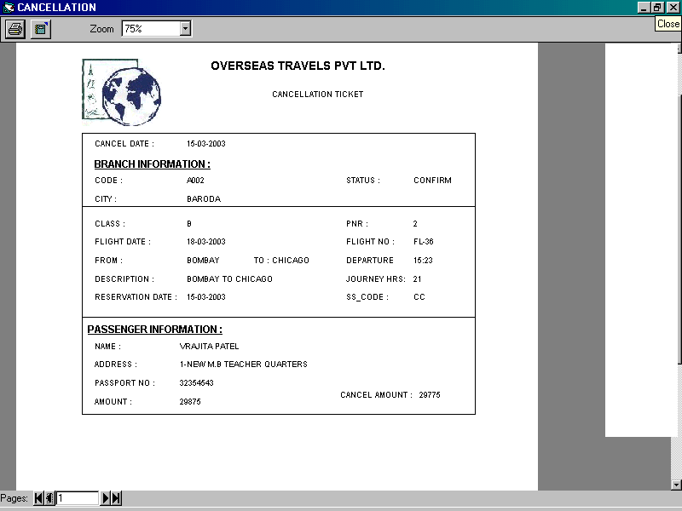

This report shows the cancellation report from the cancel ticket.

**FLIGHT INFORMATION BY BRANCH :**

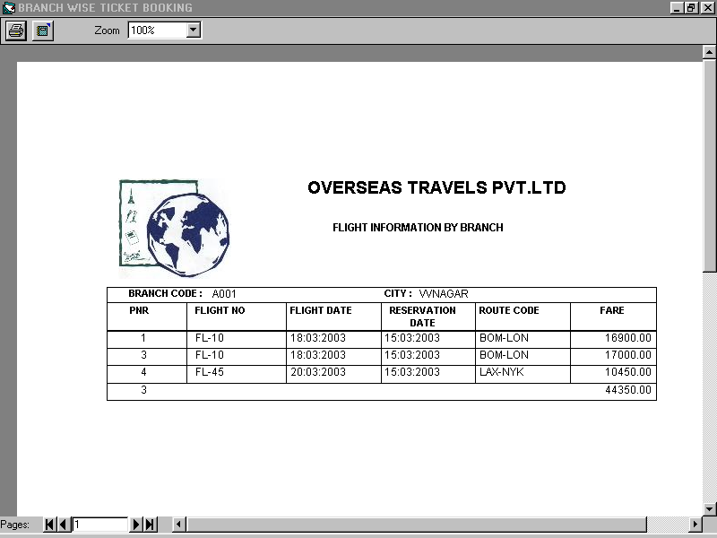

This report shows the flight information by branch.

# CONCLUSION

The Airline reservation system has been a way of minimizing the clerical work, which is almost a routine and consumes the most precious time.

This AIRLINE RESERVATION SYSTEM has been an attempt to help the user to minimize his workload along with minimizing the paper works and saving of time.

The system has been developed in a way to make it very user friendly. It provides an on-line message and an error detection and error messages every time the user needs. Any person having a little bit of window based can run this system without any pain.

Almost all the difficulties of manual reservation have been removed by this system. Ti wind up let me welcome all the suggestions and other improvements, which the system needs so that it covers all the needs if the user in the user way.

**APPENDICES**

This refers to the books, which were gone through for completion of this project report.

1. System Analysis And Design

- Senn

1. Software Engineering

- Pressman

1. System Analysis And Design

- Elias Award

1. Visual Basic 6.0

- Microsoft Press

1. System Analysis, Design And Introduction to Software

Engineering

- S. Parthasarathy

- B. W. Khalakar