## Design

The Weather for is a system that is made from visual studio as selected with .NET C#. This application uses WinForms as well as a weather API to get the essential data for an output. The application has the option for a user to login and to be able to sign up a new user. All the user’s information is connected to the MYSQL database.

The Weather Application is made containing three WINFORMs:

* USER Form

The user form is the main form that appears once we run the application. It gives the user to enter their username and password. It also has the option to register a user to the system.

* REGISTER Form

The register form is appeared once the user clicks the signup option in the user form. It contains the detail boxes for the user to enter the data which will be saved once the create account button is clicked.

* WEATHER Form

The weather form is appeared after the user enters their correct username and password. The weather form has the detail for the forecast, it can display the current information and the weekly. An addition to it is that astronomy details are displayed as well. And the last option is for it to export those details into an excel file.

### User Form

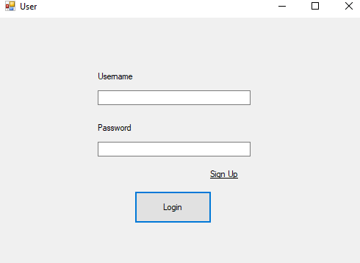

Figure (Log in. 2020)

The user form has three main components; the username, password and signup option. Once the username and the password are entered the user can click the Login button to go to the weather form.

However, there are situation where exceptions must be made. That’s why implementation of it for scenarios are available:

* When the username box is empty. Pop Text is shown.

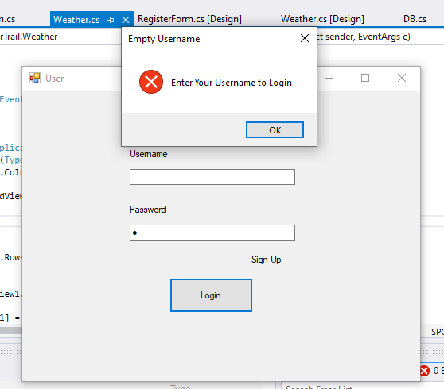

Figure (Empty Username, 2020)

* When the password box is empty. Pop Text is shown.

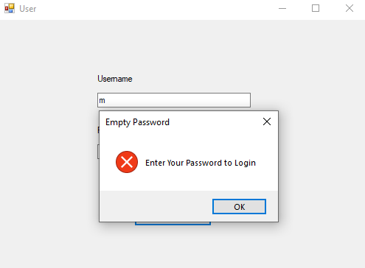

Figure (Empty Password, 2020)

* When the username box is wrong. Pop Text is shown.

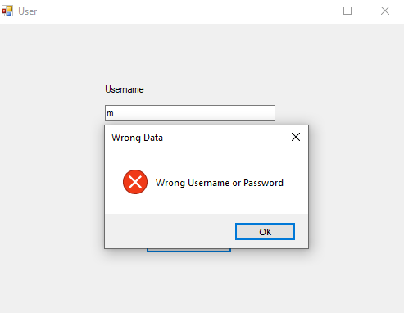

Figure (Wrong Username, 2020)

* When the password box is wrong. Pop Text is shown.

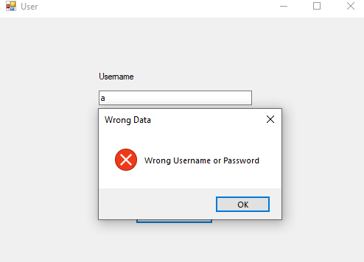

Figure (Wrong Password, 2020)

### Register Form

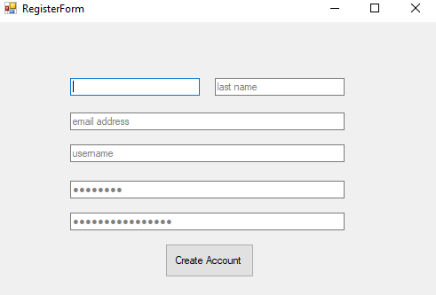

Figure (Register Form, 2020)

The register form contains details for the user to enter. The details which needed are first name, last name, email address, username, password and the confirmation password. Once that information’s are entered then the user can click the create account button.

However, there are situation where exceptions must be made. That’s why implementation of it for scenarios are available:

* When one or more boxes are empty. Pop Text is shown.

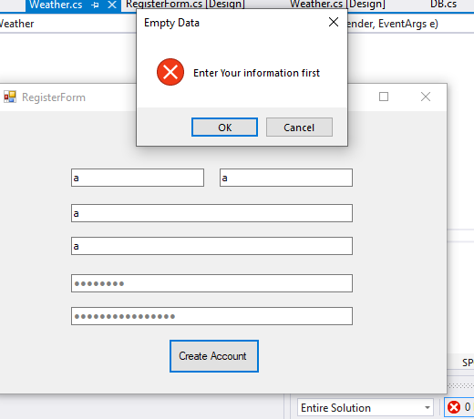

Figure (Empty Value, 2020)

* When username entered already exist. Pop Text is shown.

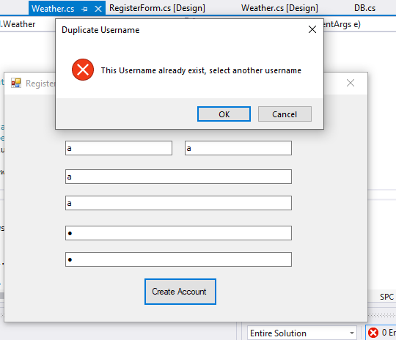

Figure (Exist Username, 2020)

* When password and the confirm password mismatch. Pop Text is shown.

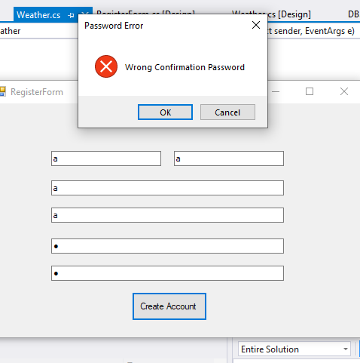

Figure (Mismatch Password, 2020)

* When all the details are correctly entered and the create account button is clicked. Pop Text is shown after it goes the userform.

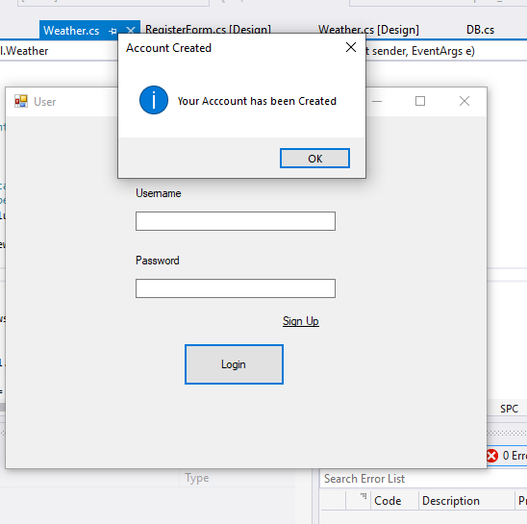

Figure (Signup Success, 2020)

### Weather Form

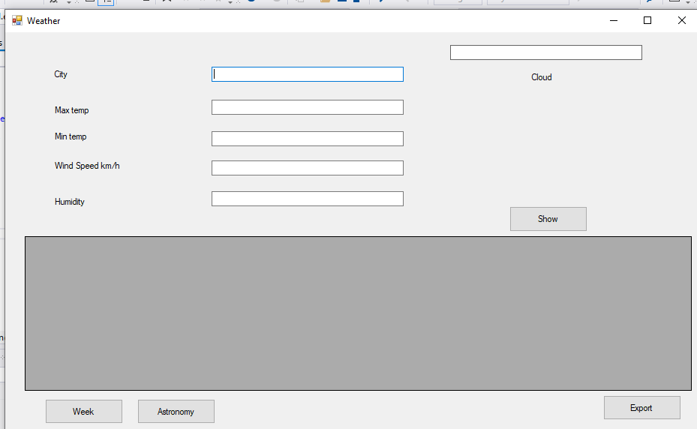

Figure (Weather Form, 2020)

The weather Form is made to display the forecast which received by the API and displayed. It shows the current location weather details in the top section. While on the bottom its displays the weekly details and the astronomy details. There is an option to export as shown in the form of a button.

* Once the location is entered in the city box the current details are displayed as example below:

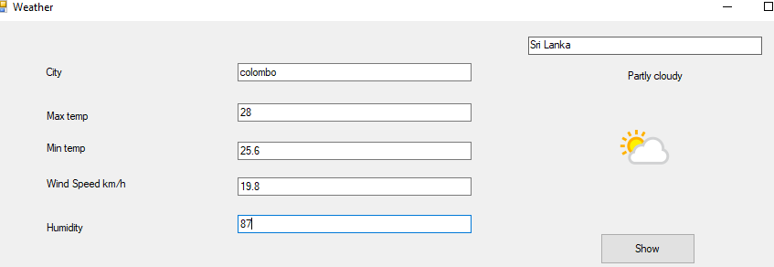

Figure (Current, 2020)

* Once the Weekly button is clicked the details are displayed as example below:

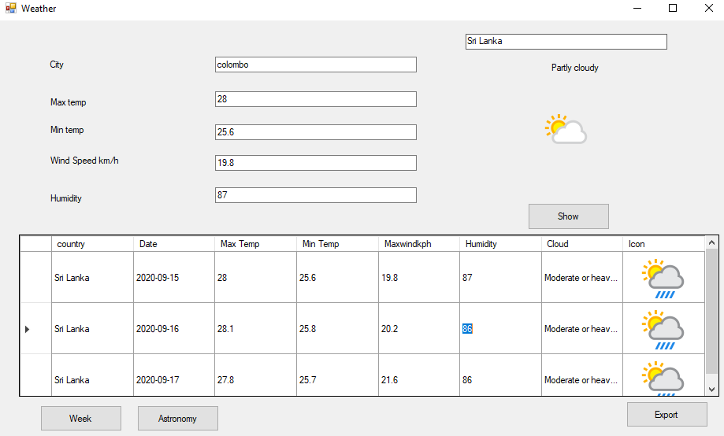

Figure (Weekly, 2020)

* Once the Astronomy button is clicked the details are displayed as example below:

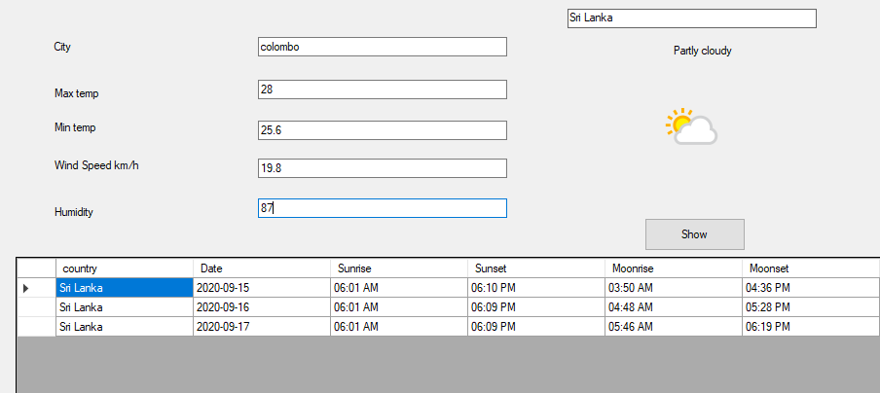

Figure (Astronomy, 2020)

* Once the Export button is clicked and excel file is created. E.g. the weekly detail of Colombo is exported as shown below.

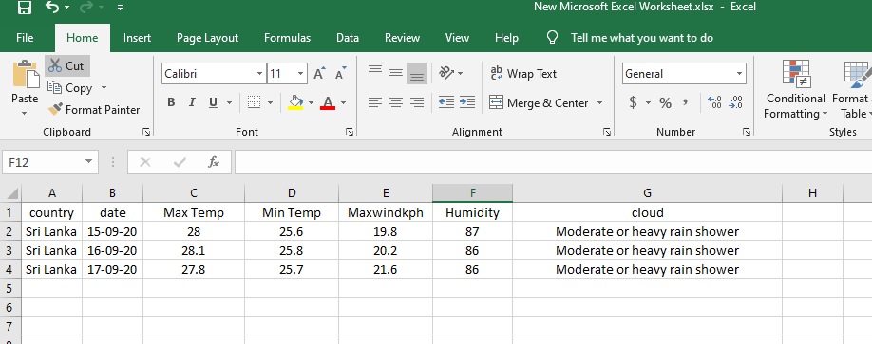

Figure (Export, 2020)

## Codes

Attached in the folder as “weatherTrail”.

## Database

Attached in the file as “user.sql”.