# Authors

Reza Bonyadi* and Maryam Ziaei

*PhD computer science

Centre for Advanced Imaging, CAI

The University of Queensland

QLD 4072, Australia

rezabny@gmail.com

# User manual for stimuli presentation program

This program simplifies the psychtoolbox by placing a wrapper around this toolbox. The user provides a set of stimuli in the format of csv files (so called operation files) and the program reads those simple commands from and show the stimuli on the screen. The program reads the operations from each line of the operation files placed in the “RunOperationsFiles” folder. The onsets and information are saved then in a text file and, for each run, as a Run#.mat file as well.

## Run the program

Run the file “mainProg.m”.

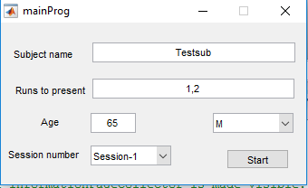

Set participant details and the operation files (“run to present”) to run and hit start (give it a go with the example csv files in the current program). You may provide multiple files separated by ‘,’. The program runs them one after another. The results are saved at the end of each run. The program reads the operations from each line of the operation files placed in the “RunOperationsFiles”. Participants can hit the keys specified in the setting file “Settings.txt” as “viable keys” and the program will save those keys if they are pressed by the participant during any “keyAndTime” operation (in the operation file).

Press and hold “o” to stop the experiment. All results are still saved. Press and hold “Esc” to skip the current run. These two do not work during a “waitForKey” operation.

## Operation files (csv)

The program reads the operations from each line of the csv files placed in the “RunOperationsFiles” folder. The files must be named as “Run#.csv” where # is a number that is provide in the GUI when the program starts (“Runs to present”). The sheet must be named as the file name.

We explain how each column of the operation files (csv files) should be provided. This version of the program only supports showing images or texts on the screen (so called “ImageShow” operation).

### ImageShow operation

The first column must be “ImageShow” for showing images or text. The second column can be waitForKey, givenTime, or keyAndTime.

* **waitForKey:** the third column shows the key that the program will wait for.
* **givenTime:** the third column will be a time in seconds.
* **keyAndTime**: the third column will be a time in seconds. The program will store the first key pressed during this time if the key belongs to the set of “viable keys” set in the “Setting.txt” file (see section Settings file). The stimuli remains on the screen for that given time.
* **keyAndTimePass:** exactly the same as “keyAndTime” but the next stimuli is presented when the first viable key was pressed.

The forth column will be either a folder name (e.g., “Figures\”) or the “justText”.

* **Folder:** The next column will be the name of the file to present.
* **justText:** the next column will be a text to display.

For the “justText”, one can also use -# (e.g., “justText-15”) where # is the font size for the text.

The sixth column is the location of the stimuli. It could be the word “screen” that tells the program to show the stimuli in the middle of the screen. Otherwise, it should be one of the options provided in the “Seetings.txt” file as “Directions”.

The seventh column is either “D” or “S” that indicates ignoring or saving information about that stimuli. Anything in any column beyond the seventh are also saved (if “S” was placed in the seventh column) in a semicolon separated format.

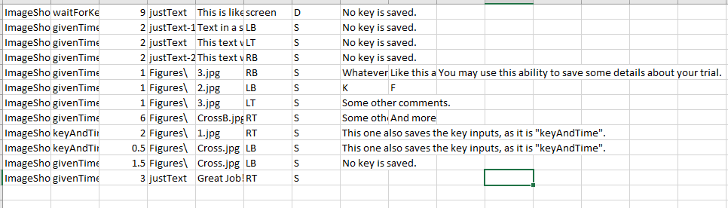

## Response file format

The program generates a folder with the name of the participant provided in the starting screen, followed by the session provided in the session number. The program saves the basic information of the participant at the beginning of the response file:

Subject name: Testsub-Session-1

Subject age: 65

Subject gender: M

Subject run files: 1,2

Vaiable response characters map: 49= '1',50= '2',

-----------------

If the participant name already exists in the folder then a random postfix is added to the name of the participant.

Each row of the csv files that has “S” in its seventh column will be saved. For different operations the saving is different:

* **waitForKey:** run number;”text”/”file name”;”location”;onset;comments
* **givenTime:** run number;”text”;”location”;onset;comments
* **keyAndTime/keyAndTimePass**: run number;”text”;”location”;onset;response time;response key;comments

The response time and response keys are -1 if no responses were provided.

## Settings file

An example settings file:

environment=psychToolbox

viable keys=1 2

screen to use=0

Font size=40

Directions=RT,RB,LB,LT

Rects=975,192;975,576;325,576;325,192

**Environment:** tells the program to use the psychtoolbox for all illustrations. If this is changed then the program will only generate results in the command line, all functionalities work fine.

**Viable keys**: is the list of all keys that the participant can press and they need to be saved. Any other keys are ignored.

**Screen to use:** this is the screen number the program uses for showing the stimuli. If there is only one screen then set to zero, if 2 screens select 2 (or one, depending on the matlab version and psychtoolbox you are using).

**Font size**: is the default font size for all texts.

**Directions:** the rectangles where the stimuli are going to be presented in. These codes here will be used in the operation files.

**Rects**: are the centers of the rectangles on the screen corresponding with those in the “directions”.

## Modify

To come