Progress Status Report

Dynatrace Appmon Implementation

Submission to PT Asuransi Jiwa Manulife Indonesia (Manulife Indonesia)

3 August 2018

Project Name | Dynatrace Appmon Implementation
Project Manager | Rahmat Julizar | Reviewed By | Hamdani Arif
Project Stage | Development | Proposed End Date | 1-July-2019
Frequency of Report | Weekly | Prepared By | Rahmat Julizar

Project Health: Green
Green : Project on track – all critical path activities on track and risk occurrence % is below 10-%
Amber: Project getting delayed. Deliverables from either party pending, critical path still in control and risk occurrence % is around 50%.
Commitment issues are present. If risk management plan activated then situation can be controlled immediately.
Red: Project Delayed. Critical path activities are delayed. Risk occurrence is above 50%. Issues are now becoming risks.

Risk management plan may not stop a delay but can curtail extent of delay.

Project Report

- Key Milestone Dates & Project Status Production

Project Phase | Progress | Responsibility | Start Date | Target Date | Status
Assessment & Design

- Existing Installation & Configuration Review (As-Is) | 100% | Rahmat & Reza | 3-July-2018 | 6-July-2018 | Done
- All monitored application assessment & design for Configuration (To-Be) | 100% | Rahmat & Reza | 9-July-2018 | 10-July-2018 | Done
Installation & Configuration

- Dynatrace AppMon Server Installation & Configuration | 100% | Reza | 9-July-2018 | 13-July-2018 | Done
- Dynatrace AppMon Collector Installation & Configuration | 100% | Reza | 9-July-2018 | 13-July-2018 | Done
- Dynatrace AppMon Agent Installation & Configuration (11 Agent + 3 Host Agent) | 100% | Reza | 9-July-2018 | 27-July-2018 | Done
- Dynatrace AppMon Client Installation & Configuration | 100% | Reza | 9-July-2018 | 13-July-2018 | Done
- Basic Configuration
- License Setup | 100% | Reza | 9-July-2018 | 13-July-2018 | Done
- Server Sizing Setup | 100% | Reza | 9-July-2018 | 13-July-2018 | Done
- Performance Warehouse Setup | 100% | Reza | 9-July-2018 | 13-July-2018 | Done
- User Management Roles Setup | 100% | Reza | 9-July-2018 | 20-July-2018 | Done
- Updates Setup | 100% | Reza | 9-July-2018 | 13-July-2018 | Done
- Storage Setup | 100% | Reza | 9-July-2018 | 27-July-2018 | Done
- Synthetic Monitoring | 50% | Reza | 30-July-2018 | - | On Progress
- Advance Configuration
- Custom Dashboard (Plugin) | 50% | Reza | 16-July-2018 | - | On Progress
- Custom Alerting (Plugin) | 50% | Reza | 16-July-2018 | - | On Progress
- Custom Scheduler (Plugin) | 100% | Reza | 16-July-2018 | - | On Progress
- Custom Measure & Business Transaction (Metrics) | 50% | Reza | 16-July-2018 | - | On Progress
- Testing | 50% | Reza | - | - | Not Started
- Final Documentation | 50% | Reza | 23-July-2018 | - | On Progress
- Training | 0% | Rahmat & Reza | - | - | Not Started
- On Deman Visit | 0% | Reza | - | - | Not Started
- Preventive Maintenance | 0% | Reza | - | - | Not Started

- Highlights

- Advance Configuration on Custom Dashboard (Plugin) -> Added some Custom Dashboard, waiting for user request (Pending Manulife).
- Advance Configuration on Custom Alerting (Plugin) -> Installed plugin for SMS Notification Alert, waiting WSDL for testing plugin using Web Service (Pending Manulife).
- Advance Configuration on Custom Scheduler (Plugin) -> Added some scheduler to check availlability Host, Application & Server Time, waiting another request from user (Pending Manulife).
- Advance Configuration on Custom Measure & Business Transaction (Metrics) -> Added some metrics for dashboard, waiting another request for Business Transaction Metrics (Pending Manulife).
- Synthetic Monitoring -> Tested. Waiting script/scenario from User. (Pending Manulife)
- Testing -> On Progress. Defining testing script/scenario (Pending MII)
- Final Documentation -> On Progress (Pending MII).

- Summarized Information – Production

Total 0 issues raised in the Production for with following break up:
Bug Data related : 0
Other Bugs : 0
Clarification : 0
Customization : 0
Close : 0

- Activities Track Sheet

Activities Completed Till – 6-July-2018
Assessment and review existing installation and configuration
Activities Completed Till – 13-July-2018
Assessment and review existing installation and configuration
Dynatrace AppMon Server Installation & Configuration
Dynatrace AppMon Collector Installation & Configuration
Dynatrace AppMon Client Installation & Configuration
Basic Configuration on License Setup
Basic Configuration on Server Sizing Setup
Basic Configuration on Performance Warehouse Setup
Basic Configuration on User Management Roles Setup
Basic Configuration on Updates Setup
Activities Completed Till – 27-July-2018
Basic Configuration on Storage Setup
Dynatrace AppMon Agent Installation & Configuration
Basic Configuration on User Management Setup
Basic Configuration on Custom Scheduler (Plugin)

- Additional Information

- MII request to Open Port (80 or 443) for mliprd91, mliprd92, mliprd93. So Agency Link and Partner Link in that server could be monitored.
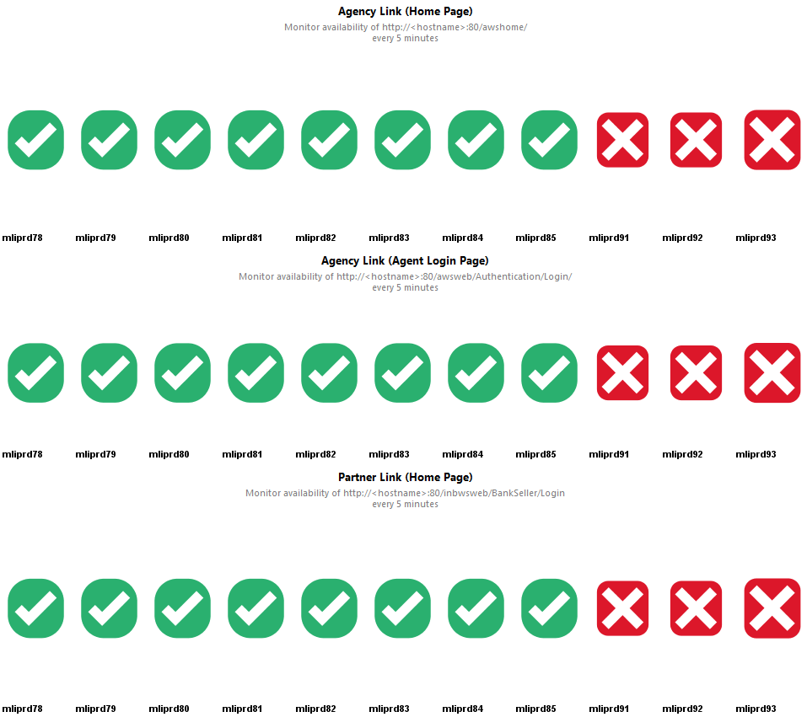
False posotive alert because port 80 (http) or 443 (https) are blocked in those server.
- MII request for the SMS Web Service URL or WSDL. The default notification alert is using E-mail. So it would be good if the alert could be notified by SMS Service.
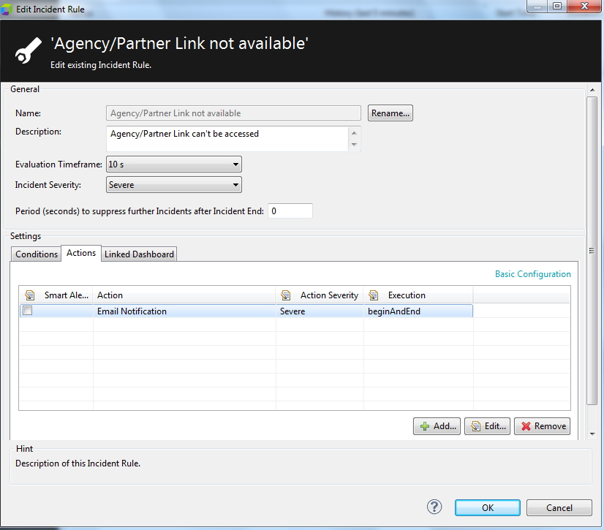
Dynatrace use E-mail Notification if there is an Incidents. It send at Start & End
- MII request for meeting to discuss about Custom Dashboard, Alert, Metrics, Report and Synthetic Monitoring script/scenario.

