COURSE 1 OF 17 — CANADIAN POULTRY TRAINING SERIES
T-FLAWS – Assessment Management Tool
A Structured Flock Assessment Framework for Commercial Poultry Farmers in Canada
———————————————————————————————
Canadian Poultry Training Series
April 2026 | Version 1.0
This course has been developed for educational purposes for commercial poultry farmers in Canada. Content is drawn from peer-reviewed literature and industry management guides. Items marked [NEEDS SOURCE] require additional verification before publication.

Contents
Introduction to T-FLAWS 3
Purpose of This Guide 3
When to Conduct Assessments 3
T — Toes 4
What It Is 4
Why It Matters 4
How to Assess 4
What Abnormal Findings Indicate 4
Recommended Management Responses 4
F — Feathers 6
What It Is 6
Why It Matters 6
How to Assess 6
What Abnormal Findings Indicate 6
Recommended Management Responses 6
L — Legs 8
What It Is 8
Why It Matters 8
How to Assess 8
What Abnormal Findings Indicate 8
Recommended Management Responses 8
A — Activity 10
What It Is 10
Why It Matters 10
How to Assess 10
What Abnormal Findings Indicate 10
Recommended Management Responses 10
W — Weight 12
What It Is 12
Why It Matters 12
How to Assess 12
What Abnormal Findings Indicate 12
Recommended Management Responses 13
S — Skin 14
What It Is 14
Why It Matters 14
How to Assess 14
What Abnormal Findings Indicate 14
Recommended Management Responses 15
Recommended Peer-Reviewed Journals and Resources 16
Peer-Reviewed Journals 16
Key Institutional Resources 16
References 18

Introduction to T-FLAWS
T-FLAWS is a structured flock assessment framework designed to provide commercial poultry farmers with a systematic, repeatable method for evaluating flock health and welfare at the barn level. The acronym stands for Toes, Feathers, Legs, Activity, Weight, and Skin — six key indicators that, when assessed together, provide a comprehensive picture of flock status at any point in the production cycle.
The T-FLAWS framework was developed in response to growing regulatory and market requirements for documented welfare assessments in Canadian poultry production. The National Farm Animal Care Council (NFACC) Code of Practice for the care and handling of hatching eggs, breeders, chickens and turkeys (2016) establishes minimum welfare standards and encourages producers to implement systematic on-farm welfare monitoring programs.
Unlike single-indicator welfare assessments, T-FLAWS provides a multi-dimensional view of flock status. Problems detected in one indicator often correlate with — or predict — problems in others. By assessing all six components together, producers can identify root causes more efficiently and respond before problems escalate.

Purpose of This Guide
This guide provides detailed protocols for assessing each T-FLAWS component, interpreting findings, and implementing evidence-based management responses. It is intended for use by experienced commercial poultry farmers, barn supervisors, and farm advisors working with broiler, layer, and breeder operations across Canada.

When to Conduct Assessments
For broiler operations: Day 7 (establishment check — Activity and Weight), Day 14 (early growth — all components), Day 21 (mid-cycle — all components), Day 28 (pre-thinning — all components), Day 35 or depopulation (pre-harvest). For layer and breeder operations: monthly during the laying period, plus after any significant flock event.

T — Toes

What It Is
The Toes component focuses on footpad dermatitis (FPD), also known as pododermatitis — a necrotic skin condition affecting the plantar surface (bottom) of the foot. FPD is scored on the Welfare Quality® scale: Score 0 — no lesion; Score 1 — superficial lesion, mild erosion; Score 2 — severe lesion, deep ulceration (Shepherd & Fairchild, 2010; Welfare Quality®, 2009). Additional conditions assessed include bumblefoot, curled toe syndrome, toe necrosis, and nail condition.

Why It Matters
FPD is the primary animal welfare indicator used in commercial poultry audits across Canada, referenced in the NFACC Code of Practice (2016) and the Canadian Chicken Farmers' Animal Care Program. It also has direct economic consequences: Grade 2 FPD results in feet being condemned at the processing plant. FPD prevalence is directly correlated with litter moisture content, ammonia concentration, and stocking density (Ekstrand et al., 1997).

How to Assess
Sample minimum 100 birds per barn, randomly selected from at least five locations. Lift each bird and score both feet on the 0–2 scale. The bird's score is the higher of the two feet. Meaningful assessment from Day 21 onward. Target: less than 5% of feet with Score 2 lesions (NFACC, 2016).

What Abnormal Findings Indicate
Score 1 (>20% prevalence at Day 21+): Early warning — intervene immediately with litter management. Score 2 (>5% prevalence): Chronic wet litter; comprehensive ventilation and litter review required. Bumblefoot: secondary bacterial infection (Staphylococcus aureus) from skin disruption. Curled toe: riboflavin (Vitamin B2) deficiency or incubation issues (Merck Veterinary Manual, 2022). Toe necrosis in chicks: high brooding temperature or dehydration. [NEEDS SOURCE]

Recommended Management Responses
Litter moisture: Target below 25%. Improve ventilation, repair drinker leaks, adjust nipple height and pressure. Ammonia: Maintain below 25 ppm at bird level at all times (NFACC, 2016). Nutrition: Ensure biotin at 150–300 mcg/kg of complete feed; consult nutritionist before changes (Merck Veterinary Manual, 2022). Stocking density: Review against NFACC Code minimums.
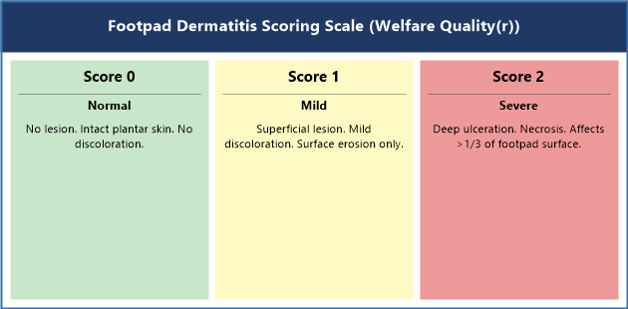
Figure 1. Footpad Dermatitis Scoring Scale (Welfare Quality(r) 0-2). Score 0: no lesion; Score 1: superficial erosion; Score 2: deep ulceration.

F — Feathers

What It Is
The Feathers component assesses plumage condition across the flock — feather coverage, integrity, and damage or loss. Scored per body region (breast, back, wings, tail, neck) on a 0–4 scale: 0 = full coverage; 4 = large bare skin area. Assessment distinguishes feather pecking (behavioral) from ectoparasite infestation from developmental abnormalities. Severe feather pecking is one of the most significant behavioral welfare problems in laying hen production (Bilcik & Keeling, 1999).

Why It Matters
Feathers are the primary insulating layer. Birds with significant feather loss pay a feed conversion ratio (FCR) penalty of 5–15% due to heat loss (Riber et al., 2018). In layer operations, feather pecking can escalate to cannibalism within hours of first blood being drawn (Daigle, 2017). Feather quality at processing affects defeathering efficiency and carcass value.

How to Assess
Sample minimum 50 birds per barn. Score each body region 0–4. Distinguish cause: pecking leaves feathers pulled out at base; mite damage causes feather breakage; developmental issues present uniformly across the flock. Assess from Day 21+ in broilers; monthly in layers.

What Abnormal Findings Indicate
Feather loss on back and vent: Most consistent with feather pecking. Review lighting program, stocking density, and feed access immediately. Bilateral broken/frayed feathers: Ectoparasite pressure — examine for northern fowl mite (Ornithonyssus sylviarum) or red mite (Dermanyssus gallinae) at night. Stress bars (fault bars): transverse weakness lines indicate a past systemic stress event (Riber et al., 2018). Slow feathering in chicks: riboflavin deficiency or sex-linked late-feathering gene.

Recommended Management Responses
Lighting: Reduce intensity below 10 lux for broilers; below 20 lux in layers. Ensure uniformity (CV <20%) (NFACC, 2016). Enrichment: Pecking blocks, hanging objects, straw bales. Ensure adequate feeder and drinker space. Nutrition: Verify sulfur amino acid (SAA — methionine + cysteine) levels meet breed recommendations. Ectoparasites: Integrated pest management; acaricide treatment as approved. Stocking density: Review against NFACC Code maximums if pecking persists.
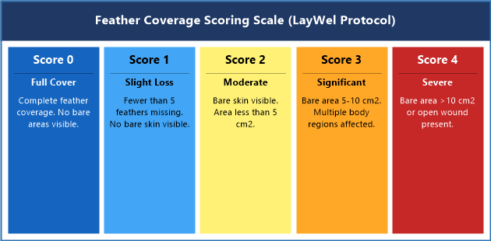
Figure 2. Feather Coverage Scoring Scale (LayWel Protocol). Score 0: full coverage; Score 1: slight loss; Score 2: moderate bare skin; Score 3: significant loss; Score 4: severe bare area or wound.

L — Legs

What It Is
The Legs component uses the Bristol Gait Scoring Scale (Kestin et al., 1992): Score 0 — normal; Score 1 — slight abnormality; Score 2 — definite difficulty; Score 3 — marked difficulty, reluctant to move; Score 4 — unable to walk without support; Score 5 — unable to walk. Also assessed: hock burn (0–2 scale), angular limb deformities (valgus/varus), tibial dyschondroplasia (TD), spondylolisthesis, joint swelling, and tendon rupture.

Why It Matters
Lameness is the single most significant welfare and production problem in commercial broiler production. Knowles et al. (2008) found 27.6% of UK commercial birds at slaughter had gait score 3+. Birds with gait score 3+ are in pain, cannot access feed and water normally, and have significantly lower slaughter weights. Leg health is an audit requirement under most Canadian processor welfare programs.

How to Assess
Gait: Observe minimum 150 birds walking undisturbed. Score as you observe. After gait scoring, catch minimum 30 birds for hock burn assessment. Post-mortem: examine tibiae of lame and dead birds for TD (characteristic white cartilaginous plug in proximal tibial growth plate). Gait scoring is most meaningful from Day 28+ in broilers.

What Abnormal Findings Indicate
Gait score 3+ in >5% of birds: Significant lameness — investigate growth rate, lighting, flooring, and nutrition (Knowles et al., 2008). Hock burn Score 2 >5%: Wet litter in the hock contact zone — same root cause as FPD. Valgus/varus: Bilateral = nutritional or genetic; unilateral = injury. TD (post-mortem): Calcium:phosphorus imbalance, Vitamin D3 deficiency, or mycotoxin exposure (Merck Veterinary Manual, 2022). Hot, swollen joints: Septic arthritis — submit for veterinary diagnosis.

Recommended Management Responses
Lighting: Minimum 6 consecutive hours of darkness per day as required by NFACC (2016). Bedding: Minimum 5 cm depth at placement; maintain throughout grow-out. Nutrition: Verify calcium, available phosphorus, and Vitamin D3 against breed specifications. Stocking density: Reduce if leg problems are persistent across flocks (NFACC, 2016).
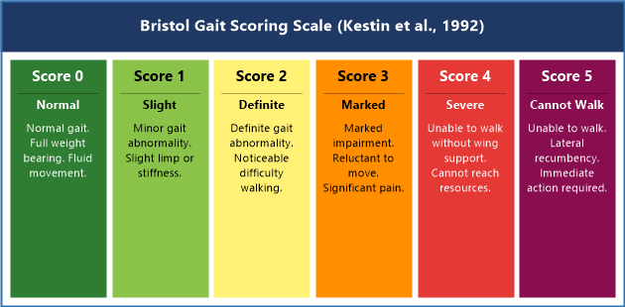
Figure 3. Bristol Gait Scoring Scale (Kestin et al., 1992). Score 0: normal gait; Score 2: definite impairment; Score 4: unable to walk without wing support; Score 5: unable to walk.

A — Activity

What It Is
The Activity component assesses the behavioral status of the flock: distribution in the house, proportion of birds engaged in feeding, drinking, resting, preening, and other behaviors, and fear response (flight distance — distance at which birds move away from an approaching observer). Activity is a composite welfare indicator reflecting environmental quality, health status, nutritional adequacy, and management practices.

Why It Matters
Activity patterns are highly sensitive to environmental and health changes, often shifting before clinical signs appear. Research has demonstrated that changes in feeding behavior precede clinical disease diagnosis by 24–48 hours (Dawkins et al., 2004). Reduced activity during the light period indicates pain, illness, or poor air quality. Flock distribution reflects environmental gradients — clustering always signals a problem (EFSA, 2012).

How to Assess
Before entering the barn, pause at the door for 2 minutes and observe undisturbed. Score distribution on a 3-point scale: 1 = even; 2 = moderately uneven; 3 = severely uneven (large bare floor areas). Measure flight distance: walk slowly down the barn center; note distance at which birds begin to move away (target: 1 meter or less). Conduct behavioral scan of 100 birds at 1-minute intervals for 5 minutes.

What Abnormal Findings Indicate
Clustering near brooders: Ambient temperature below comfort zone. Clustering in center, away from walls: Overheating at perimeter or predator disturbance. >70% resting during light period: Pain, illness, or air quality problem — check ammonia (>25 ppm), CO2 (>3,000 ppm) (EFSA, 2012). High flight distance (>2 m): Inadequate human habituation — increases handling stress (Jones, 1996). Piling: Panic response to sudden noise, light failure, or predator.

Recommended Management Responses
Temperature: Map temperature at bird level (30 cm above floor) across the barn. Achieve uniformity within ±2°C. Ventilation: If ammonia exceeds 10 ppm at nose level, increase minimum ventilation rate immediately. Human habituation: Increase frequency and duration of calm barn walks. Lighting uniformity: Measure and correct if CV >20%. Activity change without obvious cause: Review mortality and submit fresh dead birds for post-mortem.
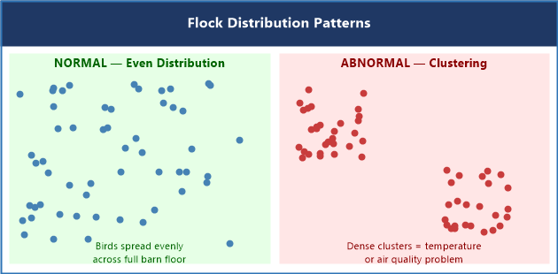
Figure 4. Flock Distribution Patterns. Left: normal even distribution across the full barn floor. Right: abnormal clustering indicating a temperature, air quality, or light gradient problem.

W — Weight

What It Is
The Weight component assesses body weight and flock uniformity: individual bird weights, flock mean, and coefficient of variation (CV% = SD ÷ Mean × 100). Target CV% for broilers: below 10% at all ages. For layer pullets at point of lay: below 8% to ensure synchronous onset of lay (Lohmann Tierzucht, 2021). Breed-standard growth curves from Aviagen (Ross), Cobb-Vantress (Cobb), and Lohmann are the benchmarks. Crop fill at 24 hours post-placement is an additional early indicator.

Why It Matters
Body weight is the primary KPI for broiler production, driving revenue and feed conversion ratio (FCR). Deviations from the breed-standard curve compound across the grow-out cycle (Zuidhof et al., 2014). High CV% at harvest causes wide carcass weight variation, resulting in processor penalties. In layers, poor uniformity at point of lay produces a flattened laying curve with lower peak production (Lohmann Tierzucht, 2021). Crop fill at 24 hours predicts early growth trajectory.

How to Assess
Weigh minimum 100 birds per barn, randomly selected from at least five locations across the barn. Calculate mean, SD, and CV%. Compare mean to breed-standard curve for the assessment age. Weigh weekly from Day 7. Crop fill at 24 hours: palpate the crop of minimum 50 chicks; score as full, partially filled, or empty. Target: >95% full crops by 24 hours.

What Abnormal Findings Indicate
Mean weight >10% below breed standard: Significant growth deficit — investigate feed quality, water access, air quality, and disease. CV% >12%: Poor uniformity — check feeder and drinker distribution and function, environmental gradients, and subclinical disease. Bimodal weight distribution: Two subpopulations (winners and losers) — investigate resource access competition. Poor crop fill (<90% full at 24 hours): Placement failure — verify brooding temperature, feed access, water flow, and transport conditions (Aviagen, 2022).

Recommended Management Responses
Below target weight: Verify scale calibration first, then systematically investigate feed delivery, water delivery, air quality, and health. Uniformity: Audit feeder and drinker spacing; ensure every bird is within 3 meters of a feeder; verify uniform water flow rates across all lines. Poor crop fill: Verify brooding temperature (25–30°C at chick level), position supplemental crumble feeders within 30 cm of all birds, verify drinker flow rates. Persistent growth lag: Consult nutritionist to review energy density, amino acid balance, and feed digestibility (Cobb-Vantress, 2021).
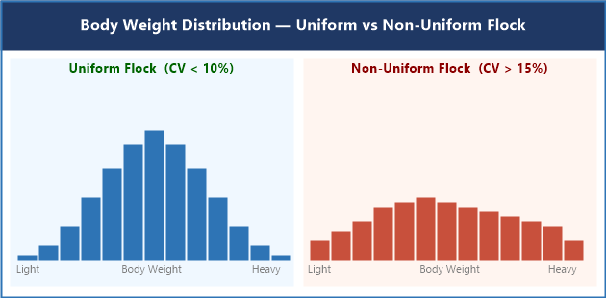
Figure 5. Body Weight Distribution — Uniform Flock (CV < 10%, narrow bell) vs. Non-Uniform Flock (CV > 15%, wide flat distribution). Source: Adapted from Aviagen Ross 308 Performance Objectives (2022).

S — Skin

What It Is
The Skin component assesses integument integrity beyond the foot and hock. Primary conditions: cellulitis (subcutaneous inflammation with fibrinous exudate — the leading cause of total carcass condemnation at Canadian processing plants; Elfadil et al., 1996), sternal bursitis (breast blisters), contact dermatitis at the breast and abdomen, ammonia burns on ventral skin, skin color abnormalities (cyanosis, jaundice, pallor), subcutaneous hemorrhage, and traumatic injuries (scratches, tears).

Why It Matters
Cellulitis is the primary cause of total carcass condemnation in Canadian broiler processing, representing complete revenue loss for that bird (Elfadil et al., 1996). Breast blisters and skin lesions downgrade carcass value below condemnation threshold. Skin condition reflects handling quality throughout the cycle — catching-related scratches allow environmental bacteria (E. coli, Staphylococcus aureus) to colonize subcutaneous tissues, causing cellulitis (Opengart, 2008).

How to Assess
In-barn: During routine weighing or handling, flip birds and examine the ventral surface (breast, abdomen, thigh). Score for: breast blister (absent, small <2 cm, large >2 cm); skin scratches/tears (absent, localized, extensive); discoloration (normal, pale, cyanotic, icteric). Palpate the keel bone for fluctuant swelling. Examine combs/wattles in layers and breeders. Request and analyze condemnation data by category from your processor after every kill.

What Abnormal Findings Indicate
Cellulitis: Bacterial subcutaneous infection — most common entry point is a scratch or skin break. Primary pathogens: E. coli, Staphylococcus aureus, Clostridium septicum (Opengart, 2008). Review catching procedures and E. coli vaccination status. Breast blisters >5%: Prolonged breast-to-litter contact — lame birds are at highest risk. Ammonia burns on ventral skin: Litter moisture >35%, ammonia >25 ppm. Cyanosis: Reduced oxygen delivery — ascites (Pulmonary Hypertension Syndrome), respiratory disease, or poor ventilation. Jaundice: Hepatic disease — Marek's, inclusion body hepatitis, or aflatoxicosis.

Recommended Management Responses
Cellulitis prevention: Minimize skin breaks — review catching crew technique; eliminate sharp surfaces inside barn; evaluate E. coli vaccination program (Poulvac E. coli, Zoetis, licensed in Canada; Zoetis, 2021). Breast blisters: Improve litter quality; reduce lame bird prevalence; ensure perch access in breeders. Ammonia burns: Litter moisture below 25%, ammonia below 10 ppm at nose level throughout. Skin color emergencies (cyanosis or jaundice in multiple birds): Same-day contact with poultry veterinarian; submit fresh chilled dead birds for post-mortem.
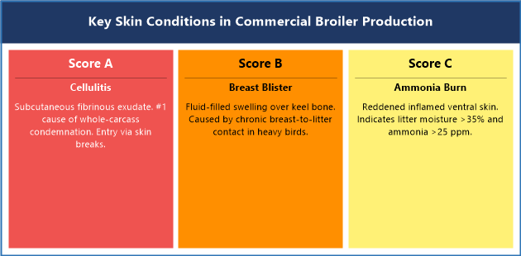
Figure 6. Key Skin Conditions in Commercial Broiler Production. A: Cellulitis (leading cause of carcass condemnation). B: Sternal Bursitis (breast blister). C: Ammonia Burn (contact dermatitis). Sources: Opengart (2008); Elfadil et al. (1996).

Recommended Peer-Reviewed Journals and Resources
The following journals represent the primary scientific literature base for poultry health, welfare, and production research. Access through university library systems or open-access options where available.

Peer-Reviewed Journals
Poultry Science. Oxford University Press / Poultry Science Association. All aspects of poultry production, health, nutrition, genetics, and processing. ISSN: 0032-5791
Avian Diseases. American Association of Avian Pathologists (AAAP). Avian diseases, diagnostic pathology, infectious disease, and immunology. ISSN: 0005-2086
World's Poultry Science Journal. Taylor & Francis / World's Poultry Science Association. International poultry science — production, nutrition, genetics, health, and welfare. ISSN: 0043-9339
British Poultry Science. Taylor & Francis. European poultry production systems, genetics, nutrition, and welfare. ISSN: 0007-1668
Journal of Applied Poultry Research. Oxford University Press / Poultry Science Association. Applied commercial poultry production, management, environment, and processing. ISSN: 1056-6171
Avian Pathology. Taylor & Francis. Avian diseases, diagnostics, pathology, and immunology. ISSN: 0307-9457
Animal Welfare. UFAW. Animal welfare science, policy, and practice — all species including poultry. ISSN: 0962-7286
Applied Animal Behaviour Science. Elsevier. Animal behavior of domestic and laboratory animals; strong poultry welfare coverage. ISSN: 0168-1591
Canadian Veterinary Journal. CVMA. Clinical and research articles relevant to veterinary practice in Canada. ISSN: 0008-5286
Veterinary Record. BMJ / BVA. Clinical findings, case reports, and research across all species. ISSN: 0042-4900

Key Institutional Resources
• National Farm Animal Care Council (NFACC) — Codes of Practice: www.nfacc.ca
• Canadian Food Inspection Agency (CFIA) — Meat Hygiene and Animal Welfare: www.inspection.gc.ca
• Aviagen Technical Resources — Ross Breed Manuals: www.aviagen.com
• Cobb-Vantress Technical Resources — Cobb Breed Manuals: www.cobb-vantress.com
• Lohmann Tierzucht — Layer Breed Guides: www.lohmann-tierzucht.com
• Merck Veterinary Manual — Poultry Section: www.merckvetmanual.com/poultry
• Welfare Quality® Assessment Protocols: www.welfarequalitynetwork.net

References
Aviagen. (2022). Ross 308 broiler: Performance objectives. Aviagen Group.
Aviagen. (2022). Ross broiler management handbook. Aviagen Group.
Aviagen. (2022). Ross broiler: Environmental management supplement. Aviagen Group.
Bilcik, B., & Keeling, L. J. (1999). Changes in feather condition in relation to feather pecking and aggressive behaviour in laying hens. British Poultry Science, 40(4), 444–451.
Canadian Food Inspection Agency. (2019). Meat hygiene manual of procedures: Chapter 17. Government of Canada.
Canadian Food Inspection Agency. (2022). Codes of practice for the care and handling of chickens, turkeys and breeders from hatch to slaughter. Government of Canada.
Canadian Veterinary Medical Association. (2020). CVMA position statement on farm animal welfare. CVMA.
CEVA Animal Health. (2020). Poultry feather condition scoring guide. CEVA Sante Animale.
Cobb-Vantress. (2021). Cobb 500 broiler performance and nutrition supplement. Cobb-Vantress Inc.
Cobb-Vantress. (2021). Cobb broiler management guide. Cobb-Vantress Inc.
Daigle, C. L. (2017). The effect of feather pecking on welfare and productivity. Journal of Applied Poultry Research, 26(4), 560–572.
Dawkins, M. S., Donnelly, C. A., & Jones, T. A. (2004). Chicken welfare is influenced more by housing conditions than by stocking density. Nature, 427(6972), 342–344.
Ekstrand, C., Algers, B., & Svedberg, J. (1997). Rearing conditions and foot-pad dermatitis in Swedish broiler chickens. Preventive Veterinary Medicine, 31(3–4), 167–174.
Elfadil, A. A., Vaillancourt, J. P., & Meek, A. H. (1996). Description of cellulitis lesions and associations between cellulitis and other indicators of health in broiler chickens. Avian Diseases, 40(3), 677–688.
European Food Safety Authority. (2012). Scientific opinion on the welfare of chickens on farm. EFSA Journal, 10(1), 2424.
Jones, R. B. (1996). Fear and adaptability in poultry: Insights, implications and imperatives. World's Poultry Science Journal, 52(2), 131–174.
Kestin, S. C., Knowles, T. G., Tinch, A. E., & Gregory, N. G. (1992). Prevalence of leg weakness in broiler chickens and its relationship with genotype. Veterinary Record, 131(9), 190–194.
Knowles, T. G., Kestin, S. C., Haslam, S. M., Brown, S. N., Green, L. E., Butterworth, A., Pope, S. J., Pfeiffer, D., & Nicol, C. J. (2008). Leg disorders in broiler chickens: Prevalence, risk factors and prevention. PLoS ONE, 3(2), e1545.
Lohmann Tierzucht. (2021). Lohmann LSL-Classic management guide. Lohmann Tierzucht GmbH.
Merck Veterinary Manual. (2022). Footpad dermatitis in poultry. Merck & Co., Inc.
Merck Veterinary Manual. (2022). Lameness in poultry. Merck & Co., Inc.
Merck Veterinary Manual. (2022). Skin disorders in poultry. Merck & Co., Inc.
National Farm Animal Care Council. (2016). Code of practice for the care and handling of hatching eggs, breeders, chickens and turkeys. NFACC.
Opengart, K. (2008). Necrotic dermatitis. In Y. M. Saif et al. (Eds.), Diseases of poultry (12th ed., pp. 1092–1095). Blackwell Publishing.
Riber, A. B., van de Weerd, H. A., de Jong, I. C., & Steenfeldt, S. (2018). Review of environmental enrichment for broiler chickens. Poultry Science, 97(2), 378–396.
Shepherd, E. M., & Fairchild, B. D. (2010). Footpad dermatitis in poultry. Poultry Science, 89(10), 2043–2051.
Welfare Quality(R). (2009). Welfare Quality assessment protocol for poultry. Welfare Quality Consortium.
Zoetis. (2021). Poulvac E. coli: Product monograph. Zoetis Canada Inc.
Zuidhof, M. J., Schneider, B. L., Carney, V. L., Korver, D. R., & Robinson, F. E. (2014). Growth, efficiency, and yield of commercial broilers from 1957, 1978, and 2005. Poultry Science, 93(12), 2970–2982.

